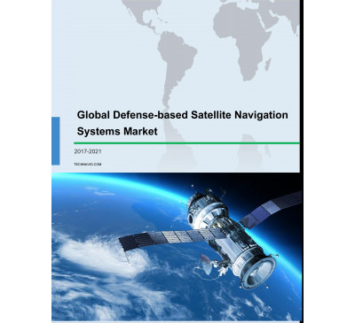

Global Defense-based Satellite Navigation Systems Market 2017-2021
- Sep 2017
- 69 pages
- USD 3500USD 2500
Overview of the global defense-based satellite navigation systems market Research analysis on the...
View Report

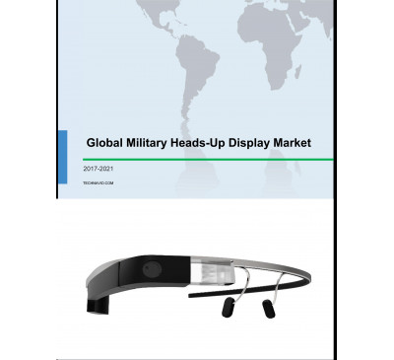

Global Military Heads-up Display (HUD) Market 2017-2021
- Sep 2017
- 66 pages
- USD 3500USD 2500
Overview of the global military heads-up display (HUD) market Research analysis on the global mil...
View Report

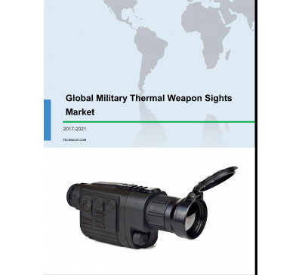

Global Military Thermal Weapon Sights Market 2017-2021
- Sep 2017
- 71 pages
- USD 3500USD 2500
Overview of the global military thermal weapon sights market Imaging technology is an integral pa...
View Report
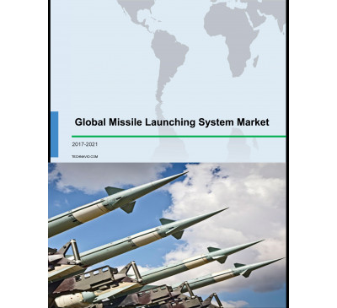

Global Missile Launching System Market 2017-2021
- Sep 2017
- 70 pages
- USD 3500USD 2500
Overview of the global missile launching system market Technavio’s market research report identif...
View Report
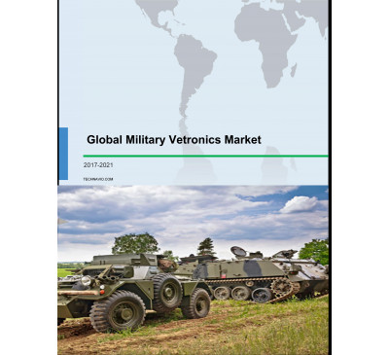

Global Military Vetronics Market 2017-2021
- Sep 2017
- 68 pages
- USD 3500USD 2500
Overview of the global military vetronics market A wide range of electronics and electrical compo...
View Report

Global Military Hybrid Electric Vehicle (HEV) And Electric Vehicle (EV) Market 2017-2021
- Aug 2017
- 70 pages
- USD 3500USD 2500
Overview of the global military hybrid electric vehicle (HEV) and electric vehicle (EV) market Te...
View Report

Global Military Aircraft Flight Control System Market 2017-2021
- Aug 2017
- 88 pages
- USD 3500USD 2500
Overview of the global military aircraft flight control system market Technavio’s market study id...
View Report
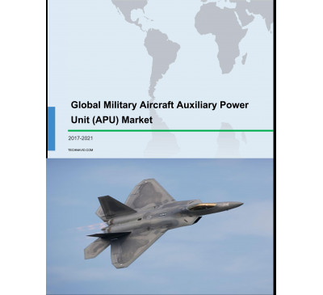

Global Military Aircraft Auxiliary Power Unit (APU) Market 2017-2021
- Aug 2017
- 64 pages
- USD 3500USD 2500
Overview of the global military aircraft auxiliary power unit (APU) market Research analysis on t...
View Report
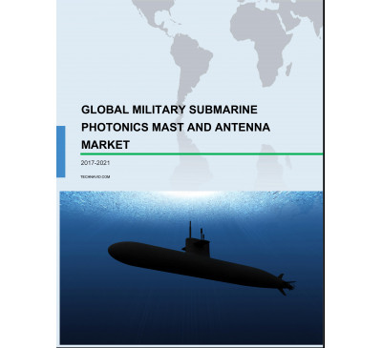

Global Military Submarine Photonics Mast And Antenna Market 2017-2021
- Aug 2017
- 70 pages
- USD 3500USD 2500
Overview of the global military submarine photonics mast and antenna market Research analysis on ...
View Report
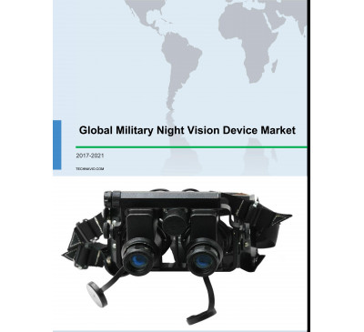

Global Military Night Vision Device Market 2017-2021
- Aug 2017
- 70 pages
- USD 3500USD 2500
Overview of the global military night vision device market Terrorist organizations carry out spy ...
View Report
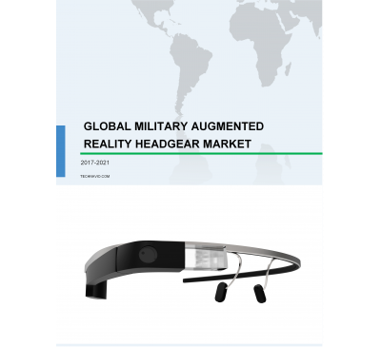

Global Military Augmented Reality (AR) Headgear Market 2017-2021
- Aug 2017
- 68 pages
- USD 3500USD 2500
Overview of the global military augmented reality (AR) headgear market Research analysis on the g...
View Report

Global Armored Vehicles Automatic Fire Extinguishing Systems (AFES) Market 2017-2021
- Aug 2017
- 61 pages
- USD 3500USD 2500
Overview of the global armored vehicles automatic fire extinguishing systems market Research anal...
View Report

Global Maritime Patrol Naval Vessels Market 2017-2021
- Aug 2017
- 68 pages
- USD 3500USD 2500
Overview of the global maritime patrol naval vessels market Technavio’s market study identifies t...
View Report

Global Military Wearable Sensors Market 2017-2021
- Jul 2017
- 68 pages
- USD 3500USD 2500
Overview of the global military wearable sensors market Market research analysts identifies the i...
View Report

Global Military Floating Bridge Market 2017-2021
- Jul 2017
- 68 pages
- USD 3500USD 2500
Overview of the global military floating bridge market Technavio’s market research analysis ident...
View Report

Global Marine Vessel Energy Efficiency Market 2017-2021
- Jul 2017
- 65 pages
- USD 3500USD 2500
Overview of the global marine vessel energy efficiency market Market research analysts at Technav...
View Report

Global Military Lightweight Armor Systems Market 2017-2021
- Jul 2017
- 70 pages
- USD 3500USD 2500
Overview of the global military lightweight armor systems market Market research analysts at Tec...
View Report
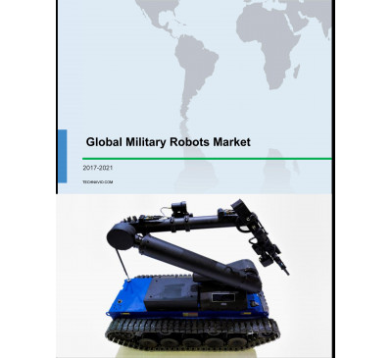

Global Military Robots Market 2017-2021
- Jul 2017
- 83 pages
- USD 3500USD 2500
Overview of the global military robots market According to Technavio’s market research report...
View Report

Global Counter Unmanned Aerial Vehicle (UAV) Defense System Market 2017-2021
- Jul 2017
- 66 pages
- USD 3500USD 2500
Overview of the global counter unmanned aerial vehicle (UAV) defense system market Market researc...
View Report
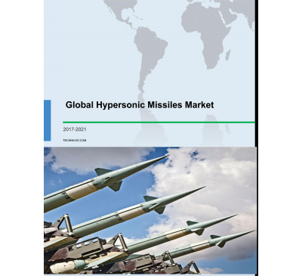

Global Hypersonic Missiles Market 2017-2021
- Jul 2017
- 70 pages
- USD 3500USD 2500
Overview of the global hypersonic missiles market Market research analysts at Technavio predict t...
View Report

Global Military Fighting Vehicles Market 2017-2021
- Jul 2017
- 67 pages
- USD 3500USD 2500
Overview of the global military fighting vehicles market Market research analysts at Technavio pr...
View Report

Global Submarine Market 2017-2021
- Jul 2017
- 73 pages
- USD 3500USD 2500
Overview of the global submarine market Market research analysts at Technavio predict that the gl...
View Report

Global UAV Ground Control Station Market 2017-2021
- Jul 2017
- 68 pages
- USD 3500USD 2500
Overview of the global UAV ground control station market Market research analysts at Technavio pr...
View Report
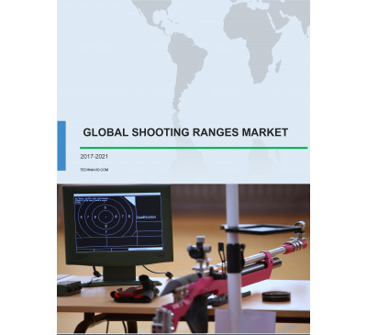

Global Shooting Ranges Market 2017-2021
- Jun 2017
- 72 pages
- USD 3500USD 2500
Overview of the global shooting ranges market Market research analysts at Technavio predict that ...
View Report
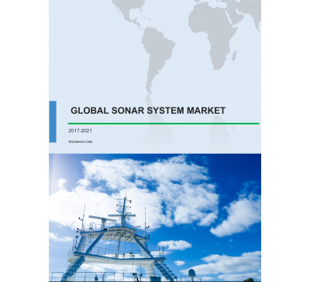

Global SONAR System Market 2017-2021
- Jun 2017
- 72 pages
- USD 3500USD 2500
Overview of the global SONAR system market Market research analysts at Technavio predict that the...
View Report
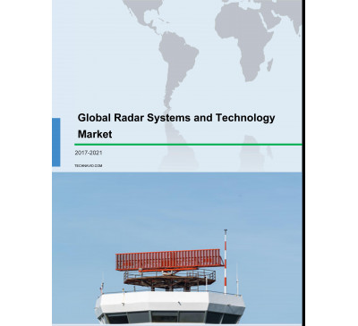

Global Radar Systems And Technology Market 2017-2021
- Jun 2017
- 74 pages
- USD 3500USD 2500
Overview of the global radar systems and technology market Market research analysts at Technavio ...
View Report
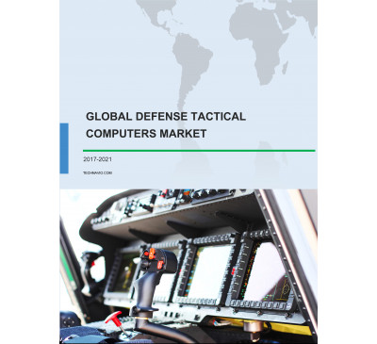

Global Defense Tactical Computers Market 2017-2021
- Jun 2017
- 71 pages
- USD 3500USD 2500
Overview of the global defense tactical computers market Market research analysts at Technavio pr...
View Report
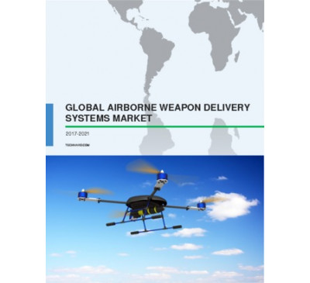

Global Airborne Weapon Delivery Systems Market 2017-2021
- Jun 2017
- 70 pages
- USD 3500USD 2500
Overview of the global airborne weapon delivery systems market Market research analysts at Techna...
View Report
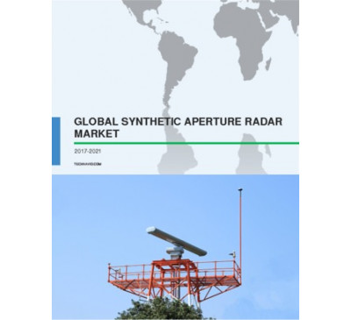

Global Synthetic Aperture Radar (SAR) Market 2017-2021
- Jun 2017
- 70 pages
- USD 3500USD 2500
Overview of the global synthetic aperture radar (SAR) market Market research analysts at Technavi...
View Report

Global Military Fire Control Systems Market 2017-2021
- May 2017
- 70 pages
- USD 3500USD 2500
Overview of the global military fire control systems market Market research analysts at Technavi...
View Report
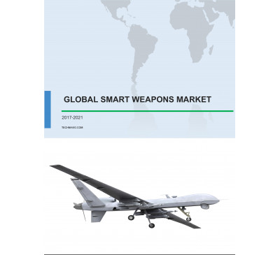

Global Smart Weapons Market 2017-2021
- May 2017
- 70 pages
- USD 3500USD 2500
Overview of the global smart weapons market Market research analysts at Technavio predict that t...
View Report
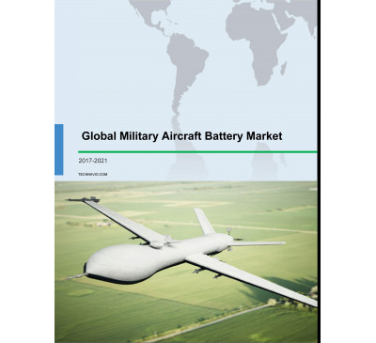

Global Military Aircraft Battery Market 2017-2021
- May 2017
- 70 pages
- USD 3500USD 2500
Overview of the global military aircraft battery market Market research analysts at Technavio pr...
View Report

Global CBRND Market 2017-2021
- May 2017
- 70 pages
- USD 3500USD 2500
Overview of the global CBRND market According to Technavio’s market research report, the global C...
View Report
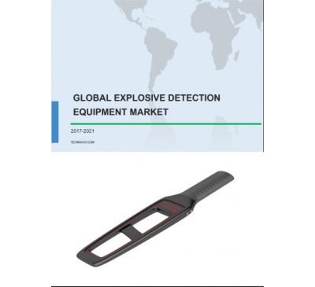

Global Explosive Detection Equipment Market 2017-2021
- May 2017
- 70 pages
- USD 3500USD 2500
Overview of the global explosive detection equipment market Market research analysts at Technavi...
View Report

Global Alternative Fuel-powered Military Fleet Market 2017-2021
- May 2017
- 70 pages
- USD 3500USD 2500
Overview of the global alternative fuel-powered military fleet market According to Technavio’s ma...
View Report
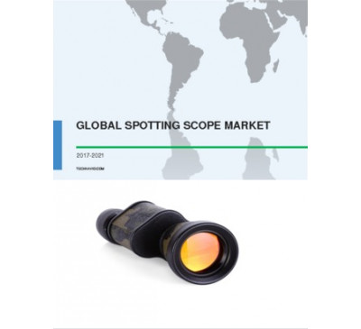

Global Spotting Scope Market 2017-2021
- May 2017
- 70 pages
- USD 3500USD 2500
Overview of the global spotting scope market The global spotting scope market is foreseen to grow...
View Report

Global Commercial Aviation And Military Headset Market 2017-2021
- Apr 2017
- 70 pages
- USD 3500USD 2500
Overview of the global commercial aviation and military headset market Technavio’s market researc...
View Report

Global Military Camouflage Uniform Market 2017-2021
- Apr 2017
- 70 pages
- USD 3500USD 2500
Overview of the global military camouflage uniform market Technavio’s market research report pred...
View Report
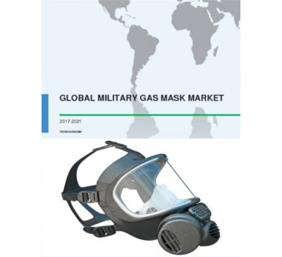

Global Military Gas Mask Market 2017-2021
- Apr 2017
- 70 pages
- USD 3500USD 2500
Overview of the global military gas mask market Market research analysts at Technavio predict tha...
View Report
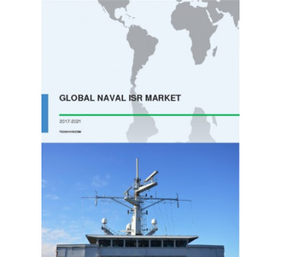

Global Naval ISR Market 2017-2021
- Apr 2017
- 70 pages
- USD 3500USD 2500
Overview of the global naval ISR market Technavio’s market research report predicts that the glob...
View Report
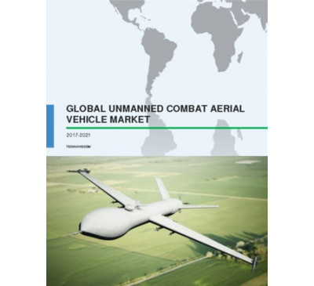

Global Unmanned Combat Aerial Vehicle (UCAV) Market 2017-2021
- Apr 2017
- 70 pages
- USD 3500USD 2500
Overview of the global UCAV market As per the Technavio’s market research report, the global UCAV...
View Report
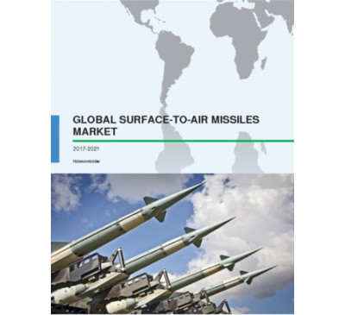

Global Surface-to-Air Missiles Market 2017-2021
- Apr 2017
- 70 pages
- USD 3500USD 2500
Overview of the global surface-to-air missiles market Technavio’s market research report predicts...
View Report

Global Soldier Monitoring System Market 2017-2021
- Apr 2017
- 70 pages
- USD 3500USD 2500
Overview of the global soldier monitoring system market Market research analysts at Technavio pre...
View Report
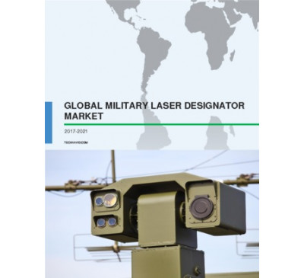

Global Military Laser Designator Market 2017-2021
- Apr 2017
- 70 pages
- USD 3500USD 2500
Overview of the global military laser designator market As per the Technavio’s market research re...
View Report
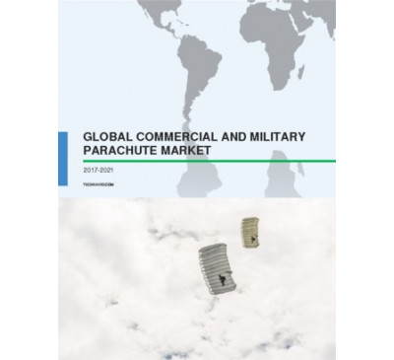

Global Commercial And Military Parachute Market 2017-2021
- Apr 2017
- 70 pages
- USD 3500USD 2500
Overview of the global commercial and military parachute market According to Technavio’s analyst,...
View Report

Global Military Exoskeleton Market 2017-2021
- Mar 2017
- 70 pages
- USD 3500USD 2500
Overview of the global military exoskeleton market Technavio’s market research analyst pr.....
View Report
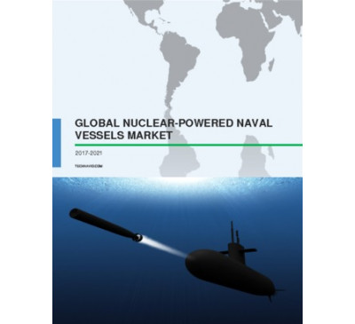

Global Nuclear Powered Naval Vessels Market 2017-2021
- Mar 2017
- 70 pages
- USD 3500USD 2500
Overview of the global nuclear-powered naval vessels market Technavio’s market research r.....
View Report

Global Military Fitness Training Equipment Market 2017-2021
- Mar 2017
- 70 pages
- USD 3500USD 2500
Overview of the global military fitness training equipment market As per the Technavio’s .....
View Report

Global Military Body-Worn Camera Market 2017-2021
- Feb 2017
- 67 pages
- USD 3500USD 2500
Overview of the military body-worn camera market Extensive research carried out by the analysts a...
View Report

Global Military Aerial Refueling Tanker Market 2017-2021
- Feb 2017
- 67 pages
- USD 3500USD 2500
Overview of the global military aerial refueling tanker market According to the Technavio&rsquo...
View Report
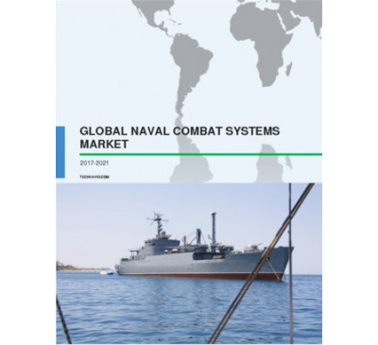

Global Naval Combat Systems Market 2017-2021
- Feb 2017
- 78 pages
- USD 3500USD 2500
Overview of the global naval combat systems market The global naval combat systems market is an...
View Report

Global UAV Flight Training And Simulation Market 2017-2021
- Jan 2017
- 74 pages
- USD 3500USD 2500
Overview of the global UAV flight training and simulation market Technavio’s market resea.....
View Report

Global Unmanned Sea Systems Market 2017-2021
- Jan 2017
- 70 pages
- USD 3500USD 2500
Overview of the global unmanned sea systems market The global unmanned sea systems market is an...
View Report
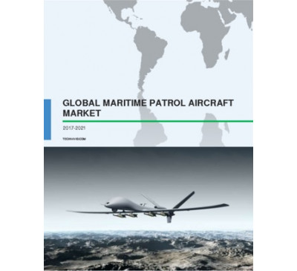

Global Maritime Patrol Aircraft Market 2017-2021
- Jan 2017
- 58 pages
- USD 3500USD 2500
Overview of the global MPA market The global MPA market is anticipated to grow at a steady rate...
View Report
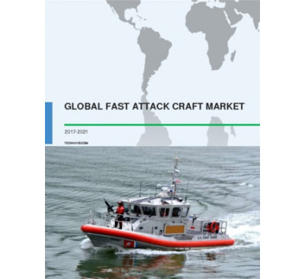

Global Fast Attack Craft Market 2017-2021
- Jan 2017
- 70 pages
- USD 3500USD 2500
Overview of the global fast attack craft (FAC) market Market research analysts at Technavio pre...
View Report
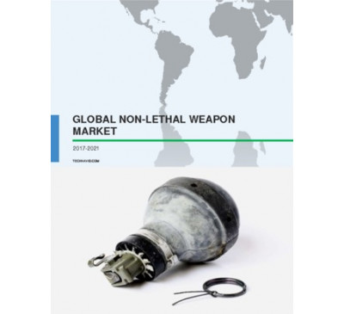

Global Non-Lethal Weapon Market 2017-2021
- Jan 2017
- 64 pages
- USD 3500USD 2500
Overview of the global non-lethal weapon market Technavio’s market research analyst predi.....
View Report
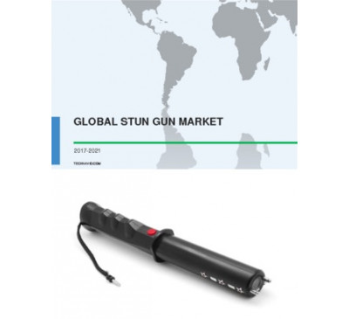

Global Stun Gun Market 2017-2021
- Jan 2017
- 68 pages
- USD 3500USD 2500
Overview of the global stun gun market The global stun gun market is anticipated to grow at a s...
View Report
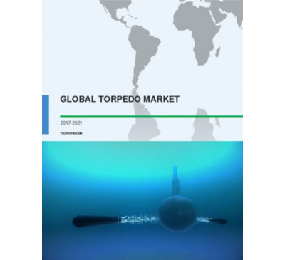

Global Torpedo Market 2017-2021
- Dec 2016
- 67 pages
- USD 3500USD 2500
Overview of the global torpedo market Market research analysts at Technavio predict that the gl...
View Report
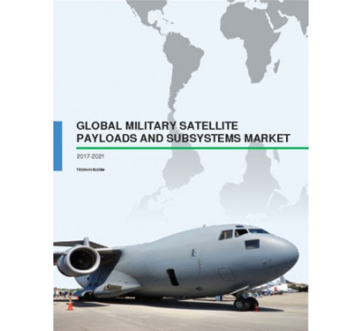

Global Military Satellite Payloads And Subsystems Market 2017-2021
- Dec 2016
- 64 pages
- USD 3500USD 2500
Overview of the global military satellite payloads and subsystems market Technavio’s mark.....
View Report
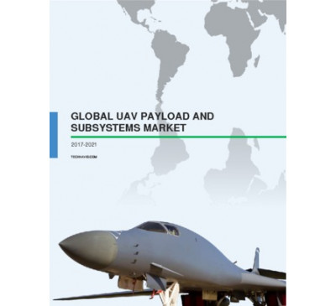

Global UAV Payload And Subsystems Market 2017-2021
- Dec 2016
- 71 pages
- USD 3500USD 2500
Outlook of the global unmanned aerial vehicle (UAV) payload and subsystems market According to ...
View Report
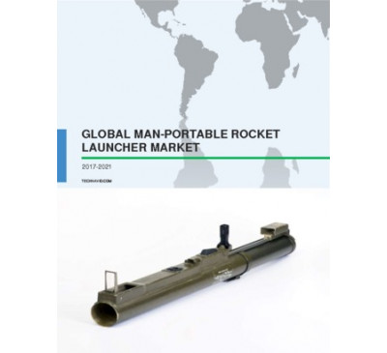

Global Man-Portable Rocket Launcher Market 2017-2021
- Dec 2016
- 66 pages
- USD 3500USD 2500
Overview of the global man-portable rocket launcher market The global man-portable rocket launc...
View Report

Global Submarine-launched Missile Market 2017-2021
- Dec 2016
- 66 pages
- USD 3500USD 2500
Overview of the global submarine-launched missile market The global submarine-launched missile ...
View Report

Global Attack Helicopter Market 2017-2021
- Dec 2016
- 61 pages
- USD 3500USD 2500
Overview of the global attack helicopter market Technavio’s market research analyst predi.....
View Report
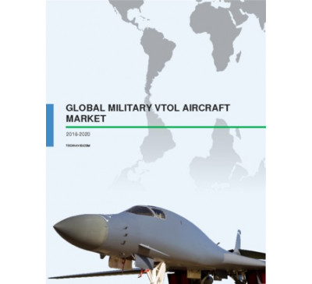

Global Military Vertical Take-off And Landing Aircraft Market 2016-2020
- Dec 2016
- 61 pages
- USD 2500USD 2375
Global outlook of the military vertical take-off and landing (VTOL) aircraft market Technavio&r...
View Report

Global Military Aircraft Modernization And Upgrade And Retrofit Market 2017-2021
- Dec 2016
- 59 pages
- USD 3500USD 2500
Overview of the global military aircraft modernization, upgrade, and retrofit market Technavio’s ...
View Report

Global Military Aircraft Avionics Market 2017-2021
- Dec 2016
- 68 pages
- USD 3500USD 2500
Overview of the global military aircraft avionics market The global military aircraft avionics ma...
View Report

Global Smart Textiles Market For Military 2016-2020
- Dec 2016
- 55 pages
- USD 2500USD 2375
Overview of the global smart textiles market in the military sector Technavio’s market re.....
View Report

Global Military Biometrics Market 2016-2020
- Dec 2016
- 60 pages
- USD 2500USD 2375
Overview of the global military biometrics market Technavio’s market research analyst predicts th...
View Report

Global Airborne Intelligence Surveillance And Reconnaissance Market 2017-2021
- Nov 2016
- 68 pages
- USD 3500USD 2500
Overview of the global airborne intelligence, surveillance, and reconnaissance (ISR) market Tec...
View Report
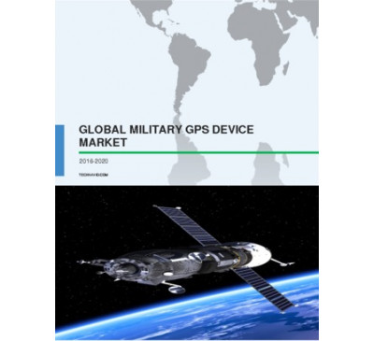

Global Military GPS Device Market 2016-2020
- Nov 2016
- 60 pages
- USD 2500USD 2375
Overview of the global military GPS device market Technavio’s market research analyst pre.....
View Report

Global Sensor-based Gun Systems Market 2016-2020
- Nov 2016
- 59 pages
- USD 2500USD 2375
Overview of the global sensor-based gun systems market Technavio’s market research analys.....
View Report
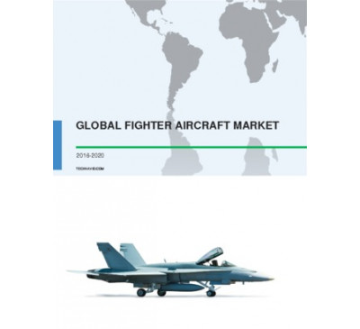

Global Fighter Aircraft Market 2016-2020
- Nov 2016
- 57 pages
- USD 2500USD 2375
Overview of the global fighter aircraft market The global fighter aircraft market is anticipate...
View Report

Global Aircraft Carriers Market 2016-2020
- Nov 2016
- 59 pages
- USD 2500USD 2375
Overview of the global aircraft carriers market The global aircraft carriers market is anticipa...
View Report
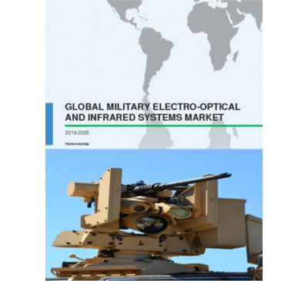

Global Military Electro-optical And Infrared Systems Market 2016-2020
- Nov 2016
- 64 pages
- USD 2500USD 2375
Overview of the global military electro-optical and infrared systems market Technavio’s m.....
View Report
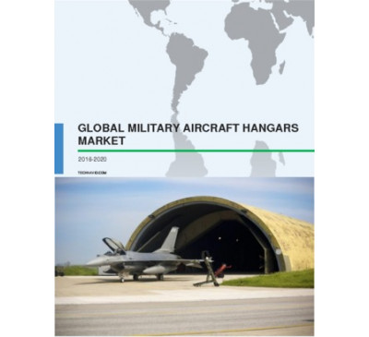

Global Military Aircraft Hangars Market 2016-2020
- Nov 2016
- 58 pages
- USD 2500USD 2375
Overview of the global military aircraft hangars market The global military aircraft hangars ma...
View Report

Global Air-cushion Vehicle Market 2016-2020
- Oct 2016
- 60 pages
- USD 2500USD 2375
Overview of the global air-cushion vehicle market The rising territorial water zone disputes an...
View Report

Global Agility Training Equipment Market 2016-2020
- Oct 2016
- 56 pages
- USD 2500USD 2375
Overview of the global agility training equipment market According to Technavio’s market .....
View Report

Global Submarine Sensors Market 2016-2020
- Oct 2016
- 61 pages
- USD 2500USD 2375
Overview of the global submarine sensors market Technavio’s market research analysts pred.....
View Report
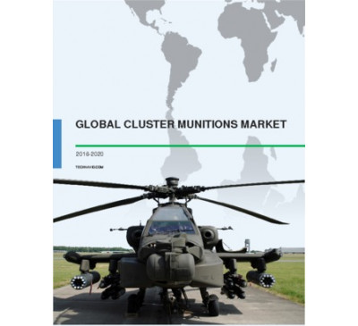

Global Cluster Munitions Market 2016-2020
- Oct 2016
- 54 pages
- USD 2500USD 2375
Overview of the global cluster munitions market Technavio’s market research analysts pred.....
View Report
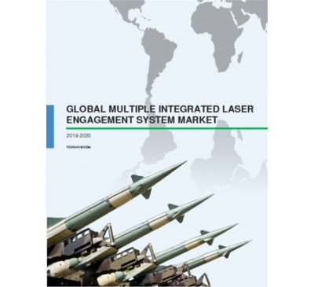

Global Multiple Integrated Laser Engagement System Market 2016-2020
- Oct 2016
- 54 pages
- USD 2500USD 2375
Overview of the global multiple integrated laser engagement system (MILES) market According to ...
View Report

Global Advanced Combat Helmet Market 2016-2020
- Oct 2016
- 54 pages
- USD 2500USD 2375
Overview of the global advanced combat helmet (ACH) market Technavio’s market research analyst pre...
View Report
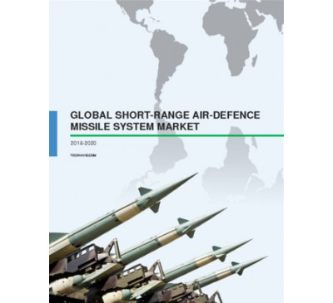

Global Short-Range Air-Defence Missile System Market 2016-2020
- Oct 2016
- 72 pages
- USD 2500USD 2375
Overview of the global short-range air-defence (SHORAD) missile system market Technavio’s market r...
View Report
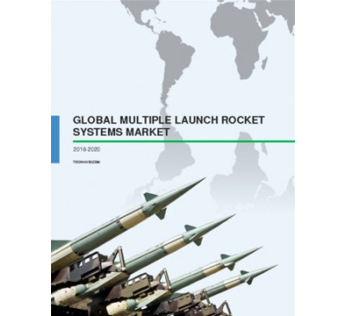

Global Multiple Launch Rocket Systems Market 2016-2020
- Oct 2016
- 55 pages
- USD 2500USD 2375
Overview of the global multiple launch rocket systems (MLRS) market Technavio’s market research an...
View Report
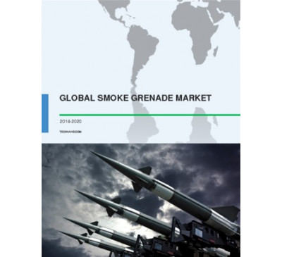

Global Smoke Grenade Market 2016-2020
- Sep 2016
- 59 pages
- USD 2500USD 2375
Overview of the global smoke grenade market Technavio’s market research analyst predicts the globa...
View Report

Global Laser Defense Eyewear Market 2016-2020
- Sep 2016
- 58 pages
- USD 2500USD 2375
Global outlook of the laser defense eyewear market According to Technavio’s market research analys...
View Report
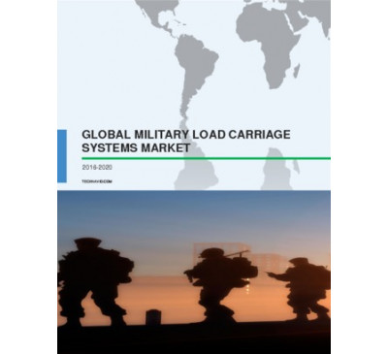

Global Military Load Carriage Systems Market 2016-2020
- Sep 2016
- 56 pages
- USD 2500USD 2375
Overview of the global military load carriage systems market According to the market research anal...
View Report

Global Amphibious Assault Vehicle Market 2016-2020
- Sep 2016
- 69 pages
- USD 2500USD 2375
Overview of the global amphibious assault vehicle (AAV) market Technavio’s market research analyst...
View Report
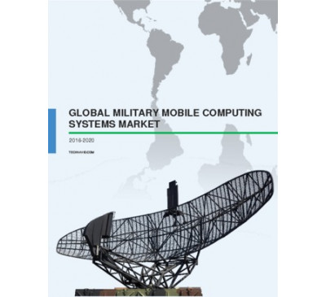

Global Military Mobile Computing Systems Market 2016-2020
- Sep 2016
- 69 pages
- USD 2500USD 2375
Overview of the global military mobile computing systems market Technavio’s market research analys...
View Report
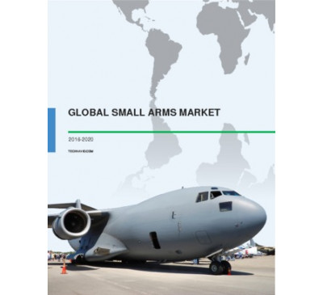

Global Small Arms Market 2016-2020
- Sep 2016
- 54 pages
- USD 2500USD 2250
Overview of the global small arms market Technavio’s market research analyst predicts the global s...
View Report

Global C4ISR Market 2016-2020
- Sep 2016
- 64 pages
- USD 2500USD 2250
Overview of the global C4ISR market The market research analysts at Technavio predict that the glo...
View Report
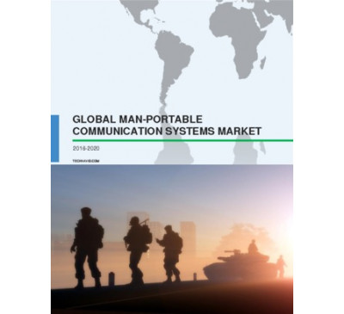

Global Man-portable Communication Systems Market 2016-2020
- Sep 2016
- 64 pages
- USD 2500USD 2250
Outlook of the global man-portable communication systems market Technavio’s market researchers pre...
View Report

Global Military Tank Containers Market 2016-2020
- Aug 2016
- 60 pages
- USD 2500USD 2250
Overview of the global military tank containers market Market research analyst at Technavio has pr...
View Report
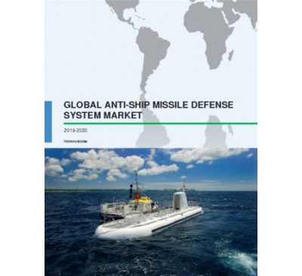

Global Anti-Ship Missile Defence System Market 2016-2020
- Aug 2016
- 82 pages
- USD 2500USD 2250
Overview of the global anti-ship missile defense system market Extensive market research carried o...
View Report
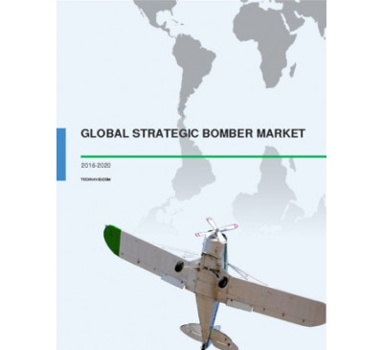

Global Strategic Bomber Market 2016-2020
- Aug 2016
- 62 pages
- USD 2500USD 2250
Outlook of the global strategic bomber market The market analyst at Technavio predicts that the gl...
View Report

Global Military Infrastructure And Logistics Market 2016-2020
- Aug 2016
- 68 pages
- USD 2500USD 2250
Overview of the global military infrastructure and logistics market Technavio’s market research an...
View Report
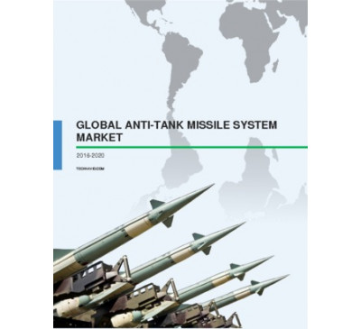

Global Anti-Tank Missile System Market 2016-2020
- Aug 2016
- 71 pages
- USD 2500USD 2250
Overview of the global anti-tank missile system market Market research analysts at Technavio have ...
View Report

Global Submarine Payload And Launch Systems Market 2016-2020
- Aug 2016
- 80 pages
- USD 2500USD 2250
Overview of the global submarine payload and launch systems market Technavio’s market research ana...
View Report

Global Ballistic Protection Market 2016-2020
- Aug 2016
- 68 pages
- USD 2500USD 2250
Outlook of the global ballistic protection market Technavio’s market research analyst has estimate...
View Report

Global Multi-Function Display Market 2016-2020
- Jul 2016
- 75 pages
- USD 2500USD 2250
Overview of the global multi-function display (MFD) market Technavio’s market research analyst pre...
View Report

Global Solar-powered UAV Market 2016-2020
- Jul 2016
- 66 pages
- USD 2500USD 2250
Global outlook of the solar-powered unmanned aerial vehicle (UAV) market Extensive research carrie...
View Report

Global Marine Electric Vehicles Market 2016-2020
- Jun 2016
- 57 pages
- USD 2500USD 2250
Overview of the marine electric vehicles market Technavio’s market research analyst predicts the g...
View Report
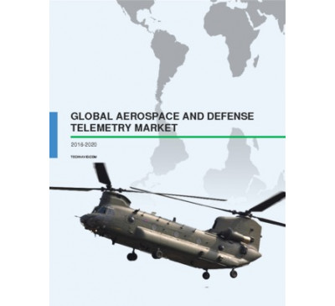

Global Aerospace And Defense Telemetry Market 2016-2020
- Jun 2016
- 67 pages
- USD 2500USD 2250
Overview of the global aerospace and defense (A&D) telemetry market Technavio’s market research an...
View Report

Global Advanced Extremely High Frequency Systems Market 2016-2020
- Jun 2016
- 67 pages
- USD 2500USD 2250
Overview of the advanced extremely high frequency (AEHF) systems market Technavio’s market researc...
View Report

Global Military Airborne Collision Avoidance System Market 2016-2020
- Jun 2016
- 75 pages
- USD 2500USD 2250
Outlook of the global military airborne collision avoidance system market Technavio’s market resea...
View Report
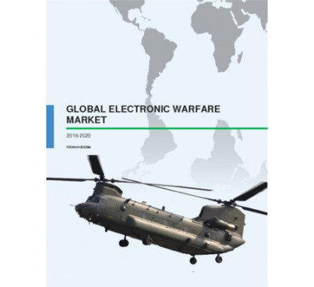

Global Electronic Warfare Market 2016-2020
- Jun 2016
- 100 pages
- USD 2500USD 2250
Outlook of the global electronic warfare market Technavio’s market research analyst predicts the g...
View Report
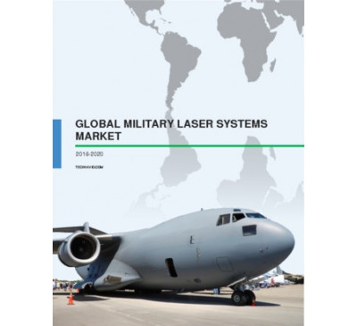

Global Military Laser Systems Market 2016-2020
- May 2016
- 77 pages
- USD 2500USD 2250
Overview of the global military laser systems market Technavio’s market research analyst predicts ...
View Report
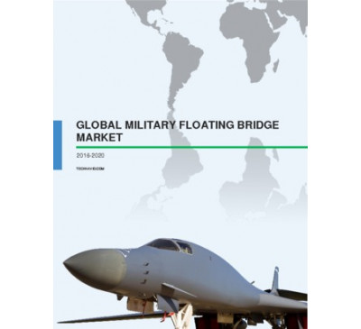

Global Military Floating Bridge Market 2016-2020
- May 2016
- 68 pages
- USD 2500USD 2250
Outlook of the military floating bridge market Military floating bridges are extensively used by m...
View Report
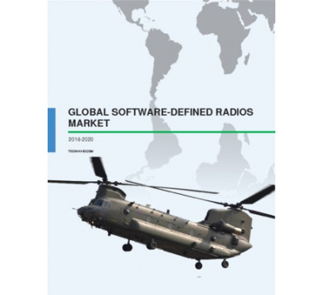

Global Software-Defined Radios Market 2016-2020
- May 2016
- 72 pages
- USD 2500USD 2250
Overview of the software-defined radios (SDR) market Software-defined radios (SDR) are partially o...
View Report
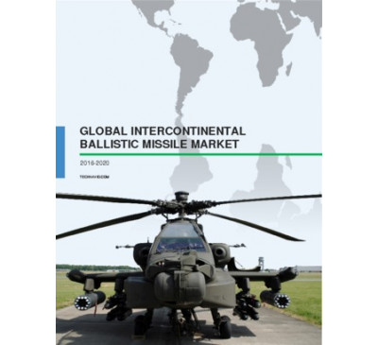

Global Intercontinental Ballistic Missile Market 2016-2020
- May 2016
- 75 pages
- USD 2500USD 2250
Overview of the global intercontinental ballistic missile (ICBM) market Intercontinental ballistic...
View Report
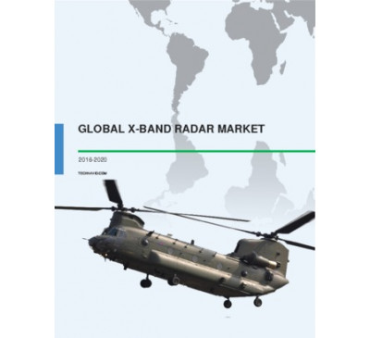

Global X-Band Radar Market 2016-2020
- Apr 2016
- 68 pages
- USD 2500USD 2250
Overview of the global X-band radar market Technavio’s market research analyst predicts the global...
View Report
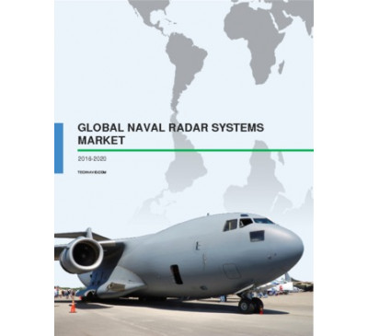

Global Naval Radar Systems Market 2016-2020
- Apr 2016
- 66 pages
- USD 2500USD 2250
Outlook of the naval radar systems market Technavio’s market research analysts have predicted the ...
View Report

Global Directed Energy Weapons Market 2016-2020
- Apr 2016
- 81 pages
- USD 2500USD 2250
Outlook of the global directed energy weapons (DEW) market Technavio’s market research analyst pre...
View Report

Global VTOL UAV Market 2016-2020
- Apr 2016
- 71 pages
- USD 2500USD 2250
Outlook of the global VTOL UAV market Technavio’s market research analyst anticipates the global v...
View Report
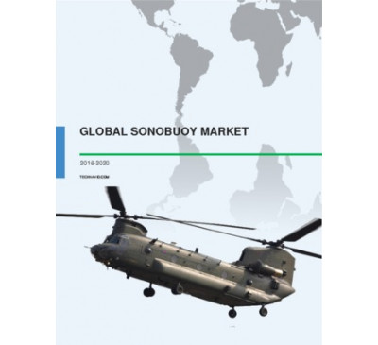

Global Sonobuoy Market 2016-2020
- Apr 2016
- 54 pages
- USD 2500USD 2250
Overview of the sonobuoy market Extensive research carried out by the analysts at Technavio has sh...
View Report
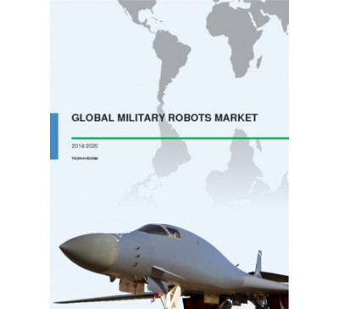

Global Military Robots Market 2016-2020
- Apr 2016
- 72 pages
- USD 2500USD 2250
Outlook of the global military robots market Technavio’s market research analyst predicts that the...
View Report

Global Riot Control System Market 2016-2020
- Apr 2016
- 55 pages
- USD 2500USD 2250
Overview of the global riot control system market Technavio’s market research analyst predicts tha...
View Report
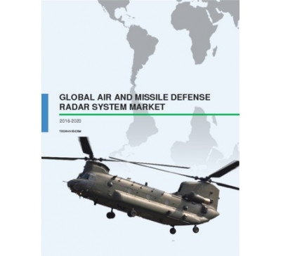

Global Air And Missile Defense Radar System Market 2016-2020
- Mar 2016
- 76 pages
- USD 2500USD 2250
Outlook of the global air and missile defense radar (AMDR) system market Technavio’s market resear...
View Report
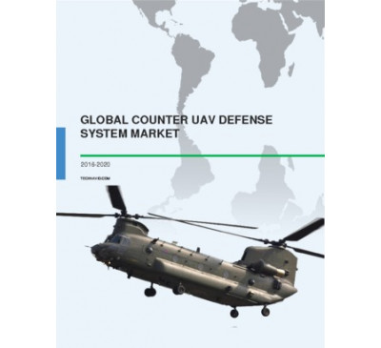

Global Counter Unmanned Aerial Vehicle Defense System Market 2016-2020
- Mar 2016
- 56 pages
- USD 2500USD 2250
Outlook of the global counter UAV defense system market The rising demand for unmanned aerial vehi...
View Report

Global Submarine Market 2016-2020
- Mar 2016
- 76 pages
- USD 2500USD 2250
Overview of the global submarine market Technavio’s market research analyst predicts the global su...
View Report
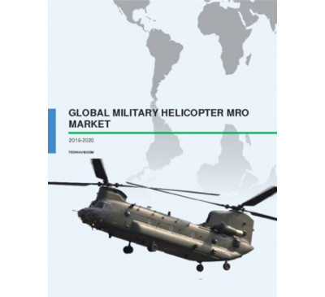

Global Military Helicopter MRO Market 2016-2020
- Feb 2016
- 68 pages
- USD 2500USD 2250
Outlook of the global military helicopter MRO market Extensive market research carried out by anal...
View Report

Global Armored Vehicles Automatic Fire Extinguishing Systems Market 2016-2020
- Feb 2016
- 56 pages
- USD 2500USD 2250
Outlook of the global armored vehicles automatic fire extinguishing systems marketIn armored vehicle...
View Report

Global Military Manpack And Vehicular Radios Market 2016-2020
- Feb 2016
- 67 pages
- USD 2500USD 2250
Outlook of the global military manpack and vehicular radios market Technavio’s market research ana...
View Report
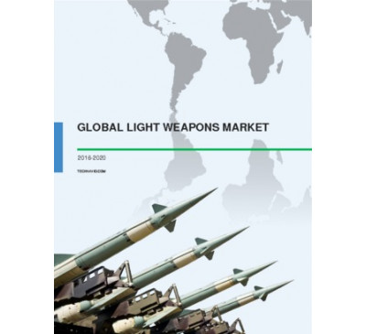

Global Light Weapons Market 2016-2020
- Feb 2016
- 79 pages
- USD 2500USD 2250
Light weapons market at a glance Technavio’s research analyst predicts the global light weapons ma...
View Report
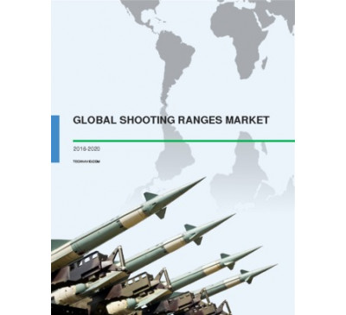

Global Shooting Ranges Market 2016-2020
- Feb 2016
- 60 pages
- USD 2500USD 2250
Market overview of shooting ranges Technavio’s market research analyst predicts the global shootin...
View Report

Global CBRND Market 2016-2020
- Jan 2016
- 66 pages
- USD 2500USD 2250
Market outlook of the global CBRND market Technavio’s research analyst predicts the global chemica...
View Report
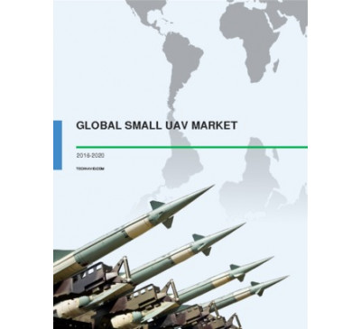

Global Small UAV Market 2016-2020
- Jan 2016
- 72 pages
- USD 2500USD 2250
Outlook of the global small UAV market Technavio’s market research analyst predicts the global sma...
View Report

Global Naval Vessels MRO Market 2016-2020
- Jan 2016
- 80 pages
- USD 2500USD 2250
Market outlook of naval vessels MRO Technavio’s research analyst predicts the global naval vessels...
View Report

Global UAV Market 2016-2020
- Jan 2016
- 67 pages
- USD 2500USD 2250
Outlook of the global UAV market Technavio’s market research analyst predicts the global unmanned ...
View Report

Global Battlefield Management Systems Market 2016-2020
- Jan 2016
- 84 pages
- USD 2500USD 2250
Market overview of the global battlefield management systems market A battle management system pro...
View Report
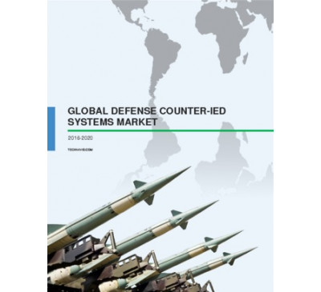

Global Defense Counter-IED Systems Market 2016-2020
- Jan 2016
- 73 pages
- USD 2500USD 2250
Market outlook of defense counter IED systems A counter improvised explosive devices (IED) is an e...
View Report
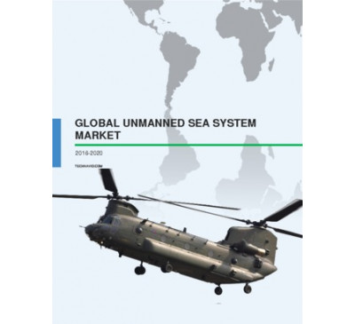

Global Unmanned Sea System Market 2016-2020
- Dec 2015
- 55 pages
- USD 2500USD 2250
Market outlook of the unmanned sea system market Technavio’s market research analyst estimates the...
View Report
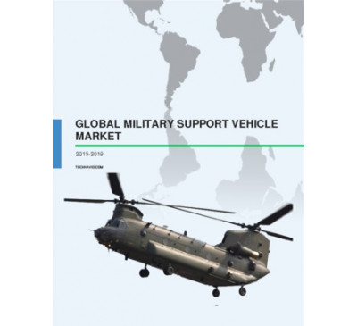

Global Military Support Vehicles Market 2015-2019
- Nov 2015
- 67 pages
- USD 2500USD 2250
About military support vehicles Military support vehicles are essential for mission support and l...
View Report
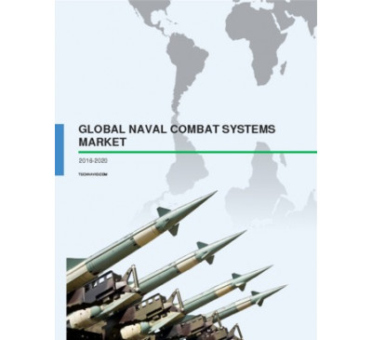

Global Naval Combat Systems Market 2016-2020
- Nov 2015
- 73 pages
- USD 2500USD 2250
Market overview of naval combat systems Technavio’s research analyst predicts the global naval com...
View Report

Global Amphibious Landing Craft Market 2016-2020
- Nov 2015
- 57 pages
- USD 2500USD 2250
Market outlook of amphibious landing crafts The market is witnessing an increase in the global sea...
View Report
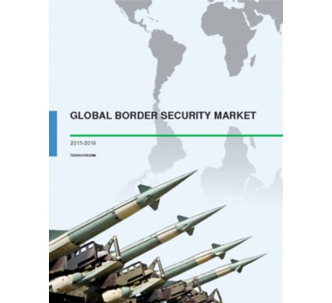

Global Border Security Market 2015-2019
- Nov 2015
- 64 pages
- USD 2500USD 2250
About border security Border security forces safeguard nations’ security, economic prosperity, an...
View Report
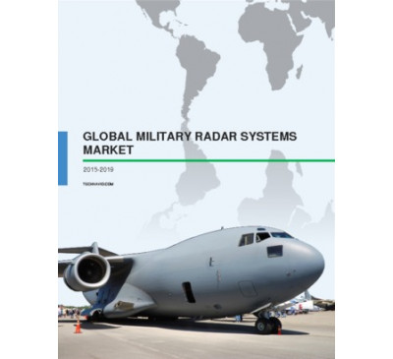

Global Military Radar Systems Market 2015-2019
- Nov 2015
- 60 pages
- USD 2500USD 2250
About military radar systems Radar systems are used to detect distant objects and track targets....
View Report

Global Warship And Naval Vessels Market 2015-2019
- Oct 2015
- 54 pages
- USD 2500USD 2250
About naval vessels On the basis of vessel type, naval vessels can be categorized into high-end w...
View Report
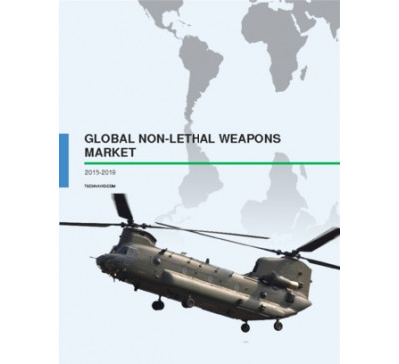

Global Non-lethal Weapons Market - Research Report 2015-2019
- Oct 2015
- 63 pages
- USD 2500USD 2250
Market overview of non-lethal weapons market The global militarization of police forces fueled b...
View Report

Global UAV Payload And Subsystems Market: Research Report 2015-2019
- Oct 2015
- 62 pages
- USD 2500USD 2250
Market outlook for UAV payload subsystems Technavio’s market research analysts predict the globa...
View Report

Global Military Aircraft Modernization And Upgrade And Retrofit Market 2015-2019
- Oct 2015
- 71 pages
- USD 2500USD 2250
About military aircraft upgrade and retrofit Military aircraft either consist of the rotary-wing ...
View Report
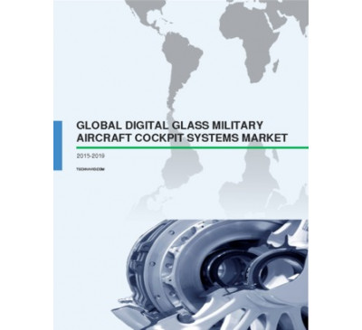

Global Digital Glass Military Aircraft Cockpit Systems Market 2015-2019
- Oct 2015
- 92 pages
- USD 2500USD 2250
What is the key utility of digital glass military aircraft systems? Integrated glass cockpits ar...
View Report

Police And Law Enforcement Equipment Market - Global Report 2015-2019
- Oct 2015
- 63 pages
- USD 2500USD 2250
Market outlook of the police and law enforcement equipment market Increased application of unman...
View Report
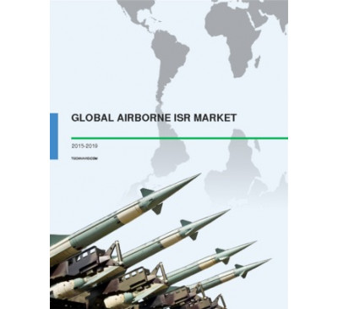

Global Airborne ISR Market 2015-2019
- Sep 2015
- 60 pages
- USD 2500USD 2250
About airborne ISR Airborne intelligence, surveillance, and reconnaissance (ISR) is a crucial fac...
View Report
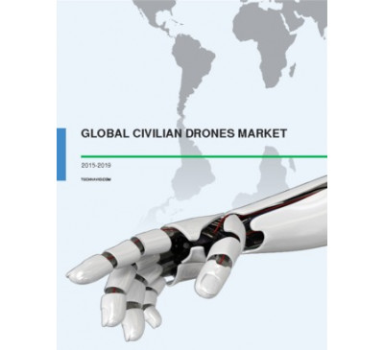

Global Civilian Drones Market 2015-2019
- Sep 2015
- 53 pages
- USD 2500USD 2250
About civilian drones A civilian drone or unmanned aerial vehicle is an airplane that can be flow...
View Report

Global Unmanned Underwater Vehicles Market 2015-2019
- Sep 2015
- 59 pages
- USD 2500USD 2000
About UUV A UUV is a small submarine and is used for different underwater tasks. This vehicle is...
View Report

Global Armoured Vehicles Upgrade And Retrofit Market 2015-2019
- Sep 2015
- 50 pages
- USD 2500USD 2000
About armored vehicles Armored vehicles include land combat and transportation vehicles used by m...
View Report
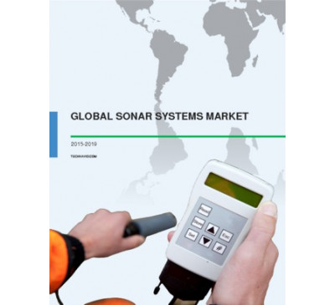

Global SONAR Systems Market 2015-2019
- Sep 2015
- 57 pages
- USD 2500USD 2000
About SONAR system A SONAR system works on using the same technology that is used by animals such...
View Report

Global C4ISR Market 2015-2019
- Jul 2015
- 70 pages
- USD 2500USD 2000
About C4ISR C4ISR (command, control, communications, computers, intelligence, surveillance and re...
View Report

Global Military Land Vehicles Market 2015-2019
- Jul 2015
- 95 pages
- USD 2500USD 2000
About Military Land Vehicles Military land vehicles include all combat and transportation vehicl...
View Report

Global Military Vetronics Market 2015-2019
- Jun 2015
- 67 pages
- USD 2500USD 2000
About Military Vetronics Vetronics (vehicle electronics) are used in military land vehicles for ...
View Report

Video Surveillance In Aircrafts - Market Outlook And Forecast Until 2019
- Apr 2015
- 73 pages
- USD 2500USD 2000
Factors Driving the Growth of Video Surveillance in Commercial Aircrafts: Safety and security of...
View Report

Global Smart Textiles Market For Military 2015-2019
- Apr 2015
- 57 pages
- USD 2500USD 2000
About Smart Textiles Smart textiles are products that integrate textiles and electronic component...
View Report

Global Ballistic Protection Market 2015-2019
- Mar 2015
- 92 pages
- USD 2500USD 2000
About Ballistic Protection Ballistic protection equipment protects both the soldiers and homeland...
View Report
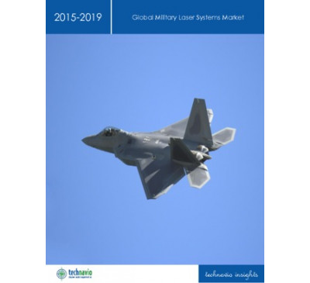

Global Military Laser Systems Market 2015-2019
- Feb 2015
- 69 pages
- USD 2500USD 2000
About Military Laser Systems Laser systems are widely used for military and defense purposes. Th...
View Report
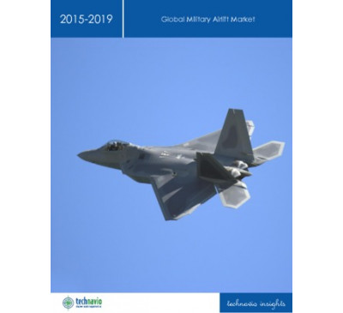

Global Military Airlift Market 2015-2019
- Jan 2015
- 64 pages
- USD 2500USD 2000
About Military Airlift Military airlifts use rotary-wing or fixed-wing aircraft in transporting ...
View Report

Global Small Arms Market 2014-2018
- Dec 2014
- 56 pages
- USD 2500USD 2000
About Small Arms There is no standard definition for small arms. However, in general the terms '...
View Report

Global AMDR Market 2014-2018
- Nov 2014
- 79 pages
- USD 2500USD 2000
About Air and Missile Defense Radar System Radar is an object detection system that detects the ...
View Report

Global Shoulder-fired Weapons Market 2014-2018
- Nov 2014
- 56 pages
- USD 2500USD 2000
About Shoulder Fired Weapons Shoulder fired weapons could be classified as 'anti-tank' or 'anti-...
View Report

Global Body Armor Market 2014-2018
- Oct 2014
- 75 pages
- USD 2500USD 2000
About Body Armor A body armor also known as personal armor is used as a protecting clothing and ...
View Report

Global Inertial Navigation System (INS) Market 2014-2018
- Sep 2014
- 54 pages
- USD 2500USD 2000
About Inertial Navigation Systems Inertial navigation systems (INS) are highly complex navigatio...
View Report

Global Maritime Security Market 2014-2018
- Jun 2014
- 49 pages
- USD 2500USD 2000
About Maritime Security Systems Maritime security relates to the protection of ports, vessels, and...
View Report
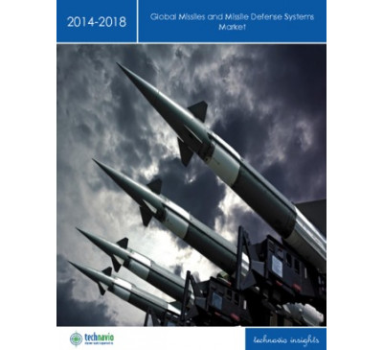

Global Missiles And Missile Defense Systems Market 2014-2018
- Jun 2014
- 53 pages
- USD 2500USD 2000
About Missiles and Missile Defense Systems Missiles are self-guided and propelled weapons that can...
View Report
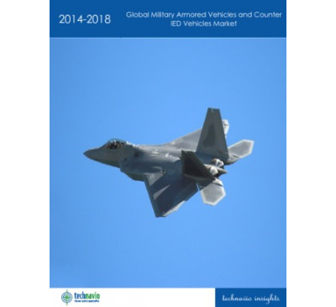

Global Military Armored Vehicles And Counter IED Vehicles Market 2014-2018
- Apr 2014
- 60 pages
- USD 2500USD 2000
About Military Armored Vehicles and Counter-IED Vehicles Military Armored vehicles provide prote...
View Report

Global Military Robots Market 2014-2018
- Apr 2014
- 51 pages
- USD 2500USD 2000
About Military Robots Military robots are machines used by the military to make their work more ...
View Report

Global Explosive Trace Detection (ETD) Market 2014-2018
- Jan 2014
- 57 pages
- USD 2500USD 2000
TechNavio's analysts forecast the Global Explosive Trace Detection market to grow at a CAGR of 13.0...
View Report

Global Submarine Market 2014-2018
- Jan 2014
- 48 pages
- USD 2500USD 2000
TechNavio's analysts forecast the Global Submarine market to grow at a CAGR of 3.27 percent over th...
View Report

Global Radar Market 2014-2018
- Jan 2014
- 50 pages
- USD 2500USD 2000
TechNavio's analysts forecast the Global Radar market to grow at a CAGR of 12.43 percent over the p...
View Report

Global Military Rotorcraft Market 2014-2018
- Jan 2014
- 52 pages
- USD 2500USD 2000
TechNavio's analysts forecast the Global Military Rotorcraft market to grow at a CAGR of (1.71) per...
View Report
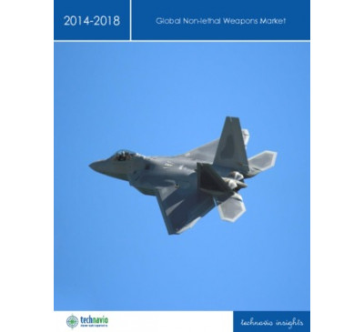

Global Non-lethal Weapons Market 2014-2018
- Nov 2013
- 59 pages
- USD 2500USD 2000
TechNavio's analysts forecast the Global Non-lethal Weapons market to grow at a CAGR of 5.22 percen...
View Report

27
Nov 2003

Aerospace & Defense Technology Impact Service (Technical Insights)

Region : Global
This research service provides an overview and analysis of emerging technologies impacting the aerospace and defense sector
USD 3,950
USD 2,765
READ MORE
10
Jul 2012

Aerospace & Defense - Emerging Countries

Region : Global
Emerging Countries Decision Support Database on Aerospace & Defense is a compendium of spreadsheet tables, which includes meaningful measurement categories to offer a comprehensive picture of the aerospace & defense industry of the emerging countries. The measurements under this Decision Support Database are clubbed under Aircraft Products & Servic...
USD 1,500
USD 1,125
READ MORE
31
Jul 2001

Compendium 2001: Business Development Opportunities in Aerospace & Defense

Region : Global
This report is a collection of many of Frost & Sullivan's annual reports segmented by major research areas. This compendium provides very general information based on existing research intended for the non-industry participant interested in gaining a better understanding of the Aerospace & Defense market and its many components. The compendium fo...
USD 1,995
USD 1,397
READ MORE
10
Jan 2014

What is Hot in the Aerospace and Defense Industry
Are Defense Budgets Cratering?
Region : Global
The aerospace and defense industry has been significantly affected by economic factors. The defense industry has traditionally been immune to economic downturns. However, the focus on reducing budgets due to economic conditions is now very directly impacting defense spending. This research looks at the opportunities for aerospace and defense contr...
USD 1,500
USD 1,350
READ MORE
27
Jan 2005

Country Industry Forecast - The South Korean Aerospace & Defense Industry

Region : Asia Pacific
This research study covers trends and forecast for the South Korean Aerospace and Defense industry for the period 1999 to 2008. It also includes political, policy and economic trends and thier implications for aerospace and defense industry in South Korea. Key industry trends are summarized in terms of SWOT analysis.
USD 795
USD 557
READ MORE
27
Sep 2006

Country Industry Forecast - Political and Policy Analysis of the Indian Aerospace & Defense Industry

Region : South Asia, Middle East & North Africa
Recent policy changes such as the new offset policy and relaxation of investment regulations in the civil aviation sector are part of the liberalization initiatives undertaken by the Government of India (GOI) in the aerospace and defense industry. The 11th five-year plan is expected to emphasize on airport infrastructure development. The GOI has us...
USD 495
USD 347
READ MORE
27
Sep 2016

Technologies Impacting the Future of the Aerospace and Defense Sector
Technologies that Will Change the Aerospace and Defense Landscape
Region : Global
The aerospace and defense industries have witnessed tremendous change in the past few years. Both sectors have seen a rising use of wearables. In the defense sector wearables are increasingly being used in the form of body-worn sensors for training and combat. Wearables are becoming ubiquitous in aerospace as well in the form of head-mounted displa...
USD 4,950
READ MORE
31
Dec 2007

Modeling and Simulation for Aerospace and Defense Applications (Technical Insights)

Region : Global
This research service analyzes the development of M&S and also describes the emerging M&S methods for aerospace and defense applications. Further, this RS also examines the industry partnership, drivers and challenges of the M&S for A&D industry.
USD 4,950
USD 3,465
READ MORE
02
Mar 2005

Aerospace and Defense Technology Impact Service (Technical Insights)

Region : Global
This research service gives a macroscopic view of emerging technologies in the aerospace and defense sectors
USD 3,950
USD 2,765
READ MORE
01
Feb 2012

Economic 360 for South Africa: Growth Prospects and Emerging Opportunities in the Aerospace and Defense Industry
Economic Policy, Recovery and Growth Influencing the South African Aerospace and Defense Industry
Region : Africa
South Africa is a democratic republic with a stable political system. The economic environment is forecast to remain stable, with policy focus on employment creation through growth and stability. The country has a long-established aerospace and defense industry with large international contracts driving local manufacturing. The aerospace industry h...
USD 1,495
USD 1,121
READ MORE
06
Mar 2013

U.S. Future Defense Market Opportunities
Where can a Defense Contractor Find Growth in 2025?
Region : North America
The U.S. Government is facing significant challenges to the overall budget. One of the largest areas of discretionary spending is the defense budget. As budget cuts are contemplated, tough choices will need to be made to produce an acceptable defense budget. One of the principal areas which can and should be changed is in both what is procured an...
USD 6,950
USD 5,908
READ MORE
27
Jan 2017

US Defense Research and Development Organizations, 2016
The United States Sets the Standard for Defense Research and Development as it Continues to Lead the Global Market in Both Programs and Initiatives
Region : North America
The US Department of Defense (DoD) owns the most sophisticated and effective research, development, testing, and evaluation (RDTE) infrastructures worldwide. An essential factor to the DoD's success is the various organizations dedicated to RDTE in support of the different military departments as well as some key joint military agencies. RDTE organ...
USD 1,500
READ MORE
26
Jun 2006

Aerospace and Defense Funding Analysis (Technical Insights)

Region : Global
This research service analyzes the Aerospace and Defense funding scenario around the world.
USD 4,950
USD 3,465
READ MORE
13
May 2013

Analysis of Global RFID in Aerospace and Defense Market
Department of Defense Mandate and the Standardization of Technology will Drive Growth
Region : Global
This study analyzes the current and future trends in global Radio Frequency Identification (RFID) in the aerospace and defense market. RFID solutions are projected to be used across various aerospace and defense applications. This study focuses on the trends, challenges, and factors that drive market growth. Also included are products, vertical and...
USD 4,950
USD 4,208
READ MORE
21
Oct 2011

Executive Analysis of IT Opportunities in Indian Defense Market
IT Opportunities in Indian Defense to grow backed by Armed Forces Modernization and Defense Offsets
Region : Asia Pacific
This research service covers the IT opportunities in the Indian defense market during the period 2011-2015. It is possible to break the defense IT market into two different segments based upon the types of systems, namely combat systems and non-combat systems. The study analyzes PESTLE factors, market drivers, restraints and challenges and trends f...
USD 4,950
USD 3,465
READ MORE
10
Nov 2016

US Department of Defense/Silicon Valley Partnerships, Forecast to 2021
The Defense Innovation Unit-Experimental (DIUx) Initiative is an Important Step in Improving Cybersecurity and Information Collaboration
Region : North America
This Growth Insight focuses on the US Department of Defense’s efforts to partner with Silicon Valley’s high technology firms. The Defense Innovation Unit-Experimental (DIUx) has established offices in several cities in order to invest in and adopt innovative technologies. Anticipated spending comprises research, development, test, and evaluatio...
USD 1,500
READ MORE
30
Aug 2006

U.S. Department of Defense 2006 Quadrennial Defense Review Impact on Industry

Region : North America
This research includes a power point brief concerning the goals of DoD's most recent QDR and 2007 budget request on the U.S. Defense Industry.
USD 3,950
USD 2,765
READ MORE
12
Jul 2013

US Department of Defense (DoD) Healthcare Budget2014
Is DoD Healthcare a Potential Fiscal Time Bomb?
Region : North America
Department of Defense (DoD) spending on healthcare for military personnel and retirees has, of late, received significant criticism. Due largely to Congressional actions, healthcare costs have been climbing, and three successive Secretaries of Defense have identified these costs as the most significant item beyond their control. This research servi...
USD 2,450
USD 2,083
READ MORE
30
Dec 2016

Innovations in Simulation - Aerospace and Defense TOE
Region : Global
This Aerospace and Defense TOE reveals advancements and opportunities in flight simulators, including virtual reality-based training simulators, simulators incorporating fewer but higher performance components, simulators combining real-world and virtual elements, versatile flight training devices, helicopter simulators, motor simulators, and weapo...
USD 950
READ MORE
10
May 2017

NORDEFCO Defense Posture, Forecast to 2021
Defense Spending of Partner Countries
Region : Europe
Since the taking of Crimea by the Russians in 2014, tensions have been rising in the Baltic Sea Region. During 2016, a Russian SU-27 fighter intercepted a US RC-135 flying within international airspace and a pair of Su-24 Russian jets flew what was described by US defense officials as mock strafing runs over a US Navy destroyer as it was conducting...
USD 4,950
READ MORE
31
Mar 2006

Nanotechnology for Defense and Security (Technical Insights)

Region : Global
This research service analyses the trends in the nanotechnology for defense and security applications.
USD 4,950
USD 3,465
READ MORE
18
Apr 2014

Global Defense Outlook
Equipment and Services Opportunities
Region : North America
This research service is an overview of procurement spending and contract activity for global defense markets. Included are research and development, procurement, operations and maintenance, and services representative programs and contracts for 7 regions, 20 countries, and 12 technology segments. The global defense industry is comprised of the na...
USD 4,950
USD 4,455
READ MORE
14
Jul 2015

2015 Global Defense Outlook
Revisiting the Cold War While Confronting Terrorism
Region : North America
This research service focuses on global defense spending categories such as research, development, testing, and evaluation; procurement; operations and maintenance, and services. Global, regional, and specific program information for 25 countries is included. The global defense outlook comprises spending forecasts for 12 technology segments, includ...
USD 6,950
READ MORE
11
Apr 2014

US Defense Geospatial Market
An Essential Market Driven by Innovation
Region : North America
Demand for defense geospatial tools and services continues to grow as new technology evolves that make it possible to fuse other types of information within a geospatial environment. The multitude of sensors and platforms that are capable to deliver vast amounts of geospatial information has led to new dilemmas of how to process and fuse large dat...
USD 4,950
USD 4,455
READ MORE
01
Apr 2013

US DoD Foreign Military Sales
Defense Budget Cuts Driving Foreign Sales Focus
Region : North America
This market insight discusses the US Foreign Military Sales (FMS) program. The domestic market for Israeli UASs is not included in this service because there is little to no competition in Israel for Israeli defense dollars. This market insight provides an executive summary; the report's definitions and scope; a ten year history of FMS; a breakdown...
USD 1,500
USD 1,275
READ MORE
13
Jun 2017

Indian Defense Market, Forecast to 2026
New Policy Dynamics, Market Requirements, and Programs Present Myriad Opportunities for Companies
Region : Global
According to SIPRI, India was the largest arms importer in the world during 2011–2015. The Indian government has revised the procurement policy after seeking responses from industry stakeholders. Frost & Sullivan has analyzed the competitive landscape of defense in India, which consists of public sector undertakings (PSUs), foreign defense compan...
USD 1,500
READ MORE
01
Sep 2016

Global Defense Vision
Cold War and National Borders Resurgence
Region : Global
This research service focuses on global defense spending categories such as research, development, testing, and evaluation; procurement; operations and maintenance; and services. Global, regional, and specific program information for 7 regions is included. The global defense vision comprises spending forecasts for 12 technology segments, including ...
USD 4,950
READ MORE
31
Dec 2007

Global Advances in Communication for Defense Research and Development (Technical Insights)

Region : Global
This research service provides a comprehensive overview on the advances of research and development in the field of defense communications. Drivers, challenges, opportunities, threats and recommendations have also been given in this research service.
USD 4,950
USD 3,465
READ MORE
29
Jul 2013

Analysis of the U.S. DoD and Civil Helicopter Markets
The Civil Market Flourishes as the Defense Market Suffers from Budget Pressures
Region : North America
As the DoD's discretionary spending continues to decrease, upgrading and/or remanufacturing helicopters has gained favour over developing entirely new rotorcraft systems. However, a modest global economic recovery following the great recession and a limited supply of used airframes have resulted in a significant increase in new US civil helicopter...
USD 6,950
USD 5,908
READ MORE
08
Sep 2014

Aerospace & Defence Market Opportunities in Central and Eastern Europe
Major Programme Opportunities are to be Found in Poland
Region : Europe
Despite the economic slowdown and defence budget cuts in Western Europe, the Central and Eastern European (CEE) military markets will present positive dynamics fuelled by defence procurement programs in the CEE countries. Therefore, the study assesses the market opportunities for industry participation in the aerospace & defence sector in the CEE r...
USD 1,500
USD 1,350
READ MORE
24
Sep 2010

Economic 360 for Vietnam: Growth Prospects and Emerging Opportunities in the Aerospace and Defense Industry

Region : Asia Pacific
This research service provides a comprehensive overview of the aerospace and defence industry in Vietnam, encompassing socio-economic, legal and political factors that have fuelled the growth of the industry over the years. With an emphasis on civil aviation, in particular, air fleet expansion, air traffic management and construction and upgrading ...
USD 1,495
USD 1,047
READ MORE
21
Nov 2005

Country Industry Forecast - The United States Aerospace and Defense Industry

Region : North America
The research serivice analyzes the U.S aerospace and defense industry in the present context keeping in view its developments in the past that are influenced largely by extensive consolidation and the changing political agenda of the U.S government. The 21st century has opened flood gates of oppurtunitiy for aerospace and defense firms as defense ...
USD 795
USD 557
READ MORE
31
Mar 2006

Country Industry Forecast - Political and Policy Analysis for the Brazilian Aerospace and Defense Industry

Region : Latin America
This study is a comprehensive, in-depth political and policy study of the Aerospace and Defense industry in Brazil between 2000 and 2009. This research service analyzes Brazil's international relations in context to the Aerospace and Defense industry. The privatization process of the aerospace and defense industry is explained elaborately. The rese...
USD 450
USD 315
READ MORE
31
Mar 2006

Country Industry Forecast - Economic Analysis for the Brazilian Aerospace and Defense Industry

Region : Latin America
This study is a comprehensive, in-depth study of the Aerospace and Defense industry in Brazil between 2000 and 2009. It provides an overview of the Brazilian economy and analyses the implications of economic developments on the Aerospace and Defense industry. Trends in passenger and air cargo traffic are analyzed in the context of prevailing econom...
USD 450
USD 315
READ MORE
11
May 2006

Country Industry Forecast - Infrastructure Analysis for the Brazilian Aerospace and Defense Industry

Region : Latin America
This research service extensively covers Embraer's Aerospace cluster with regard to several of Embraer's suppliers. Details of modernization programs in Brazil's airports are mentioned in this research service along with key details on Infraero's airport modernization schedule. Details on investments in Cargo terminals with details of opportunities...
USD 450
USD 315
READ MORE
11
May 2006

Country Industry Forecast - Political & Policy Analysis for the Russian Aerospace and Defense Industry

Region : Asia Pacific
This study is a comprehensive, in-depth political and policy study of the Aerospace and Defense industry in Russia between 2000 and 2009. This research service analyzes Russia's international relations in context to the Aerospace and Defense industry. The privatization process of the aerospace and defense industry is explained elaborately. The rese...
USD 450
USD 315
READ MORE
31
Mar 2006

Country Industry Forecast - Economic Analysis for the Russian Aerospace and Defense Industry

Region : Asia Pacific
This study is a comprehensive, in-depth study of the Aerospace and Defense industry in Russia between 1999 and 2009. It provides an overview of the Russian economy and analyses the implications of economic developments on the Aerospace and Defense industry. Trends in passenger and air cargo traffic are analyzed in the context of prevailing economic...
USD 450
USD 315
READ MORE
05
Apr 2006

Country Industry Forecast - Infrastructural Analysis for the Russian Aerospace and Defense Industry

Region : Asia Pacific
This research provides infrastructure details relating to aerospace and defense industry in Russia. Based on the current policy trends and government priorities, business opportunities are identified in airport, civil airlines, space market and in the defense industry.
USD 450
USD 315
READ MORE
03
Oct 2006

Country Industry Forecast - Economic Analysis of the Indian Aerospace and Defense Industry

Region : South Asia, Middle East & North Africa
Economic reforms and increased foreign direct investment has contributed to higher economic growth and personal disposable income in India. Changes in civil aviation policies have lead to increase in number of private airlines and competition and an increase in the domestic air passenger traffic. Booming outsourcing and medical tourism are some of ...
USD 450
USD 315
READ MORE
15
Nov 2006

Country Industry Forecast - Social and Infrastructure Analysis of the Indian Aerospace and Defense Industry

Region : South Asia, Middle East & North Africa
The 2007-2011 five year plan is expected to have special emphasis on the provision of infrastructure at airports to cope up with the growth of the civil aviation industry. The overall growth in the air passenger traffic has been greater than expected and the growth cannot be sustained with the current airport infrastructure. Infrastructure moderniz...
USD 450
USD 315
READ MORE
18
May 2007

Country Industry Forecast - Political and Policy Analysis for the Chinese Aerospace and Defense Industry

Region : Asia Pacific
China is the worlds fastest growing aviation market and the Chinese government is promulgating investor friendly policies to sustain the aviation industry growth. Air craft manufacturing, air port development are some of the areas that exected to provide opportunities due to policy changes. This research service outlines Chinas political structur...
USD 450
USD 315
READ MORE
05
Jul 2007

Country Industry Forecast - Social and Infrastructure Analysis for the Chinese Aerospace and Defense Industry
Region : Asia Pacific
Rapid economic and industrial growth in China are leading to increased demand for air travel and frieght. China has liberalized policies relating to airport infrastructure development and modernization. Maintenance, repair and overhaul market and aircraft suppliers are expected to benefit from the growing demand for Chinese air travel. Growth oppo...
USD 450
USD 315
READ MORE
30
Sep 2006

Growth Opportunities in the North American Aerospace and Defense EMS Provider Markets
Region : North America
This research service covers the electronics manufacturing service (EMS) providers opportunities in the North American aerospace and defense (A&D) industry. The research also discusses various trends within the EMS penetration in North American market as compared to the world A&D industry. These trends have been analysed in terms drivers, restraint...
USD 4,950
USD 3,465
READ MORE
20
Dec 2006

Country Industry Forecast - Political & Policy Analysis of the United Kingdom Aerospace and Defense Industry

Region : Europe
The United Kingdom aerospace industry is currently the second largest in the world, with a turnover in 2005 representing 13 percent of the worldwide aerospace market. The global defense market continues to be an important driver of the UK aerospace sector. The industry is, to an increasing extent, export-oriented. Governmental policies like smart ...
USD 495
USD 347
READ MORE
23
Sep 2008

Analysis of Surface Mount Technology (SMT) Equipment Market in the North American Aerospace and Defense (A&D) Industry
Region : North America
This research service covers the total North American Surface Mount Technology (SMT) equipments market in the Aerospace & Defense (A&D) industry. The study covers the market trends, product trends, and key competitive factors relevant in the market. Market dynamics delving into industry challenges, market drivers, and restraints have also been inve...
USD 4,950
USD 3,465
READ MORE
23
Jan 2015

Aerospace and Defense Technology Alert. Unmanned Navy Helicopter Extends Operational Range of Vessels; Handheld Device Simplifies Flight Line Testing; Integrating Battlefield Information to the Squad Level
Region : Global
This issue profiles an unmanned navy helicopter that extends operational range of vessels, a handheld device that simplifies flight line testing, and integrating battlefield information to the squad level.
USD 950
READ MORE
27
Mar 2015

Aerospace and Defense Technology Alert. Vehicle Tracking Solution Raises Airport Efficiency; Military Cargo Jet Performs Multiple Roles; Small Flying Robot to Help Locate Fires Aboard US Navy Vessels
Region : Global
This issue provides a vehicle tracking solution that raises airport efficiency, a military cargo jet that performs multiple roles, and a small flying robot to help locate fires aboard US navy vessels.
USD 950
READ MORE
24
Apr 2015

Aerospace and Defense Technology Alert. Electronics Upgraded for Ballistic Missile Radar; Advanced System Extends Troposcatter Range and Data Rate; IR Sensor System Improves Collaborative Targeting
Region : Global
This issue profiles electronics upgraded for ballistic missile radar, an advanced system that extends troposcatter range and data rate, and an IR sensor system that improves collaborative targeting.
USD 950
READ MORE
22
May 2015

Aerospace and Defense Technology Alert. Software Upgrade Improves Anti-Ballistic Missiles; Robotic Fin Improves Littoral Autonomous Underwater Vehicles; Electrically Propelled Satellite Cuts Launch Weight and Costs
Region : Global
This issue profiles software upgrade for improving anti-ballistic missiles, a robotic fin that improves littoral autonomous underwater vehicles, and an electrically propelled satellite that cuts launch weight and costs.
USD 950
READ MORE
26
Jun 2015

Aerospace and Defense Technology Alert. Advanced Air Resupply System Protects Ammunition Drops; Integrating Australian Military and Commercial Aviation; Gold Shield Helps Study Dark Matter
Region : Global
This issue profiles an advanced air resupply system that protects ammunition drops, integrating Australian military and commercial aviation, and a gold shield that helps study dark matter.
USD 950
READ MORE
25
Mar 2016

Augmented Reality in the Air and on the Ground-Aerospace and Defense Alert
Region : Global
Augmented reality continues to make inroads in both civilian and military aviation applications, as well as on the ground in helmet mounted displays worn by dismounted soldiers. This edition of Aerospace and Defense Alert profiles recent innovations in augmented reality. Aerospace and Defense Alert delves into the technologies and applications th...
USD 950
READ MORE
27
Feb 2015

Aerospace and Defense Technology Alert. Solid-State Power Controller Reduces Footprint and Raises Reliability; Novel Chip Ensures Safe Avionics Data Transfer in Flight; Internet Protocol-Based System Upgrades Communication in European Navies
Region : Global
This issue profiles a solid-state power controller that reduces footprint and raises reliability, a novel chip that ensures safe avionics data transfer in flight, and an Internet protocol-based system that upgrades communication in European navies.
USD 950
READ MORE
24
Jul 2015

Aerospace and Defense Technology Alert. Single Board Computers Resist Mechanical/Thermal Shocks and Vibrations; Radar Jammer Helps Shield US Navy and Air Force Planes; Satellite Communications Helps Secure Digital Modular Tactical Radios
Region : Global
This issue profiles single board computers that resist mechanical/thermal shocks and vibrations, a radar jammer that helps shield US Navy and Air Force planes, and satellite communications that help in securing digital modular tactical radios
USD 950
READ MORE
06
Mar 2013

U.S. Future Defense Market Opportunities
Where can a Defense Contractor Find Growth in 2025?
Region : North America
The U.S. Government is facing significant challenges to the overall budget. One of the largest areas of discretionary spending is the defense budget. As budget cuts are contemplated, tough choices will need to be made to produce an acceptable defense budget. One of the principal areas which can and should be changed is in both what is procured an...
USD 6,950
USD 5,908
READ MORE
27
Jan 2017

US Defense Research and Development Organizations, 2016
The United States Sets the Standard for Defense Research and Development as it Continues to Lead the Global Market in Both Programs and Initiatives
Region : North America
The US Department of Defense (DoD) owns the most sophisticated and effective research, development, testing, and evaluation (RDTE) infrastructures worldwide. An essential factor to the DoD's success is the various organizations dedicated to RDTE in support of the different military departments as well as some key joint military agencies. RDTE organ...
USD 1,500
READ MORE
27
Nov 2003

Aerospace & Defense Technology Impact Service (Technical Insights)

Region : Global
This research service provides an overview and analysis of emerging technologies impacting the aerospace and defense sector
USD 3,950
USD 2,765
READ MORE
21
Oct 2011

Executive Analysis of IT Opportunities in Indian Defense Market
IT Opportunities in Indian Defense to grow backed by Armed Forces Modernization and Defense Offsets
Region : Asia Pacific
This research service covers the IT opportunities in the Indian defense market during the period 2011-2015. It is possible to break the defense IT market into two different segments based upon the types of systems, namely combat systems and non-combat systems. The study analyzes PESTLE factors, market drivers, restraints and challenges and trends f...
USD 4,950
USD 3,465
READ MORE
10
Nov 2016

US Department of Defense/Silicon Valley Partnerships, Forecast to 2021
The Defense Innovation Unit-Experimental (DIUx) Initiative is an Important Step in Improving Cybersecurity and Information Collaboration
Region : North America
This Growth Insight focuses on the US Department of Defense’s efforts to partner with Silicon Valley’s high technology firms. The Defense Innovation Unit-Experimental (DIUx) has established offices in several cities in order to invest in and adopt innovative technologies. Anticipated spending comprises research, development, test, and evaluatio...
USD 1,500
READ MORE
30
Aug 2006

U.S. Department of Defense 2006 Quadrennial Defense Review Impact on Industry

Region : North America
This research includes a power point brief concerning the goals of DoD's most recent QDR and 2007 budget request on the U.S. Defense Industry.
USD 3,950
USD 2,765
READ MORE
12
Jul 2013

US Department of Defense (DoD) Healthcare Budget2014
Is DoD Healthcare a Potential Fiscal Time Bomb?
Region : North America
Department of Defense (DoD) spending on healthcare for military personnel and retirees has, of late, received significant criticism. Due largely to Congressional actions, healthcare costs have been climbing, and three successive Secretaries of Defense have identified these costs as the most significant item beyond their control. This research servi...
USD 2,450
USD 2,083
READ MORE
10
May 2017

NORDEFCO Defense Posture, Forecast to 2021
Defense Spending of Partner Countries
Region : Europe
Since the taking of Crimea by the Russians in 2014, tensions have been rising in the Baltic Sea Region. During 2016, a Russian SU-27 fighter intercepted a US RC-135 flying within international airspace and a pair of Su-24 Russian jets flew what was described by US defense officials as mock strafing runs over a US Navy destroyer as it was conducting...
USD 4,950
READ MORE
31
Mar 2006

Nanotechnology for Defense and Security (Technical Insights)

Region : Global
This research service analyses the trends in the nanotechnology for defense and security applications.
USD 4,950
USD 3,465
READ MORE
18
Apr 2014

Global Defense Outlook
Equipment and Services Opportunities
Region : North America
This research service is an overview of procurement spending and contract activity for global defense markets. Included are research and development, procurement, operations and maintenance, and services representative programs and contracts for 7 regions, 20 countries, and 12 technology segments. The global defense industry is comprised of the na...
USD 4,950
USD 4,455
READ MORE
14
Jul 2015

2015 Global Defense Outlook
Revisiting the Cold War While Confronting Terrorism
Region : North America
This research service focuses on global defense spending categories such as research, development, testing, and evaluation; procurement; operations and maintenance, and services. Global, regional, and specific program information for 25 countries is included. The global defense outlook comprises spending forecasts for 12 technology segments, includ...
USD 6,950
READ MORE
11
Apr 2014

US Defense Geospatial Market
An Essential Market Driven by Innovation
Region : North America
Demand for defense geospatial tools and services continues to grow as new technology evolves that make it possible to fuse other types of information within a geospatial environment. The multitude of sensors and platforms that are capable to deliver vast amounts of geospatial information has led to new dilemmas of how to process and fuse large dat...
USD 4,950
USD 4,455
READ MORE
01
Apr 2013

US DoD Foreign Military Sales
Defense Budget Cuts Driving Foreign Sales Focus
Region : North America
This market insight discusses the US Foreign Military Sales (FMS) program. The domestic market for Israeli UASs is not included in this service because there is little to no competition in Israel for Israeli defense dollars. This market insight provides an executive summary; the report's definitions and scope; a ten year history of FMS; a breakdown...
USD 1,500
USD 1,275
READ MORE
13
Jun 2017

Indian Defense Market, Forecast to 2026
New Policy Dynamics, Market Requirements, and Programs Present Myriad Opportunities for Companies
Region : Global
According to SIPRI, India was the largest arms importer in the world during 2011–2015. The Indian government has revised the procurement policy after seeking responses from industry stakeholders. Frost & Sullivan has analyzed the competitive landscape of defense in India, which consists of public sector undertakings (PSUs), foreign defense compan...
USD 1,500
READ MORE
01
Sep 2016

Global Defense Vision
Cold War and National Borders Resurgence
Region : Global
This research service focuses on global defense spending categories such as research, development, testing, and evaluation; procurement; operations and maintenance; and services. Global, regional, and specific program information for 7 regions is included. The global defense vision comprises spending forecasts for 12 technology segments, including ...
USD 4,950
READ MORE
31
Dec 2007

Global Advances in Communication for Defense Research and Development (Technical Insights)

Region : Global
This research service provides a comprehensive overview on the advances of research and development in the field of defense communications. Drivers, challenges, opportunities, threats and recommendations have also been given in this research service.
USD 4,950
USD 3,465
READ MORE
29
Jul 2013

Analysis of the U.S. DoD and Civil Helicopter Markets
The Civil Market Flourishes as the Defense Market Suffers from Budget Pressures
Region : North America
As the DoD's discretionary spending continues to decrease, upgrading and/or remanufacturing helicopters has gained favour over developing entirely new rotorcraft systems. However, a modest global economic recovery following the great recession and a limited supply of used airframes have resulted in a significant increase in new US civil helicopter...
USD 6,950
USD 5,908
READ MORE
08
Sep 2014

Aerospace & Defence Market Opportunities in Central and Eastern Europe
Major Programme Opportunities are to be Found in Poland
Region : Europe
Despite the economic slowdown and defence budget cuts in Western Europe, the Central and Eastern European (CEE) military markets will present positive dynamics fuelled by defence procurement programs in the CEE countries. Therefore, the study assesses the market opportunities for industry participation in the aerospace & defence sector in the CEE r...
USD 1,500
USD 1,350
READ MORE
13
May 2016

U.S. Department of Defense (DoD) 2017 Budget Assessment
Top Priority Segments Generate Exciting Growth Potential as Aircraft and Ship Procurement and Sustainment Segments Make Gains
Region : North America
This research service focuses on the United States Department of Defense (DoD) budget spending categories, including research, development, testing, and evaluation (RDT&E); procurement; operations and maintenance (O&M); and services. The intent of this study is to indicate which segments of products and services the DoD has emphasized in the budget...
USD 4,950
READ MORE
16
Nov 2011

General Purpose Test Equipment Market in China
Communications and Aerospace and Defense to Fuel Market Growth
Region : Asia Pacific
This study researches the general purpose test equipment market in China. It covers the key segments of this industry including traditional instruments such as oscilloscopes, signal generators, arbitrary waveform generators, logic analyzers, network analyzers, spectrum analyzers, power meters, multimeters, and electronic counters as well as modula...
USD 4,950
USD 3,465
READ MORE
30
Sep 2008

Assessment of Communication Technologies for Maritime Defense (Technical Insights)

Region : Global
This research service provides an assessment of recent and emerging information and communication technologies, according to their utility value for applications in maritime defense.
USD 4,950
USD 3,465
READ MORE
31
Dec 2008

Assessment of Communication Technologies for Military Defense (Technical Insights)

Region : Global
This research service provides an assessment of communication technologies for applications in military defense.
USD 4,950
USD 3,465
READ MORE
13
Jan 2016

US Naval Ship Self-defense Systems
Meeting Advanced Threats
Region : North America
This research service focuses on the US Department of Defense (DoD) ship self-defense systems (SSDS) budget spending. This study includes an analysis of research, development, test, and evaluation (RDT&E); procurement; operations and maintenance (O&M); and a variety of services. Contract activity for the DoD SSDS for 2014 and 2015 is also included...
USD 6,000
READ MORE
15
Feb 2017

US DoD Foreign Military Sales Market, Forecast to 2021
Domestic Defense Firms Must Become More Innovative and Cost Efficient to Succeed in the Increasingly Competitive Race to Sell International Arms
Region : North America
An overall increase in global defense spending is expected, after several years of relatively flat growth, which will cause the US Department of Defense (DoD) market for foreign military sales (FMS) to grow at an estimated 3.4% over the 2015 to 2021 study period. However, overall sales of US military equipment will grow at an even greater rate beca...
USD 4,950
READ MORE
23
Jul 2013

Revenue Opportunity and Stakeholder Mapping in the Turkish Defence Market
Modernisation and Localisation Drive the Turkish Defence Market
Region : Europe
Turkeys unique geo-strategic position, as the most eastern member state of the NATO, continues to influence the countrys defence procurement policies, and Turkeys defence budget continues to rise. In order to encourage domestic defence production, the Turkish defence market will be increasingly difficult for foreign companies to penetrate, conse...
USD 3,950
USD 3,358
READ MORE
20
Feb 2013

Latin America Defence Market Assessment
Defence Modernization Needs Generate Market Opportunities for Foreign Weapon Suppliers
Region : Latin America
The Latin American defence market is an attractive market for the defence suppliers during the forecast period (20122021). Stable market revenue is mainly driven by the strong need to replace legacy defence platforms. On the other hand, defence procurement projects offer the Latin American countries the opportunity to not only increase security bu...
USD 3,950
USD 3,358
READ MORE
03
May 2013

The Middle East and Africa Defence Market Assessment
Transforming Forces in Emerging Markets
Region : Africa
The Middle East and Africa Defence Market Assessment study takes into account all the major segments of the defence marketair, land, naval, C4ISR, support in service, and training and simulation; and all products under each segment. The methodology used is a combination of bottom-up and top-down. Bottom-up approach is used to present programme lev...
USD 3,950
USD 3,358
READ MORE
10
May 2017

NORDEFCO Defense Posture, Forecast to 2021
Defense Spending of Partner Countries
Region : Europe
Since the taking of Crimea by the Russians in 2014, tensions have been rising in the Baltic Sea Region. During 2016, a Russian SU-27 fighter intercepted a US RC-135 flying within international airspace and a pair of Su-24 Russian jets flew what was described by US defense officials as mock strafing runs over a US Navy destroyer as it was conducting...
USD 4,950
READ MORE
31
Mar 2006

Nanotechnology for Defense and Security (Technical Insights)

Region : Global
This research service analyses the trends in the nanotechnology for defense and security applications.
USD 4,950
USD 3,465
READ MORE
18
Apr 2014

Global Defense Outlook
Equipment and Services Opportunities
Region : North America
This research service is an overview of procurement spending and contract activity for global defense markets. Included are research and development, procurement, operations and maintenance, and services representative programs and contracts for 7 regions, 20 countries, and 12 technology segments. The global defense industry is comprised of the na...
USD 4,950
USD 4,455
READ MORE
14
Jul 2015

2015 Global Defense Outlook
Revisiting the Cold War While Confronting Terrorism
Region : North America
This research service focuses on global defense spending categories such as research, development, testing, and evaluation; procurement; operations and maintenance, and services. Global, regional, and specific program information for 25 countries is included. The global defense outlook comprises spending forecasts for 12 technology segments, includ...
USD 6,950
READ MORE
11
Apr 2014

US Defense Geospatial Market
An Essential Market Driven by Innovation
Region : North America
Demand for defense geospatial tools and services continues to grow as new technology evolves that make it possible to fuse other types of information within a geospatial environment. The multitude of sensors and platforms that are capable to deliver vast amounts of geospatial information has led to new dilemmas of how to process and fuse large dat...
USD 4,950
USD 4,455
READ MORE
01
Apr 2013

US DoD Foreign Military Sales
Defense Budget Cuts Driving Foreign Sales Focus
Region : North America
This market insight discusses the US Foreign Military Sales (FMS) program. The domestic market for Israeli UASs is not included in this service because there is little to no competition in Israel for Israeli defense dollars. This market insight provides an executive summary; the report's definitions and scope; a ten year history of FMS; a breakdown...
USD 1,500
USD 1,275
READ MORE
13
Jun 2017

Indian Defense Market, Forecast to 2026
New Policy Dynamics, Market Requirements, and Programs Present Myriad Opportunities for Companies
Region : Global
According to SIPRI, India was the largest arms importer in the world during 2011–2015. The Indian government has revised the procurement policy after seeking responses from industry stakeholders. Frost & Sullivan has analyzed the competitive landscape of defense in India, which consists of public sector undertakings (PSUs), foreign defense compan...
USD 1,500
READ MORE
01
Sep 2016

Global Defense Vision
Cold War and National Borders Resurgence
Region : Global
This research service focuses on global defense spending categories such as research, development, testing, and evaluation; procurement; operations and maintenance; and services. Global, regional, and specific program information for 7 regions is included. The global defense vision comprises spending forecasts for 12 technology segments, including ...
USD 4,950
READ MORE
31
Dec 2007

Global Advances in Communication for Defense Research and Development (Technical Insights)

Region : Global
This research service provides a comprehensive overview on the advances of research and development in the field of defense communications. Drivers, challenges, opportunities, threats and recommendations have also been given in this research service.
USD 4,950
USD 3,465
READ MORE
29
Jul 2013

Analysis of the U.S. DoD and Civil Helicopter Markets
The Civil Market Flourishes as the Defense Market Suffers from Budget Pressures
Region : North America
As the DoD's discretionary spending continues to decrease, upgrading and/or remanufacturing helicopters has gained favour over developing entirely new rotorcraft systems. However, a modest global economic recovery following the great recession and a limited supply of used airframes have resulted in a significant increase in new US civil helicopter...
USD 6,950
USD 5,908
READ MORE
08
Sep 2014

Aerospace & Defence Market Opportunities in Central and Eastern Europe
Major Programme Opportunities are to be Found in Poland
Region : Europe
Despite the economic slowdown and defence budget cuts in Western Europe, the Central and Eastern European (CEE) military markets will present positive dynamics fuelled by defence procurement programs in the CEE countries. Therefore, the study assesses the market opportunities for industry participation in the aerospace & defence sector in the CEE r...
USD 1,500
USD 1,350
READ MORE
13
May 2016

U.S. Department of Defense (DoD) 2017 Budget Assessment
Top Priority Segments Generate Exciting Growth Potential as Aircraft and Ship Procurement and Sustainment Segments Make Gains
Region : North America
This research service focuses on the United States Department of Defense (DoD) budget spending categories, including research, development, testing, and evaluation (RDT&E); procurement; operations and maintenance (O&M); and services. The intent of this study is to indicate which segments of products and services the DoD has emphasized in the budget...
USD 4,950
READ MORE
16
Nov 2011

General Purpose Test Equipment Market in China
Communications and Aerospace and Defense to Fuel Market Growth
Region : Asia Pacific
This study researches the general purpose test equipment market in China. It covers the key segments of this industry including traditional instruments such as oscilloscopes, signal generators, arbitrary waveform generators, logic analyzers, network analyzers, spectrum analyzers, power meters, multimeters, and electronic counters as well as modula...
USD 4,950
USD 3,465
READ MORE
30
Sep 2008

Assessment of Communication Technologies for Maritime Defense (Technical Insights)

Region : Global
This research service provides an assessment of recent and emerging information and communication technologies, according to their utility value for applications in maritime defense.
USD 4,950
USD 3,465
READ MORE
31
Dec 2008

Assessment of Communication Technologies for Military Defense (Technical Insights)

Region : Global
This research service provides an assessment of communication technologies for applications in military defense.
USD 4,950
USD 3,465
READ MORE
13
Jan 2016

US Naval Ship Self-defense Systems
Meeting Advanced Threats
Region : North America
This research service focuses on the US Department of Defense (DoD) ship self-defense systems (SSDS) budget spending. This study includes an analysis of research, development, test, and evaluation (RDT&E); procurement; operations and maintenance (O&M); and a variety of services. Contract activity for the DoD SSDS for 2014 and 2015 is also included...
USD 6,000
READ MORE
15
Feb 2017

US DoD Foreign Military Sales Market, Forecast to 2021
Domestic Defense Firms Must Become More Innovative and Cost Efficient to Succeed in the Increasingly Competitive Race to Sell International Arms
Region : North America
An overall increase in global defense spending is expected, after several years of relatively flat growth, which will cause the US Department of Defense (DoD) market for foreign military sales (FMS) to grow at an estimated 3.4% over the 2015 to 2021 study period. However, overall sales of US military equipment will grow at an even greater rate beca...
USD 4,950
READ MORE
23
Jul 2013

Revenue Opportunity and Stakeholder Mapping in the Turkish Defence Market
Modernisation and Localisation Drive the Turkish Defence Market
Region : Europe
Turkeys unique geo-strategic position, as the most eastern member state of the NATO, continues to influence the countrys defence procurement policies, and Turkeys defence budget continues to rise. In order to encourage domestic defence production, the Turkish defence market will be increasingly difficult for foreign companies to penetrate, conse...
USD 3,950
USD 3,358
READ MORE
20
Feb 2013

Latin America Defence Market Assessment
Defence Modernization Needs Generate Market Opportunities for Foreign Weapon Suppliers
Region : Latin America
The Latin American defence market is an attractive market for the defence suppliers during the forecast period (20122021). Stable market revenue is mainly driven by the strong need to replace legacy defence platforms. On the other hand, defence procurement projects offer the Latin American countries the opportunity to not only increase security bu...
USD 3,950
USD 3,358
READ MORE
03
May 2013

The Middle East and Africa Defence Market Assessment
Transforming Forces in Emerging Markets
Region : Africa
The Middle East and Africa Defence Market Assessment study takes into account all the major segments of the defence marketair, land, naval, C4ISR, support in service, and training and simulation; and all products under each segment. The methodology used is a combination of bottom-up and top-down. Bottom-up approach is used to present programme lev...
USD 3,950
USD 3,358
READ MORE
05
Jun 2014

Rapidly Evolving Defence Markets: 10-country Budget Assessment
From 'Know-how' to 'Know Why'
Region : Europe
This research service analyses the rapidly evolving defence markets for 10 selected countries: Algeria, Brazil, Chile, India, Indonesia, Japan, Oman, Poland, the Russian Federation, and the United Arab Emirates. From a global perspective, the countries' defence budgets are most significantly driven by modernisation programs and arms threats due to ...
USD 3,950
USD 3,555
READ MORE
23
Jun 2015

Rapidly Evolving Defence Markets, Part 1
Combat Readiness Plans Win Over Indigenization Targets
Region : North America
In this 2015 edition, 10 new countries with rapidly evolving defence spending have been selected. This study comprises a thorough market assessment for 2015-2025 of Colombia, Kuwait, Malaysia, Morocco, and Singapore, including projected defence spending by appropriation: procurement (equipment), personnel, operations and maintenance, infrastructure...
USD 4,950
READ MORE
08
Jul 2015

Rapidly Evolving Defence Markets, Part 2
From Domestic Demand Fulfilment to Military Export Targets
Region : Europe
In this 2015 edition, 10 new countries with rapidly evolving defence spending have been selected. This study comprises a thorough market assessment for 2015-2025 of Angola, Azerbaijan, Peru, Qatar, and South Korea, including projected defence spending by appropriation: procurement (equipment), personnel, operations and maintenance, infrastructure, ...
USD 3,950
READ MORE
17
Dec 2015

Military Airborne Electronic Warfare (EW) Market in 14 Key Countries
Upgrades and Evolving Technologies Focus on Integrated EW Architecture and Remotely Piloted Aircraft
Region : Global
This study covers 14 key countries that are looking to invest in airborne Electronic Warfare (EW) capabilities due to rising threat perceptions. Revenue is forecasted for some countries with established or published EW programs while qualitative assessment has been done for others. Key platform procurement and upgrade programs are covered, focusing...
USD 2,450
READ MORE
13
May 2013

US DoD Anti-Access/Area Denial Challenges
Ensuring Technological Dominance
Region : North America
This research is a qualitative overview of the US DoD Anti-Access/Area Denial operational concept, based on the 2013 program spending request for Department of Defense (DoD) anti-submarine warfare, cybersecurity, electronic warfare, interoperability, and nine other technology areas. Included in this service are research, development, testing, and e...
USD 6,950
USD 5,908
READ MORE
03
Jul 2013

Finding Value Beyond Compliance: The New Dimension to Traceability
Critical Business Imperatives that Drive Incremental Changes in Traceability Markets
Region : Global
The predominant issue across diverse industry verticals, with respect to product safety, continues to be traceability. The ability to seamlessly collect information throughout the supply chain while enabling real-time intelligence on product movement, placement, and conditions is delivering higher value to customers. Regulatory compliance requireme...
USD 15,000
USD 12,750
READ MORE
30
Sep 2013

US DoD Battle Management Systems
Managing War through Networks
Region : North America
US Battle Management Systems (BMS) are critical assets that serve as the eyes and ears of commanders in the field. Systems range from exotic command centers with numerous video screens and computer hardware to specialized airborne platforms equipped with tools that integrate and distribute information to operators on the battlefield. This research ...
USD 4,950
USD 4,208
READ MORE
11
Jun 2013

US DoD 2014 Budget Assessment
Balancing Essential Requirements and Fiscal Restraint
Region : North America
This research service focuses on the US Department of Defense (DoD) budget spending categories, including: research, development, testing, and evaluation (RDT&E), procurement, operations and maintenance (O&M), and services. Contract activity for the US DoD for the year 2012 is also included. The US DoD 2014 Budget is comprised of spending plans for...
USD 6,950
USD 5,908
READ MORE
27
Nov 2013

US ISR Video Analytics
Modern Imaging Analysis
Region : North America
The demand for ISR video analytics and the processing, exploitation, and dissemination (PED) of it has increased significantly in recent years. A key factor to this demand is the amount of sensors and platforms that provide full motion video (FMV) that has increased from a few dozen systems a decade ago to thousands today. ISR video analytics has ...
USD 4,950
USD 4,208
READ MORE
21
Nov 2013

US DoD Special Operations Command Budget
Providing Capable Forces and Synchronized Planning
Region : North America
This research service focuses on the US Department of Defense (DoD) special operations command (SOCOM) budget spending. Included in this service are research, development, testing, and evaluation (RDT&E); procurement; operations and maintenance (O&M); and services. Contract activity for the DoD SOCOM for 2012 is also included. The DoD SOC 2014 Budg...
USD 6,950
USD 5,908
READ MORE
28
May 2014

US DoD Night Vision Devices Market
Advanced Technologies and Capabilities Attainable but Development Stifled by Budget Constraints
Region : North America
As the DoD's discretionary spending continues to decrease, investments in the night vision device market will also decrease. Redeployments from large ground occupations in Iraq and Afghanistan will reduce the need for man portable devices, while the DoD's strategic pivot to the Asia-Pacific region will drive demand for airborne and maritime night v...
USD 6,950
USD 6,255
READ MORE
06
Aug 2014

US Base Operational Support Services
Is this the Tip of the Support Iceberg?
Region : North America
US Base Operational Support Services (BOSS) funding is one of the areas that has absorbed the impact of increased spending in other sectors, especially during sequestration. While the key area for negative growth is the conflict zones, continental US spending has faced consistent pressure. The return of personnel from Afghanistan and Iraq has all...
USD 6,950
USD 6,255
READ MORE
19
Jun 2014

US DoD 2015 Budget Assessment
Force Reduction and Limited Modernization
Region : North America
This research service focuses on the US Department of Defense (DoD) 2015 budget request. Included in this service are research, development, testing, and evaluation (RDT&E); procurement; operations and maintenance (O&M); overseas contingency operations (OCO); and services. Contract activity for DoD market participants for 2013 is also included. The...
USD 4,950
USD 4,455
READ MORE
20
Feb 2015

Global Airborne IR Countermeasures Market
The Growth of Laser-based Systems
Region : North America
The most lethal threat to low flying aircraft has historically been man-portable surface-to-air-missiles. In recent years, advancements in these types of missiles have prompted the research and development of technology that autonomously defends against this threat. This research contains an analysis and the spending forecasts for the global airbor...
USD 6,950
READ MORE
05
Jun 2015

US DoD 2016 Budget Assessment
Continuing Operations, Resets, and Modernization
Region : North America
This research service focuses on the US Department of Defense (DoD) budget spending categories, including research, development, testing, and evaluation (RDT&E); procurement; operations and maintenance (O&M); and services. Contract activity for the US DoD for 2014 is also included. The US DoD 2016 Budget is comprised of spending plans for the Army,...
USD 6,950
READ MORE
30
Jan 2013

U.S. Department of Veterans Affairs
Caring for Future U.S. Veterans
Region : North America
This market insight reviews the Department of Veterans Affairs budget for the 2013 fiscal year. The research focuses on spending forecasts in addition to competitor market share according to 2011 contract data. Some key programs and projects are also listed in the appendix. Budget information concerning administration costs and some benefit spendin...
USD 1,500
USD 1,275
READ MORE
09
Dec 2013

Global Force Protection Market
Global Economics will Dictate Force Protection Requirements for the Next 10 Years
Region : Global
This research service takes a look at the global force protection market. Short-term interventions with limited commitment of land forces are expected to be the norm for western countries. Modernisation of militaries is being reflected in strategies which emphasise the need for an increased number of light and mobile force elements. This can be see...
USD 1,500
USD 1,275
READ MORE
18
Oct 2013

Dual-Use Technology
Dual-Use Technology an Efficient Way to Conquer the Commercial Market for the Defence Contractors
Region : Global
Dual-use technology has the potential to generate new revenues for the defence contractors, which house a multitude of technologies within their portfolios and R&D programmes. However, dual-use is not always a clear concept, it needs to be identified, defined, and understood so companies can make the most of it. In this paper, with an aim to facili...
USD 1,500
USD 1,275
READ MORE
31
Mar 2014

Competitive AnalysisDefence Contractors
Big Fish in a Shrinking Pond Looking for New Ways to Survive
Region : Global
This is an historical review of the major global defence contractors. Relevant metrics such as revenue, revenue growth, research and development expenditure, major merger and acquisition activities, market presence and geographical presence are included to profile the contractors. Various strategic mappings are also offered to compare and assess th...
USD 1,500
USD 1,350
READ MORE
23
Dec 2014

Competitive Analysis of Defence Contractors
Deepening Before Broadening Will Increase the Likelihood of Success in the Future
Region : Global
This study focuses on defence business and defence contractors, while also considering the non-defence activities of these companies. Globalisation and the blurring of boundaries between commercial and defence companies are likely to significantly impact the long-term strategy of both defence business and defence contractors. Now and in the future,...
USD 1,500
USD 1,350
READ MORE
26
Nov 2014

US Government Use of Commercial Mobile Devices
Saving Money and Increasing Capability
Region : North America
This market insight is an overview of the commercial mobile device market for the US Department of Defense and other federal agencies. The government’s desire to leverage commercial technology advances while saving money drives the market. End-user program, trends, and major market participants are included. US federal program of record activity ...
USD 1,500
USD 1,350
READ MORE
21
Sep 2015

Arabic PeninsulaDefence Market Overview
Tackling Obsolescence and Future Industrial Developments
Region : South Asia, Middle East & North Africa
Declining oil prices, regional threats, and changes in political intent are drawing new trends and perspectives across the Gulf Co-operation Council (GCC) countries. This private market insight assesses future military spending, new equipment requirements, and best-positioned local companies in the Middle-Eastern countries of Bahrain, Kuwait, Oman,...
USD 1,500
READ MORE
27
Jul 2016

Global Missile Defense
A Growth Market Driven by Rogue Nations
Region : North America
This Frost & Sullivan research service examines the drivers, restraints, forecasts, and trends in the global missile defense market and provides a competitive analysis of the same. The research is primarily an examination of the missiles, launchers, and radars that make up missile defense systems worldwide. In this research, Frost & Sullivan's expe...
USD 4,950
READ MORE
09
Aug 2017

Global Naval Ship Modernization Assessment, Forecast to 2026
Defense Budget Pressures are Driving Navies to Initiate Comprehensive Ship Service Life Extension and Modernization Programs
Region : Global
The economic downturn over the last decade has resulted in a number of cancellation, postponement, or downsizing of high-value defense programs. These actions have slowed down the induction of new ships into naval fleets. However, the requirement for strong naval assets is at a high amidst the political tensions in Central Asia, Eastern Europe, Sou...
USD 1,500
READ MORE
07
Aug 2014

The Future of US Government Robotics
Developing Innovative Systems to Reduce Manpower Requirements and Human Exposure to Hazardous Missions
Region : North America
Government robotic systems capabilities in all categories are advancing rapidly due to the substantial amount of investment and resources being dedicated to research, development, and testing. Robots will be doing a significant amount of the dull, dangerous, or dirty jobs in the future to reduce the need for manpower and keep government personnel o...
USD 1,500
USD 1,350
READ MORE
24
Sep 2015

Big Data in Defence and Security
From the User's Perspective
Region : North America
As the hype continues around Big Data, its ambiguous nature continues to obscure the potential applications of the technology. Clarity is beginning to emerge within the A&D community about how Big Data can be leveraged for 'intelligence amplification' and companies are beginning to respond. This research aims to define these emerging applications a...
USD 1,500
READ MORE
29
Nov 2016

Global Airborne Intelligence, Surveillance, and Reconnaissance (ISR) Aircraft Market, Forecast to 2025
Rising Tensions Worldwide Drive Investments in Modernizing and Procuring New Capabilities
Region : Global
This study will benefit anyone interested in learning more about the global manned airborne intelligence, surveillance, and reconnaissance (ISR) aircraft market including the related revenue opportunities for the period 2017–2025. It will also help those who are looking to learn about the market drivers and emerging opportunities across the vario...
USD 4,950
READ MORE
28
Jun 2017

US DoD Budget Assessment, 2018–2022
A New Administration with New Priorities
Region : North America
The first budget under the Trump administration, which includes the fiscal year 2018 Department of Defense (DoD) budget request highlighted within this research, has been published. The DoD request is notably higher than that of 2017 and may encounter opposition from both sides of the political aisle. The new research details the defense department...
USD 4,950
READ MORE
04
Sep 2017

Global Naval Shipbuilding Market, Forecast to 2026
How to Convert New Procurement Programs and Upcoming Contracts into Opportunities as Global Powers Expand their Fleets
Region : Global
Rising global tensions, territorial expansionism, rise of non-state actor-led conflicts, and the associated displacement of population have fueled the expansion of naval deployments. As many nations face vessel obsolescence in the next few years and others have to deploy new, advanced naval assets to counter rival fleet expansionism, the market is ...
USD 4,950
READ MORE
31
Dec 2008

Nanotechnology for Defense and Security (Technical Insights)

Region : Global
The research service discusses global development of nanotechnology for defense and security applications. It discusses in detail, development and adoption trends of nanotechnology based solutions focussing on domains like ballistic protection, imaging and sensors. It further highlights the new developments in this sector.
USD 4,950
USD 3,465
READ MORE
30
Jun 2007

Ground Sensors and Surveillance Technologies for Defense and Security--A Technology Overview (Technical Insights)

Region : Global
This research service focuses in a short, concise manner on general technology trends within the unattended ground sensors sector. It identifies major areas of development, and looks at drivers and challenges within this sector.
USD 4,950
USD 3,465
READ MORE
13
May 2016

Nanotechnology Innovations for Defense and Security Applications - Nanotech TOE
Region : Global
Nanotechnology influences miniaturization in defense and security applications. Such a capability may possibly result in more effective surveillance, smaller weapons, and more efficient signaling. Soldiers equipped with nanotechnology-enabled sensors and devices can be more versatile and adapt to surroundings quickly, and get medical attention fast...
USD 250
READ MORE
08
Dec 2011

General Purpose Test Equipment Markets in Russia and CIS Countries
Education and Aerospace & Defense are key end-user segments driving market growth.
Region : Europe
This study covers the state of the general purpose test equipment market in Russia and CIS countries examining drivers and restraints for growth, end-user trends, and geographical trends. Based on these trends, market growth for each product segment namely electronic counters, logic analyzers, network analyzers, spectrum analzyers, power meters, mu...
USD 4,950
USD 3,465
READ MORE
28
Apr 2011

Economic 360 Perspective for Russia: Growth Prospects and Emerging Opportunities in the Defense Industry

Region : Asia Pacific
Russian defense is one of the largest sectors in the country along with the energy and heavy industries. Russia is the second largest exporter of weapons in the world, but its infrastructure needs in-depth modernisation. The various reforms launched by the Government aim at improving business climate, regulations and strengthening cooperation with ...
USD 1,495
USD 1,047
READ MORE
31
Jul 2001

Compendium 2001: Business Development Opportunities in Aerospace & Defense

Region : Global
This report is a collection of many of Frost & Sullivan's annual reports segmented by major research areas. This compendium provides very general information based on existing research intended for the non-industry participant interested in gaining a better understanding of the Aerospace & Defense market and its many components. The compendium fo...
USD 1,995
USD 1,397
READ MORE
24
Mar 2006

MEMS Technology Update (Technical Insights)

Region : Global
This research service discusses the research developments and emerging opportunities in the MEMS area worldwide. The sectors profiled include electronics, automotive/transportation and aerospace/defense.
USD 4,950
USD 3,465
READ MORE
04
May 2015

Global Test, Measurement, and Instrumentation Market
Current and Evolving Opportunities in the Aerospace & Defense Industry
Region : Global
This research service provides a detailed analysis of the current and evolving opportunities in the aerospace and defense industry for the test, measurement, and instrumentation market. This assessment includes forecasts, an overview of the competitive structure, competitors market share, market trends, and product analysis. Market drivers and res...
USD 4,950
READ MORE
30
Nov 2011

Strategic Analysis of Indian Aircraft Component Manufacturing and Services Industry
Industry revenue to double by 2015 backed by domestic aircraft market growth and defense offsets
Region : South Asia, Middle East & North Africa
This research service analyzes the growth of Indian aircraft component manufacturing and services industry while also discussing the existing and possible opportunity areas. The study includes a brief overview evolution of manufacturing value chain and emergence of India in global aircraft industry. Then study presents emerging trends, PESTLE facto...
USD 4,950
USD 3,465
READ MORE
08
Sep 2011

U.S. Department of Defense: Unmanned Aircraft System Ground Control Stations and Data Links
Implementing Hunter/Killer Unmanned Aircraft Systems
Region : North America
This study focuses on both the ground control stations and data links that make up key infrastructure nodes and communication networks supporting unmanned aircraft systems (UAS). The last several years have seen enormous growth of UAS, mostly due to their flexibility and variety. Now that this market has revealed its maximum value, companies are ...
USD 6,950
USD 4,865
READ MORE
02
May 2011

U.S. Department of Defense Intelligence Community Overview

Region : North America
This market insight outlines unclassified programs, budgets and market participants for DoD Intelligence. It includes all contract obligations over $5.0 million in direct DoD contracts for intelligence products and services in calendar year 2010 and the companies that received them
USD 1,500
USD 1,050
READ MORE
13
Sep 2012

Department of Defense Green Initiatives
Billions to be Spent Over the Next Two Decades
Region : North America
The United States (US) Department of Defense (DoD) is at the forefront of establishing green technologies. In an effort to reduce reliance on fossil fuels and decrease operational risks, the DoD has invested heavily in renewable energy, alternative fuels, energy efficient technologies, and waste management/reduction. This market insight provides ...
USD 1,500
USD 1,125
READ MORE
19
Sep 2003

U.S. Department of Defense RDT&E Budget Analysis

Region : North America
This Research, Development, Test & Evaluation (RDT&E) report has been segmented by service, application categories, and development phase. The services covered in this report include: the U.S. Army (US-A), the U.S. Navy and Marine Corps. (USN), the U.S. Air Force (USAF), and Other Department of Defense agencies (Other). Not all chapters of this re...
USD 3,950
USD 2,765
READ MORE
14
Jan 2004

U.S. Federal Homeland Security and Defense Markets

Region : North America
The analysis of the Federal Government Homeland Security/Homeland Defense markets has been segmented into Department of Homeland Security (DHS) directorate, DHS standalone agencies, and 'other' Federal agencies homeland security and/or homeland defense responsibilities
USD 2,450
USD 1,715
READ MORE
27
Jan 2005

United States Department of Defense RDT&E Budget Analysis

Region : North America
This study details the findings for the United States DoD RDT&E Budget Analysis. Budget forecasts are presented along with competitive analysis, market and technology trends, and industry awards. In addition, industry challenges and strategies are discussed.
USD 3,950
USD 2,765
READ MORE
25
Nov 2016

Rising Tensions in the South China Sea
Impact on Regional Geopolitics and Defense Spending
Region : South Asia, Middle East & North Africa
Spurred by Chinese expansionist advances and economic potential, the South China Sea is emerging as a contentious region between regional and world powers. A look into the history of the regional conflict from the perspective of the nations involved throws light on possible geopolitical scenarios and present and future priorities. The nations invol...
USD 1,500
READ MORE
08
Feb 2012

Analysis of the U.S. Department of Defense Cloud Computing Market
An operational imperative for collaboration and cost savings
Region : North America
This research service is an outline of the research, development, testing, and evaluation (RDT&E); procurement; operations and maintenance (O&M); and services spending and contract activity for the U.S. DoD cloud computing market. Cloud computing is defined by DoD as a scalable IT infrastructure network that is provided as a service to multiple use...
USD 6,950
USD 5,213
READ MORE
31
Mar 2005

Advances in Laser Systems (Technical Insights)
A detailed assessment of advances in laser systems in the electronics, industrial, medical, aerospace & defense and other niche markets have been analyzed in this research service.
USD 3,950
USD 2,765
READ MORE
10
Jul 2012

Aerospace & Defense - Emerging Countries

Region : Global
Emerging Countries Decision Support Database on Aerospace & Defense is a compendium of spreadsheet tables, which includes meaningful measurement categories to offer a comprehensive picture of the aerospace & defense industry of the emerging countries. The measurements under this Decision Support Database are clubbed under Aircraft Products & Servic...
USD 1,500
USD 1,125
READ MORE
27
Jan 2005

Country Industry Forecast - The South Korean Aerospace & Defense Industry

Region : Asia Pacific
This research study covers trends and forecast for the South Korean Aerospace and Defense industry for the period 1999 to 2008. It also includes political, policy and economic trends and thier implications for aerospace and defense industry in South Korea. Key industry trends are summarized in terms of SWOT analysis.
USD 795
USD 557
READ MORE
27
Sep 2006

Country Industry Forecast - Political and Policy Analysis of the Indian Aerospace & Defense Industry

Region : South Asia, Middle East & North Africa
Recent policy changes such as the new offset policy and relaxation of investment regulations in the civil aviation sector are part of the liberalization initiatives undertaken by the Government of India (GOI) in the aerospace and defense industry. The 11th five-year plan is expected to emphasize on airport infrastructure development. The GOI has us...
USD 495
USD 347
READ MORE
30
May 2016

Analysis of the Global Civil Helicopters Market
After 2008 Turbulence, New Tensions To Arise
Region : Global
This global study of the civil helicopters market examines the potential of two main segments—parapublic and commercial rotorcraft—between 2015 and 2025. Each of these segments exhibits specific trends and challenges, regulations, mission requirements, and local infrastructure demands. Planned orders and future capability gaps are discussed. Th...
USD 4,950
READ MORE
19
Oct 2016

Global Passenger Screening Market, Forecast to 2021
Automation, Biometrics, and Mobile App Solutions to Transform Air Transportation Security in Anticipation of Increased Terrorist Attempts
Region : North America
Terrorism remains the single most influential driver sustaining the global passenger screening market. Efforts to increase both security and efficiency at airports have given birth to additional screening technologies and mechanisms such as automated passport control (APC) kiosks, automated border control (ABC) (also known as eGates), and a mobile ...
USD 4,950
READ MORE
26
Nov 2015

Global Battery Management Systems
Rising Adoption of Electric Vehicles, Energy Storage, and Aerospace & Defense Equipment Makes BMS Ubiquitous
Region : Global
A battery management system (BMS) is the brain behind the battery pack. It monitors and protects cells in a battery pack. The BMS market is diverse, with multiple applications that use a large number of battery packs. Rising demand for electric vehicles, energy storage systems, and aerospace and defense equipment powered by batteries make BMS an im...
USD 1,500
READ MORE
27
Jun 2011

Asia Pacific Air Defense Systems Market Outlook

Region : Asia Pacific
The Asia Pacific air defense systems market is segmented into air-to-air defense, land-to-air defense, naval air defense, and C4ISR. This research service explores the market dynamics and factors driving and restraining this market. With increasing threats around Asia Pacific, countries are upgrading and modernizing their defense capabilities to pr...
USD 12,500
USD 8,750
READ MORE
31
Dec 2008

Wireless Sensors and Sensor Networks (Technical Insights)

Region : Global
This research service analyzes the emerging trends in wireless sensor network technologies and the application sectors catered to including industrial automation, defense, healthcare, environmental monitoring etc.
USD 4,950
USD 3,465
READ MORE
16
Oct 2012

Analysis of the U.S. Defense Geospatial Market
Focus Shifts from Products to Tools and Services
Region : North America
This research service examines the U.S. defense geospatial market from 2011 to 2017. The market has grown as new tools and technologies have been developed through real-world operations. Afghanistan and Iraq have provided problem sets driving innovation and development of better geospatial tools and services. Geospatial intelligence (GEOINT) has ma...
USD 4,950
USD 3,713
READ MORE
31
Dec 2009

Asia Pacific Land Defense Systems Market Outlook

Region : Asia Pacific
This research service provides a market analysis of the Asia Pacific Land Defense Systems with a focus in the land based defense systems segment. The research gives an overview of the market over a period between 2006-2016 with revenue forecasts for total market.
USD 12,500
USD 8,750
READ MORE
15
Sep 2010

Australian Air Defense Programs Market - Revenue Opportunities and Stakeholder Mapping

Region : Asia Pacific
This study covers the state of the Australian Air Defense Programs market, examining market drivers and restraints for growth, challenges, technology and demand trends. Following from these, market growth for regional and market segments are forecasted. In addition, analysis of the competitive situation is performed, along with detailed profiles of...
USD 15,000
USD 10,500
READ MORE
13
Dec 2011

U.S. DoD Missile Defense
The Maturing of Star Wars
Region : North America
This research investigates the current status of the United States missile defense initiative. Many of the 'Star Wars' aspects of the programs have been replaced by more readily achievable goals. The Navy's Standard Missile-3 has become one of the 'stars' of the current efforts, as has the Army's Patriot-based PAC-3 missile. These known technolo...
USD 4,950
USD 3,465
READ MORE
05
May 2009

European Defense Logistics (Information Systems) Market Assessment

Region : Europe
Defence logistics is moving from a mass model of dumping huge amounts of supplies into a combat theater to a lean, agile delivery system focused on warfighter needs.This research service on European defence logistics (information systems) market covers the software systems market which facilitate modern military logistics in ten nations of Europe a...
USD 10,300
USD 7,210
READ MORE
05
Nov 2012

A Chinese Defense Market Assessment

Region : Europe
Despite the global economic slowdown,China ranks itself among the three biggest military spenders in the world. Indeed, the Chinese Government has undertaken few years ago a structural and highly expensive modernisation of its Armed Forces and military equipment in order to increase its force projection capacities, not only for counter-piracy and o...
USD 1,500
USD 1,125
READ MORE
18
Sep 2002

United States Homeland Defense Market: Transportation- Special Report

Region : North America
The U.S. Homeland Defense Market, Transportation segment, is an emerging sector in terms of potential revenues and customer base. Springing from the attacks on September 11, 2001, it is characterized in part by a number of government regulations and a continuously updated stance on its overall scope and magnitude. Report contains forecasts, compe...
USD 2,450
USD 1,715
READ MORE
23
Dec 2010

Defense Outlook

Region : Global
This insight examines the defense markets for insight on technology, regions, and competitors through FY2015. It uses 2009 procurement budget information as the base year. The insight looks for mega trends, top countries, required technologies, and key competitors in procurement and the key trends and challenges of each region over the next five ...
USD 1,500
USD 1,050
READ MORE
02
Feb 2012

2011 Defense Outlook
Opportunity Despite Reduced Budgets
Region : Global
This research service outlines global defense spending and summarizes research, operations, procurement, and services spending. The base year for this study is 2010 with a 2008 to 2016 global defense spending forecast. This studys intent is to indicate which segments of products and services spending the leading defense markets are emphasizing glob...
USD 6,950
USD 5,213
READ MORE
07
Sep 2011

Asia Pacific Defense Budget and Procurement Analysis
Region : Asia Pacific
The defense budget in Asia Pacific is steadily increasing and opening opportunities in each segment. The trends of spending and focus of spending by major countries - Japan, South Korea, Australia, Indonesia, Singapore and Taiwan - are identified. With economic constraints, Japan procurement budget is estimated to decrease while Indonesia with its ...
USD 12,500
USD 8,750
READ MORE
23
Jun 2017

Global Airborne Maritime Surveillance Aircraft Market, Forecast to 2026
Upcoming Investment Hotspots, Defense Programs, and Country-wise Quantitative & Qualitative Requirement Assessment for Winnable Go-to-Market Strategie
Region : Global
Geopolitical and economic factors such as territorial expansionism, security of Sea Lanes of Communications (SLOC)/offshore energy assets, expanding surface and submarine fleets, non-state actor-led to conflict, and the associated displacement of population mandate the need to increase maritime awareness and interdiction capabilities and to keep th...
USD 3,000
READ MORE
25
Aug 2017

Advancements in Aircraft Materials and Wing Flaps, Missile Defense, Jet Fighter Training Aircraft, Helicopters, and Orbiting Instruments
Region : Global
This Aerospace and Defense TOE profiles developments and advancements in glassy carbon aircraft materials; flexible, shape-changing wing flaps; radar-based missile defense simulation systems; jet fighter training aircraft; helicopters design and displays; and precise orbiting instruments. Aerospace and Defense TechVision Opportunity Engine (TOE) d...
USD 950
READ MORE
10
Aug 2016

Military Training and Simulation Trends 2016–2030
New Capabilities and Concepts for Live Virtual Constructive and Distributed Synthetic Training Environments
Region : Global
It is extremely costly to use traditional live training exercises and almost impractical to bring together all the force elements to provide the ‘train as you fight, fight as you train’ experience required to meet the operational challenges faced by the armed forces. During the next 10–15 years, new capabilities and technologies such as Battl...
USD 1,500
READ MORE
19
Dec 2016

Global Shipborne Radar Market, Forecast to 2021
Radar Services will Generate Growth Opportunities as Nations Advance their Naval Capabilities
Region : North America
The seas around the world are becoming increasingly dangerous as territorial disputes, contingency support operations, and piracy spark a renewed interest in advancing current and future radar capabilities. According to the International Maritime Bureau, which is part of the International Chamber of Commerce, more than 205 pirate raids in the Gulf ...
USD 4,950
READ MORE
12
May 2017

US DoD Training and Simulation Market, Forecast to 2021
Advanced Technologies Will Produce Cost and Time Efficiencies by Providing High-Quality Training When and Where Needed
Region : North America
The US armed services are beginning to see the benefits of mixed reality training; however, more funding needs to be dedicated to researching and developing the optimal mix of virtual and live training to maximize cost efficiencies. Demand for increasingly complex and realistic virtual environments, immersive virtual training, and distributed learn...
USD 4,950
READ MORE
26
Apr 2017

Global Air-to-Ground Missile Market, Forecast to 2021
Technology Advancements Drive Demand
Region : North America
For the last several years, conflicts across the Middle East and Afghanistan have been a costly undertaking for the United States and its allies. During 2015, the United States alone dropped over 20,000 bombs and missiles on both Iraq and Syria. The number of bombs and missiles applied by NATO and Gulf Cooperation Council allies cannot be determine...
USD 4,950
READ MORE
21
Nov 2016

Opportunities in Defence Electronics Manufacturing in India
Region : South Asia, Middle East & North Africa
India has one of the largest budgets for Defence. The allocated Defence budget for 2015-16 is INR 2,467.27 Billion, which is 7.7% more than 2014-15’s allocation of INR 2,290 Billion. This Whitepaper tries to highlight the opportunities in manufacturing of defence electronics. It is one segment where in there is huge unexplored potential for priva...
USD 1,500
READ MORE
25
Jul 2017

Global Military Unmanned Aerial Systems (UAS) Suppliers, 2017
A Regional List of Non-government Military UAS Manufacturers Reveals Global Trends and Trade Relationships
Region : North America
The competition to supply militaries with various types of Unmanned Aerial Systems (UAS) is increasing. A global rise in defense spending to attain UAS capabilities is leading to companies continuously developing and/or upgrading platforms and sensors to meet rapidly changing and expanding military applications. In response, military UAS suppliers ...
USD 1,500
READ MORE
11
Aug 2017

Global Navigation Satellite Systems and Vulnerabilities, 2016
The Space Race is Alive and Well as Countries Seek Independence from Long-standing Current Satellite Navigation Systems to Capitalize on Downstream Ma
Region : North America
Frost & Sullivan estimates that by the end of 2017 there will be close to 6 billion devices worldwide that will utilize GNSS data in some form or fashion. This number could rise to almost 8.5 billion by 2021 as more of the populace purchases devices that in, some manner, use position and timing information. The largest installed base for GNSS dow...
USD 1,500
READ MORE
19
Sep 2014

Global Military Unmanned Aerial Vehicles Market Assessment
Demand in Asia to Incite Growth Despite US Slowdowns
Region : Global
This research service provides an assessment of the global military unmanned aerial vehicles (UAVs). Despite a slowdown, the United States will remain the major market for UAVs. Also, demand from the Asia-Pacific and Europe will partially supplement reduced revenue from the United States. This market analysis focuses on revenue opportunities for ne...
USD 3,950
USD 3,555
READ MORE
15
Nov 2013

Global Helicopters Market Assessment
Helicopters Flying Towards New Promising Skies
Region : Global
This global study on the helicopters market covers two main segments: platforms and support in service. Throughout, these segments have been examined across three different end users, including military, parapublic, and commercial end users. Each of these end-user segments exhibit specific trends and challenges, based on budget capacities, regulati...
USD 3,950
USD 3,358
READ MORE
24
Sep 2013

Global Military Naval Vessels and SIS Market Assessment
Frigate Segment will Generate the Highest Market Potential for the Naval Shipbuilding Companies
Region : Global
The research service indicates that despite the global economic crisis, the military naval vessels and SIS market is relatively immune from the austerity measures that have been implemented in many countries. North America continues to be the biggest market for military naval vessel suppliers. However, the highest percentage growth for the market w...
USD 3,950
USD 3,358
READ MORE
29
Oct 2013

Global Military, Parapublic and Commercial Helicopter Systems Market Assessment
Systems to Bring a Second Youth to Helicopters
Region : Europe
This global research service on helicopter systems is broken down into three end-user segments which are military, parapublic, and commercial end users. It provides analyses of helicopter avionics, mission systems, vehicle systems, and weapon systems at the regional level for Africa, Asia-Pacific, Central Asia, Europe, Latin America, the Middle Eas...
USD 3,950
USD 3,358
READ MORE
22
May 2014

Global Military Land Vehicles Market Assessment
Recovery driven growth in the Medium-to-Long Term Revives the Global Market
Region : Global
This research service analyses the global military land vehicles market for 20132022, and seeks to elucidate future revenues split between new procurements (platform and modernisation acquisitions) and support-in-service (maintenance and other platform support services) to highlight potential market opportunities beyond new platform sales alone. T...
USD 3,950
USD 3,555
READ MORE
28
May 2014

Global Military Support in Service Platforms Market Assessment
Heavy Maintenance Segment will Dominate the Market in the Forecast Period
Region : Global
The findings of the Global Military Support in Service (SIS) Platforms Market Assessment research service indicate that despite the financial crisis, the military SIS market is relatively immune to austerity measures, which were implemented in many countries across the globe. However, due to economic constraints, Western countries prefer to finance...
USD 3,950
USD 3,555
READ MORE
10
Jun 2014

Global Military Unmanned Aerial Vehicles Systems and Sensors Market Assessment
Upgrading Capabilities through Next-generation Systems
Region : Global
The global surge in unmanned aerial vehicle (UAV) use in recent years has led to leaps in development and spending on sensors, radars, cameras, signals intelligence (SIGINT), detection, communications and attack capabilities included in their payloads. This study analyses the UAV market in 77 countries and is discussed in 6 regional segmentsNorth ...
USD 3,950
USD 3,555
READ MORE
30
May 2014

Global Military Systems Support-in-Service Market Assessment
Power-by-the-Hour and Platform Availability-based Contracts Drive Growth
Region : North America
This research identifies the current trends of the developing military systems support-in-service market and forecasts market growth. It analyses potential areas where suppliers and service providers can expand to achieve increased revenues, while satisfying the growing need for cheaper military platform support without compromising platform availa...
USD 4,950
USD 4,455
READ MORE
10
Oct 2014

Analysis of the Global Military Satcom Applications Market
Migration to High Throughput Bandwidth and IP-based MilSatCom Networks
Region : North America
This study analyzes the global military satcom applications market, on the downstream hardware segments. The focus area of this study is high throughput satellites and their impact on military satcom (MilSatCom) spend, owing to the migration to high throughput satellites and high frequency bandwidths for enhanced connectivity across strategic and t...
USD 4,950
USD 4,455
READ MORE
26
May 2015

Global Military Fixed Wing Market Assessment
Small, Highly Capable Fleets are the Order of the Day
Region : North America
Military Fixed Wing end users are seeking out platforms and upgrades which are cost effective over their entire life cycle. Platforms are purchased in fewer numbers; however, higher capability is a must. Rising tensions across Central Asia and the APAC region are driving demand in these areas while requirements in emerging regions continue to grow,...
USD 4,950
READ MORE
20
Oct 2014

Global Military Naval Vessels Platforms Market Assessment
Market Growth Driven by Procurement Of Multi-role Frigates and Submarines
Region : Global
This research service assesses industry participation in the global military naval vessels platforms market and identifies key trends and market characteristics for new platform procurements and platform modernisation. The analysis considers 13 main military naval vessel platformssuper carriers, light aircraft carriers, amphibious vessels, cruiser...
USD 3,950
USD 3,555
READ MORE
29
Oct 2014

Global Military Helicopters Market Assessment
Is the End Close? Platforms and Systems Undertaking the Last Phases of the Fleet Renewal Trend
Region : North America
Is the end close? Dramatic budget cuts and frozen orders have blurred promises of market recovery across Western markets. Moreover, the rising adoption of unmanned aerial systems seems to progressively make manned helicopters irrelevant. Yet, military helicopters are witnessing continued interest from military end users as helicopters still offer u...
USD 4,950
USD 4,455
READ MORE
16
Apr 2013

U.S. DoD Commercial Off-the-Shelf Aircraft Market
Expect a Flat Market Despite Popularity of COTS Platforms
Region : North America
As the DoD's discretionary spending continues to decrease in favor of mandatory government programs, utilization of COTS aircraft has become more popular due to perceived cost savings over developing entirely new aircraft systems. COTS aircraft have also been favored for quick reaction capability (QRC) systems because they allow flexibility and sp...
USD 6,950
USD 5,908
READ MORE
12
Feb 2013

U.S. DoD Information Technology Enterprise Networks
Applying Commercial Solutions
Region : North America
This research service focuses on the U.S. Department of Defense (DoD) information technology (IT) systems budget spending. Included in this service are research, development, testing, and evaluation (RDT&E); procurement; operations and maintenance (O&M); and services. Contract activity for the DoD IT enterprise networks for 2011 is also included. T...
USD 6,950
USD 5,908
READ MORE
10
Jun 2013

Global Military Fixed-wing Aircraft
A Clear Shift to New Markets
Region : Global
The market for fixed-wing aircraft used by the military has been consistently growing in the overall defense market. Since defense budgets are now facing significant turmoil in North America and Europe, the market for fixed-wing aircraft will be under considerable downward pressure. The exits of several key manufacturers and the entries of new man...
USD 6,950
USD 5,908
READ MORE
05
Nov 2013

Analysis of the US DoD Unmanned Aerial Systems Market
Demand for Persistent Platforms with Open Systems Architecture is Driving a Shrinking Market
Region : North America
As the Department of Defense's discretionary spending continues to decrease, unmanned aerial systems will still be in high demand, mainly as tools for persistent intelligence gathering. However, even though demand is shrinking in the US military, it is increasing within global militaries as well as in the commercial market. The US Department of D...
USD 6,950
USD 5,908
READ MORE
06
Aug 2014

Global Military Unmanned Maritime Systems Market
Market is Poised for Substantial Growth After a Few More Years of Development and Testing
Region : North America
The global unmanned maritime systems (UMS) market is a relatively nascent market in which innovations are rapidly improving capabilities. Some of these innovations are being developed by companies in response to the large demand requirements from oil and gas companies. Military users are taking advantage of these innovations and adapting UMS capab...
USD 6,950
USD 6,255
READ MORE
31
Dec 2014

US DoD Unmanned Aerial System Market
A Market in Transition from New System Procurement to Supporting and Upgrading Existing Systems
Region : North America
The Department of Defense (DoD) unmanned aerial systems (UAS) market is currently transitioning from procurement of new systems to providing support and upgrades for existing systems. There will be few new start programs over the next decade, creating intense competition for them between the top UAS companies in the market. This research service is...
USD 6,950
USD 6,255
READ MORE
14
Mar 2013

Israeli Unmanned Aerial Systems
Top Exporter Aggressively Marketing UAS Products Worldwide
Region : North America
This market insight discusses Israeli unmanned aerial system (UAS) companies and their marketing of UAS and UAS-related systems worldwide. The domestic market for Israeli UASs is not included in this service because there is little to no competition in Israel for Israeli defense dollars. This market insight provides an executive summary; the serv...
USD 1,500
USD 1,275
READ MORE
05
Dec 2013

2013 Global Military Land Vehicles Market Insight
Changing Conflict and Changing Strategies
Region : Global
When analysing the Global Military Land Vehicles Market 20132022, Frost & Sullivan has sought to elucidate future revenues split between new procurements (platform and modernisation acquisitions) and support-in-service (maintenance and other platform support services) to highlight potential market opportunities to be found beyond new platform sale...
USD 1,500
USD 1,275
READ MORE
22
Jul 2015

Global UAS Indigenous Programs
Potential Challengers and Investment Opportunities
Region : North America
Indigenous unmanned aerial system (UAS) development and manufacturing capabilities are advancing rapidly worldwide. North America and Europe lead the world in technological capabilities, along with Israel. While those regions will continue to build on the successes of advanced UAS programs, countries in Asia, the Middle East, and South America will...
USD 1,500
READ MORE
04
Mar 2015

Global Military Land Vehicles Open Systems Architecture
The United States and Europe will be the Most Advanced Adopters
Region : North America
This Market Insight identifies the current standards in place and the benefits of adopting open systems architecture (OSA) for military combat land vehicles, both from industry and end-user perspectives. It identifies the main stakeholders, as well as the market drivers and restraints, for global OSA adoption. The study also provides OSA adoption r...
USD 1,500
READ MORE
20
Jan 2015

Optionally Piloted Helicopters
Get Unmanned or Die Trying? Redefining User Limits
Region : North America
The rise of unmanned aerial systems (UAS) is shaking the aviation industry, including the helicopter segment. Recent research programs in North America and Europe have been looking at integrating unmanned aerial technology with existing helicopter capabilities, hence developing a manned/unmanned capable platform called Optionally Piloted Helicopter...
USD 1,500
READ MORE
16
Jul 2015

Counter UAS Technologies
Drone Proliferation is Driving Investment in and Development of Technologies to Counter Military and Commercial Threats
Region : North America
In the past decade, the technology for building and operating unmanned aerial systems (UASs)also commonly referred to as unmanned aerial vehicles (UAVs), remotely piloted aircraft (RPA), or droneshas become relatively inexpensive and very accessible. This has caused a rapid proliferation in use. This rapid proliferation is occurring military, civ...
USD 1,500
READ MORE
10
Mar 2016

Competitive Analysis of Defence Contractors, 2014
Future Success to Hinge on Deepening Core Markets Before Diversifying, R&D Focus to Leverage Demand for High-Tech Solutions
Region : Global
This study is an update of the 2014 report on defence contractors. There are slight changes in the top 15 companies selected to reflect their performance in 2014; the quantitative analysis has been done from 2005-2014. The study focuses on defence businesses and contractors, while also considering the non-defence activities of these companies. Glob...
USD 3,000
READ MORE
22
Mar 2016

Global Airport Communications Market, Forecast to 2020
Mobile Radio Technologies to Spark Market Evolution, Future Systems to Integrate Two-way Radio Systems and Cellular Phones
Region : North America
This Frost & Sullivan research service examines the drivers, restraints, forecasts, and trends in the global airport communications market and provides a competitive analysis of the same. The research is primarily an examination concerning the evolution of mobile radio systems in airport communications. In this research, Frost & Sullivan's expert a...
USD 4,950
12
Apr 2016

Global Civil Unmanned Aerial Systems (UAS) Market Outlook, Forecast to 2021
Uptake of Aerial Photography, Video, and other Sensing Capabilities to Result in Doubling of Overall Revenues
Region : North America
The civil unmanned aerial systems (UAS) market is growing rapidly as public agencies are exposed to the benefits of aerial photography, video, and other sensing capabilities through product demonstrations and testing. The market is unique as it commonly utilizes both traditional military and non-military platforms. By comparison, commercial and mil...
USD 1,500
READ MORE
24
Mar 2016

US DoD Training And Simulation Market, Forecast to 2020
Renewed Focus on Readiness and Mixed Reality Training Investments to Support Growth
Region : North America
This Frost & Sullivan research service provides an in-depth analysis of the US DoD training and simulation market. It also examines the drivers and restraints and provides a competitive analysis of the market participants. The total DoD training and simulation budget is forecast to increase over the fiscal years defense plan (FYDP) to make up for t...
USD 4,950
READ MORE
16
Mar 2016

Defence Market in Poland, Forecast to 2025
Focused, Realistic, and Cost-effective Projects to Gain Preference as Ambitious Technical Modernisation Programme Unleashes Growth Opportunities
Region : Europe
The Polish defence forces are undergoing the most ambitious modernisation programme in the countrys history. The countrys Technical Modernisation Programme, along with military activities in neighbouring Ukraine, relaxed offset regulations, and the newly introduced mandatory 2% spending of GDP on defense, all continue to drive consistent government...
USD 1,500
READ MORE
30
Jun 2008

Emerging Trends in Terahertz Imaging (Technical Insights)
Non-contact Temperature Sensors Exhibit Increased Penetration into Diverse Applications
Region : Global
The research service discusses in the details technology advances in the field of terahertz technologies focussing on key developments, technology trends, market trends, patent scenario, funding scenario and other important aspects that will project the position of the technology in the market space.
USD 4,950
USD 3,465
READ MORE
06
May 2016

Top Technologies in Environment & Sustainability 2016
Sustaining Life on Earth
Region : Global
This research report highlights the top ten environmental technologies that increases the earth’s sustainability and are projected to make the highest impact in the near and medium terms. The technologies have been filtered from a wide spectrum of atmospheric, land-based, water and general environmental technologies using TechVision’s proprieta...
USD 4,950
READ MORE
12
Jul 2016

US Military Unmanned Aircraft Market
Region : North America
Despite a military budget that will continue to be unpredictable, DoD unmanned aerial system (UAS) funding through 2019 is forecast to experience a relatively strong 6.9% compound annual growth rate (CAGR). Market growth will vacillate between positive and negative growth years throughout the forecast period with an overall upward trend. Opportunit...
USD 4,950
READ MORE
29
Apr 2016

2016 Top Technologies in Sensors and Instrumentation
Sensors and Instrumentation technologies that will have the highest impact in 2016
Region : Global
Sensor technology has been the key enabler for various applications related to automation, monitoring, and testing. Developments in sensors have always been geared at addressing industry-specific challenges. Sensors are enabling next-generation consumer-centric applications. Information collection is the key in realizing the concept of Internet of...
USD 4,950
READ MORE
02
Aug 2016

Rapidly Evolving Defence Markets—India
Charting the Progress of Indian Defence Modernisation
Region : Europe
According to SIPRI, India was the largest arms importer in the world during 2011–2015. The Indian government has revised the procurement policy after seeking responses from industry stakeholders. Frost & Sullivan has analysed the competitive landscape of defence in India, which consists of public sector undertakings (PSUs), foreign defense compan...
USD 1,500
READ MORE
09
Jun 2016

US Department of Homeland Security Budget
FY 2017 Proposed Spending Assessment
Region : North America
The last budget under the Obama administration, which includes the fiscal year 2017 Department of Homeland Security budget request highlighted within this research, has been published. The budget is expected to pass Congress with little resistance, as both major political parties are more focused on the 2016 presidential race. The new research deta...
USD 4,950
READ MORE
31
May 2016

Small Satellite Based Connectivity Solutions Market Assessment
Multi-satellite Constellations to Increase Internet User Base by Delivering Wireless Broadband to Remote Locations
Region : North America
Scope of the report The research report includes the following segments: Product scope: Wireless broadband services in remote locations Geographic scope: Global End-user scope: Smartphone users, consumers in remote locations without access to Broadband Internet This study will benefit those who are interested in learning more about small satellit...
USD 3,000
READ MORE
25
Jul 2016

US DoD C4ISR 2016
Election Year Uncertainty and Cybersecurity Expansion
Region : North America
This research service focuses on the US Department of Defense (DoD) command, control, communications, computers, intelligence, surveillance, and reconnaissance (C4ISR) budget spending. Included in this study is an analysis of research, development, test, and evaluation (RDT&E); procurement; operations and maintenance (O&M); and a variety of service...
USD 4,950
READ MORE
19
Jul 2016

Global Military Helicopter Market Assessment
Looking at Multiplying Forces of Existing Assets to Reverse the Adverse Effects of the “More with Less” Trend
Region : Europe
Defense budget uncertainty and multiple threats across emerging helicopter markets are blurring market growth opportunities, where cancelled orders, reduced procurement, or modernisation plans preferred against newly built platforms are becoming increasingly common. This context also encourages the market penetration of emerging helicopter OEMs. Mo...
USD 4,950
READ MORE
27
Apr 2016

Global Automated Border Control (ABC) Systems Market, Forecast to 2020
New Technology Developments, Partnerships and Harmonization of Standards Key to Sustaining Growth Trajectory
Region : North America
Airports around the world continue to increase efficiency and security with technologies designed to expedite the customs process for international travelers. Implementation of automated border control (ABC) systems or eGates, in use for several years at international airports, is gradually increasing. Biometric capabilities are key aspects of ABC ...
USD 1,500
READ MORE
02
May 2017

Global Military Airframe Maintenance, Repair, and Overhaul (MRO) Market, Forecast to 2026
Reduced Deliveries of New Aircraft and Increased Reliance on Health Management Systems Conflict with Rising Event Costs Resulting in Minimal Growth
Region : Global
The global airframe MRO market registered $24.34 billion in 2016 revenue and is expected to reach 27.31 billion by 2026 growing at a compound annual growth rate of 1.2%. The North American market is the largest, but will experience modest growth. Meanwhile, rotary wing utility aircraft will experience the most significant segment growth. New delive...
USD 4,950
READ MORE
28
Jun 2017

Global Military Aircraft Engine Maintenance, Repair, and Overhaul Market, Forecast to 2025
Reduced Deliveries of New Aircraft, Increased Reliance on Modular Design, and Improved Engine Control Conflicts with Increased Event Costs Result in M
Region : North America
The North American engine maintenance, repair, and overhaul (MRO) market is the largest individual market, but will experience modest growth. Meanwhile, Fighter aircraft market will experience the most significant aircraft segment growth. New deliveries of airframes are slow, except in Russia and China, which are not included. Additionally, initial...
USD 4,950
READ MORE
26
Jul 2017

Global Military Unmanned Maritime Systems Market, Forecast to 2021
A High-Growth Market that will Transition from Research and Testing to a Procurement Focus by the Early 2020s
Region : North America
The global military unmanned maritime systems (UMS) market is experiencing significant growth and investment; however, funding has been, and continues to be, focused on research, development, and testing of unmanned maritime platforms and enabling technologies. Similar to the unmanned aircraft market, UMS technologies are advancing faster than Moor...
USD 4,950
READ MORE
03
Apr 2013

Global Military Training and Simulation Market Assessment
LVC is Key to Overcoming Tactical Challenges, Albeit in the Distant Future
Region : Global
Pressurised defence budgets and changing military priorities are expected to significantly affect the training and simulation market growth. However, this negative impact is mitigated by transitioning economies extending their fleet sizes and the global modernisation trend, comprising mostly new procurements of advanced weapon systems and complex c...
USD 3,950
USD 3,358
READ MORE
23
Apr 2014

Global C4ISR Market Assessment
Leveraging Commercial Technology
Region : Global
The global C4ISR market will grow modestly between 2012 and 2021 amid continued defence budget cuts in the United States and Europe. This study provides a picture of general defence spending by region and by individual countries. It also gives an overview of the market trends in competition, as market participants are measured on their ability to d...
USD 3,950
USD 3,555
READ MORE
10
Jun 2014

Global Military Training and Simulation (T&S) Market Assessment
Augmented Training Solutions Continue to Gain Traction
Region : Europe
The global military T&S market has been broken down into three end-user segments: Air, Land and Naval end users. It provides an analysis of accessible revenue to the market by regions (Africa, Asia-Pacific, Central Asia, Europe, Latin America, Middle-East, and North America), training equipment, and training services. Revenue for training equipment...
USD 3,950
USD 3,555
READ MORE
15
May 2015

Global Military Avionics Market Assessment 2014-2023
The Future of Airborne Electronic Warfare
Region : North America
This study covers military avionics spending on new procurement and upgrade programs across the globe, specifically focusing on nations having defense budgets of $1 billion and above. It identifies the recent and upcoming key programs and provides insights into the estimated avionics spending. It discusses the current and future trends with regard ...
USD 4,950
READ MORE
30
Dec 2015

Analysis of the Global Military Training & Simulation Market
Achieving Combat Readiness for Asymmetric and Conventional Warfare
Region : Europe
The analysis of the global military training and simulation market is broken down into four end-user segments: air, land, naval, and joint. Accessible revenues are analyzed by region (Africa, Asia-Pacific, Central Asia, Europe, Latin America, Middle-East, and North America), training equipment, and training services. This study covers 85 countries....
USD 6,000
READ MORE
25
Mar 2013

US DoD C4ISR Competitive Analysis
Trending Towards Even Distribution of Short-term Contracts
Region : North America
This research is a competitive environment overview based on the 2012 contracts for Department of Defense (DoD) command and control, communications, computers, intelligence, surveillance and reconnaissance (C4ISR), and electronic warfare/information operations (EW/IO). Included in this service are research, development, testing, and evaluation (RD...
USD 6,950
USD 5,908
READ MORE
24
Apr 2013

US DoD Tactical Networks Market
A Solid Market in a Troubled Fiscal Era
Region : North America
Military departments are developing secure tactical networking that conforms to a joint architecture, synchronized with real time information. Defense programs are being funded to provide broadband capabilities in the forms of voice, data, and imagery to commanders. As the US continues operations in Afghanistan, the lessons learned indicate the v...
USD 6,950
USD 5,908
READ MORE
26
Sep 2013

DoD C4ISR
Consolidating Technology Advances
Region : North America
This research service focuses on the US Department of Defense (DoD) command and control, communications, computers, intelligence, and surveillance and reconnaissance (C4ISR) budget spending. Included is an analysis of research, development, testing, and evaluation (RDT&E), procurement, operations and maintenance (O&M), and services. Contract activi...
USD 6,950
USD 5,908
READ MORE
10
Apr 2014

Analysis of the US DoD Training and Simulation Market
The Market will Remain Strong Despite Continuing Budget Cuts
Region : North America
As the Department of Defense's discretionary spending continues to decrease, the training and simulation market will remain relatively strong. As the services try to find the correct balance between live and simulated training, money will be spent on more immersive, virtual training to achieve an overall cost savings. With decreasing defense budg...
USD 6,950
USD 6,255
READ MORE
29
Jul 2014

US DoD C4ISR
Consolidating Technology Gains
Region : North America
This research service focuses on the US Department of Defense (DoD) command and control, communications, computers, intelligence, and surveillance and reconnaissance (C4ISR) budget spending. Included in this study is an analysis of research, development, test, and evaluation (RDT&E), procurement, operations and maintenance (O&M), and a variety of s...
USD 4,950
USD 4,455
READ MORE
27
Nov 2015

Global C4ISR Market Assessment
A Sense of Urgency
Region : North America
This research service focuses on the global projected spending and priorities for command and control, communications, computers, intelligence, and surveillance and reconnaissance (C4ISR). Anticipated spending comprises the following activities: research, development, test, and evaluation (RDT&E); procurement; operations and maintenance (O&M); and ...
USD 6,000
READ MORE
24
Nov 2016

Global C4ISR Market, 2016
Renewal of Cold War Tensions, Terrorism Concerns, and Border Security Generate Opportunities for New Market Participants
Region : North America
The global command and control, communications, computers, intelligence, surveillance, and reconnaissance (C4ISR) market size is estimated to grow from USD 115.20 billion in 2016 to USD 125.10 billion by 2020, at a compound annual growth rate (CAGR) of 3.0%. The study estimates the size and future growth of the market across segments such as tactic...
USD 4,950
READ MORE
04
Apr 2017

Middle East Homeland Security Market, 2015
Post-Arab-Spring Opportunities to Bring in $17.05 Billion by 2021
Region : South Asia, Middle East & North Africa
The Middle Eastern Homeland Security market will grow at a CAGR of 15.5% to achieve $17.05 billion by 2021, strongly driven by government initiatives to create a smart and secure environment amidst high terrorist activities in the region. The Middle Eastern Homeland Security market registered a revenue of $7.19 billion in 2015. Frost and Sullivan ...
USD 4,950
READ MORE
28
Jul 2016

2030 Vision for the Aerospace Industry
Model Changes and New Market Entrants Complicate the Market
Region : Global
The recent reductions in oil price appear to be long-term trends, which will reduce the drive for flight efficiency. However, fuel cost is still the single most significant operating cost for airlines and will impact all modernization decisions. Despite an improving economic environment, the heady days of the mid-2000s for business aircraft will no...
USD 4,950
READ MORE
09
Apr 2015

2025 Vision for the Aerospace Industry
Record Deliveries and New Aircraft in a Diverse Market
Region : Global
The recent reductions in oil price appear to be long-term trends, which will reduce the drive for flight efficiency. However, fuel cost is still the single most significant operating cost for airlines and will effect all modernization decisions. Despite an improving economic environment, the heady days of the mid-2000s for business aircraft will ...
USD 4,950
READ MORE
29
Sep 2016

Growth Opportunities in the Aerospace Manufacturing Market
Strategies and Tactics such as 3D Printing and Internet of Things to Accelerate Margin Growth in a Transforming Space
Region : Global
The commercial aircraft market is at record production levels. However, military aircraft, commercial rotary wing aircraft, and business aircraft are all flat to declining markets. Defense budgets globally are under pressure, and the military aircraft market reflects that strain. Growth for most manufacturing companies in these markets will be diff...
USD 4,950
READ MORE
29
Apr 2016

Use of Composites Manufacturing Technology in the Aerospace industry - Advanced Manufacturing TOE
Region : Global
This issue of Advanced Manufacturing TOE notes developments and innovations in composites manufacturing for aircraft, including jet engines, hybrid airships, supersonic aircraft, rockets. The Advanced Manufacturing TechVision Opportunity Engine (TOE) covers global innovations and developments related to manufacturing and industrial automation on a...
USD 250
READ MORE
10
Mar 2017

Plastics and Composites for the Aerospace Industry
Region : Global
The aerospace industry is focusing on reducing the weight of aircraft in order to attain better fuel efficiency and performance. This is creating a need for materials with better mechanical, chemical, and thermal properties that can replace heavy metals. With lightweight and durability of components of prime importance, lightweight composites (f...
USD 950
READ MORE
22
Apr 2016

3D Printing Developments in the Aerospace Industry - Advanced Manufacturing TOE
Region : Global
This issue of Advanced Manufacturing TOE profiles key 3D printing developments, such as engine part and larger structures or components, and also notes opportunities and challenges, impacting 3D printing in the aerospace industry. The Advanced Manufacturing TechVision Opportunity Engine (TOE) covers global innovations and developments related to ...
USD 250
READ MORE
26
Jun 2015

Global Military Aircraft Maintenance, Repair, and Overhaul (MRO) Market
Reduced Operations Tempo has Little Effect
Region : Global
The global military maintenance, repair, and overhaul (MRO) market is one of the most diverse markets in the defense industry. Market participants include the militaries, aircraft manufacturers, engine manufacturers, component manufacturers, specialty MRO companies, and airlines. This market research examines all of the military aircraft fleets glo...
USD 6,950
READ MORE
15
Jul 2016

3D Printing for Aerospace Applications - Advanced Manufacturing Technology
Region : Global
This issue of Advanced Manufacturing TOE highlights developments and opportunities for 3D printing in the aerospace industry, including UAVs, rocket engines, commercial aero engines, and satellites. The Advanced Manufacturing TechVision Opportunity Engine (TOE) covers global innovations and developments related to manufacturing and industrial auto...
USD 250
READ MORE
09
Sep 2016

An Assessment of the Readiness of Brazilian Airports for 2016 and Beyond
Brazil’s Concession Strategy—Opportunities for Private and Government Entities
Region : North America
Scope of the report This Market Insight report includes the following segments: Product scope: Readiness Assessment of Airports in Brazil for the Olympics and Beyond Geographic scope: Global End-user scope: Airport operators, airlines, airport IT suppliers, airport service enablers, ground handlers, MRO firms This study will benefit anyone with v...
USD 1,500
READ MORE
14
Jul 2015

Global Airport Passenger Screening Market
An Evolving Market Prepares to Take a Leap Forward into the Future
Region : North America
The events of 9-11 forever changed how the world views airport security and today serves as the rationale for higher security at airports all over the world. Better technologies and more stringent traveler guidelines were developed because passenger screening serves as a last line of defense. Demand for speedier, more-efficient screening has result...
USD 6,950
READ MORE
06
Sep 2016

US DoD Unmanned Aircraft Systems Payloads
Innovative Technologies Drive Growth in UAS Security, Modular Sensors, Precision Weapons, and Autonomous Operations
Region : North America
The US Department of Defense (DoD) has been transitioning from acquiring new UAS to upgrading current platforms, sensors payloads, and overall capabilities. This market insight focuses on the technologies involved in this transition as well as how prospective requirements and enabling innovations will shape future UAS payloads and the demand for th...
USD 1,500
READ MORE
07
Oct 2016

Satellite-based Maritime Surveillance Market for Civil Government Customers
Detecting and Tracking Non-cooperative Vessels in Open Waters
Region : North America
This research report analyzes the global satellite-based maritime surveillance solutions market, focusing on the civil government customers. The study discusses the results of an investigation into the evolution of maritime surveillance capabilities and the contributions of its space segment. The integrated surveillance capabilities covering AIS/SA...
USD 3,000
READ MORE
12
Feb 2015

Space Mega Trends
Key Trends and Implications to 2030
Region : North America
This research covers a brief analysis of key space technology trends and their implications on the future. Space-based technologies have become the backbone of our daily lives, many times without our realising it. Stakeholders across industries are exploring opportunities in and with space-based technologies, from providing broadband to the other 3...
USD 1,500
READ MORE
23
Jun 2017

Advancements in Sonar
Region : Global
This Aerospace and Defense TOE profiles key innovations and developments in sonar technology for defense purposes, such as detecting enemy submarines and torpedoes. The advancements include portable diver detection sonar, towed array depth sonar for anti-submarine warfare, sonar systems that are not impaired by noise, acoustic processing systems, ...
USD 950
READ MORE
26
May 2017

Innovations in Radar Systems
Region : Global
This Aerospace and Defense TOE highlights advancements and innovations in aircraft radar systems, including mobile systems, perimeter defense radar systems, advanced airborne radar, and radar to pinpoint distant nautical threats. Aerospace and Defense TechVision Opportunity Engine (TOE) delves into the technologies and applications that shape bo...
USD 950
READ MORE
28
Jul 2017

Advancements in Unmanned Aerial Vehicles
Region : Global
This Aerospace and Defense TOE profiles innovations, advancements, and opportunities in unmanned aerial vehicles (UAVs), such as data security, wide-area cameras, air-to-ground in-flight connectivity, munitions, bioinspired aerial robots, solar-powered UAVs, aircraft satellite communications, and encryption of classified data. Aerospace and Defens...
USD 950
READ MORE
06
Sep 2017

Global Aerospace Sealants Market, Forecast to 2023
High Demand for Aircraft Fleet Expansion in Asia-Pacific and the Middle East is Expected to Spur Demand
Region : Global
Aerospace is one of the key industries of leading economies that supplies to market such as commercial aviation, defense aviation, and general aviation. Aircrafts and related components and products that are in operation or are being manufactured require a variety of highly specific and durable sealants for various applications on parts such as fue...
USD 4,950
READ MORE
01
Mar 2012

U.S. DoD Sonar Markets
Research to meet emerging threats
Region : North America
This research service outlines efforts of the United States Department of Defense to upgrade sonar technologies. Operations, procurement, research, and services spending are summarized, and a sonar spending forecast is included. This study indicates aspects of sonar products and services spending emphasized by the Department of Defense so firm...
USD 6,950
USD 5,213
READ MORE
27
Jan 2017

Innovations in Tactical Commmunications
Region : Global
This Aerospace and Defense TOE profiles innovations and developments in tactical communications, including frequency hopping, wireless IP networks, portable radio repeaters, tethered drone-based antennas, jammer-proof communications, satellite communications, and radio-phone connectivity. Aerospace and Defense TechVision Opportunity Engine (TOE) d...
USD 950
READ MORE
24
Feb 2017

Innovations in Unmanned Aerial Vehicles
Region : Global
This Aerospace and Defense TOE profiles innovations in UAVs, including UAV validation, identification, and certification; utility and other commercial applications for UAVs; dual thermal/visible cameras for UAVs; Submersible UAVs; and exploration of the noctural boundary layer. Aerospace and Defense TechVision Opportunity Engine (TOE) delves into ...
USD 950
READ MORE
22
Jun 2011

U.S. DoD 2012 Budget
A Stable Core With Planned Reductions in OCO Funding
Region : North America
This research service is an outline of the United States Department of Defense 2012 Budget plan. The study summarizes DoD research, operations, procurement and services spending. A forecast of future DoD spending is included. The base year for the financial spending is 2010, and the market forecast is from 2011to 2016. The intent of this study i...
USD 6,950
USD 4,865
READ MORE
25
Mar 2010

U.S. DoD 2011 Budget

Region : North America
This research service is an outline of the United States Department of Defense 2011 Budget plan. The study summarizes DoD research, operations, procurement and services spending. A forecast of future DoD spending is included. The base year for the financial spending is 2009, and the market forecasts is from 2010-2015. The intent of this study is...
USD 6,950
USD 4,865
READ MORE
09
Jan 2008

U.S. Airborne ISR Platforms Markets

Region : North America
This research service identifies the spending forecasts for airborne ISR programs in each U.S. military service within the U.S. department of defense. In addition, the study identifies all major DoD manned and unmanned airborne ISR programs and provides a brief overview of DoD spending on airborne sensor systems.
USD 4,950
USD 3,465
READ MORE
27
Mar 2007

North American Unmanned Aerial Systems Market Analysis

Region : North America
This research service identifies the budget and budget forecast for each U.S. Military service within the U.S. Department of Defense. In addition, the study identifies all major DoD UAS programs. Both U.S. Department of Homeland Security and Canadian UAS programs are also examined. The study also briefly discusses the potential commercial UAS marke...
USD 4,950
USD 3,465
READ MORE

26
Feb 2003

North American Commercial and Military Flight Simulation Markets

Region : North America
This report covers the North American Commercial and Military Flight Simulation market. The commercial segment includes:Full flight simulators, Flight training devices, and Independent flight simulator-training centers. The military flight simulation market includes: Full flight simulators, weapon systems trainers and other training devices, Oper...
USD 2,450
USD 1,715
READ MORE
09
Dec 2016

Advancements in Image Sensing Impacting Homeland Security Applications - Homeland Security TOE
Region : Global
This Homeland Security TechVision Opportunity Engine covers advancement in image sensing impacting homeland security applications. Innovations profiled include: Bio inspired vision sensor for computer vision by Chronocam Advancement in image sensor pixel architecture by Pixpolar LIDAR sensor for advanced presence detection by LeddarTech CMOS imagin...
USD 950
READ MORE

19
Aug 2015

US DoD Helicopter Market
Upgrades and Service Life Extension Projects Drive a Decreasing Market with Limited New Starts
Region : North America
Research Overview
This Frost & Sullivan research service on the United States (US) Department of Defense (DoD) helicopter market provides detailed revenue forecasts, drivers and restraints as well as market shares and competitive analyses of participants from 2014 to 2020. In this research, Frost & Sullivan's expert analysts thoro...
USD 6,950
READ MORE
28
Sep 2016

Advanced Sensor Technologies for Homeland Security (TechVision)
Region : Global
• The technology and innovation research service assess advanced sensor technologies for homeland security. Increasing terrorist attacks necessities enhanced security measures and sophisticated sensing technology play a vital role in supporting first responders, security personnel with informed decisions. The research service covers different t...
USD 4,950
READ MORE
05
May 2015

DoD Training and Simulation Market
Expecting a Flat Market as the Industry Focuses on Providing Cost-efficient Proficiency Training through Blended Means
Region : North America
As the Department of Defense’s discretionary spending levels off, the training and simulation market will remain relatively strong. As the services try to find the correct balance between live and simulated training, money will be spent on more immersive, virtual training to achieve an overall cost savings. Many issues such as networking standard...
USD 6,950
READ MORE
24
Feb 2017

3D Printing for Military/Aerospace Applications
Region : Global
This Advanced Manufacturing TOE highlights innovations and opportunities in 3D printing for military/aerospace applications, including 3D laser metal printing of weapons, 3D printing of electronic components, 3D printing of food, 3D bioprinting of functional skin. The Advanced Manufacturing TechVision Opportunity Engine (TOE) covers global innovat...
USD 250
READ MORE
29
Aug 2003

United States Battery Markets for Military/Aerospace Applications

Region : North America
The U.S. battery market for military/aerospace applications is segmented into 2 battery areas including aircraft and communication equipment batteries. Additionally, one segment addresses the Department of Defense budget analysis and the affect on the battery market. Each segment discusses current issues facing the market, revenue forecasts, market...
USD 3,950
USD 2,765
READ MORE
22
Nov 2012

North American Military Avionics Market
Is it Only a Reset Market?
Region : North America
The Canadian and United States military have spent a considerable amount of money to purchase avionics for new aircraft and as retrofits for older aircraft. As pressure on the budgets of both countries forces reassessments of that spending the military services will need to think strategically about the future procurements and methodologies. The ...
USD 6,950
USD 5,213
READ MORE
15
Oct 2012

U.S. DoD Electro-Optical/Infrared Systems Market
Improving Surveillance and Targeting
Region : North America
This research service focuses on the U.S. Department of Defense (DoD) electro-optical/infrared (EO/IR) systems budget spending. Included in this service are research, development, testing, and evaluation (RDT&E), procurement, operations and maintenance (O&M), and services. Contract activity for the DoD EO/IR Systems for 2011 is also included. The D...
USD 6,950
USD 5,213
READ MORE
14
Feb 2012

DoD Unmanned Aerial Systems (UAS)
Transitioning from UAS Procurement to Sustainment and Sensor RDT&E
Region : North America
This research forecasts the U.S. Department of Defense (DoD) Unmanned Aerial System (UAS) market, including general trends and program analysis. This market includes five classifications of UAS platforms as well as UAS sensors/subsystems services. UASs provide military services with near real-time threat identification data. UAS missions and capabi...
USD 6,950
USD 5,213
READ MORE
09
Mar 2012

Analysis of the U.S. DoD Soldier and Crew Served Weapons Market
A New Generation on the Horizon for DoD Budget Spending
Region : North America
This research service focuses on categories of spending, including: research, development, testing, and evaluation (RDT&E), procurement, operations and maintenance (O&M), and services. Contract activity for the U.S. Department of Defense (DoD) Soldier and Crew Served Weapons market is also included. The U.S. DoD Soldier and Crew Served Weapons mark...
USD 6,950
USD 5,213
READ MORE
14
Jul 2009

U.S. DoD 2010 Budget

Region : North America
This research service is an outline of the United States Department of Defense 2010 Budget plan. The study summarizes DoD research, operations, procurement and services spending. A forecast of future DoD spending is included. The base year for the financial spending is 2008, and the market forecasts is from 2008-2015.
USD 4,950
USD 3,465
READ MORE
30
Apr 2008

U.S. Unmanned Systems Markets

Region : North America
U.S. Unmanned Systems Markets covers unmanned aerial systems (UAS), unmanned ground vehicles (UGVs), and unmanned maritime systems (UMS). The study delves into what is driving and restraining the market across all three segments. Additionally market challenges, trends and opportunities are addressed. The study analysis the U.S. unmanned systems mar...
USD 4,950
USD 3,465
READ MORE
11
Jun 2010

U.S. DoD Enterprise IT Market

Region : North America
This research services is an assessment of the fiscal year 2009 spending for the United States Department of Defense (DoD) on products and services related to enterprise IT. The research service identifies the major market dynamics that are currently influencing growth (drivers and restraints), as well as trends and threats that are impacting the i...
USD 6,950
USD 4,865
READ MORE
19
Apr 2011

U.S. DoD Radar Markets
U.S. DoD Radar Markets
Region : North America
This research is an overview of program funding and contract activity for the United States (U.S.) Department of Defense (DoD) Radar (Radio Detection and Ranging) programs and activities. Radar technology transmits radio waves which bounce off objects in their path and are used to determine the range, altitude, direction, and speed of both moving a...
USD 6,950
USD 4,865
READ MORE
12
May 2010

U.S. Military Training and Simulation Market
U.S. Military Training and Simulation Market
Region : North America
This research services is an assessment of the fiscal year 2009 spending for the United States Department of Defense (DoD) on products and services related to training and simulation. The research service identifies the major market dynamics that are currently influencing growth (drivers and restraints), as well as trends and threats that are impac...
USD 6,950
USD 4,865
READ MORE
14
Dec 2007

U.S. DoD 2008 Budget Analysis

Region : North America
This research service is an outline of the U.S. Department of Defense Fiscal Year 2008 budget plan. The study summarizes the classifications for government spending. A forecast of future DoD spending is included, as well as areas of expected emphasis and decline. The base year for the financial data included in the research is 2007; the market is ...
USD 4,950
USD 3,465
READ MORE
21
Feb 2008

U.S. Electronic Warfare Markets

Region : North America
This research service is an outline of the U.S. Department of Defense Fiscal Year 2008 Electronic Warfare budget and equipment plan. The study summarizes the Electronic Warfare programs and government spending. A forecast of future DoD EW spending is included, as well as areas of expected emphasis and decline. The base year for the financial data ...
USD 4,950
USD 3,465
READ MORE
24
Aug 2012

Non-military Use of Unmanned Aerial Systems in the United States

Region : North America
Several government agencies outside of the Department of Defense (DoD), local law enforcement agencies, and universities use unmanned aerial systems (UASs). UAS use is governed and limited by the FAA, and commercial platforms cannot operate without certificates of authorization. The FAA is working to incorporate all sizes of UAS into the National A...
USD 1,500
USD 1,125
READ MORE
11
Nov 2016

Advances in Surveillance Technology - Homeland Security TOE
Region : Global
This issue of Homeland Security TOE covers advancements in surveillance technologies. Innovations profiled include: Video-based business intelligence for retailers by March Networks Artificial intelligence-based detection and tracking by CalAtlantic Visual merchandising and video analytics tool by Prism Skylabs Smarter video surveillance using deep...
USD 950
READ MORE
29
Sep 2014

Internet of Things (IoT) - Disruptive Opportunities in Key Sectors (Technical Insights)
Connecting Anyone, Anywhere, Anytime Intelligently
Region : Global
The Internet of things (IoT) is a concept that has emerged from a vision of an always connected world. Seamless connectivity between devices anywhere, anytime, in any condition is the goal behind the concept of IoT. This research service explores the impact of Internet of Things in key sectors such as Energy, Healthcare, Transportation, Manufacturi...
USD 4,950
USD 4,455
READ MORE
21
Feb 2013

U.S. Government Cybersecurity Market
Addressing the Growing Threat
Region : North America
This market insight reviews the U.S. government cybersecurity market for the 2012 calendar year. An executive summary, definitions and scope, products and services, market size and forecast, major programs, and significant contract activity, conclusions, and the Frost & Sullivan story are included. The U.S. government cybersecurity market primaril...
USD 1,500
USD 1,275
READ MORE
05
Jan 2007

U.S. C4ISR - An Overview of Key Programs

Region : North America
The U.S. C4ISR - Overview of Key Programs takes a detailed look what which programs in this area are the most successful while also listing those program in the most danger. The following report details the top programs within each of the Command, Control, Communications, Computer, Intelligence, Surveillance and Reconnaissance segments of defense. ...
USD 4,950
USD 3,465
READ MORE
07
Jun 2012

DoD C4ISR
Networks and Collaboration
Region : North America
This research service focuses on the U.S. Department of Defense (DoD) command and control, communications, computers, intelligence, and surveillance and reconnaissance (C4ISR) budget spending. Included in this service are research, development, testing, and evaluation (RDT&E), procurement, operations and maintenance (O&M), and services. Contract ac...
USD 6,950
USD 5,213
READ MORE
22
Nov 2012

U.S. DoD C4ISR Services Market
Opportunities to Expand Participation
Region : North America
This research service focuses on the U.S. Department of Defense (DoD), command and control, communications, computers, intelligence, and surveillance and reconnaissance (C4ISR) services contract spending. Included in this service are research, development, testing, and evaluation (RDT&E), procurement, and operations and maintenance (O&M), services....
USD 6,950
USD 5,213
READ MORE
09
Mar 2009

U.S. C4ISR Services Market

Region : North America
This research service is an outline of the United States Department of Defense C4ISR Services plan. Thew study summarizes C4ISR services and government spending. A forecast of future governemtnt C4ISR Services spending is included. The base year for the financial spending is 2007, and the market forecast is from 2008-2013.
USD 4,950
USD 3,465
READ MORE

18
Sep 2015

US DoD C4ISR
Systems and Commercial Technology Integration
Region : North America
This research service focuses on the US Department of Defense (DoD) command and control, communications, computers, intelligence, and surveillance and reconnaissance (C4ISR) budget spending. Included in this study is an analysis of research, development, test, and evaluation (RDT&E); procurement; operations and maintenance (O&M); and a variety of s...
USD 4,950
READ MORE

12
Sep 2014

Outlook of Simulation Training Across Global Non-Defence Markets of Oil and Gas, Transportation, and Healthcare
Safety Boost Simulation Training to Alleviate High-risk Operations
Region : North America
Increasingly high risks environments, skilled personnel shortages, and market expansion are driving the demand for operator training across different industries. The usage of simulators and computer-based exercises is becoming the norm to boost the learning curve. This market insight provides an overview of different existing training types and tra...
USD 1,500
USD 1,350
READ MORE
29
Feb 2016

Global Primary Lithium Battery Market, Forecast to 2022
Aerospace, Defence, Industrial and Medical Applications to Stimulate Growth
Region : Global
This study analyses the global market for primary lithium batteries. It includes revenue forecasts, pricing trends, market trends, drivers and restraints, opportunities, and a competitive overview for the period 2013 to 2022. The market is analyzed through 2 main segments: by battery chemistry and by end-user application. Battery chemistry analysis...
USD 4,950
READ MORE
29
Dec 2015

Contact-Free Monitoring - Enabling Technologies & Emerging Opportunities (Technical Insights)
Monitoring every moment without physical presence
Region : Global
Contact-free monitoring (CFM), an emerging technology domain is likely to impact applications related to automation, digitalization and smart devices. This technology aids in monitoring and detecting motion of a moving object or human activity. CFM employs advanced sensors to monitor properties such as temperature, vibration, speed, phase, velocity...
USD 4,950
READ MORE
09
Dec 2011

U.S. Airborne and Naval Surface Electronic Warfare Market
Controlling the Electromagnetic Spectrum
Region : North America
This study will familiarize reader with the major programs, funding efforts and key players within the U.S. Airborne and Naval Surface Electronic Warfare market and its segments. It will summarize unclassified programs, budgets, and market participants for the U.S. Airborne and Naval Surface Electronic Warfare Markets. It will identify key companie...
USD 6,950
USD 4,865
READ MORE
08
Mar 2009

Military Fixed-Wing Manned Aircraft (US)

Region : North America
This insight examines the 2010 Quadrennial Defense Review and FY 2011 DoD budget submission for insight on the future of manned aircraft procurement through FY2015. It uses 2008-2009 actual contract information plus the 2010 enacted budget as the point of comparison for the 2011 submission. The insight looks for trends in procurement and collater...
USD 1,500
USD 1,050
READ MORE
21
Dec 2001

United States C4ISR Markets

Region : North America
The U.S. Command and Control, Communications, Computers, Intelligence, Surveillance and Reconnaissance Market is normally driven by government budgets, and the war on terrorism is expected to generate increased funding for this market. Interoperability becomes a key issue among the military services of the United States as well as between the Unit...
USD 2,450
USD 1,715
READ MORE
24
Mar 2017

Innovations in Virtual Reality
Region : Global
This Aerospace and Defense TOE highlights and clarifies key innovations in virtual reality for aerospace and defense applications, such as combat vehicles, aircraft or ship design, flight crew training, firearms or warfighter training. Aerospace and Defense TechVision Opportunity Engine (TOE) delves into the technologies and applications that shap...
USD 950
READ MORE
28
Apr 2017

Innovations in Aviation Composites
Advancements in Strength, Electrical and Thermal Conductivity of Carbon Nanotube Composites
Region : Global
This Aerospace and Defense TOE highlights innovations in composites for aviation, including composite propellers, shape memory alloy composites, ceramic matrix composites, carbon nanotube composites, a carbon fiber bonded composite repair technique, and graphene nanocomposites. Aerospace and Defense TechVision Opportunity Engine (TOE) delves into ...
USD 950
READ MORE
07
Dec 2011

Analysis of the Signal Generator and Arbitrary Waveform Generator Market
Wireless decade to drive the test equipment industry
Region : North America
An analysis of the North American signal generator and arbitrary waveform generator market is provided in this Research service/study. This market covers three segments including radio frequency signal generators (RF SGs), microwave signal generators (MW SGs) and arbitrary waveform generators (AWGs). North America holds the largest market share com...
USD 4,950
USD 3,465
READ MORE
25
Feb 2008

World Accelerometers Markets in Test & Measurement and OEM Applications

Region : Global
Research service N203 discusses the applications of accelerometers in various test and measurement and OEM applications. Product types include piezoelectric and MEMS based accelerometers. Automotive, Industrial and Aerospace and Defense are the various end-user industries covered.
USD 4,950
USD 3,465
READ MORE
12
Sep 2014

Outlook of Simulation Training Across Global Non-Defence Markets of Oil and Gas, Transportation, and Healthcare
Safety Boost Simulation Training to Alleviate High-risk Operations
Region : North America
Increasingly high risks environments, skilled personnel shortages, and market expansion are driving the demand for operator training across different industries. The usage of simulators and computer-based exercises is becoming the norm to boost the learning curve. This market insight provides an overview of different existing training types and tra...
USD 1,500
USD 1,350
READ MORE
29
Feb 2016

Global Primary Lithium Battery Market, Forecast to 2022
Aerospace, Defence, Industrial and Medical Applications to Stimulate Growth
Region : Global
This study analyses the global market for primary lithium batteries. It includes revenue forecasts, pricing trends, market trends, drivers and restraints, opportunities, and a competitive overview for the period 2013 to 2022. The market is analyzed through 2 main segments: by battery chemistry and by end-user application. Battery chemistry analysis...
USD 4,950
READ MORE
29
Dec 2015

Contact-Free Monitoring - Enabling Technologies & Emerging Opportunities (Technical Insights)
Monitoring every moment without physical presence
Region : Global
Contact-free monitoring (CFM), an emerging technology domain is likely to impact applications related to automation, digitalization and smart devices. This technology aids in monitoring and detecting motion of a moving object or human activity. CFM employs advanced sensors to monitor properties such as temperature, vibration, speed, phase, velocity...
USD 4,950
READ MORE
09
Dec 2011

U.S. Airborne and Naval Surface Electronic Warfare Market
Controlling the Electromagnetic Spectrum
Region : North America
This study will familiarize reader with the major programs, funding efforts and key players within the U.S. Airborne and Naval Surface Electronic Warfare market and its segments. It will summarize unclassified programs, budgets, and market participants for the U.S. Airborne and Naval Surface Electronic Warfare Markets. It will identify key companie...
USD 6,950
USD 4,865
READ MORE
08
Mar 2009

Military Fixed-Wing Manned Aircraft (US)

Region : North America
This insight examines the 2010 Quadrennial Defense Review and FY 2011 DoD budget submission for insight on the future of manned aircraft procurement through FY2015. It uses 2008-2009 actual contract information plus the 2010 enacted budget as the point of comparison for the 2011 submission. The insight looks for trends in procurement and collater...
USD 1,500
USD 1,050
READ MORE
21
Dec 2001

United States C4ISR Markets

Region : North America
The U.S. Command and Control, Communications, Computers, Intelligence, Surveillance and Reconnaissance Market is normally driven by government budgets, and the war on terrorism is expected to generate increased funding for this market. Interoperability becomes a key issue among the military services of the United States as well as between the Unit...
USD 2,450
USD 1,715
READ MORE
24
Mar 2017

Innovations in Virtual Reality
Region : Global
This Aerospace and Defense TOE highlights and clarifies key innovations in virtual reality for aerospace and defense applications, such as combat vehicles, aircraft or ship design, flight crew training, firearms or warfighter training. Aerospace and Defense TechVision Opportunity Engine (TOE) delves into the technologies and applications that shap...
USD 950
READ MORE
28
Apr 2017

Innovations in Aviation Composites
Advancements in Strength, Electrical and Thermal Conductivity of Carbon Nanotube Composites
Region : Global
This Aerospace and Defense TOE highlights innovations in composites for aviation, including composite propellers, shape memory alloy composites, ceramic matrix composites, carbon nanotube composites, a carbon fiber bonded composite repair technique, and graphene nanocomposites. Aerospace and Defense TechVision Opportunity Engine (TOE) delves into ...
USD 950
READ MORE
07
Dec 2011

Analysis of the Signal Generator and Arbitrary Waveform Generator Market
Wireless decade to drive the test equipment industry
Region : North America
An analysis of the North American signal generator and arbitrary waveform generator market is provided in this Research service/study. This market covers three segments including radio frequency signal generators (RF SGs), microwave signal generators (MW SGs) and arbitrary waveform generators (AWGs). North America holds the largest market share com...
USD 4,950
USD 3,465
READ MORE
25
Feb 2008

World Accelerometers Markets in Test & Measurement and OEM Applications

Region : Global
Research service N203 discusses the applications of accelerometers in various test and measurement and OEM applications. Product types include piezoelectric and MEMS based accelerometers. Automotive, Industrial and Aerospace and Defense are the various end-user industries covered.
USD 4,950
USD 3,465
READ MORE
14
Oct 2016

Polymers in 3D Printing - Plastics Advisor TOE
Plastics that are used for 3D printing are mostly of synthetic origin that includes nylon (polyamides) and acrylonitrile butadiene styrene (ABS). Apart from plastics, metals and ceramics are also used. The key application segments are healthcare, electronics, automotive, aerospace and defense. Out of these, healthcare and electronics segments have ...
USD 1,500
READ MORE
19
Feb 2016

High-Tech Materials--Recent Innovations in Glass Fiber Reinforcements
Region : Global
The global glass fiber reinforcements industry can be considered as a rapidly evolving market. The companies operating in this segment are focusing on increasing their production capacities to meet the increase in the demand from automotive, construction and infrastructure, aerospace and defense, and wind energy sectors especially from Asia Pacific...
USD 250
READ MORE
12
Mar 2014

Sensors in Test and Measurement
Innovation in Testing Methods for Achieving Greater Reliability and Performance Drives Demand
Region : Global
This PMI discusses sensors in different test and measurement applications such as in aerospace and defense, automotive and transportation, power generation, civil engineering, consumer electronics, environmental. Sensors discussed here are accelerometers, pressure sensors, load cells, microphones, temperature sensors, displacement sensors, torque s...
USD 2,450
USD 2,205
READ MORE
15
Apr 2016

Electronic Test and Measurement (T&M) Market in Research and Development, Forecast to 2021
Innovative Technologies Initiate Frequency and Bandwidth Shifts, Compelling Strategic Rethink
Region : Global
The electronic test and measurement market will undergo significant transformation over the next 5 to 7 years with the advent of new technologies changing customer requirements in frequency and bandwidth among other equipment specifications. Worth $1.99 Billion in 2015, revenues are expected to reach $2.36 Billion by 2021 at a CAGR of 2.8% although...
USD 4,950
READ MORE
21
Mar 2011

North American General Purpose Test Equipment Markets
Region : North America
This research service covers some of the key segments of the general purpose test and measurement (T&M) equipment market in North America, including electronic counters, multimeters, network analyzers, spectrum analyzers, power meters and logic analyzers. The North American general purpose test equipment market is mature and expected to grow slowl...
USD 4,950
USD 3,465
READ MORE
30
Jun 2006

Strategic Assessment of Opportunities in the Southeast Asian MEMS Markets

Region : Asia Pacific
This study covers the technology segments: Pressure sensors, Gyroscopes, Accelerometers, RF MEMS, IR sensors, Optical MEMS and Microphones . The geographic regions covered include Singapore, Malaysia, Thailand and Indonesia. The end user segments covered include Automotive, Consumer, Medical, Industrial and Aerospace and Defense segments....
USD 2,450
USD 1,715
READ MORE
31
Dec 2008

Analysis of the Southeast Asian MEMS Sensors Market
Region : Asia Pacific
This study covers the technology segments: Pressure sensors, Gyroscopes, Accelerometers, RF MEMS, IR sensors, Optical MEMS and Microphones . The geographic regions covered include Singapore, Malaysia, Thailand and Indonesia. The end user segments covered include Automotive, Consumer, Medical, Industrial and Aerospace and Defense segments. Forecasts...
USD 4,950
USD 3,465
READ MORE
26
Feb 2007

World Machine Vision and X-Ray Inspection Systems Markets

Region : Global
The research service investigates the market demand for machine vision and x-ray inspection equipment in both established and developing markets, and it describes the drivers, restraints, and challenges that will impact future market conditions. The various market trends and dynamics of such technology within the electronics manufacturing, medical ...
USD 4,950
USD 3,465
READ MORE
17
Oct 2007

World Calipers and Micrometers Markets

Region : Global
The research service investigates the market demand for calipers and micrometers in both established and developing markets, and it describes the drivers, restraints, and challenges that will impact future market conditions. The various market trends and dynamics of such technology within the medical and life sciences, automotive, and aerospace and...
USD 4,950
USD 3,465
READ MORE
28
Feb 2006

World Magnetic Sensor Components and Modules/Sub-systems Markets

Region : Global
Emergence of newer applications has been a great booster to the magnetic sensors market. Due to the extensive research and development efforts a number of new and innovative equipment using various types of hall sensors have been developed. This has evinced a great interest of diverse end user industry from research to aerospace and defense. Total ...
USD 4,950
USD 3,465
READ MORE
05
Sep 2008

World Semiconductor Sensors Market

Region : Global
Research service N367-32, World Semiconductor sensors market, discusses the market drivers and restraints, total market size, revenue forecasts, unit shipments, pricing trends, technology trends, competitive structure, market share analysis and major market participants for - Hall ICs, MEMS Accelerometers, MEMS Pressure sensors, MEMS Gyroscopes, ME...
USD 4,950
USD 3,465
READ MORE
02
Dec 2002

North American Power Quality Equipment and Services Markets: Opportunity Analysis

Region : North America
The Opportunity Analysis of the North American Power Quality (PQ) Equipment and Services markets are segmented into 4 end-user sectors including industrial, communication, institutional, and aerospace and defense. Each segment discusses applicable opportunity analysis, challenges, revenue and demand analysis for each product technology including UP...
USD 3,950
USD 2,765
READ MORE
24
Jan 2013

Analysis of the Indian Electronics Manufacturing Services Market
Lifestyle Changes, Affordable Prices, and Rising Demand Fuel Growth
Region : Asia Pacific
The expanding gap between supply and demand for electronic products as well as the lack of an electronics manufacturing ecosystem to meet this growing gap has created opportunities for electronics manufacturing services (EMS) companies to grow in India. This market engineering research service analyzes the EMS market in India by outlining market dr...
USD 4,950
USD 4,208
READ MORE
30
Jul 2012

Globalization Trends in the General Purpose Test Equipment Market
Region : Global
This market insight provides a detailed analysis of globalization and outsourcing trends. A thorough assessment of the top 10 general purpose test equipment vendors has been performed. Globalization trends corresponding to communication, automotive, and aerospace and defense industries have been analyzed. Competitive landscape discussions include D...
USD 1,500
USD 1,125
READ MORE
18
Apr 2014

Global Radio Frequency Testing Market
Shift of Wireless Communication to High Radio Frequency will Drive Growth
Region : Global
This research service analyzes the global RF testing market, which consists consists of three segments: traditional general purpose instrumentation, modular general purpose instrumentation, and semiconductor automated test equipment. The study examines market drivers and restraints, and presents revenue forecasts through 2020. The base year is 2013...
USD 4,950
USD 4,455
READ MORE
13
Jul 2017

Emerging Innovations in Battery Management Systems
Innovations and Technologies Transforming Battery Management Systems
Region : Global
The battery management system (BMS) market is diverse, with multiple applications that use a large number of battery packs. Rising demand for electric vehicles, energy storage systems, and aerospace and defense equipment powered by batteries make BMS an important component in daily life. BMS has evolved from a mere monitoring unit to an advanced, i...
USD 4,950
READ MORE
02
Apr 2015

Hardware-in-the-Loop (HIL) Simulation for Design and Test
HIL Systems for Power Electronics Creates New Opportunities
Region : Global
The research analyzes growth opportunities and current trends in the Hardware-in-loop (HIL) market. The increasing complexity of electronic assembly and of product safety has bolstered the demand for HIL simulation testing. This research includes detailed analysis into selective HIL applications, such as automotive, aerospace and defense (A&D) and ...
USD 1,500
READ MORE
06
Mar 2013

Global Accelerometers, Gyroscopes, and IMU Sensors Markets
Increasing Importance of Motion Sensing Across All Verticals Strengthens Demand for Devices
Region : Global
This research service analyses the different types of accelerometers, gyroscopes, and inertial measurement units used across different verticals such as in test and measurement, consumer electronics, cell phones, medical, automotive, industrial, aerospace, and defense. The study period is 20092019, and the base year is 2012. Piezoelectric, IEPE, M...
USD 4,950
USD 4,208
READ MORE
30
Jun 2008

Advances in High Power Electronics (Technical Insights)

Region : Global
This research service reports on development trends in the high power electronics sector, more specifically in the silicon carbide (SiC) power electronics domain. The research service analyzes in detail the underlined platform technology, the factors affecting development and adoption of SiC technology, the industry trends, the application scenario...
USD 4,950
USD 3,465
READ MORE
08
Sep 2008

World Calibration Services Market

Region : Global
The World Calibration Services market is segmented into Electrical,Mechanical,Thermodynamic and Physical/Dimensional calibration services. End-User markets like Communications ,Electronic manufacturing , Automotive , Aerospace and Defense are analysed fore each of the segments.Current issues facing the market, revenue and distribution forecasts...
USD 4,950
USD 3,465
READ MORE
17
Oct 2002

North American MEMS-Based Sensors Markets

Region : North America
Over recent years, Micro-Electromechanical Systems (MEMS)-based sensors has experienced healthy growth rates in all four North American end-user markets covered in this study such as industrial, automotive, aerospace and defense (A&D), and medical. Nevertheless, all of these markets are anticipated to experience slight declines in revenue growth ra...
USD 2,450
USD 1,715
READ MORE
03
May 2016

North America Calibration and Repair Services Market, Forecast to 2022
Strategic Repositioning as Laboratories Become One-stop Shops to Meet Customer Safety and Quality Requirements
Region : North America
Calibration and repair services for instrumentation are witnessing greater demand due to increasing safety and quality requirements. With the proliferation of high-tech products and pervasive connectivity, this market grew steadily over the past few years to reach $1.31 billion in 2015. By 2022, revenues are expected to reach $1.85 billion at a CAG...
USD 4,950
READ MORE
10
Nov 2016

Global Mobile Hydraulic Equipment Market, Forecast to 2020
Compact, Integrated, and Smart Solutions Unlock New Growth Opportunities Linked to the Industrial Internet of Things Landscape
Region : North America
The global mobile hydraulic equipment market is estimated to experience an approximate 3% compound annual growth rate (CAGR) from 2015 to 2020. This market constitutes more than 60% of the of the total hydraulics market revenue that includes both industrial and mobile applications. The objective of this study is to identify strategic opportunities...
USD 4,950
READ MORE
18
May 2017

Li-Fi Communication Opportunities in Homes and Buildings, 2016
Li-Fi will Present New Alternatives to Wi-Fi, Which is Limited Due to Bandwidth Constraints and Security Challenges
Region : Global
Lighting fidelity (Li-Fi) communication opportunities in homes and buildings, retail and supermarkets, automotive and transportation, industry process control, consumer electronics, aerospace and defense, and healthcare are covered in this research service, with specific focus on opportunities in homes and buildings. This study provides a detailed ...
USD 1,500
READ MORE
07
Oct 2016

Unmanned Ground Vehicles - Advanced Manufacturing TOE
Region : Global
This issue of Advanced Manufacturing TOE profiles advancements in unmanned ground vehicles for civilian or defense/homeland security applications. The Advanced Manufacturing TechVision Opportunity Engine (TOE) covers global innovations and developments related to manufacturing and industrial automation on a weekly basis. Innovations are focused t...
USD 1,500
READ MORE
28
Oct 2016

Specially Developed Robots for the Military Sector - Advanced Manufacturing TOE
Region : Global
This issue of Advanced Manufacturing TOE profiles key developments and opportunities in robots for military and defense applications, including remotely operated weapons systems, multi-task battlefield robots, armed tactical robots. The Advanced Manufacturing TechVision Opportunity Engine (TOE) covers global innovations and developments related to...
USD 1,500
READ MORE
30
Dec 2016

Nanocoatings - Nanotech TOE
Region : Global
Thin nano-films, nano-scale coating systems, and nano-structured surfaces have proven to deliver desired multi-functionalities such as corrosion protection, hydrophobicity, self cleaning, heat resistance, and thermal management. Significant long-term cost benefits offered by these coatings in niche applications, such as in the aerospace, defense, m...
USD 250
READ MORE
06
Sep 2013

Global Industrial Batteries Market
Grid-level Energy Storage Applications will Create Strong Demand in the Long Term
Region : Global
This research service discusses the current state and future potential of the global industrial batteries market. It provides an in-depth analysis of the industrial batteries used in different applications such as telecom and data communication, UPS/backup, industrial equipment, medical devices, aerospace and defense, grid-level energy storage, and...
USD 3,950
USD 3,358
READ MORE
02
Jul 2007

World AC-DC SPS Market

Region : Global
This research covers the world AC-DC SPS market segmented based on the power ranges that include low, medium, high, very high and extremely high ranges. Each segment is further analyzed based on the geographic regions and end-user application markets. Every segment discusses revenue forecasts, market trends, distribution channels, technology trend...
USD 4,950
USD 3,465
READ MORE
31
Dec 2007

World DC-DC Converter Markets

Region : Global
This research covers the world DC-DC converter market segmented based on the power ranges that include low, medium and high ranges. Each segment is further analyzed based on the geographic regions and end-user markets or applications. Every segment discusses revenue forecasts, market trends, distribution channels, technology trends, pricing trends,...
USD 4,950
USD 3,465
READ MORE
26
May 2006

World Product Lifecycle Management Solutions Markets

Region : Global
This research service on World Product Lifecycle Management Solutions Markets provides critical insights into the market including challenges, drivers, restraints, and revenue forecasts. The research service looks into the authoring and analysis tools, collaborative product definition management, software, services, automotive, aerospace and defens...
USD 4,950
USD 3,465
READ MORE
31
May 2009

Analysis on World AC-DC Switching Power Supplies Market

Region : Global
This research covers the world AC-DC SPS market segmented based on the power ranges that include low, medium, high, very high and extremely high ranges. Each segment is further analyzed based on the geographic regions and end-user application markets. Every segment discusses revenue forecasts, market trends, and competitive analysis. The applicatio...
USD 4,950
USD 3,465
READ MORE
18
Jan 2005

World AC/DC Switching Power Supply (SPS) Markets

Region : Global
This research covers the world AC-DC SPS market segmented based on the power ranges that include low, medium, high, very high and extremely high ranges. Each segment is further analyzed based on the geographic regions and end-user application markets. Every segment discusses revenue forecasts, market trends, distribution channels, technology trend...
USD 2,450
USD 1,715
READ MORE
10
Nov 2004

World DC-DC Converter Markets

Region : Global
This research covers the world DC-DC converter market segmented based on the power ranges that include low, medium and high ranges. Each segment is further analyzed based on the geographic regions and end-user markets or applications. Every segment discusses revenue forecasts, market trends, distribution channels, technology trends, pricing trends,...
USD 2,450
USD 1,715
READ MORE
30
Jun 2015

Energy Harvesting Innovations Disrupting Key Applications (Technical Insights)
Ambient Energy to Power Electronic Devices
Region : Global
The process of powering devices by utilizing small amount of energy from one or more ambient energy sources is termed as Energy Harvesting (EH). Energy harvested from the ambient sources can also be captured and stored in a battery for future use. Different types of ambient sources and energy harvesters are being explored for varied applications in...
USD 4,950
READ MORE
27
Nov 2012

Mega Trends to Shape the Future of the Electronics Test and Measurement (T&M) Industry
Region : North America
This private Market Insights provides an overview of the key mega trends expected to impact some of the major end-user industries of electronics test and measurement equipment. They include wireless communications, aerospace and defense, medical devices, energy, automotive, consumer electronics and the electronics manufacturing services industries....
USD 1,500
USD 1,125
READ MORE
07
Dec 2011

Analysis of the Signal Generator and Arbitrary Waveform Generator Market
Wireless decade to drive the test equipment industry
Region : Asia Pacific
An analysis of the signal generator and arbitrary waveform generator market in emerging regions is provided in this research service/study. This market covers three segments including radio frequency signal generators (RF SGs), microwave signal generators (MW SGs) and arbitrary waveform generators (AWGs). Military aerospace and defense activities a...
USD 4,950
USD 3,465
READ MORE
06
May 2016

Global Industrial Enclosures and Cabinets Factbook, 2015
Increase in Safety Compliance Measures Offers Branded Manufacturers the Prospect of Making Strong Gains
Region : North America
Scope of the report The research report includes the following segments: Product scope: Industrial enclosures and cabinets Geographic scope: North America, Europe, Middle East and Africa, Asia-Pacific, Latin America End-user scope: Oil and Gas, Chemical and Petrochemicals, Power Generation, Metals and Mining, Food and Beverages, Pharmaceutica...
USD 4,950
READ MORE
02
Sep 2016

Industrial Grade 3D Printing - Advanced Manufacturing TOE
Region : Global
This issue of Advanced Manufacturing TOE profiles developments and advancements in 3D printing of large parts, components, or tools. The Advanced Manufacturing TechVision Opportunity Engine (TOE) covers global innovations and developments related to manufacturing and industrial automation on a weekly basis. Innovations are focused toward improving ...
USD 250
READ MORE
09
Sep 2016

Automation Innovations in Oil and Gas Industry - Advanced Manufacturing TOE
Region : Global
This issue of Advanced Manufacturing TOE highlights key innovations in safety instrumented systems and related technologies for the oil and gas sector. The Advanced Manufacturing and Automation (AMA) Cluster covers technologies that enable clean, lean and flexible manufacturing and industrial automation. Technologies such as three-dimensional (3D)...
USD 250
READ MORE
16
Sep 2016

3D Printed Food - Advanced Manufacturing TOE
Region : Global
This issue of Advanced Manufacturing TOE profiles advancements in 3D printing of food, such as synthetic milk, cooking of food, plug and play 3D food printers, and 3D printed food restaurants. The Advanced Manufacturing and Automation (AMA) Cluster covers technologies that enable clean, lean and flexible manufacturing and industrial automation. T...
USD 250
READ MORE
23
Sep 2016

3D Printing in Healthcare Industry (Series 2) - Advanced Manufacturing TOE
Region : Global
This issue of Advanced Manufacturing TOE profiles certain key providers, developments, opportunities, and focus areas for 3D printing in healthcare, including 3D printing of hearing aids, dental implants, orthopedic implants, surgical tools, innovative catheters. The Advanced Manufacturing TechVision Opportunity Engine (TOE) covers global innovat...
USD 250
READ MORE
10
Mar 2016

VXI, PXI, and AXIe Test and Measurement Market, Forecast to 2020
New Technologies Such as 5G to Promote Modular Approach, Drive New Growth Opportunities
Region : Global
Instrumentation based on PXI and AXIe are driving growth in the automated test equipment market and a shift from bench to modular instruments. Worth $809.7 million in 2015, market revenues are expected to reach $1,766.7 million by 2020, at a CAGR of 15.2%. Research Scope In comparison to traditional rack-and-stack test systems, modular systems are ...
USD 3,000
READ MORE
09
Sep 2016

Thermal Barrier Coatings - Advanced Coatings & Surface TOE
Region : Global
Thermal barrier coatings are highly advanced coatings that are applied on surfaces such as gas turbines, aerospace parts that are exposed to high temperatures. They are used in various industries such as automotive, energy, healthcare, defense, oil and gas. The thickness of the coatings can be varied from 100 micrometers to around 2 millimeters. ...
USD 250
READ MORE
12
Feb 2016

Advanced Manufacturing Technology--Metal-cutting Tool Innovations
Region : Global
Metal-cutting is a crucial process in metal fabrication. Cutting metals with precision and in required dimensions has been a challenge for several centuries. The growth technology has brought many methods and processes to cut metals in different shapes, sizes, and dimensions that was unimaginable a few decades ago. Today, as metals are being used i...
USD 250
READ MORE
19
Feb 2016

Advanced Manufacturing Technology--Metal Hard-facing Innovations
Region : Global
This issue of Advanced Manufacturing Technology highlights key technologies for metal hard facing. The Advanced Manufacturing Technology TechVision Opportunity Engine (TOE) covers global innovations and developments related to manufacturing and industrial automation on a weekly basis. Innovations are focused toward improving product traceability, ...
USD 250
READ MORE
26
Feb 2016

Advanced Manufacturing Technology--Heads-up Display (HUD) Technology in the Automotive Industry
Region : Global
This issue of Advanced Manufacturing Technology notes and discusses developments in heads-up displays for automotive applications. The Advanced Manufacturing Technology TechVision Opportunity Engine (TOE) covers global innovations and developments related to manufacturing and industrial automation on a weekly basis. Innovations are focused toward ...
USD 250
READ MORE
04
Mar 2016

Advanced Manufacturing Technology--Social Robots
Region : Global
This issue of Advanced Manufacturing Technology highlights advancements in social robots with enhanced robot-human interaction capabilities. Such robots can provide companionship for humans or serve as therapeutic devices. The Advanced Manufacturing Technology TechVision Opportunity Engine (TOE) covers global innovations and developments related t...
USD 250
READ MORE
11
Mar 2016

Robotic Exoskeletons for Industries--Advanced Manufacturing Alert
Region : Global
This issue of Advanced Manufacturing Alert identify key developments in robot exoskeletons for industrial and manufacturing applications, such as material handling, enhanced human movement, and improved ability to lift heavier items. The Advanced Manufacturing Alert covers global innovations and developments related to manufacturing and industrial...
USD 250
READ MORE
18
Mar 2016

3D Printing in the Fashion Industry-Advanced Manufacturing Alert
Region : Global
This issue of Advanced Manufacturing Alert identifies and explains key developments in the use of 3D printing equipment and materials for innovative fashion design. The Advanced Manufacturing Alert covers global innovations and developments related to manufacturing and industrial automation on a weekly basis. Innovations are focused toward improvi...
USD 250
READ MORE
25
Mar 2016

3D Printing Plastic Materials-Advanced Manufacturing Alert
Region : Global
This issue of the Advanced Manufacturing Alert highlights key developments and trends in plastic 3D printing materials for fused deposition modeling(FDM)/fused filament fabrication (FFF). The Advanced Manufacturing Alert covers global innovations and developments related to manufacturing and industrial automation on a weekly basis. Innovations are...
USD 250
READ MORE
01
Apr 2016

3D Printing in the Sports Industry-Advanced Manufacturing Alert
Region : Global
This issue of the Advanced Manufacturing Alert profiles developments and opportunities for 3D printing for sports protective gear, shoes, and equipment. The Advanced Manufacturing Alert covers global innovations and developments related to manufacturing and industrial automation on a weekly basis. Innovations are focused toward improving product t...
USD 250
READ MORE
08
Apr 2016

3D Printed Medical Implants and Organs-Advanced Manufacturing Alert
Region : Global
This issue of Advanced Manufacturing Alert contains information about key innovations and opportunities in 3D printed medical organs and implants. The Advanced Manufacturing Alert covers global innovations and developments related to manufacturing and industrial automation on a weekly basis. Innovations are focused toward improving product traceab...
USD 250
READ MORE
15
Apr 2016

3D Printing in the Drone Industry-Advanced Manufacturing Alert
Region : Global
This issue of Advanced Manufacturing Alert highlights innovations in 3D printing of drones and opportunities and applications for 3D printed drones. The Advanced Manufacturing Alert covers global innovations and developments related to manufacturing and industrial automation on a weekly basis. Innovations are focused toward improving product trace...
USD 250
READ MORE
06
May 2016

Innovations in Welding Technologies - Advanced Manufacturing TOE
Region : Global
This issue of Advanced Manufacturing TOE clarifies developments, opportunities and applications for welding technologies. The Advanced Manufacturing TechVision Opportunity Engine (TOE) covers global innovations and developments related to manufacturing and industrial automation on a weekly basis. Innovations are focused toward improving product tr...
USD 250
READ MORE
13
May 2016

Use of Composites Manufacturing Technology in the Automotive Industry - Advanced Manufacturing TOE
Region : Global
This issue of Advanced Manufacturing TOE profiles key developments, opportunities and benefits for composites manufacturing in the automotive sector. The Advanced Manufacturing TechVision Opportunity Engine (TOE) covers global innovations and developments related to manufacturing and industrial automation on a weekly basis. Innovations are focused...
USD 250
READ MORE
20
May 2016

Innovations in Consumer Robotics - Advanced Manufacturing TOE
Region : Global
This issue of Advanced Manufacturing TOE pinpoints advancements in consumer robotics, including home and pool cleaning robots, robots for physical rehabilitation, and personal robotic assistants. The Advanced Manufacturing TechVision Opportunity Engine (TOE) covers global innovations and developments related to manufacturing and industrial automa...
USD 250
READ MORE
27
May 2016

Advances in 3D Printing of Metals - Advanced Manufacturing TOE
Region : Global
This issue of Advanced Manufacturing TOE identifies key advancements in 3D printing of metals, including high-strength stainless steel powder, a technique for 3D printing metal components at the nanoscale level, 3D printing of micro metal structures in free space, and enhanced refractory metals for 3D printing. The Advanced Manufacturing TechVisio...
USD 250
READ MORE
03
Jun 2016

Innovations in SCARA Robots - Advanced Manufacturing TOE
Region : Global
This issue of Advanced Manufacturing TOE notes advancements in SCARA robots, and key markets drivers and R&D areas for such robots. The Advanced Manufacturing TechVision Opportunity Engine (TOE) covers global innovations and developments related to manufacturing and industrial automation on a weekly basis. Innovations are focused toward improving ...
USD 250
READ MORE
10
Jun 2016

Impact of 3D Printing on Animal Healthcare - Advanced Manufacturing TOE
Region : Global
This issue of Advanced Manufacturing TOE provides intriguing information about advancements in the use of 3D printing to create prosthetics for animals. The Advanced Manufacturing TechVision Opportunity Engine (TOE) covers global innovations and developments related to manufacturing and industrial automation on a weekly basis. Innovations are focu...
USD 250
READ MORE
17
Jun 2016

Innovations in 4D Printing - Advanced Manufacturing TOE
Region : Global
This issue of Advanced Manufacturing TOE highlights developments in 4D printing–an intriguing technology that combines 3D printing with materials that respond, and change their structure, in the presence of key environmental stimuli. The Advanced Manufacturing TechVision Opportunity Engine (TOE) covers global innovations and developments relat...
USD 250
READ MORE
24
Jun 2016

Opportunities for 3D Printing in the Auto Industry - Advanced Manufacturing TOE
Region : Global
This Advanced Manufacturing TOE highlights developments in 3D printing for automotive applications and identifies key opportunities for 3D printing in the auto industry. The Advanced Manufacturing TechVision Opportunity Engine (TOE) covers global innovations and developments related to manufacturing and industrial automation on a weekly basis. Inn...
USD 250
READ MORE
01
Jul 2016

Opportunities for 3D Printing Materials - Advanced Manufacturing TOE
Region : Global
This Advanced Manufacturing TOE profiles innovations in 3D printing materials, including stem-cell bio-ink, electroactive polymers, orange peel bioplastics, and environmentally-friendly filaments. The Advanced Manufacturing TechVision Opportunity Engine (TOE) covers global innovations and developments related to manufacturing and industrial automa...
USD 250
READ MORE
08
Jul 2016

Large 3D Printers in the Additive Manufacturing Industry - Advanced Manufacturing TOE
Region : Global
This issue of Advanced Manufacturing TOE identifies key innovations and opportunities in large-format 3D printers, including machines that use fused deposition modeling or inkjet 3D printing technologies. The Advanced Manufacturing TechVision Opportunity Engine (TOE) covers global innovations and developments related to manufacturing and industria...
USD 250
READ MORE
22
Jul 2016

Technologies and Solutions for Joining Materials - Advanced Manufacturing TOE
Region : Global
This issue of Advanced Manufacturing TOE presents developments and advancements in multi-material joining technologies, including RF welding of low-loss polymers and innovative laser welding technology that is faster and more efficient than conventional techniques. The Advanced Manufacturing TechVision Opportunity Engine (TOE) covers global innova...
USD 250
READ MORE
29
Jul 2016

Innovations in Safety Instrumented Systems - Advanced Manufacturing TOE
Region : Global
This issue of Advanced Manufacturing TOE clarifies innovations and opportunities in safety instrumented systems (SIS). The Advanced Manufacturing TechVision Opportunity Engine (TOE) covers global innovations and developments related to manufacturing and industrial automation on a weekly basis. Innovations are focused toward improving product trac...
USD 250
READ MORE
05
Aug 2016

3D Printing Technology Aids the Visually Impaired - Advanced Manufacturing TOE
Region : Global
This issue of Advanced Manufacturing TOE profiles innovations in 3D printing technology that are directed at helping visually impaired people. Innovations profiled include the development of a tactile teaching aid by Korea Institute of Science and Technology, a 3D printed map by Rutgers School of Engineering, a 3D printed display for the visually i...
USD 250
READ MORE
12
Aug 2016

Industrial Internet of Things (IIoT) Platforms - Advanced Manufacturing TOE
Region : Global
This issue of Advanced Manufacturing TOE highlights key innovations in the Industrial Internet of Things (IIoT), and notes key opportunities, trends, and requirements for IIoT technologies, such as integrated platforms. The Advanced Manufacturing TechVision Opportunity Engine (TOE) covers global innovations and developments related to manufacturi...
USD 250
READ MORE
19
Aug 2016

3D Printing in Outer Space - Advanced Manufacturing TOE
Region : Global
This issue of Advanced Manufacturing TOE profiles key developments and initiatives in 3D printing for the space industry, such as contour crafting, printing tools or objects, bioprinting, and printing food. The Advanced Manufacturing TechVision Opportunity Engine (TOE) covers global innovations and developments related to manufacturing and indust...
USD 250
READ MORE
26
Aug 2016

Advancements in 3D Printing Materials - Advanced Manufacturing TOE
Region : Global
This issue of Advanced Manufacturing TOE highlights key developments and opportunities in enhanced 3D printing materials, ushc as graphene, polymers, and ceramics. The Advanced Manufacturing TechVision Opportunity Engine (TOE) covers global innovations and developments related to manufacturing and industrial automation on a weekly basis. Innovat...
USD 250
READ MORE

Goldfire Product Design Tools for the Aerospace & Defense Industry
IHS Goldfire: Aerospace & Defense Preserve corporate knowledge and accelerate problem-solving Need to overcome corporate knowledge...
Technical research
Problem solving
Next-generation products
New product design
Internal knowledge management
Equipment and technology
Airport
Technical and Specialized Data
Aerospace and Defense Industry Analysis and Consulting
Aerospace and Defence Industry Consulting Develop effective strategies and capture new revenue Want to develop the most effective market...
Industry monitoring & trends
Consulting
Aerospace & Defense
Aerospace and Defense Industry Economics and Country Risk Services
Economics & Country Risk Services for Aerospace & Defense Understand the economic and country risk environment. Emerging...
Scenario planning & analysis
Risk assessment
Political risk
Economic forecasts and analysis
Country Intelligence
Consumer spend & income distribution
Aerospace & Defense
Economics & Country Risk
Aerospace and Defense Industries Association of Europe - Standardization (ASD STAN) Standards
Aerospace and Defense Industries Association of Europe - Standardization (ASD STAN) Comply with European requirements for Aerospace...
Standards management
Next-generation products
New product design
Feasibility Analysis
Equipment and technology
Standards and Regulations
Aerospace & Defense
Standards and Regulations
Aerospace Industries Association (AIA) Standards
, NA and NAM standards developed jointly by commercial and defense aircraft and aerospace manufacturers. Covering airframe structural...
Standards management
Next-generation products
New product design
Feasibility Analysis
Equipment and technology
Standards and Regulations
Aerospace & Defense
Standards and Regulations
American Institute of Aeronautics and Astronautics (AIAA) Standards
and Astronautics (AIAA) contains both active and historical standards that are applied globally. These aerospace and defense standards...
Standards management
Next-generation products
New product design
Feasibility Analysis
Equipment and technology
Energy equipment & services
Standards and Regulations
Aerospace & Defense
Sea-web Maritime Risk and Security
& Trade and IHS Aerospace, Defense & Security, Sea-web Security provides you with timely reporting on international developments...
Ship and ownership data
AIS ship-movement-tracking
Market Insight, Forecasts & Company Analysis
Maritime
Operations
Jane's Defence Industry Solutions
Get free report "3-D Printing in Defense & Aerospace" Download Report Now View global sales phone numbers Email...
Budgets
Market Insight, Forecasts & Company Analysis
Aerospace & Defense
ASTM International Standards
DatabaseThis aerospace and defense manufacturer avoids backorders in its supply chain by using a best-in-class system to identify...
Standards management
Standards and Regulations
Aerospace & Defense
Standards and Regulations
Engineer
International Civil Aviation Organization (ICAO) Standards
aerospace and defense manufacturer avoids backorders in its supply chain by using a best-in-class system to identify and locate...
Standards management
Equipment and technology
Environmental compliance
Airport
Air traffic control
Standards and Regulations
Aerospace & Defense
Standards and Regulations
ADS Standards
ADS Ensure compliance in the UK aerospace industry A|D|S was formed from the merger of the Association of Police and Public Security...
Weapons
Standards management
Military platforms
Equipment and technology
Environmental compliance
Standards and Regulations
Aerospace & Defense
Standards and Regulations
Standards Expert with Goldfire
collection of core technical knowledge for engineers and technical professionals.Industry Knowledge Collections Oil & Gas, Aerospace...
Standards management
Market Insight, Forecasts & Company Analysis
Aerospace & Defense
Standards and Regulations
Engineer
Maritime Sea-web Online Ship Register
& wet) 관련 정보를 얻을 수 있습니다. 방대한 규모의 검색 기능이 포함되어 있어 다음 내용을 포함합니다:용선주물품용선 계약 톤수계약 조건날짜 및 물품선/하적 지역 및 항구계약 시작 및 종료 일자계약 이력Security (안보)IHS...
Ship and ownership data
AIS ship-movement-tracking
Market Insight, Forecasts & Company Analysis
Maritime
Operations
Aviation Handbooks and Manuals (HM)
successesProp Shaft Supply, Inc. Reduces Lead Time and Cost with NFTD Forging Tool and Supplier DatabaseThis aerospace and defense...
Standards management
New product design
Feasibility Analysis
Equipment and technology
Environmental compliance
Standards and Regulations
Aerospace & Defense
Standards and Regulations
Haystack® Gold
and functionality you need. Aerospace and defense professionals who design, optimize, and maintain defensesystems worldwide...
Weapons
Supply chain
Procurement
Price benchmarks & indexes
Military platforms
Equipment and technology
Market Insight, Forecasts & Company Analysis
Aerospace & Defense
Wiley Major Reference Works
industry and discipline Aerospace & Defense Essential Reference Works for the Aerospace & Defense Sector...
Aerospace & Defense
Engineering Knowledge & Tools
Commodity Coverage - Metals
nickel prices down and where are they heading John Mothersole - Global aluminum market developments in the aerospace defense and...
Commodity price forecast
Subscription
Construction
Standards Expert plus AV-DATA
European Aviation Safety Agency (EASA) Aerospace and Defense Industries Association of Europe - Standardization (ASD STAN) Flight...
Standards management
Standards and Regulations
Aerospace & Defense
Standards and Regulations
Compliance
ESDU: Validated engineering design methods
and sway buildings, needed for the prediction of their response to wind or earthquake Method for estimating the damping of buildings Learn more...
Problem solving
Technical and Specialized Data
Academic/Education
Engineering Knowledge & Tools

اگر منبع مورد نظرتان موجود نبود در ادامه درخواست دهید

از این به بعد شما اساتید و دانشجویان و پژوهشگران گرامی می توانید با دادن اطلاعی از منبع مورد نظر خود به ایمیل ما، کتاب های خود را از طریق درخواست کتاب این سایت بسیار ارزان قیمت دانلود کنید.

–شابک کافیست مشخصات کتاب همچون نام | شماره | نام نویسنده و … را برای ما بفرستید.
– یا لینکی از آن در سایت های دیگر همچون آمازون ، ایی بِی، گوگل بوک ، انتشارات های اصلی و … آن را به ما بگویید.
-باقی کار را به ما بسپارید؛ به شما در کمتر از ۲۴ ساعت اطلاع خواهیم داد.

