JUST PUBLISHED

Global Commercial Aircraft Piezoelectric Accelerometer Market 2017-2021
- Sep 2017
- 71 pages
- USD 3500USD 2500
Overview of the global commercial aircraft piezoelectric accelerometer market The turbulence inci...
View Report

Global Commercial Aircraft Turbine Fuel Injection Component Market 2017-2021
- Aug 2017
- 75 pages
- USD 3500USD 2500
Overview of the global commercial aircraft turbine fuel injection component market Research analy...
View Report
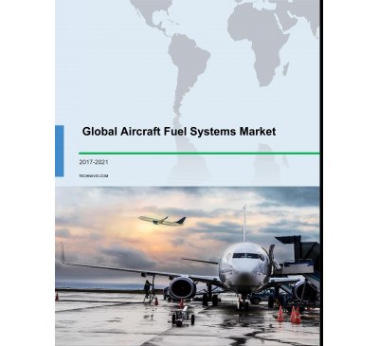

Global Aircraft Fuel Systems Market 2017-2021
- Aug 2017
- 69 pages
- USD 3500USD 2500
Overview of the global aircraft fuel systems market Research analysis on the global aircraft fuel...
View Report
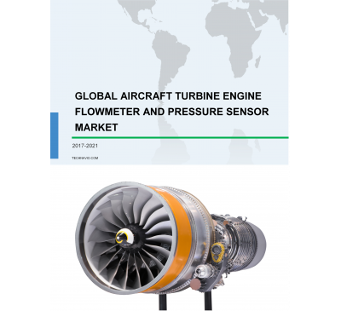

Global Aircraft Turbine Engine Flowmeter And Pressure Sensors Market 2017-2021
- Aug 2017
- 74 pages
- USD 3500USD 2500
Overview of the global aircraft turbine engine flowmeter and pressure sensors market Research ana...
View Report

Global Nanotech-enabled Aircraft Power Solutions Market 2017-2021
- Aug 2017
- 64 pages
- USD 3500USD 2500
Overview of the global nanotech-enabled aircraft power solutions market Technavio’s market resear...
View Report
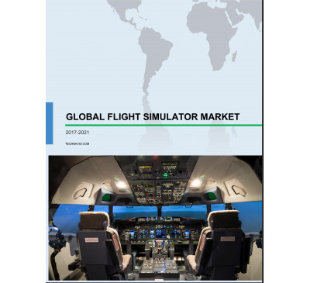

Global Flight Simulator Market 2017-2021
- Aug 2017
- 71 pages
- USD 3500USD 2500
Overview of the global flight simulator market Technavio’s market research analysts predict that ...
View Report

Global Nanotechnology Enabled Coatings For Aircraft Market 2017-2021
- Jul 2017
- 69 pages
- USD 3500USD 2500
Overview of the global nanotechnology enabled coatings for aircraft market According to Technavio...
View Report

Global Airport Surveillance Radar Market 2017-2021
- Jun 2017
- 71 pages
- USD 3500USD 2500
Overview of the global airport surveillance radar market Market research analysts at Technavio pr...
View Report
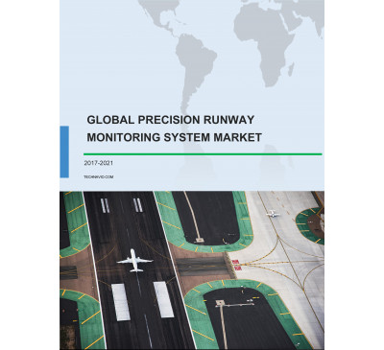

Global Precision Runway Monitoring (PRM) System Market 2017-2021
- May 2017
- 70 pages
- USD 3500USD 2500
Overview of the global precision runway monitoring (PRM) system market Technavio’s market researc...
View Report

Global Aviation Actuation System Market 2017-2021
- May 2017
- 70 pages
- USD 3500USD 2500
Overview of the global aviation actuation system market Technavio’s market research report predic...
View Report
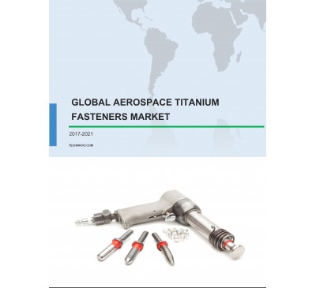

Global Aerospace Titanium Fasteners Market 2017-2021
- May 2017
- 70 pages
- USD 3500USD 2500
Overview of the global aerospace titanium fasteners market Technavio’s market research report pre...
View Report

Global Aircraft Electric Taxiing Systems Market 2017-2021
- May 2017
- 70 pages
- USD 3500USD 2500
Overview of the global aircraft electric taxiing systems market As per the Technavio’s market res...
View Report

Global Airport Walkway Market 2017-2021
- May 2017
- 70 pages
- USD 3500USD 2500
Overview of the global airport walkway market Technavio’s market research report predicts that th...
View Report

Global Unmanned Aerial Vehicle (UAV) Market 2017-2021
- Apr 2017
- 70 pages
- USD 3500USD 2500
Overview of the global unmanned aerial vehicle (UAV) market Market research analysts at Technavio...
View Report

Global Airport Digitization Market 2017-2021
- Apr 2017
- 70 pages
- USD 3500USD 2500
Overview of the global airport digitization market Technavio’s market research report predicts th...
View Report

Renewable Energy-based Commercial Aviation Market In Scandinavia 2017-2021
- Apr 2017
- 70 pages
- USD 3500USD 2500
Overview of the renewable energy-based commercial aviation market in Scandinavia Technavio’s mark...
View Report

Global Helicopter Tourism Market 2017-2021
- Mar 2017
- 70 pages
- USD 3500USD 2500
Overview of the global helicopter tourism market Technavio’s market research analyst pred.....
View Report

Global Airport Fire Safety Equipment Market 2017-2021
- Mar 2017
- 70 pages
- USD 3500USD 2500
Overview of the global airport fire safety equipment market Technavio’s market rese.....
View Report

Global Smart Baggage Handling Solutions Market 2017-2021
- Mar 2017
- 70 pages
- USD 3500USD 2500
Overview of the global smart baggage handling (SBH) solutions market Technavio’s market r.....
View Report

Global Airline Ancillary Services Market 2017-2021
- Mar 2017
- 70 pages
- USD 3500USD 2500
Overview of the global airline ancillary services market As per Technavio’s .....
View Report

Commercial Vehicle EGR System Market In APAC 2017-2021
- Feb 2017
- 70 pages
- USD 3500USD 2500
Overview of the commercial vehicle EGR system market in APAC Market research analysts at Technavi...
View Report
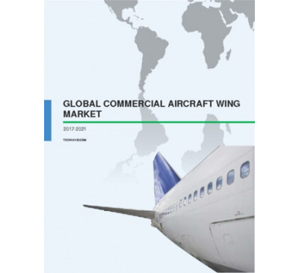

Global Commercial Aircraft Wing Market 2017-2021
- Feb 2017
- 80 pages
- USD 3500USD 2500
Overview of the global commercial aircraft wing market According to the market research analyst...
View Report
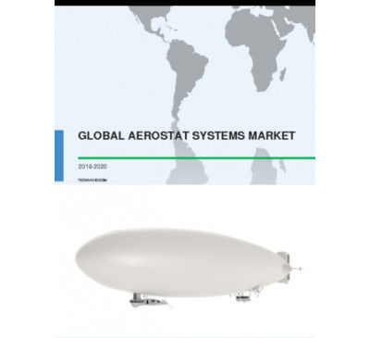

Global Aerostat Systems Market 2016-2020
- Dec 2016
- 63 pages
- USD 2500USD 2375
Overview of the global aerostat systems market The global aerostat systems market is anticipate...
View Report

Global In-flight Broadband Market 2016-2020
- Dec 2016
- 56 pages
- USD 2500USD 2375
Overview of the global in-flight broadband market Technavio’s market research analyst pre.....
View Report

Global Commercial Aircraft Battery Market 2016-2020
- Dec 2016
- 58 pages
- USD 2500USD 2375
Overview of the global commercial aircraft battery market Technavio’s market research ana.....
View Report
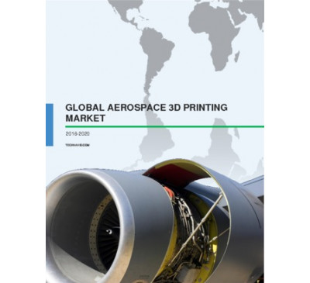

Global Aerospace 3D Printing Market 2016-2020
- Nov 2016
- 57 pages
- USD 2500USD 2375
Overview of the global aerospace 3D printing market The global aerospace 3D printing market is ...
View Report

Global Aerospace Insurance Market 2016-2020
- Nov 2016
- 59 pages
- USD 2500USD 2375
Overview of the global aerospace insurance market Technavio’s market research analyst pre.....
View Report
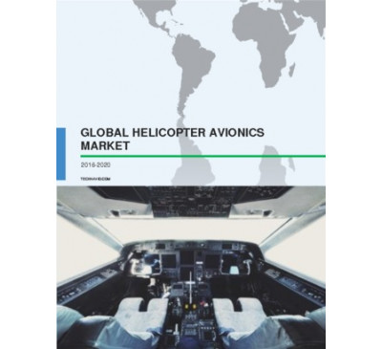

Global Helicopter Avionics Market 2016-2020
- Nov 2016
- 58 pages
- USD 2500USD 2375
Overview of the global helicopter avionics market Technavio’s market research analyst pre.....
View Report

Global Aviation Alternative Fuels Market 2016-2020
- Nov 2016
- 60 pages
- USD 2500USD 2375
Global market outlook for aviation alternative fuels The global aviation alternative fuels mark...
View Report

Global Business Jet Market 2016-2020
- Nov 2016
- 61 pages
- USD 2500USD 2375
Overview of the global business jet market In terms of revenue, the global market for business ...
View Report

Global Airline Passenger Communications System Market 2016-2020
- Oct 2016
- 57 pages
- USD 2500USD 2375
Overview of the global airline passenger communications system market Technavio’s marke.....
View Report

Global Helicopter Blades Market 2016-2020
- Oct 2016
- 65 pages
- USD 2500USD 2375
Overview of the global helicopter blades market Technavio’s market research analyst predicts the g...
View Report

Global Aircraft Ejection Seats Market 2016-2020
- Sep 2016
- 63 pages
- USD 2500USD 2375
Overview of the global aircraft ejection seats market Technavio’s market research analyst predicts...
View Report

Global Aircraft Heavy Maintenance Visit Market 2016-2020
- Sep 2016
- 67 pages
- USD 2500USD 2375
Overview of the aircraft heavy maintenance visit (HMV) market Market research analysts at Technavi...
View Report

Global Commercial Aircraft Windows And Windshields Market 2016-2020
- Sep 2016
- 62 pages
- USD 2500USD 2375
Overview of the global commercial aircraft windows and windshield market Aircraft manufacturers an...
View Report

Global Unmanned Aerial Vehicle Battery Market 2016-2020
- Sep 2016
- 64 pages
- USD 2500USD 2375
Overview of the global unmanned aerial vehicle (UAV) battery market Technavio’s market research an...
View Report

Global Unmanned Aerial Vehicle Landing Gear Market 2016-2020
- Sep 2016
- 63 pages
- USD 2500USD 2375
Global outlook of unmanned aerial vehicle (UAV) landing gear market Technavio’s market research an...
View Report

Global All-Weather Landing System Market 2016-2020
- Aug 2016
- 62 pages
- USD 2500USD 2250
Overview of the global all-weather landing systems market Technavio’s market research analyst pred...
View Report

Global Autopilot Systems Market 2016-2020
- Aug 2016
- 58 pages
- USD 2500USD 2250
Outlook of the global autopilot systems market Technavio’s market research analyst predicts that t...
View Report

Global Aircraft Galley Equipment Market 2016-2020
- Aug 2016
- 60 pages
- USD 2500USD 2250
Overview of the global aircraft galley equipment market According to Technavio’s market research a...
View Report

Global Commercial Aircraft Carbon Brakes Market 2016-2020
- Aug 2016
- 57 pages
- USD 2500USD 2250
Outlook of the global commercial aircraft carbon brakes market According to Technavio’s market res...
View Report
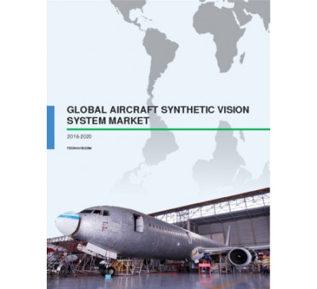

Global Aircraft Synthetic Vision System Market 2016-2020
- Aug 2016
- 60 pages
- USD 2500USD 2250
Overview of the global aircraft synthetic vision system (SVS) market Technavio’s market research a...
View Report
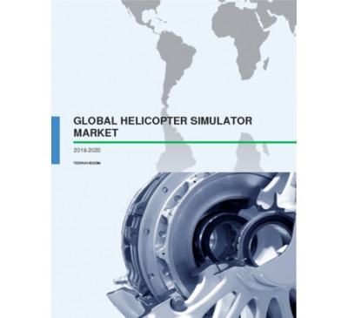

Global Helicopter Simulator Market 2016-2020
- Jul 2016
- 66 pages
- USD 2500USD 2250
Overview of the global helicopter simulator market Technavio’s market research analyst predicts th...
View Report
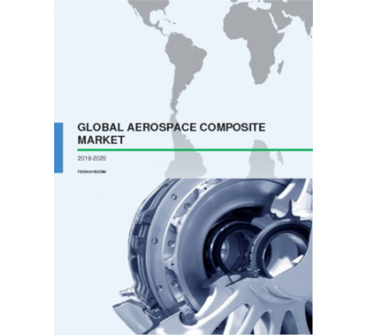

Global Aerospace Composite Market 2016-2020
- Jul 2016
- 59 pages
- USD 2500USD 2250
Overview of the global aerospace composite market Technavio’s market research analyst predicts the...
View Report

Global Aircraft Refurbishing Market 2016-2020
- Jul 2016
- 68 pages
- USD 2500USD 2250
Overview of the global aircraft refurbishing market Technavio’s market research analyst predicts t...
View Report

Global Supersonic Business Jet Market 2016-2020
- Jun 2016
- 49 pages
- USD 2500USD 2250
Outlook of the global supersonic business jet market Extensive research carried out by the analyst...
View Report

Global Air Ambulance Market 2016-2020
- Jun 2016
- 66 pages
- USD 2500USD 2250
Overview of the global air ambulance market Technavio’s market research analyst predicts the globa...
View Report

Global Commercial Aircraft Seating Market 2016-2020
- Jun 2016
- 70 pages
- USD 2500USD 2250
Overview of the global commercial aircraft seating market Technavio’s market research analysts hav...
View Report

Global Flight Management Systems Market 2016-2020
- May 2016
- 61 pages
- USD 2500USD 2250
Overview of the FMS market Extensive research carried out by the analysts at Technavio has shown t...
View Report

Global Commercial Aircraft Flight Control Systems Market 2016-2020
- May 2016
- 72 pages
- USD 2500USD 2250
Overview of the commercial aircraft flight control systems (FCS) market The commercial aircraft fl...
View Report

Global Aircraft Ground-Handling System Market 2016-2020
- May 2016
- 66 pages
- USD 2500USD 2250
Overview of the global aircraft ground-handling system market Market research analysts at Technavi...
View Report

Global Helicopter Flight Control Systems Market 2016-2020
- May 2016
- 56 pages
- USD 2500USD 2250
Overview of the global helicopter flight control systems (FCS) market Technavio’s market research ...
View Report
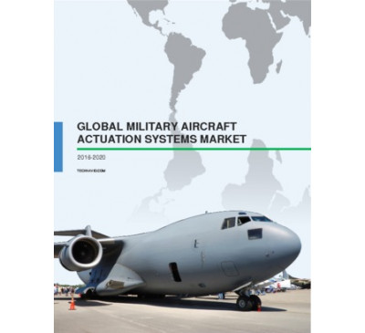

Global Military Aircraft Actuation Systems Market 2016-2020
- May 2016
- 78 pages
- USD 2500USD 2250
Outlook of the global military aircraft actuation systems market According to the analysts at Tech...
View Report
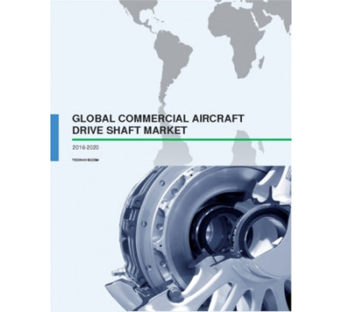

Global Commercial Aircraft Drive Shaft Market 2016-2020
- May 2016
- 61 pages
- USD 2500USD 2250
Outlook of the global commercial aircraft drive shaft market Technavio’s market research analyst p...
View Report

Global Commercial Airframe Component Market 2016-2020
- May 2016
- 67 pages
- USD 2500USD 2250
Overview of the global commercial airframe component market Technavio’s market research analyst pr...
View Report

Global Commercial Aircraft Turbine Blades And Vanes Market 2016-2020
- May 2016
- 58 pages
- USD 2500USD 2250
Outlook of the commercial aircraft turbine blades and vanes market Technavio’s market research ana...
View Report

Global Air Traffic Control Equipment Market 2016-2020
- May 2016
- 58 pages
- USD 2500USD 2250
Overview of the global air traffic control (ATC) equipment market According to the analysts at Tec...
View Report

Global Commercial Aircraft Cockpit Display System Market 2016-2020
- May 2016
- 78 pages
- USD 2500USD 2250
Outlook of the global commercial aircraft cockpit display system (CDS) market The global commercia...
View Report

Global Airport Information Systems Market 2016-2020
- Apr 2016
- 88 pages
- USD 2500USD 2250
Outlook of the airport information systems (AIS) market Technavio’s market research analysts have ...
View Report

Global Commercial Aircraft Propeller Systems Market 2016-2020
- Apr 2016
- 55 pages
- USD 2500USD 2250
Outlook of the global commercial aircraft propeller systems market Technavio’s market research ana...
View Report

Global Inertial Navigation Systems Market 2016-2020
- Apr 2016
- 65 pages
- USD 2500USD 2250
Overview of the Inertial Navigation Systems (INS) Market Technavio’s market research analysts have...
View Report

Global Aviation Test Equipment Market 2016-2020
- Mar 2016
- 76 pages
- USD 2500USD 2250
Outlook of the aviation test equipment market Extensive research by the analysts at Technavio show...
View Report

Global In-Flight Entertainment Market 2016-2020
- Mar 2016
- 69 pages
- USD 2500USD 2250
Outlook of the in-flight entertainment (IFE) market Extensive research carried out by the analysts...
View Report
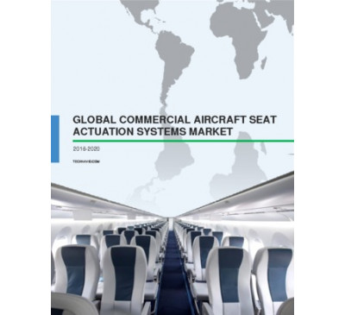

Global Commercial Aircraft Seat Actuation Market 2016-2020
- Feb 2016
- 63 pages
- USD 2500USD 2250
Outlook of the global commercial aircraft seat actuation market Aircraft seat actuation systems pr...
View Report

Global Airborne Laser Obstacle Avoidance Monitoring Systems Market 2016-2020
- Feb 2016
- 57 pages
- USD 2500USD 2250
Overview of the global airborne laser obstacle avoidance monitoring systems market The global mark...
View Report

Global Aircraft Fuel Systems Market 2016-2020
- Feb 2016
- 70 pages
- USD 2500USD 2250
Outlook of the global aircraft fuel systems market A fuel system allows the fuel to pass to the au...
View Report

Global Commercial Aircraft Fuel Nozzle Market 2016-2020
- Feb 2016
- 61 pages
- USD 2500USD 2250
Outlook of the global commercial aircraft fuel nozzle market Technavio’s market research analyst p...
View Report

Global Commercial Aircraft Health Monitoring Systems Market 2016-2020
- Jan 2016
- 69 pages
- USD 2500USD 2250
Market outlook of commercial aircraft health monitoring systems Technavio’s research analyst predi...
View Report

Global Satellite-Based Augmentation Systems 2016-2020
- Jan 2016
- 78 pages
- USD 2500USD 2250
Market outlook of global satellite-based augmentation system Technavio’s research analyst estimate...
View Report

Global Commercial Aviation Crew Management Systems Market 2016-2020
- Jan 2016
- 58 pages
- USD 2500USD 2250
Market overview of commercial aviation crew management systems Technavio’s market research analyst...
View Report
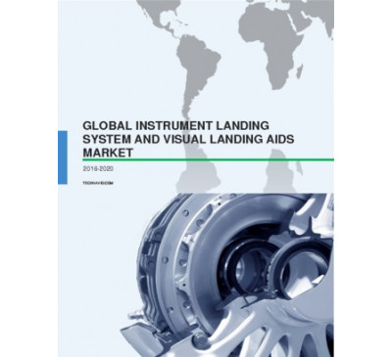

Global Instrument Landing System And Visual Landing Aids Market 2016-2020
- Jan 2016
- 72 pages
- USD 2500USD 2250
Market outlook of instrument landing system and visual landing aids Technavio’s market research an...
View Report

Global Ground-Based Augmentation Systems 2016-2020
- Jan 2016
- 70 pages
- USD 2500USD 2250
Market outlook of the global ground-based augmentation system market The global market for ground-...
View Report

Global Automotive Lighting Market 2016-2020
- Dec 2015
- 77 pages
- USD 2500USD 2250
Market outlook of the automotive lighting market Technavio’s market research analyst predicts the...
View Report
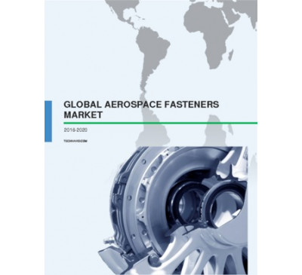

Global Aerospace Fasteners Market 2016-2020
- Nov 2015
- 63 pages
- USD 2500USD 2250
Market outlook of aerospace fasteners Technavio’s market research analysts expect the global aeros...
View Report
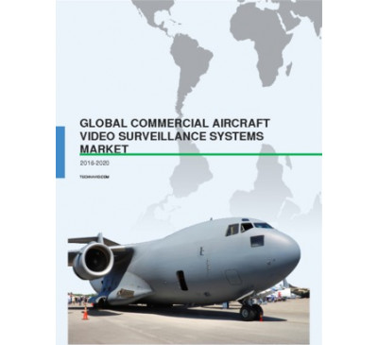

Global Commercial Aircraft Video Surveillance Systems Market 2016-2020
- Nov 2015
- 57 pages
- USD 2500USD 2250
Market outlook of the global commercial aircraft video surveillance systems market Technavio’s mar...
View Report

Global Full-Service Carrier Market 2016-2020
- Nov 2015
- 68 pages
- USD 2500USD 2250
Outlook of the full-service carrier market Technavio’s research analyst predicts the full-service ...
View Report

Global Commercial Aircraft Next-Gen Avionics Market 2015-2019
- Nov 2015
- 72 pages
- USD 2500USD 2250
About nextgen avionics Next-generation avionics are electronic equipment incorporated in aircraft...
View Report

Global Flight Navigation System Market 2015-2019
- Nov 2015
- 63 pages
- USD 2500USD 2250
Market outlook of flight navigation systems Latest avionics systems and accurate flight navigation...
View Report

Global Man Portable Military Electronics Market 2015-2019
- Nov 2015
- 64 pages
- USD 2500USD 2250
About man portable military electronics Man portable military electronic systems include mobile c...
View Report

Global Aviation Security Market 2015-2019
- Oct 2015
- 66 pages
- USD 2500USD 2250
Market overview of the global aviation security Over the years, airports all over the globe have m...
View Report

Global Aerospace High Performance Alloys Market 2015-2019
- Oct 2015
- 60 pages
- USD 2500USD 2250
About high performance alloys (HPAs) HPAs are alloys used in extremely high temperature applicati...
View Report

Global Commercial Aircraft Cabin Interiors Market: Forecast Until 2019
- Aug 2015
- 69 pages
- USD 2500USD 2000
Key growth drivers for commercial aircraft cabin interiors market A key factor that fuels the de...
View Report

Global More Electric Aircraft Market 2015-2019
- Aug 2015
- 71 pages
- USD 2500USD 2000
About More Electric Aircraft More electric aircrafts are advanced next generation aircrafts that ...
View Report

Global Commercial Aircraft Aftermarket Parts Market 2015-2019
- Jul 2015
- 78 pages
- USD 2500USD 2000
Market overview of the commercial aircraft aftermarket parts market In 2014, the market size of ...
View Report

Global Commercial Aircraft Electrical And Environmental Systems Market 2015-2019
- Jul 2015
- 87 pages
- USD 2500USD 2000
About Aircraft Electrical and Environmental Systems Aircraft electrical systems generate, regulat...
View Report

Global Commercial Aircraft Interior Lighting Market 2015-2019
- Jul 2015
- 71 pages
- USD 2500USD 2000
About Commercial Aircraft Interior Lighting Aircraft interior lighting systems are one of the key...
View Report

Global Commercial Aircraft Gas Turbine Engine Market 2015-2019
- Jul 2015
- 83 pages
- USD 2500USD 2000
About Aircraft Engines Aircraft are either powered by piston engines or gas turbine engines. Gas ...
View Report

Commercial Airport Lighting Market: Global Trends & Forecast 2015-2019
- Jul 2015
- 57 pages
- USD 2500USD 2000
.....
View Report

Global Commercial Aircraft Lighting Market 2015-2019
- Jul 2015
- 58 pages
- USD 2500USD 2000
About Commercial Aircraft Lighting Aircraft lighting systems are a key component of an aircraft. ...
View Report

Global Commercial Aircraft Windows And Windshields Market 2015-2019
- Jul 2015
- 70 pages
- USD 2500USD 2000
About Aircraft Windows and Windshields Windows and windshields of aircraft are designed for viewi...
View Report

Global Aerospace Composite Market 2015-2019
- Apr 2015
- 71 pages
- USD 2500USD 2000
About Aerospace Composite Composites are a combination of two or more materials, with physical or...
View Report

Global Commercial Aircraft Seating Market 2015-2019
- Mar 2015
- 74 pages
- USD 2500USD 2000
About Commercial Aircraft Seating An aircraft seat often consists of adjustable headrests, electr...
View Report

Global Aircraft Synthetic Vision System Market 2015-2019
- Mar 2015
- 71 pages
- USD 2500USD 2000
About Aircraft Synthetic Vision System Aircraft SVS uses the database of terrains, runways, obsta...
View Report

Global Commercial Aircraft Cabin Interior Market 2014-2018
- Dec 2014
- 62 pages
- USD 2500USD 2000
About Commercial Aircraft Cabin Interior The interior of an aircraft cabin consists of lights, I...
View Report

Global Air Cargo Security And Screening Systems Market 2014-2018
- Oct 2014
- 52 pages
- USD 2500USD 2000
About Air Cargo Security and Screening Systems An increase in global air cargo traffic has resul...
View Report

Global Commercial Aircraft Aftermarket Parts Market 2014-2018
- Sep 2014
- 66 pages
- USD 2500USD 2000
About Commercial Aircraft Aftermarket Parts Market Aircraft aftermarket parts are mainly used in...
View Report

Global In-flight Entertainment Market 2014-2018
- Aug 2014
- 61 pages
- USD 2500USD 2000
IFE systems provide entertainment to aircraft passengers in the form of movies, music, and games....
View Report

Global Software Defined Radios Market 2014-2018
- May 2014
- 48 pages
- USD 2500USD 2000
About Software Defined Radios SDR refers to those types of user radios which, with the help of s...
View Report

Global Military Electro-optic Infrared Systems Market 2014-2018
- Apr 2014
- 59 pages
- USD 2500USD 2000
About Military Electro Optical Infrared Systems EO/IR systems are one of the important systems ...
View Report

Global Commercial Aircraft Carbon Brakes Market 2014-2018
- Apr 2014
- 53 pages
- USD 2500USD 2000
About Carbon Brakes Currently, lightweight and fuel-efficient aircraft are in demand. Aircraft m...
View Report

Global Aerospace Composites Market 2014-2018
- Mar 2014
- 52 pages
- USD 2500USD 2000
TechNavio’s analysts forecast the Global Aerospace Composites market will grow at a CAGR of 11.85 p...
View Report

Global Aerospace Fasteners Market 2014-2018
- Feb 2014
- 48 pages
- USD 2500USD 2000
TechNavio's analysts forecast the Global Aerospace Fasteners market to grow at a CAGR of 7.75 perce...
View Report

Global Commercial Airport Baggage Handling Systems Market 2014-2018
- Feb 2014
- 58 pages
- USD 2500USD 2000
TechNavio’s analysts forecast the Global Commercial Airport Baggage Handling Systems market will gr...
View Report

Global Aerospace Plastics Market 2014-2018
- Jan 2014
- 47 pages
- USD 2500USD 2000
TechNavio's analysts forecast the Global Aerospace Plastics market to grow at a CAGR of 8.04 percen...
View Report

Global Commercial Aircraft Lighting Market 2014-2018
- Nov 2013
- 59 pages
- USD 2500USD 2000
TechNavio's analysts forecast the Global Commercial Aircraft Lighting market to grow at a CAGR of 5...
View Report

30
Jan 2015

High-Tech Materials Alert. Novel Method to Quantify the Use of Polysaccharide Gums in Food Products; Infusion Techniques for Producing Aerospace Components Using Benzoxazine Resin
Region : Global
This issue profiles a novel method to quantify the use of polysaccharide gums in food products, infusion techniques for producing aerospace components using benzoxazine resin, and research aimed at developing a viable eco-friendly solution to replace plastics in beverage packaging.
USD 250
READ MORE
09
Jan 2008

European Commercial Airframe Components Aftermarket Analysis

Region : Europe
This research describes the growing European airframe components aftermarket and supply chain in the aircraft and engine maintenance, repair and overhaul domain.
USD 4,950
USD 3,465
READ MORE
04
Jul 2005

North American Hydraulic Components Markets for Aerospace Applications

Region : North America
This research service examines the North American market for hydraulic components in the aerospace industry. Products discussed are cylinders, valves, motors and pumps. This research service also gives information about the distribution structure and customer needs along with key trends in the aerospace industry.
USD 3,950
USD 2,765
READ MORE
28
Feb 2006

World Magnetic Sensor Components and Modules/Sub-systems Markets

Region : Global
Emergence of newer applications has been a great booster to the magnetic sensors market. Due to the extensive research and development efforts a number of new and innovative equipment using various types of hall sensors have been developed. This has evinced a great interest of diverse end user industry from research to aerospace and defense. Total ...
USD 4,950
USD 3,465
READ MORE
25
Jan 2012

Economic 360 for China: Growth Prospects and Emerging Opportunities in the Aerospace Industry
Industry and infrastructure upgrades, and technology breakthroughs to drive aerospace industry
Region : Asia Pacific
China has been the fastest growing economy, expanding at 10.0 percent annually, driven by exports and investment. High priority is given to economic restructuring, from an export-driven to consumption-driven economy during the 12th five year plan period. The aerospace industry is a driver of economic growth, supported by government initiatives and ...
USD 1,495
USD 1,121
READ MORE
10
Mar 2017

Plastics and Composites for the Aerospace Industry
Region : Global
The aerospace industry is focusing on reducing the weight of aircraft in order to attain better fuel efficiency and performance. This is creating a need for materials with better mechanical, chemical, and thermal properties that can replace heavy metals. With lightweight and durability of components of prime importance, lightweight composites (f...
USD 950
READ MORE
22
Apr 2016

3D Printing Developments in the Aerospace Industry - Advanced Manufacturing TOE
Region : Global
This issue of Advanced Manufacturing TOE profiles key 3D printing developments, such as engine part and larger structures or components, and also notes opportunities and challenges, impacting 3D printing in the aerospace industry. The Advanced Manufacturing TechVision Opportunity Engine (TOE) covers global innovations and developments related to ...
USD 250
READ MORE
31
Jul 2001

Compendium 2001: Business Development Opportunities in Aerospace & Defense

Region : Global
This report is a collection of many of Frost & Sullivan's annual reports segmented by major research areas. This compendium provides very general information based on existing research intended for the non-industry participant interested in gaining a better understanding of the Aerospace & Defense market and its many components. The compendium fo...
USD 1,995
USD 1,397
READ MORE
30
Dec 2016

Innovations in Simulation - Aerospace and Defense TOE
Region : Global
This Aerospace and Defense TOE reveals advancements and opportunities in flight simulators, including virtual reality-based training simulators, simulators incorporating fewer but higher performance components, simulators combining real-world and virtual elements, versatile flight training devices, helicopter simulators, motor simulators, and weapo...
USD 950
READ MORE
30
Jan 2015

Commercial Aircraft Fuel Systems Market
Aircraft Power Production Series
Region : Global
The commercial aircraft Fuel Systems market consists of the pumps that produce the flow, various storage and safety systems, and the controls that provide this power to the engines. As such, it is part of an integrated system. The primary focus of this research was the provision of new components into new aircraft. This is a market strongly domina...
USD 1,500
READ MORE
12
Jul 2016

Advances in Digital Manufacturing (TechVision)
New Opportunities in Automotive, Aerospace, Construction, Electronics, and Healthcare
Region : Global
With the advent of Industry 4.0 and smart factories, digital manufacturing technologies have been experiencing significant technological growth in the recent years. Technologies are playing a vital role in the revolutionary transformation of many key industries, such as aerospace, automotive, industrial automation, healthcare, and oil and gas secto...
USD 4,950
READ MORE
19
May 2016

2016 Global Outlook for the Air Transport Industry
Continued Record Production Facing Possible Model Change Delays
Region : Global
Continued record commercial aircraft production will be slowed slightly by model changes. New, clean sheet of paper models will be unlikely, but major upgrades of existing models will be more prevalent than ever before. However, original equipment manufacturers (OEMs) will have missteps during this process. Second and third tier suppliers will be m...
USD 4,950
READ MORE
18
Nov 2016

Global Airport Supply Chain Market
An Overview of Business Transformation Projects and Competitive Strategies across Major Global Suppliers
Region : North America
The research provides a competitive analysis of industry strategies and growth potential for ten major airport suppliers. The research also identifies key industry trends and lists the major competitors that provide solutions for various airport segments. The increase in demand for air travel, coupled with the necessity for airports to optimize op...
USD 3,000
READ MORE
12
May 2016

Global Commercial Cabin Interiors Market, Forecast to 2020
Record Aircraft Production Sustains the Cabin Interiors Market
Region : Global
This study on the global cabin interiors market provides market forecasts and drivers and restraints as well as market shares and competitive analyses of participants from 2015 to 2020. This study covers 4 market segments: seating, lavatories, galleys, and cabin components. This study presents the technological changes to the market and the compani...
USD 4,950
READ MORE
26
May 2016

Innovations in Image Sensors (TechVision)
High resolution and dynamic range imaging drive opportunities
Region : Global
The technology and innovation report assess innovations in image sensors and also its impact on different industries. Increasing need for high resolution and dynamic range and fast imaging in applications such as automotive, aerospace, medical, consumer electronics and industrial drives the need for enhanced image sensing device. The automotive se...
USD 4,950
READ MORE
27
Sep 2013

Global Cabin Interiors Market
Is it Time for Renewed Growth?
Region : North America
This research describes the global market for aircraft cabin interiors. Supporting research data was collected from industry records for delivery of new aircraft; contracts for modifications; and contracts for maintenance, repair, and overhaul. Data was verified by conversations with industry participants. Market segmentation includes: cabin compo...
USD 6,950
USD 5,908
READ MORE
30
Mar 2012

Software Defined Radios: Technology Penetration and Roadmapping (Technical Insights)

Region : Global
The research service assesses the key trends pertaining to the development and testing platform providers, the waveform developers, the infrastructure providers, and the spectrum sensing technology providers in the software defined radio (SDR) industry. With regards to these components of the value chain, the key innovations and their market impact...
USD 4,950
USD 3,713
READ MORE
29
Jun 2015

Technology Innovations Enabling Manufacturing of Fuel Efficient & Low Noise Aircrafts (Technical Insights)
Paving way for the future of eco-friendly aircraft
Region : Global
The future of the aerospace sector in terms of eco-friendly aircraft will depend on the developments in the manufacturing sector. Some of the manufacturing technologies such as three-dimensional (3D) printing, nanomanufacturing, composite manufacturing, and multimaterial manufacturing technologies will have a crucial role in the transformation of ...
USD 4,950
READ MORE
28
Jun 2017

Global Military Aircraft Engine Maintenance, Repair, and Overhaul Market, Forecast to 2025
Reduced Deliveries of New Aircraft, Increased Reliance on Modular Design, and Improved Engine Control Conflicts with Increased Event Costs Result in M
Region : North America
The North American engine maintenance, repair, and overhaul (MRO) market is the largest individual market, but will experience modest growth. Meanwhile, Fighter aircraft market will experience the most significant aircraft segment growth. New deliveries of airframes are slow, except in Russia and China, which are not included. Additionally, initial...
USD 4,950
READ MORE
05
Nov 2014

Commercial Aircraft Hydraulic Systems
Aircraft Power Production Series
Region : North America
The commercial aircraft hydraulic power market consists of the pumps that produce the power, various storage and safety systems, and the controls that provide this power to the operating systems. As such, it is part of an integrated system of systems. The primary focus of this research was the provision of new components into new aircraft. This ...
USD 1,500
USD 1,350
READ MORE
03
Jul 2017

Future of Thermoelectric Energy Harvesting
Building and Home Automation Sectors will Drive Growth Opportunities for Thermal Harvesters
Region : Global
Increased population and pollution are largely contributing to energy crisis. In manufacturing and industrial power plants, a high amount of energy is wasted in the form of heat. Though some countries have restructured their electricity infrastructure with highly expensive processes, the electricity crisis still prevails. This energy and electricit...
USD 4,950
READ MORE
02
May 2017

Global Military Airframe Maintenance, Repair, and Overhaul (MRO) Market, Forecast to 2026
Reduced Deliveries of New Aircraft and Increased Reliance on Health Management Systems Conflict with Rising Event Costs Resulting in Minimal Growth
Region : Global
The global airframe MRO market registered $24.34 billion in 2016 revenue and is expected to reach 27.31 billion by 2026 growing at a compound annual growth rate of 1.2%. The North American market is the largest, but will experience modest growth. Meanwhile, rotary wing utility aircraft will experience the most significant segment growth. New delive...
USD 4,950
READ MORE
22
Aug 2008

European Sea Port Security Market

Region : Europe
The European Sea Port Security market is highly competitive market with a number of participants providing port security related products and services to its end-users. Total market for port security systems and services across Europe grew from 376 million in 2006 to 466 million in 2011, and is expected to decrease to 367 million in 2015. Market...
USD 10,300
USD 7,210
READ MORE
06
Sep 2017

Global Aerospace Sealants Market, Forecast to 2023
High Demand for Aircraft Fleet Expansion in Asia-Pacific and the Middle East is Expected to Spur Demand
Region : Global
Aerospace is one of the key industries of leading economies that supplies to market such as commercial aviation, defense aviation, and general aviation. Aircrafts and related components and products that are in operation or are being manufactured require a variety of highly specific and durable sealants for various applications on parts such as fue...
USD 4,950
READ MORE
29
Dec 2014

Breakthrough Innovations in Optoelectronics (Technical Insights)
Innovations in optoelectronics enabling next generation products and wider commercial adoption
Region : Global
The research service profiles key breakthrough innovations in optoelectronics that have the potential to highly impact product functionality and/or reduce cost of components. Along with that, the report also covers a basic overview of optoelectronics, key application areas, drivers and challenges, innovation indicators (Funding and IP scenario), an...
USD 4,950
USD 4,455
READ MORE
12
Aug 2009

Indian Commercial Aviation MRO Market Assessment

Region : Asia Pacific
The study aims to capture the market potential of commercial MRO in India. The MRO market has been estimated based on the current number of aircraft in the country and the number of aircraft expected to be added in the next 7 years. The maintenance cycle for different type of aircraft currently present and expected has been developed, revenue poten...
USD 4,950
USD 3,465
READ MORE
04
Mar 2009

The Proliferation of Aircraft Maintenance Outsourcing in the United States

Region : North America
The proliferation of aircraft maintenance outsourcing in the United States. shares an analysis of the growing trend of aircraft maintenance outsourcing in the United States. It covers the critical components and make-up of the U.S. MRO market that includes original equipment manufactures, third-party and in-house aircraft maintenance. The main focu...
USD 4,950
USD 3,465
READ MORE
28
Apr 2015

US Department of Homeland Security Budget
FY 2016 Spending Assessment
Region : North America
The FY 2016 Department of Homeland Security budget request was published and distributed in February 2015, a scheduled event that has not been on time for the last several years. A key article of interest is the increase from the 2015 request that may open opportunities for companies trying to enter the homeland security market. The new research di...
USD 6,950
READ MORE
24
Feb 2017

3D Printing for Military/Aerospace Applications
Region : Global
This Advanced Manufacturing TOE highlights innovations and opportunities in 3D printing for military/aerospace applications, including 3D laser metal printing of weapons, 3D printing of electronic components, 3D printing of food, 3D bioprinting of functional skin. The Advanced Manufacturing TechVision Opportunity Engine (TOE) covers global innovat...
USD 250
READ MORE
04
Mar 1998

World Military and Commercial Microwave Component and Assembly Markets

Region : Global

USD 2,450
USD 1,715
READ MORE
30
Nov 2011

Strategic Analysis of Indian Aircraft Component Manufacturing and Services Industry
Industry revenue to double by 2015 backed by domestic aircraft market growth and defense offsets
Region : South Asia, Middle East & North Africa
This research service analyzes the growth of Indian aircraft component manufacturing and services industry while also discussing the existing and possible opportunity areas. The study includes a brief overview evolution of manufacturing value chain and emergence of India in global aircraft industry. Then study presents emerging trends, PESTLE facto...
USD 4,950
USD 3,465
READ MORE
27
May 2016

Advances in 3D Printing of Metals - Advanced Manufacturing TOE
Region : Global
This issue of Advanced Manufacturing TOE identifies key advancements in 3D printing of metals, including high-strength stainless steel powder, a technique for 3D printing metal components at the nanoscale level, 3D printing of micro metal structures in free space, and enhanced refractory metals for 3D printing. The Advanced Manufacturing TechVisio...
USD 250
READ MORE
16
Dec 2016

Manufacturing Technologies for Automotive Lightweighting - Advanced Manufacturing TOE
Region : Global
This issue of Advanced Manufacturing TOE identifies innovations for producing light-weight components, such as 3D roll forming, one-step joining processes, laser-assisted light-weight material processing, and large linear friction welders. The Advanced Manufacturing TechVision Opportunity Engine (TOE) covers global innovations and developments r...
USD 250
READ MORE
02
Sep 2016

Industrial Grade 3D Printing - Advanced Manufacturing TOE
Region : Global
This issue of Advanced Manufacturing TOE profiles developments and advancements in 3D printing of large parts, components, or tools. The Advanced Manufacturing TechVision Opportunity Engine (TOE) covers global innovations and developments related to manufacturing and industrial automation on a weekly basis. Innovations are focused toward improving ...
USD 250
READ MORE
10
Nov 2016

Global Mobile Hydraulic Equipment Market, Forecast to 2020
Compact, Integrated, and Smart Solutions Unlock New Growth Opportunities Linked to the Industrial Internet of Things Landscape
Region : North America
The global mobile hydraulic equipment market is estimated to experience an approximate 3% compound annual growth rate (CAGR) from 2015 to 2020. This market constitutes more than 60% of the of the total hydraulics market revenue that includes both industrial and mobile applications. The objective of this study is to identify strategic opportunities...
USD 4,950
READ MORE
30
Sep 2015

Additive Manufacturing Technology Innovations Impacting Automotive Sector (Technical Insights)
Transforming the Manufacturing Paradigm in Automotive Sector
Region : Global
Additive manufacturing (AM) is a rapidly growing technology that includes rapid prototyping and three-dimensional (3D) printing. These technologies are playing a crucial role in transforming industries such as automotive, aerospace, medical, fashion and food industry. Additive manufacturing is mainly used for more efficient, less time consuming and...
USD 4,950
READ MORE
21
Oct 2016

High-strength Glass Fiber Reinforcements - High-Tech Materials TOE
Region : Global
Continuous glass fibers have evolved through the years since the commercialization of the first product in 1935. Manufactured using a mix of raw materials such as silicates, soda, clay, boric acid, and a range of metal oxides, glass fibers exhibit a combination of desirable mechanical and chemical properties based on their chemical composition. Wit...
USD 1,500
READ MORE
30
Nov 2011

Strategic Analysis of Indian Aircraft Component Manufacturing and Services Industry
Industry revenue to double by 2015 backed by domestic aircraft market growth and defense offsets
Region : South Asia, Middle East & North Africa
This research service analyzes the growth of Indian aircraft component manufacturing and services industry while also discussing the existing and possible opportunity areas. The study includes a brief overview evolution of manufacturing value chain and emergence of India in global aircraft industry. Then study presents emerging trends, PESTLE facto...
USD 4,950
USD 3,465
READ MORE
27
May 2016

Advances in 3D Printing of Metals - Advanced Manufacturing TOE
Region : Global
This issue of Advanced Manufacturing TOE identifies key advancements in 3D printing of metals, including high-strength stainless steel powder, a technique for 3D printing metal components at the nanoscale level, 3D printing of micro metal structures in free space, and enhanced refractory metals for 3D printing. The Advanced Manufacturing TechVisio...
USD 250
READ MORE
16
Dec 2016

Manufacturing Technologies for Automotive Lightweighting - Advanced Manufacturing TOE
Region : Global
This issue of Advanced Manufacturing TOE identifies innovations for producing light-weight components, such as 3D roll forming, one-step joining processes, laser-assisted light-weight material processing, and large linear friction welders. The Advanced Manufacturing TechVision Opportunity Engine (TOE) covers global innovations and developments r...
USD 250
READ MORE
02
Sep 2016

Industrial Grade 3D Printing - Advanced Manufacturing TOE
Region : Global
This issue of Advanced Manufacturing TOE profiles developments and advancements in 3D printing of large parts, components, or tools. The Advanced Manufacturing TechVision Opportunity Engine (TOE) covers global innovations and developments related to manufacturing and industrial automation on a weekly basis. Innovations are focused toward improving ...
USD 250
READ MORE
10
Nov 2016

Global Mobile Hydraulic Equipment Market, Forecast to 2020
Compact, Integrated, and Smart Solutions Unlock New Growth Opportunities Linked to the Industrial Internet of Things Landscape
Region : North America
The global mobile hydraulic equipment market is estimated to experience an approximate 3% compound annual growth rate (CAGR) from 2015 to 2020. This market constitutes more than 60% of the of the total hydraulics market revenue that includes both industrial and mobile applications. The objective of this study is to identify strategic opportunities...
USD 4,950
READ MORE
30
Sep 2015

Additive Manufacturing Technology Innovations Impacting Automotive Sector (Technical Insights)
Transforming the Manufacturing Paradigm in Automotive Sector
Region : Global
Additive manufacturing (AM) is a rapidly growing technology that includes rapid prototyping and three-dimensional (3D) printing. These technologies are playing a crucial role in transforming industries such as automotive, aerospace, medical, fashion and food industry. Additive manufacturing is mainly used for more efficient, less time consuming and...
USD 4,950
READ MORE
21
Oct 2016

High-strength Glass Fiber Reinforcements - High-Tech Materials TOE
Region : Global
Continuous glass fibers have evolved through the years since the commercialization of the first product in 1935. Manufactured using a mix of raw materials such as silicates, soda, clay, boric acid, and a range of metal oxides, glass fibers exhibit a combination of desirable mechanical and chemical properties based on their chemical composition. Wit...
USD 1,500
READ MORE

Aerospace Industries Association (AIA) Standards
, NA and NAM standards developed jointly by commercial and defense aircraft and aerospace manufacturers. Covering airframe structural...
Standards management
Next-generation products
New product design
Feasibility Analysis
Equipment and technology
Standards and Regulations
Aerospace & Defense
Standards and Regulations
Liquid Crystal Polymers - Chemical Economics Handbook (CEH)
/electrical industry consumed a little over 80% of global demand for LCPs. The major component here for LCPs is in SMT connectors...
Trade Data
Technical research
Supply/Demand Data
Supply chain
Scenario planning & analysis
Risk assessment
Regulatory
Production & Capacity
Fluoroelastomers - Chemical Economics Handbook (CEH)
working periods they will take even higher temperatures. Some perﬂuorocarbon elastomer types can resist temperatures up to 327°C. Components...
Trade Data
Technical research
Supply/Demand Data
Supply chain
Scenario planning & analysis
Risk assessment
Regulatory
Production & Capacity
ESDU: Validated engineering design methods
for aircraft and aerospace structures, including: Strength analysis of cracked/flawed structures or components Curves of...
Problem solving
Technical and Specialized Data
Academic/Education
Engineering Knowledge & Tools
Engineer
Aromatic Ketone Polymers - Chemical Economics Handbook (CEH)
. The major end-use sectors for AKPs include transportation (mainly aerospace and automotive), industrial/energy, electrical/electronic...
Trade Data
Technical research
Supply/Demand Data
Supply chain
Scenario planning & analysis
Risk assessment
Regulatory
Production & Capacity
Elastomers Overview - Chemical Economics Handbook (CEH)
available, many of which overlap each other in cost and/or performance. Major applications for specialty elastomers are in automotive components...
Trade Data
Technical research
Supply/Demand Data
Supply chain
Scenario planning & analysis
Risk assessment
Regulatory
Production & Capacity
Compounding of Engineering Thermoplastics: Specialty - Specialty Chemicals Update Program (SCUP)
. The transportation market includes automotive, truck/bus, motorcycle, marine and aerospace applications. All electrical/electronic...
Trade Data
Technical research
Supply/Demand Data
Supply chain
Scenario planning & analysis
Risk assessment

اگر منبع مورد نظرتان موجود نبود در ادامه درخواست دهید

از این به بعد شما اساتید و دانشجویان و پژوهشگران گرامی می توانید با دادن اطلاعی از منبع مورد نظر خود به ایمیل ما، کتاب های خود را از طریق درخواست کتاب این سایت بسیار ارزان قیمت دانلود کنید.

–شابک کافیست مشخصات کتاب همچون نام | شماره | نام نویسنده و … را برای ما بفرستید.
– یا لینکی از آن در سایت های دیگر همچون آمازون ، ایی بِی، گوگل بوک ، انتشارات های اصلی و … آن را به ما بگویید.
-باقی کار را به ما بسپارید؛ به شما در کمتر از ۲۴ ساعت اطلاع خواهیم داد.

