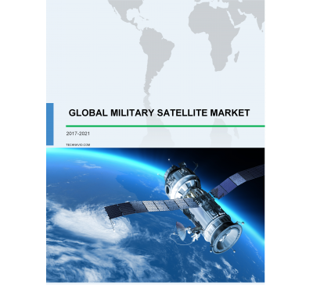

Global Military Satellite Market 2017-2021
- Aug 2017
- 68 pages
- USD 3500USD 2500
Overview of the global military satellite market Technavio’s market research analysis identifies ...
View Report
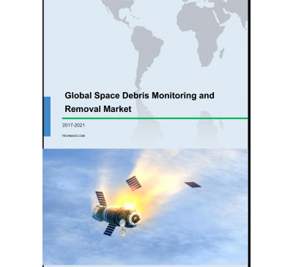

Global Space Debris Monitoring And Removal Market 2017-2021
- Aug 2017
- 70 pages
- USD 3500USD 2500
Overview of the global space debris monitoring and removal market Technavio’s market research rep...
View Report
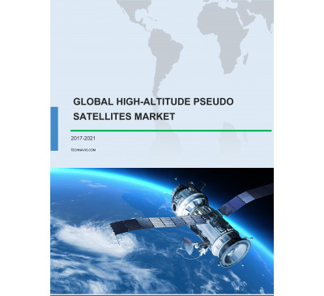

Global High-altitude Pseudo Satellites (HAPS) Market 2017-2021
- Jul 2017
- 73 pages
- USD 3500USD 2500
Overview of the global high-altitude pseudo satellites (HAPS) market Research analysis on the glo...
View Report
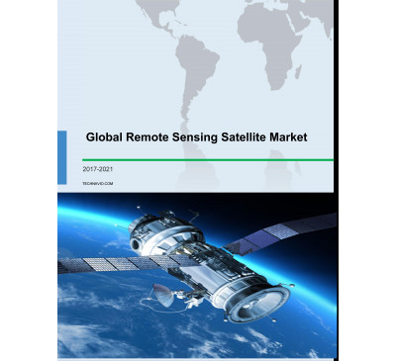

Global Remote Sensing Satellite Market 2017-2021
- Jul 2017
- 74 pages
- USD 3500USD 2500
Overview of the global remote sensing satellite market Market research analysts at Technavio pred...
View Report

Global Aero Structure Equipment Market 2017-2021
- Jul 2017
- 70 pages
- USD 3500USD 2500
Overview of the global aero structure equipment market Market research analysts at Technavio pred...
View Report
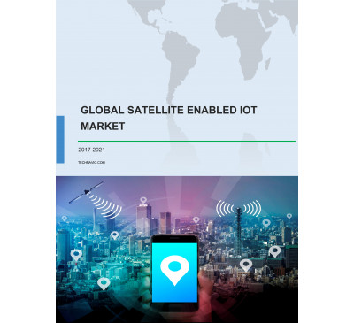

Global Satellite-enabled IoT Market 2017-2021
- Jun 2017
- 71 pages
- USD 3500USD 2500
Overview of the global satellite-enabled IoT market Market research analysts at Technavio predict...
View Report
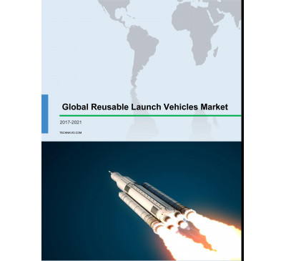

Global Reusable Launch Vehicles Market 2017-2021
- Jun 2017
- 70 pages
- USD 3500USD 2500
Overview of the global reusable launch vehicles market According to Technavio’s market research r...
View Report
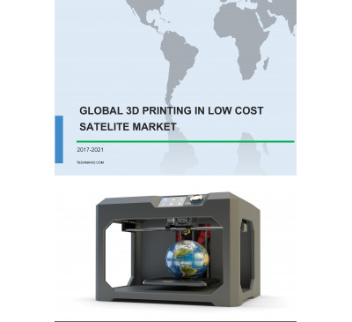

Global 3D Printing In Low-Cost Satellite Market 2017-2021
- May 2017
- 70 pages
- USD 3500USD 2500
Overview of the global 3D printing in low-cost satellite market Market research analysts at Techn...
View Report
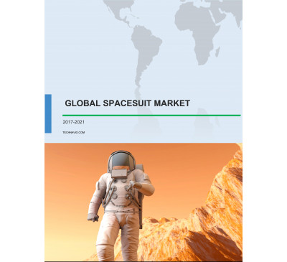

Global Spacesuit Market 2017-2021
- May 2017
- 70 pages
- USD 3500USD 2500
Overview of the global spacesuit market Market research analysts at Technavio predict that the gl...
View Report
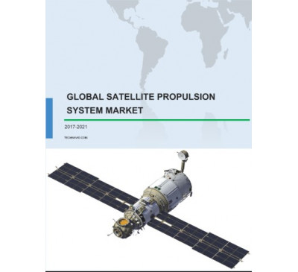

Global Satellite Propulsion System Market 2017-2021
- May 2017
- 70 pages
- USD 3500USD 2500
Overview of the global satellite propulsion system market According to Technavio’s market researc...
View Report
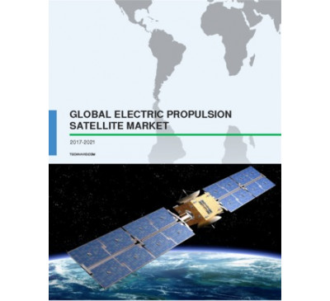

Global Electric Propulsion Satellite Market 2017-2021
- Apr 2017
- 70 pages
- USD 3500USD 2500
Overview of the global electric propulsion satellite market Market research analysts at Technavio...
View Report
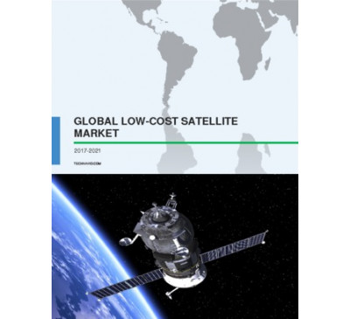

Global Low-Cost Satellite Market 2017-2021
- Apr 2017
- 70 pages
- USD 3500USD 2500
Overview of the global low-cost satellite market Technavio’s market research analyst predicts the...
View Report
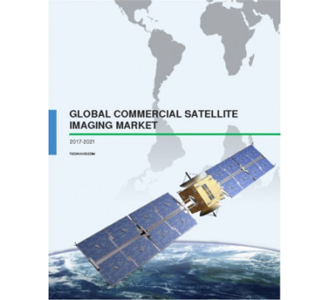

Global Commercial Satellite Imaging Market 2017-2021
- Mar 2017
- 70 pages
- USD 3500USD 2500
Overview of the global commercial satellite imaging market According to Technavio’s analysts, the...
View Report

Global Nano And Microsatellite Market 2016-2020
- Sep 2016
- 58 pages
- USD 2500USD 2375
Overview of the global nano and microsatellite market Technavio’s market research analyst predicts...
View Report

Global Satellite Manufacturing And Launch Market 2016-2020
- Sep 2016
- 62 pages
- USD 2500USD 2250
Global outlook of the satellite manufacturing and launch market Technavio’s market research analys...
View Report

12
Feb 2015

Space Mega Trends
Key Trends and Implications to 2030
Region : North America
This research covers a brief analysis of key space technology trends and their implications on the future. Space-based technologies have become the backbone of our daily lives, many times without our realising it. Stakeholders across industries are exploring opportunities in and with space-based technologies, from providing broadband to the other 3...
USD 1,500
READ MORE
22
Dec 2014

Global Launch Systems and Satellites
Demand for Space Capabilities Will Increase as Competition Drives Prices Down
Region : Global
Global space spending will be relatively flat through 2025, but at the same time, both the number of launches and number of satellites placed in orbit will increase. This is due to the fact that increased competition and innovations will drive overall costs down. These innovations include tools such as 3-Dimensional (3-D) printing, all-electric sat...
USD 6,950
USD 6,255
READ MORE
09
Apr 2014

Military Global Navigation Satellite Systems Market Assessment
High CAGR Growth Likely for Receivers Due to the Implementation of the Precision Strike Paradigm
Region : Global
Recent conflicts in Iraq and Afghanistan showed that precision strikes seem to be a new feature of contemporary military conflicts. From the military point of view, a single strike of a 155mm GNSS-guided artillery round can bring a solution which previously required a utilization of dozen of unguided rounds. Therefore, a substantial demand growth i...
USD 3,950
USD 3,555
READ MORE
10
Oct 2014

Analysis of the Global Military Satcom Applications Market
Migration to High Throughput Bandwidth and IP-based MilSatCom Networks
Region : North America
This study analyzes the global military satcom applications market, on the downstream hardware segments. The focus area of this study is high throughput satellites and their impact on military satcom (MilSatCom) spend, owing to the migration to high throughput satellites and high frequency bandwidths for enhanced connectivity across strategic and t...
USD 4,950
USD 4,455
READ MORE
28
Sep 2015

Assessment of the Small-Satellite Market
Persistent Earth-Observation/GIS Analytics and Broadband Connectivity for Remote Locations to Dominate the 2015-2020 Timeline
Region : Global
This market insight covers the small-satellite market from an Earth-imaging standpoint. It touches on the research and commercial versions of small-satellite technology. Other domains such as in-orbit debris mitigation and satellite-based internet services have also been covered. The study attempts to identify the differentiating factors and succes...
USD 1,500
READ MORE
23
Nov 2016

Global Commercial Satellite-Based Maritime Surveillance Market Assessment
Integrated Solutions Covering Multiple Datasets, Delivered on Web-based Applications will Drive Growth
Region : North America
This study analyzes the market for Web-based integrated maritime solutions and the evolution of stand-alone surveillance mechanisms into integrated formats supported by EO/SAR satellite data. The discussion includes revenue forecast, covering 2,326 customers (port operators, port authorities and ship operators), regional trends, industry participan...
USD 1,500
READ MORE
07
Oct 2016

Satellite-based Maritime Surveillance Market for Civil Government Customers
Detecting and Tracking Non-cooperative Vessels in Open Waters
Region : North America
This research report analyzes the global satellite-based maritime surveillance solutions market, focusing on the civil government customers. The study discusses the results of an investigation into the evolution of maritime surveillance capabilities and the contributions of its space segment. The integrated surveillance capabilities covering AIS/SA...
USD 3,000
READ MORE

اگر منبع مورد نظرتان موجود نبود در ادامه درخواست دهید

از این به بعد شما اساتید و دانشجویان و پژوهشگران گرامی می توانید با دادن اطلاعی از منبع مورد نظر خود به ایمیل ما، کتاب های خود را از طریق درخواست کتاب این سایت بسیار ارزان قیمت دانلود کنید.

–شابک کافیست مشخصات کتاب همچون نام | شماره | نام نویسنده و … را برای ما بفرستید.
– یا لینکی از آن در سایت های دیگر همچون آمازون ، ایی بِی، گوگل بوک ، انتشارات های اصلی و … آن را به ما بگویید.
-باقی کار را به ما بسپارید؛ به شما در کمتر از ۲۴ ساعت اطلاع خواهیم داد.

