Global Biotechnology Reagents Market 2017-2021
- Apr 2017
- 70 pages
- USD 3500USD 2500
Overview of the global biotechnology reagents market Technavio’s market research analyst predicts the global biotechnology reagents market to grow steadily
View Report
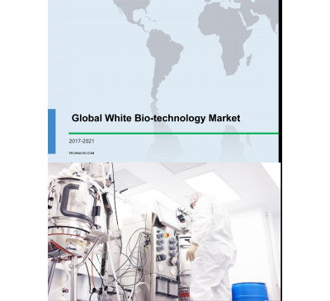

Global White Biotechnology Market 2017-2021
- Aug 2017
- 76 pages
- USD 3500USD 2500
Overview of the global white biotechnology market Research analysis on the global whitebiotechnology market identifies that the increasing adoption
View Report

Global Biotechnology Reagents Market 2014-2018
- Aug 2014
- 99 pages
- USD 2500USD 2000
About Biotechnology Reagents Biotechnology reagents are chemical compounds or substances that are added to a system to detect and examine another substance
View Report

Global Cleanroom Apparel Market 2017-2021
- Aug 2017
- 60 pages
- USD 3500USD 2500
will be one of the primary growth drivers for the global cleanroom apparel market till 2021. Contamination can occur in the pharmaceutical and biotechnology
View Report
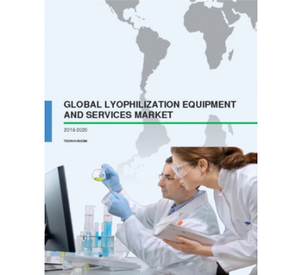

Global Lyophilization Equipment And Services Market 2016-2020
- Jul 2016
- 59 pages
- USD 2500USD 2250
that mandate the adoption of advanced freeze drying equipment among the pharmaceutical andbiotechnology industries will also play a major role in augmenting
View Report

Biorefinery Market 2015-2019
- Oct 2015
- 72 pages
- USD 2500USD 2250
the industrial biotechnology segment to account for more than 49% of the total market share by 2019. Industrial biotechnology, or white biotechnology, involves...
View Report
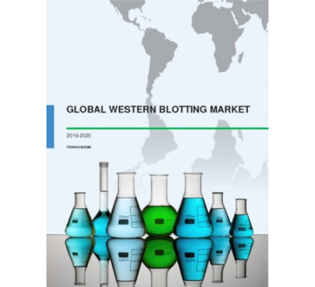

Global Western Blotting Market 2016-2020
- Jun 2016
- 70 pages
- USD 2500USD 2250
In addition, most of the R D centres of pharmaceutical and biotechnology companies located in this region have developed vaccinations to treat for HIV/AIDS....
View Report
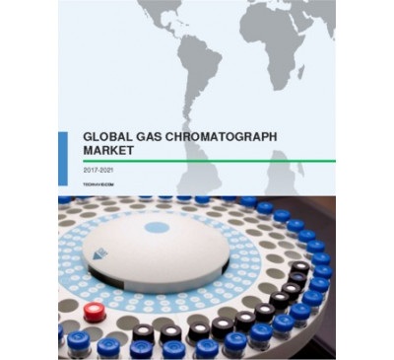

Global Gas Chromatograph Market 2017-2021
- Feb 2017
- 79 pages
- USD 3500USD 2500
During 2016, the life sciences segment that consists of the biotechnology and pharmaceutical sectors accounted for the major shares and dominated this market.
View Report

Global Microbial Growth Media Market 2017-2021
- Jun 2017
- 71 pages
- USD 3500USD 2500
and length of the inflammatory response of the body. The re-engineering of microorganisms to produce proteins and therapeutic agents using advanced biotechnology
View Report
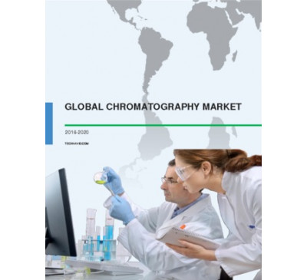

Global Chromatography Market 2016-2020
- Nov 2016
- 81 pages
- USD 2500USD 2375
is attributed to the increasing adoption of highly advanced chromatic techniques by the pharmaceutical and biotechnology industries in these countries. The...
View Report

Global Cell Lysis Market 2017-2021
- Jul 2017
- 81 pages
- USD 3500USD 2500
such as research laboratories, hospitals, and pharmaceutical and biotechnology companies. Key vendors in this market are - Bio-Rad Laboratories Beckman Coulter...
View Report

Global Molecular Spectroscopy Market 2017-2021
- Feb 2017
- 77 pages
- USD 3500USD 2500
and developing countries, there has been a significant increase in focus towards drug discovery and development by pharmaceutical and biotechnology companies and...
View Report
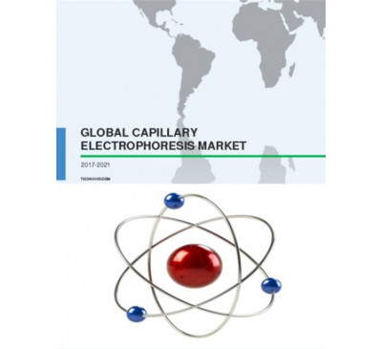

Global Capillary Electrophoresis Market 2017-2021
- Feb 2017
- 85 pages
- USD 3500USD 2500
for the market. The rise of the biotechnology sector is mainly attributed to the innovations in bioinformatics, advancements in the biotechnology, and improved
View Report

Global Protein Crystallization And Crystallography Market 2017-2021
- Aug 2017
- 105 pages
- USD 3500USD 2500
Various pharmaceutical and biotechnology companies are compelled to develop new drugs due to the rising prevalence of diseases. This in turn, will boost the demand
View Report

Global Muconic Acid Market 2015-2019
- Jul 2015
- 68 pages
- USD 2500USD 2000
Cruz Biotechnology • Sigma Aldrich Other Prominent Vendors • Chemeiliva Pharmaceutical • Clearsynth Labs • Leap Labchem • Hangzhou Dayangchem •...
View Report

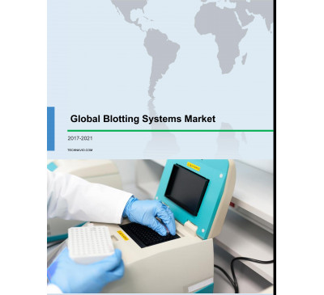

Global Blotting Systems Market 2017-2021
- Jun 2017
- 64 pages
- USD 3500USD 2500
and the capability of imaging fluorescent blots is driving the adoption of digital blotting in laboratories and pharmaceutical and biotechnology companies.
View Report

Global Oxidative Stress Detection Market 2016-2020
- Sep 2016
- 72 pages
- USD 2500USD 2375
are the healthcare industry, pharmaceutical industry, and research institutes. Within the pharmaceutical industry, biopharmaceutical and biotechnology sectors
View Report
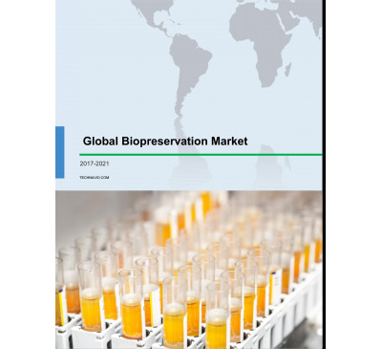

Global Biopreservation Market 2017-2021
- Jul 2017
- 81 pages
- USD 3500USD 2500
As a result, the demand for laboratory equipment such as biopreservation systems is increasing from pharma industries, biotechnology industries, and research
View Report
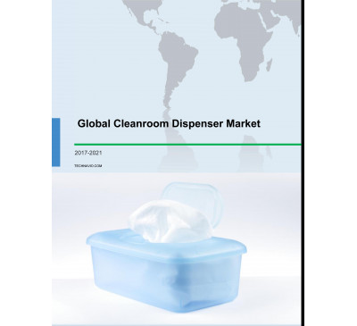

Global Cleanroom Dispenser Market 2017-2021
- Jun 2017
- 70 pages
- USD 3500USD 2500
during the predicted period. Industries such as pharmaceuticals and biotechnology involve costly and complex drug development processes. This drives the need to...
View Report
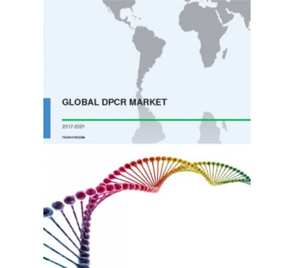

Global DPCR Market 2017-2021
- Mar 2017
- 70 pages
- USD 3500USD 2500
This increase in focus on medical research and drug discovery and development of several diseases is mainly driven by pharmaceutical and biotechnology companies
View Report
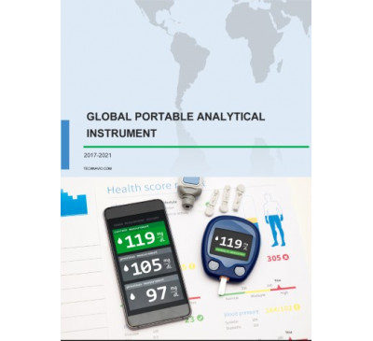

Global Portable Analytical Instrument Market 2017-2021
- May 2017
- 70 pages
- USD 3500USD 2500
market Food and beverage companies Pharmaceutical and biotechnology companies Environmental testing organizations The pharmaceutical and biotechnology...
View Report

Global Refurbished Medical Equipment Market 2015-2019
- Jan 2015
- 90 pages
- USD 2500USD 2000
Biotechnology Instruments, and Radiation Oncology Systems. TechNavio's report, the Global Refurbished Medical Equipment Market 2015-2019, has been prepared...
View Report

Global Modular Cleanroom Market 2017-2021
- Jun 2017
- 79 pages
- USD 3500USD 2500
of the market during the estimated period. The pharmaceutical and biotechnology sectors highly rely on cleanrooms to control the level of contamination arising
View Report

Global Cell Therapy Market 2017-2021
- Sep 2017
- 118 pages
- USD 3500USD 2500
factors for the growth of the cell therapy market. Small and large biotechnology companies are developing progenitor cells, adult and embryonic stem cells,
View Report

Global Nematicides Market 2015-2019
- Jul 2015
- 96 pages
- USD 2500USD 2000
K. Corporation • Ishihara Sangyo Kaisha • Jiangsu Haoyang Biotechnology Market Drivers • Rapid Urbanization Leading to Shortage of Arable Land • For a full,
View Report
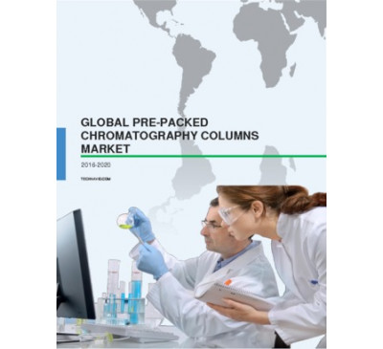

Global Pre-packed Chromatography Columns Market 2016-2020
- Sep 2016
- 59 pages
- USD 2500USD 2375
Pharmaceutical and biotechnology Food and beverages Water and environmental The pharmaceutical and biotechnology segment is the largest end-user in the...
View Report

Global Azoxystrobin Market 2016-2020
- Jun 2016
- 57 pages
- USD 2500USD 2250
Biotechnology Jiangsu KWIN Syngenta Yancheng Limin Chemical Other prominent vendors analyzed in this market research report are CHEMOS, Jinan Glyline Chemical,...
View Report

Global Genome Engineering Market 2016-2020
- Sep 2016
- 69 pages
- USD 2500USD 2375
and genetic diseases. Furthermore, several biotechnology companies will invest in research for new and improved innovations that will change the landscape of rare
View Report

Global Boronate Affinity Chromatography Market 2016-2020
- Sep 2016
- 77 pages
- USD 2500USD 2375
Biotechnology Bio-Rad Laboratories Merck Thermo Fisher Scientific Other prominent players in the market include Becton, Dickinson and Company, Helena...
View Report

Global Biologic Therapeutics Market 2015-2019
- Oct 2015
- 104 pages
- USD 2500USD 2250
Roche Novo Nordisk Sanofi Other prominent vendors AbbVie AstraZeneca Bavarian Nordic Baxter International Beijing Minhai Biotechnology Bharat Biotech Bharat
View Report
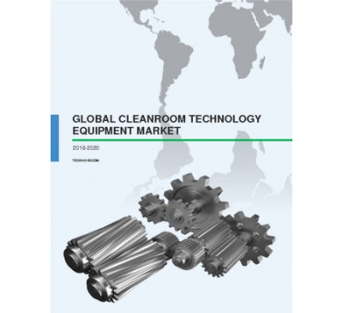

Global Cleanroom Technology Equipment Market 2016-2020
- May 2016
- 63 pages
- USD 2500USD 2250
for sterilized pharmaceutical formulations, is also driving the expansion of the market. The growing demand from the pharmaceutical and biotechnology industries
View Report
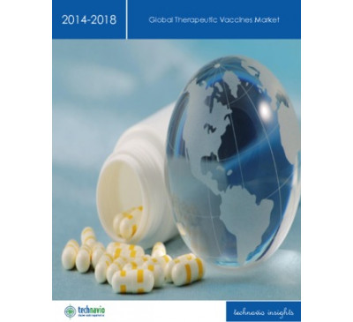

Global Therapeutic Vaccines Market 2014-2018
- Mar 2014
- 54 pages
- USD 2500USD 2000
Celldex Therapeutics Inc. CEL-SCI Corp. Cytos Biotechnology AG GlobeImmune Inc. NewLink Genetics Corp. NovaRx Corp. Oncothyreon Inc. TVAX Biomedical Inc. TapImmune
View Report

Global Digital Pathology Market 2017-2021
- Aug 2017
- 79 pages
- USD 3500USD 2500
Segmentation by end user and analysis of the digital pathology market Hospitals, diagnostics laboratories, and pharmaceutical and biotechnology companies
View Report

Global Chromatography Accessories And Consumables Market 2017-2021
- Aug 2017
- 76 pages
- USD 3500USD 2500
and healthcare industries. The pharmaceutical and biotechnology sectors are witnessing significant growth due to the rising investments. This will result
View Report

Global Protein Crystallization And Crystallography Market 2016-2020
- Dec 2015
- 75 pages
- USD 2500USD 2250
crystallography techniques are primarily used in the pharmaceutical and biotechnology industries to aid in genetic engineering and drug discovery processes.
View Report
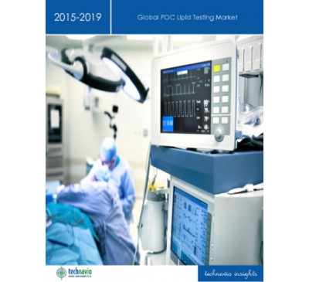

Global POC Lipid Testing Market 2015-2019
- Feb 2015
- 74 pages
- USD 2500USD 2000
General Life Biotechnology • Helena Laboratories • Nova Biomedical • OraSure Technologies • Quidel • Randox Laboratories • Sekisui Diagnostics • Siemens
View Report

Global Chiral Chromatography Column Market 2017-2021
- Apr 2017
- 70 pages
- USD 3500USD 2500
of various countries such as China, India, Singapore, South Korea, and Taiwan in the biotechnologyand pharmaceutical sector will further propel the growth
View Report

Global Hollow Microspheres Market 2017-2021
- Jun 2017
- 80 pages
- USD 3500USD 2500
technology, and biotechnology will contribute to the growth of the hollow microspheres market in this region. Competitive landscape and key vendors The hollow
View Report

Global Cleanroom Cable Market 2017-2021
- May 2017
- 70 pages
- USD 3500USD 2500
such as the pharmaceutical and biotechnology industries, hospitals, and medical devices, will drive the growth prospects of this market segment. Segmentation by...
View Report
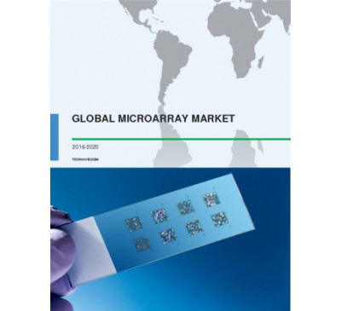

Global Microarray Market 2016-2020
- Nov 2016
- 85 pages
- USD 2500USD 2375
investments made by several biotechnology and pharmaceutical companies to develop targeted therapeutics using microarray technologies , such as tissue, DNA,
View Report

Global Process Analytical Instruments Market 2015-2019
- Aug 2015
- 67 pages
- USD 2500USD 2000
are mostly used across the chemical and petrochemical, oil and gas, and pharmaceutical andbiotechnology industries. Technavio's analysts forecast the global...
View Report

Global ADME-Toxicology Testing Market 2015-2019
- Jun 2015
- 93 pages
- USD 2500USD 2000
Xenobiotic Detection Systems • Xenometrix Market Driver • Demand from Biotechnology and Pharmaceutical Companies • For a full, detailed list, view our report...
View Report
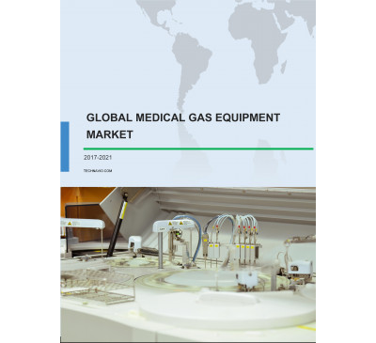

Global Medical Gas Equipment Market 2017-2021
- Jul 2017
- 76 pages
- USD 3500USD 2500
and analysis of the medical gas equipment market Hospitals and clinics Home healthcare Pharmaceutical and biotechnology companies Academic and research...
View Report

Global Chromatography Resins Market 2017-2021
- Aug 2017
- 70 pages
- USD 3500USD 2500
Chemical, and Purolite. Segmentation by application and analysis of the chromatography resins market Pharmaceutical and biotechnology Food and beverages
View Report
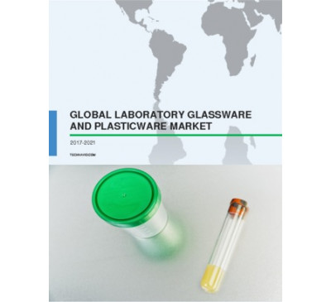

Global Laboratory Glassware And Plasticware Market 2017-2021
- Apr 2017
- 70 pages
- USD 3500USD 2500
industry. The parallel growth in biology and biotechnology industry, including major areas such as vaccine development, stem cell research, and disease research
View Report

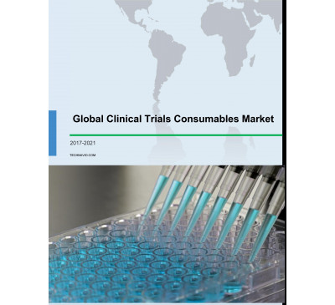

Global Clinical Trials Consumables Market 2017-2021
- Jun 2017
- 70 pages
- USD 3500USD 2500
by end user and analysis of the clinical trials consumables market Pharmaceutical andbiotechnology companies Contract Research Organizations (CROs) Owing
View Report

Global Bio Alcohol Market - Industry Insights And Forecast 2015-2019
- May 2015
- 62 pages
- USD 2500USD 2000
products will be eligible for loan guarantees to build the manufacturing plants. Key Trends of the Bio-alcohol Market: Key advances in biotechnology have enabled
View Report

Global High Content Screening (HCS) Market 2015-2019
- Jul 2015
- 76 pages
- USD 2500USD 2000
prospects of the global HCS market for the period 2015-2019. The market can be segmented into three customer segments: Pharmaceutical and biotechnology companies,
View Report
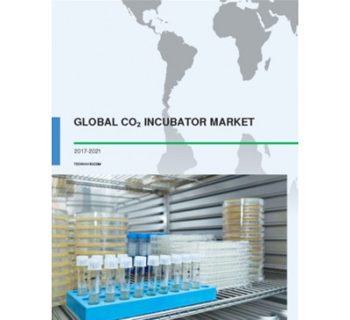

Global CO2 Incubator Market 2017-2021
- Feb 2017
- 81 pages
- USD 3500USD 2500
facilities and institutes in these regions. The US witnessed the investment of more than USD 28 billion towards R D in the field of biotechnology by major...
View Report
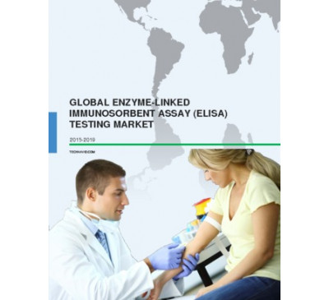

Global Enzyme-Linked Immunosorbent Assay (Elisa) Testing Market 2015-2019
- Aug 2015
- 55 pages
- USD 2500USD 2000
Affinity Biologicals • Affymetrix • Agdia Biofords • ALPCO • AMS Biotechnology • ANIARA • Beckman Coulter • Bhat Bio-tech • Bio-Rad Laboratories •...
View Report
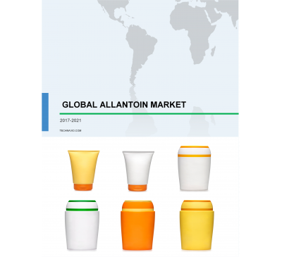

Global Allantoin Market 2017-2021
- Aug 2017
- 79 pages
- USD 3500USD 2500
Suntime Chemical Industry Co., Ltd., Allan Chemical Corporation, Zhanhua Jinyuan LideBiotechnology Co., Ltd., Sunwell Chemical Co., and Yizhang Hongyuan Chemical...
View Report

Global DNA Microarray Market 2016-2020
- Sep 2016
- 75 pages
- USD 2500USD 2375
of technologies such as DNA microarray s for testing and development of new drugs. Additionally, the recent increase in investments by biotechnology
View Report
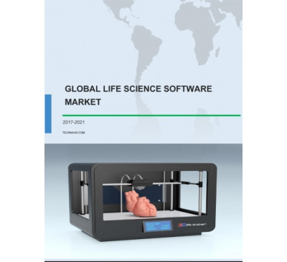

Global Life Science Software Market 2017-2021
- Jun 2017
- 67 pages
- USD 3500USD 2500
such as pharmaceuticals and biotechnology . The US and Canada are the key contributors to the life science software market in the Americas. Some of the major...
View Report
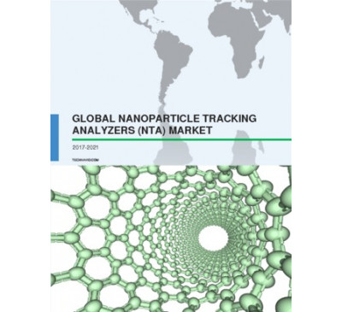

Global Nanoparticle Tracking Analyzer Market 2017-2021
- Mar 2017
- 70 pages
- USD 3500USD 2500
discovery and development. It has been observed that focus on drug discovery and development by pharmaceutical and biotechnology companies has increased over the...
View Report

Global Biologic Therapeutics Market 2014-2018
- Oct 2014
- 185 pages
- USD 2500USD 2000
AstraZeneca • Bavarian Nordic • Baxter International • Beijing Minhai Biotechnology • Bharat Biotech • Bharat Immunologicals and Biologicals • bioCSL •...
View Report
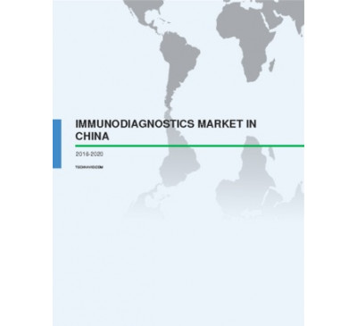

Immunodiagnostics Market In China 2016-2020
- Nov 2015
- 103 pages
- USD 2500USD 2250
Biotechnology Science, DIAsource, DiaSys Diagnostic Systems, Fosun Pharma, Getein Biotechnology, Hitachi, Immunodiagnostic System Holdings, Luminex, NewScen
View Report
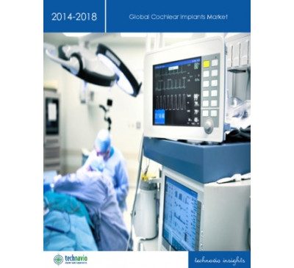

Global Cochlear Implants Market 2014-2018
- Dec 2013
- 48 pages
- USD 2500USD 2000
and Neurelec SA. Another vendor mentioned in the report is Nurotron Biotechnology Co. Ltd. Key questions answered in this report: What will the market size be in...
View Report

Global Genetically Modified Seeds Market 2016-2020
- Aug 2016
- 67 pages
- USD 2500USD 2250
during the forecast period and is likely to occupy around 30% of the total market share by 2020. The growing adoption of biotechnology in agricultural practices
View Report
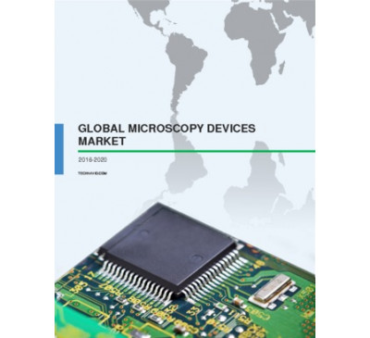

Global Microscopy Device Market 2016-2020
- Apr 2016
- 86 pages
- USD 2500USD 2250
in the future with research institutions and companies looking to innovate and create breakthroughs in various fields. For instance, in 2013, the Biotechnology
View Report

Apiculture Market In China 2015-2019
- Apr 2015
- 66 pages
- USD 2500USD 2000
Industry • Hunan Mingyuan Apiculture • Lanxi HongXiang Biotechnology • Ningxia Natural Honey Product Technology and Development • Zhejiang Jiangshan Hengliang
View Report
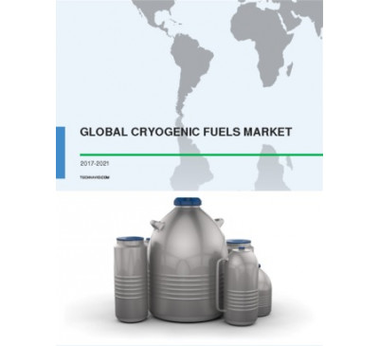

Global Cryogenic Fuels Market 2017-2021
- Apr 2017
- 70 pages
- USD 3500USD 2500
and testing facilities, especially in the field of pharmaceuticals and biotechnology, will propel the demand for cryogenic gases for freezing biotechnology
View Report

Global Travel Vaccines Market 2015-2019
- Mar 2015
- 84 pages
- USD 2500USD 2000
GlaxoSmithKline • Merck Co. • Novartis • Sanofi Other Prominent Vendors • Beijing MinhaiBiotechnology • Bharat Biotech • Bio Med • Crucell • CSL •...
View Report

Global Life Sciences BPO Market 2014-2018
- Nov 2014
- 66 pages
- USD 2500USD 2000
About Life Science BPO BPO has an important role in the Life Science industry. Pharmaceutical companies and biotechnology companies are constantly facing
View Report
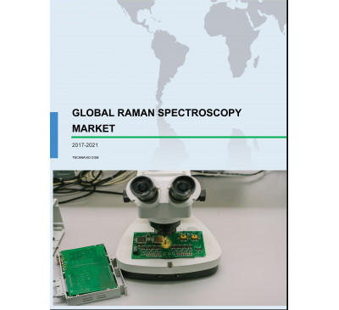

Global Raman Spectroscopy Market 2017-2021
- Aug 2017
- 67 pages
- USD 3500USD 2500
population and rising cases of chronic diseases. The leading end-user segments of life sciences are the biotechnology and biopharmaceutical sector. The demand
View Report

Global Automated Colony Pickers Market 2017-2021
- Aug 2017
- 67 pages
- USD 3500USD 2500
pickers market Research institutes Biotechnology and pharmaceutical industries Hospitals and private labs Academic institutes The research institutes segment
View Report

Global Specialty Enzymes Market 2017-2021
- Jun 2017
- 70 pages
- USD 3500USD 2500
by application and analysis of the specialty enzymes market Pharmaceutical applicationsBiotechnology and R D application During 2016, the pharmaceutical
View Report

Global Adipic Acid Market 2015-2019
- Dec 2014
- 84 pages
- USD 2500USD 2000
Rivneazot Open Joint Stock Company • Santa Cruz Biotechnology • Severodonetsk Azot Association • Shandong Hongye • Shenyang Ruikai Chemicals • ShiJiaZhuang...
View Report

Global Molecular Spectroscopy Market 2014-2018
- Oct 2014
- 84 pages
- USD 2500USD 2000
technological innovations in various areas such as pharmaceutical research, scientific research inbiotechnology and life sciences, and industrial processes
View Report
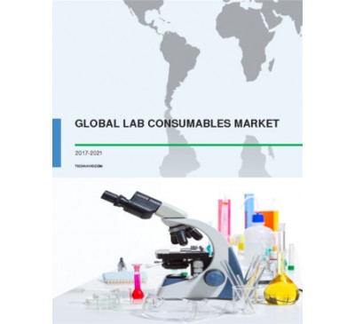

Global Lab Consumables Market 2017-2021
- Apr 2017
- 70 pages
- USD 3500USD 2500
innovations in the fields of medicine, food and health, biotechnology , and industrial segments. Thus, these rapidly growing industries will drive the growth
View Report

Global Industrial Dryers Market 2016-2020
- Jun 2016
- 70 pages
- USD 2500USD 2250
securing a significant place in the pharmaceutical, chemical , and biotechnology industries, thereby, augmenting the growth of the industrial dryers market.
View Report
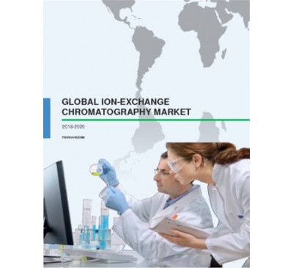

Global Ion-Exchange Chromatography Market 2016-2020
- Sep 2016
- 85 pages
- USD 2500USD 2375
application and study include the pharmaceutical industry for drug discovery and the biotechnologysector for genetic engineering . Moreover, crop yield
View Report
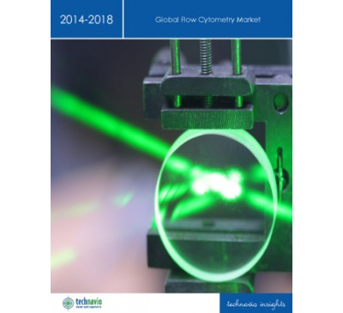

Global Flow Cytometry Market 2014-2018
- Aug 2014
- 91 pages
- USD 2500USD 2000
Sony Biotechnology • Stratedigm • TTP LabTech Market Driver • Advancements in Technology • For a full, detailed list, view our report Market Challenge •...
View Report
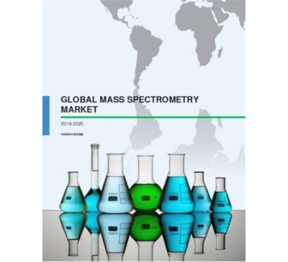

Global Mass Spectrometry Market 2016-2020
- Apr 2016
- 68 pages
- USD 2500USD 2250
to witness rapid fast-paced growth during the predicted period. In the pharmaceutical sector, biopharmaceutical and biotechnology are the primary users of mass
View Report
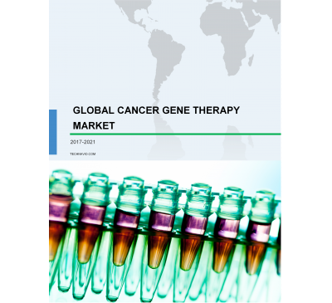

Global Cancer Gene Therapy Market 2017-2021
- Aug 2017
- 85 pages
- USD 3500USD 2500
with the presence of several international and regional players and a large number of start-ups andbiotechnology companies involved in R D activities, the cancer
View Report

Global Clostridium Diagnostics Market 2017-2021
- Jul 2017
- 91 pages
- USD 3500USD 2500
at the hospital. According to the National Center for Biotechnology Information CBI) studies, 80% of the deaths reported in Africa and Southeast Asia
View Report
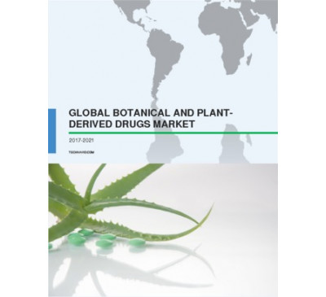

Global Botanical And Plant-Derived Drugs Market 2017-2021
- Apr 2017
- 70 pages
- USD 3500USD 2500
is backed by the Department of Biotechnology and the Ministry of Science and Technology, India. Competitive analysis and key vendors The global botanical
View Report
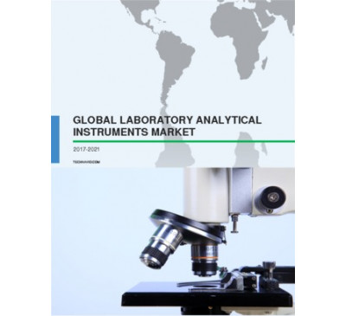

Global Laboratory Analytical Instruments Market 2017-2021
- Mar 2017
- 70 pages
- USD 3500USD 2500
discovery and development using lab instruments among several pharmaceutical andbiotechnology companies. Key questions answered in the report include
View Report

Global Gaucher Disease Market 2015-2019
- Mar 2015
- 88 pages
- USD 2500USD 2000
Other Prominent Vendors • Amicus Therapeutics • Belrose Pharma • Bionaturis • Biosidus • ISU Abxis • JCR Pharmaceuticals • LIXTE Biotechnology •...
View Report
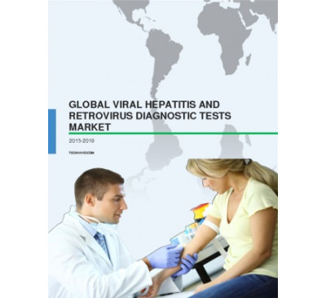

Global Viral Hepatitis And Retrovirus Diagnostic Tests Market 2015-2019
- Oct 2015
- 85 pages
- USD 2500USD 2250
Jaksh Enterprises, Krishco Medical Products, Micro Sidd, Nantong Egens Biotechnology Co, Nexus Lifecare, Ortho-Clinical Diagnostics, Qingdao Hightop Biotech Co,
View Report

Global Industrial Vacuum Pump Market 2016-2020
- May 2016
- 62 pages
- USD 2500USD 2250
of almost 39%. Increased application of dry vacuum pumps in the pharmaceutical andbiotechnology industries will drive the demand for these pumps in the process...
View Report

Global Polyurethane Market 2016-2020
- Sep 2016
- 73 pages
- USD 2500USD 2375
are collaborating with biotechnology companies for developing advanced polymers to decrease the overall production expenses. The expansion and technological
View Report

Global Industrial Heating Ventilation And Air Conditioning Market 2016-2020
- May 2016
- 77 pages
- USD 2500USD 2250
by end user and analysis of the industrial HVAC market Manufacturing Food and beverage Pharmaceutical and biotechnology The manufacturing sector is the largest
View Report
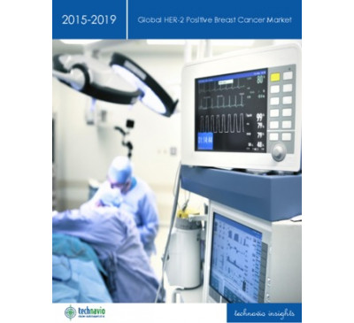

Global HER-2 Positive Breast Cancer Market 2015-2019
- Mar 2015
- 123 pages
- USD 2500USD 2000
DARA BioSciences • EddingPharm • Eisai • Galena Biopharma • Halozyme Therapeutics • Hospira • Mylan • Oncothyreon • Pfizer • ProStrakan • Puma...
View Report

Analytical Instrument Market In The US 2014-2018
- May 2014
- 58 pages
- USD 2500USD 2000
and Biotechnology industries. TechNavio's analysts forecast the Analytical Instrument market in the US will grow at a CAGR of 3.78 percent over the period...
View Report

Global Air Jacketed CO2 Incubator Market 2016-2020
- Aug 2016
- 74 pages
- USD 2500USD 2250
of the market. The increasing number of research and testing facilities in the developing countries, particularly in the field of pharmaceutical and biotechnology
View Report

Global Affinity Chromatography Reagents Market 2014-2018
- Oct 2014
- 71 pages
- USD 2500USD 2000
Market Trend • Expanding Global Biotechnology and Pharmaceutical Industries • For a full, detailed list, view our report Key Questions Answered in this Report •
View Report
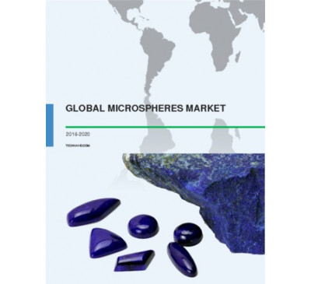

Global Microspheres Market 2016-2020
- Mar 2016
- 92 pages
- USD 2500USD 2250
segmentation and analysis of the microspheres market Medical technology Construction composites Biotechnology and medicine Cosmetics and personal care In this...
View Report
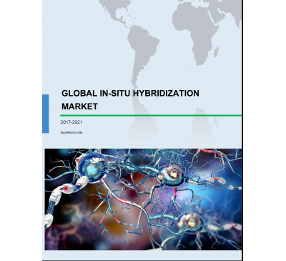

Global In-situ Hybridization (ISH) Market 2017-2021
- Jul 2017
- 85 pages
- USD 3500USD 2500
and analysis of the ISH market Molecular Diagnostic Laboratories Pharmaceutical andbiotechnology companies Molecular diagnostic laboratories
View Report
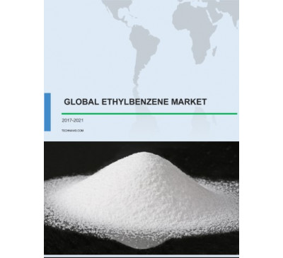

Global Ethylbenzene Market 2017-2021
- May 2017
- 70 pages
- USD 3500USD 2500
on the ethylbenzene market also covers vendors like Tianjin Jixin Industrial Trade Co., Ltd., Qufu Xindi Chemical Research Limited Company, and Zhejiang Weishi...
View Report

Global Process Analyzer Market 2014-2018
- Oct 2014
- 66 pages
- USD 2500USD 2000
These instruments are majorly being used across several end-users such as Chemical and Petrochemical, Oil and Gas, and Pharmaceutical and Biotechnology industries.
View Report
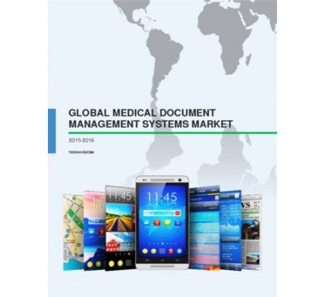

Global Medical Document Management Systems Market 2015-2019
- Dec 2015
- 69 pages
- USD 2500USD 2250
activities in advanced areas of biotechnology such as proteomics and glycomics. However, the Americas region is expected to witness a slow market growth rate
View Report
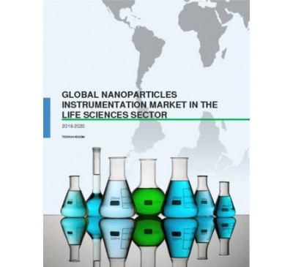

Global Nanoparticles Instrumentation Market In The Life Sciences Sector 2016-2020
- Apr 2016
- 69 pages
- USD 2500USD 2250
of biotechnology start-ups and research facilities within the US will propel this market’s growth in the Americas. Competitive landscape and key vendors The...
View Report
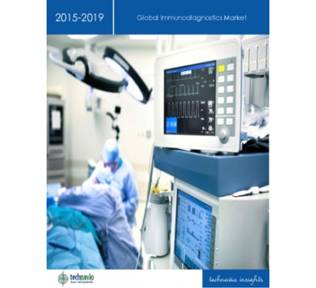

Global Immunodiagnostics Market 2015-2019
- Apr 2015
- 72 pages
- USD 2500USD 2000
Vendors • Affimetrix • Alere • Allele Biotechnology • Axis-Shield • bioMérieux • Diametra • DiaSorin • Enzo Life Sciences • ImmunoDX •...
View Report

Global Proteomics Market 2015-2019
- Apr 2015
- 80 pages
- USD 2500USD 2000
Affymetrix • AMS Biotechnology • Avacta Life Sciences • BD Biosciences • Biocompare • Bio-Rad • Bio-WORLD • Bruker Daltonics • Caprion Proteomics •...
View Report
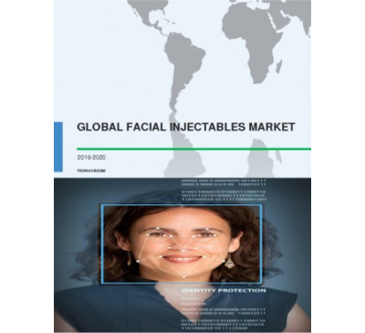

Global Facial Injectables Market 2016-2020
- Oct 2016
- 80 pages
- USD 2500USD 2375
that will have an effect on their product portfolios. The leading vendors in the market are - Allergan Bloomega BioTechnology Galderma Merz Aesthetics
View Report

Global Agricultural Enzymes Market 2017-2021
- Sep 2017
- 93 pages
- USD 3500USD 2500
biotechnology and environment-friendly agricultural practices. Competitive landscape and key vendors The agricultural enzymes market has the presence
View Report
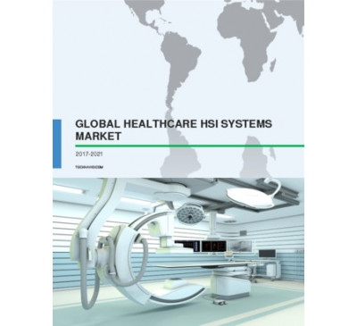

Global Healthcare Hyperspectral Imaging (HSI) Systems Market 2017-2021
- May 2017
- 70 pages
- USD 3500USD 2500
market Hospitals and clinics Pharmaceutical and biotechnology Research laboratories Hospitals and clinics segment dominated the healthcare hyperspectral imaging
View Report

Global Type 1 Diabetes Market 2014-2018
- May 2014
- 63 pages
- USD 2500USD 2000
Inc. Generex Biotechnology Corp. Lexicon Pharmaceuticals Inc. Macrogenics Inc. MannKind Corp. Osiris Therapeutics Inc. Tolerion Inc. XOMA Corp. Key Market Driver
View Report
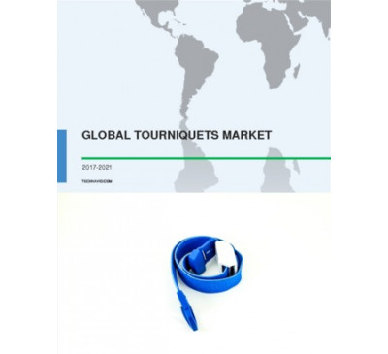

Global Tourniquets Device Market 2017-2021
- Apr 2017
- 70 pages
- USD 3500USD 2500
Gadelius Medical, Hammarplast Medical, Hokanson, IMPROVE MEDICAL Technology, Inmed Equipments, Jiangsu Xingtong Biotechnology Group, Kimetec, Medline, Olberon,...
View Report

Global Hyaluronic Acid (HA) Market 2014-2018
- Oct 2014
- 86 pages
- USD 2500USD 2000
Documedica • Expanscience • F. Hoffmann-La Roche • Galderma • Genzyme • HTL Biotechnology • Hyaltech • Lifecore Biomedical • Lipo Chemicals • Meiji Seika...
View Report

Global Clinical Trial Supply And Logistics Market 2015-2019
- Jul 2015
- 69 pages
- USD 2500USD 2000
Biopharma Medical devices The biopharma industry is witnessing a high demand forbiotechnology products such as vaccines and blood related products.
View Report
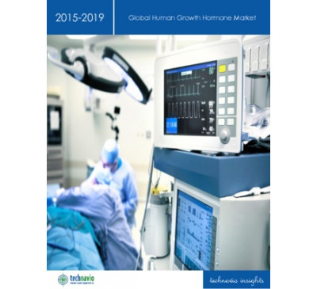

Global Human Growth Hormone Market 2015-2019
- Nov 2014
- 87 pages
- USD 2500USD 2000
• EMEA Key Vendors • F. Hoffmann-La Roche • Merck Serono • Novo Nordisk • Pfizer Other Prominent Vendors • Anhui Anke Biotechnology (Group) • BioPartners...
View Report

Global Huntington's Disease Therapeutics Market 2017-2021
- Aug 2017
- 86 pages
- USD 3500USD 2500
a significant role in the performance of the vendors in this marketspace. The leading vendors in the market are - F. Hoffmann-La Roche H. Lundbeck Prana...
View Report

Global Humanized Mouse Model Market 2017-2021
- Aug 2017
- 82 pages
- USD 3500USD 2500
market Pharmaceutical and biotechnology companies CROs Academic and research institutions The contract research organization (CROs) segment accounted
View Report
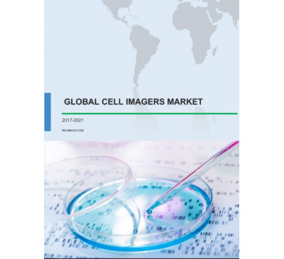

Global Cell Imagers Market 2017-2021
- Jun 2017
- 86 pages
- USD 3500USD 2500
will fuel growth in the pharmaceutical and biotechnology industries. These industries highly adopt cell imagers to carry out research activities in cancer cells.
View Report
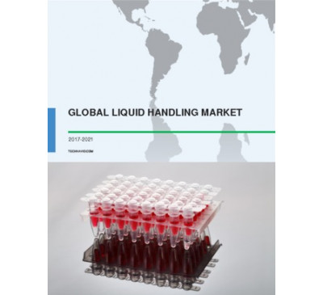

Global Liquid Handling Market 2017-2021
- May 2017
- 70 pages
- USD 3500USD 2500
economies. The developing economies are showcasing a high initial investment in research facilities and institutes, especially in the field of biotechnology
View Report

Global Industrial Chillers Market 2017-2021
- Aug 2017
- 80 pages
- USD 3500USD 2500
and analysis of the industrial chillers market Plastic Food and beverage Chemical and petrochemical Pharmaceutical and biotechnology During 2016, the plastics...
View Report

Global Cellulosic Ethanol Market 2017-2021
- Jun 2017
- 72 pages
- USD 3500USD 2500
such as the biotechnology reagents and biocatalysis and biocatalysts , which are expected to grow at a CAGR of almost 10% and about 6%, respectively, by the year...
View Report
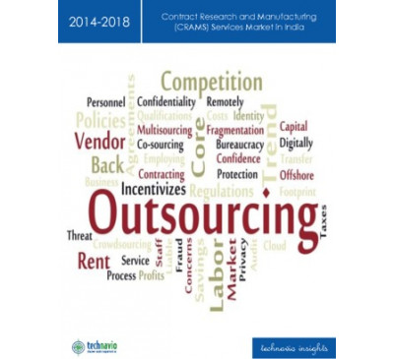

Contract Research And Manufacturing (CRAMS) Service Market In India 2014-2018
- Aug 2014
- 48 pages
- USD 2500USD 2000
is mainly used in the Pharmaceutical and Biotechnology sectors that require extensive R D and large-scale manufacturing facilities. It is expected that the demand...
View Report
JUST PUBLISHED

Global Biological Safety Testing Market 2017-2021
- Sep 2017
- 74 pages
- USD 3500USD 2500
sub segments like health and wellness . The rapid growth in pharmaceutical and biotechnologyindustries is driving the growth of the biological safety testing...
View Report
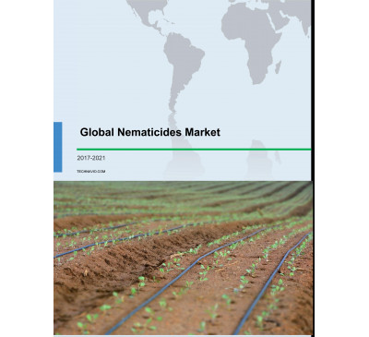

Global Nematicides Market 2017-2021
- Sep 2017
- 76 pages
- USD 3500USD 2500
Valent BioSciences, and Marrone Bio Innovations. The growing popularity of agriculture-relatedbiotechnology solutions such as the application
View Report

Global Gene Expression Market 2017-2021
- Aug 2017
- 86 pages
- USD 3500USD 2500
discovery Diagnostics Pharmaceutical and biotechnology companies are increasingly investing in R D activities for drug development and discovery through gene
View Report
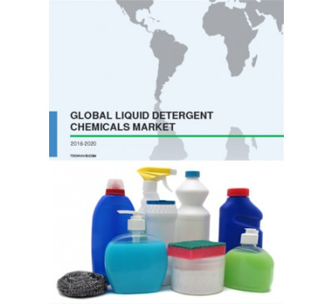

Global Liquid Detergent Chemicals Market 2016-2020
- Aug 2016
- 69 pages
- USD 2500USD 2250
is likely to witness tough competition during the predicted period. Many chemical companies such as BASF and Clariant dominate the market while biotechnology...
View Report
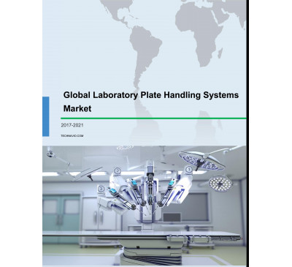

Global Laboratory Plate Handling Systems Market 2017-2021
- Aug 2017
- 68 pages
- USD 3500USD 2500
and PlateCentric Solutions. Segmentation by end-user and analysis of the laboratory plate handling systems market Research institutes Biotechnology
View Report

Global Molecular Cytogenetics Market 2017-2021
- Jul 2017
- 70 pages
- USD 3500USD 2500
Clinical and research laboratories Pharmaceutical and biotechnology companies The application of molecular cytogenetics is increasing in the clinical
View Report
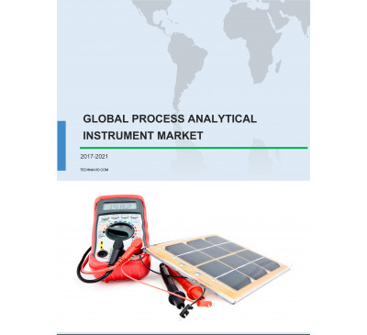

Global Process Analytical Instrument Market 2017-2021
- Jul 2017
- 88 pages
- USD 3500USD 2500
market Chromatographs Spectrophotometers Liquid analyzers Gas analyzers The growing number of pharmaceutical and biotechnology industries, the rising population,
View Report
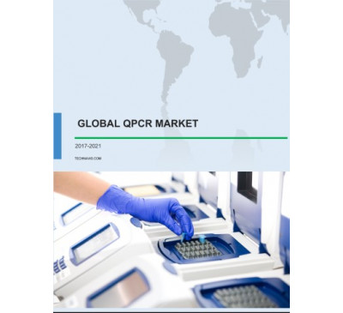

Global QPCR Market 2017-2021
- Jun 2017
- 61 pages
- USD 3500USD 2500
of contract research organization (CROs) by drug manufacturing and biotechnology companies helps vendors to reduce their expenditure on research and developmental
View Report

Global Microplate Readers Market 2017-2021
- Jun 2017
- 70 pages
- USD 3500USD 2500
of the microplate readers market Hospitals and diagnostic centers Academic and research institutions Pharmaceutical and biotechnology companies According to this...
View Report

Global Transcriptomics Market 2016-2020
- Sep 2016
- 78 pages
- USD 2500USD 2375
and continuous improvements in healthcare infrastructures are encouraging drug discovery and research. Several biotechnology companies, such as F. Hoffmann-La
View Report
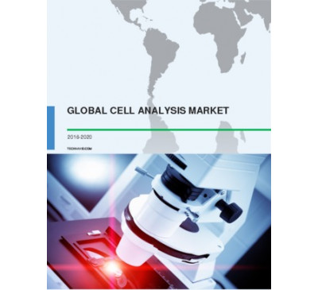

Global Cell Analysis Market 2016-2020
- Sep 2016
- 76 pages
- USD 2500USD 2375
patients. Due to the focus on reducing their manufacturing and distribution costs, several pharmaceutical and biotechnology companies have started outsourcing
View Report
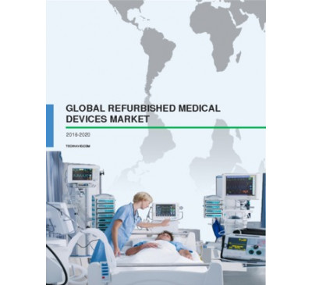

Global Refurbished Medical Devices Market 2016-2020
- Sep 2016
- 65 pages
- USD 2500USD 2375
by product and analysis of the refurbished medical devices market Refurbished radiation oncology systems Refurbished biotechnology instruments Refurbished...
View Report

IVD Market In China 2015-2019
- Jun 2015
- 88 pages
- USD 2500USD 2000
Johnson • Luminex • Nantong Egens Biotechnology Company • Nantong Voyage International Trade • PerkinElmer • Qiagen • Quicking Biotech • Quest...
View Report

Global Biosimulation Market 2014-2018
- Nov 2013
- 62 pages
- USD 2500USD 2000
InhibOx Ltd., INOSIM Software GmbH, In Silico Biosciences Inc., Insilico Biotechnology AG, LeadInvent Technologies Pvt. Ltd., Leadscope Inc., Molecular Knowledge
View Report

Global Endocrine Testing Market 2015-2019
- Jun 2015
- 101 pages
- USD 2500USD 2000
Diagnostics • Siemens Healthcare • Thermo Fisher Scientific Other Prominent Vendor • AdnaGen • Alere • Allele Biotechnology • Axis-Shield • Beckman...
View Report

Global QPCR And DPCR Market 2015-2019
- Jan 2015
- 115 pages
- USD 2500USD 2000
Diagnostics • Biotools B M Labs • Central Biotechnology Services • Cepheid • Eppendorf • Eurogentec (a part of Kaneka Corporation) • Exiqon • Fast-track...
View Report

Global Bio-based Polyurethane Market 2016-2020
- Apr 2016
- 65 pages
- USD 2500USD 2250
and raw material costs. However, several vendors in the market are collaborating withbiotechnology companies for developing advanced biopolymers to decrease
View Report

Global Meningococcal Vaccines Market 2014-2018
- Aug 2014
- 78 pages
- USD 2500USD 2000
Sanofi Pasteur Other Prominent Vendors • Beijing Minhai Biotechnology • Bio Med • Hualan Biological Engineering • Imunoloski Zavod • JN International Medical...
View Report

Global Cell And Tissue Analysis Products Market 2014-2018
- Nov 2014
- 81 pages
- USD 2500USD 2000
Illumina • LC Sciences • Luminex • Miltenyi Biotec • Mindray • Partec • PerkinElmer • Sigma-Aldrich • SonyBiotechnology • SouthernBiotech • Stem Cell...
View Report
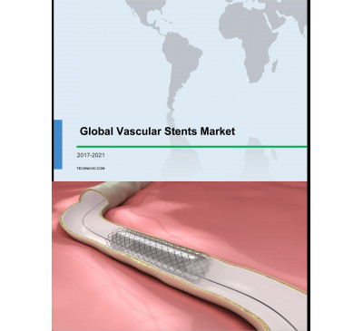

Global Vascular Stents Market 2017-2021
- Sep 2017
- 83 pages
- USD 3500USD 2500
in the hospitals have increased exponentially in the past two decades according to the National Center for Biotechnology Information CBI). Key questions answered
View Report

Global Green Chemicals Market 2014-2018
- Nov 2014
- 131 pages
- USD 2500USD 2000
Industrial Biotechnology • Dow • Drystills • DSM • DuPont Industrial Biosciences (Genencor) • Dyadic • Ecosynthetix • EdeniQ • Elevance Renewable Sciences...

13
May 2016

Bio-based Chemicals - High-Tech Materials TOE
Region : Global
Sustainability initiatives across the world have resulted in the steady adoption of bio-based chemicals and intermediates for use across different industries. These chemicals help in reducing oil dependence while promoting green initiatives. While biopolymers are well established across many geographies, growth of the bio-based chemical industry as...
USD 250
READ MORE
04
Aug 2017

Material Advances Facilitating a Bio-based Economy
Region : Global
The issue of High Tech Materials TOE is focused on material advances facilitating a bio-based economy, and research advances in hydrogen sulfide removal. It also profiles research initiatives that can result in the manufacture of biofuel from fermentation waste, a biodiesel additive, and a process to manufacture bio-based aliphatic polycarbonates. ...
USD 250
READ MORE
16
Jun 2017

Innovations in Biopackaging, Fragrances, Bio-based Materials, and Protein Production
Region : Global
This edition of the Industrial Bioprocessing TOE features trends and innovations in biopackaging and bio-based recyclable materials. The TOE also focuses on various technological innovations in natural fragrance extraction and sustainable protein production. The Industrial Bioprocessing TechVision Opportunity Engine (TOE) provides intelligence on ...
USD 250
READ MORE
07
Jul 2017

Innovations in Plastic Recycling, Textile Industries, Bio-based Materials and Chemicals
Region : Global
This edition of the Industrial Bioprocessing TOE features trends and innovations in plastic recycling, textile industries, bio-based materials and chemicals. The TOE also focuses on various technological innovations in bio-based viscose fibers, polymers, and acids aimed to replace petroleum-based materials and chemicals. The Industrial Bioprocessi...
USD 250
READ MORE
17
Jun 2016

Innovations in Bio-based Sunscreens - Industrial Bioprocessing TOE
Region : Global
This Industrial Bioprocessing TOE features innovations in bio-based sunscreens, which are composed of natural ingredients. The trend toward bio-based sunscreens is driven by higher awareness and incidences of skin cancer and the need to prevent the effects of chemicals-based sunscreens. The innovations featured in this TOE edition are sunscreens ma...
USD 250
READ MORE
16
Oct 2015

Advanced Coatings & Surface Technology Alert - Bio-based Adhesives for Healthcare Applications
Combination of environmental and performance benefits drive its adoption
Region : Global
This edition of the Bio-based Advanced Coatings & Surface Technology Alert profiles bio-based adhesives for healthcare applications.
USD 250
READ MORE
17
Mar 2014

Analysis of the Global Industrial Greases Market and Opportunities for Bio-based Materials
Strategic Opportunities Available for Bio-Greases Suppliers
Region : North America
This research service analyses the global industrial greases market as well as the opportunities for bio-based materials that can be used in industrial greases production. Moreover, it analyses the global situation, developments, trends and future opportunities for industrial greases. The market for industrial greases, especially synthetic and semi...
USD 6,950
USD 6,255
READ MORE
30
Sep 2015

Bio-based Solvents - 6 Dimensional Analysis (TechVision)
Evaluating Bio-Solvents through a 6-Dimensional Approach
Region : Global
Bio based solvents, an emerging grade of fluids is considered as a key technology to facilitate a greener manufacturing across industries. Developments in processes using bio based feed-stocks has resulted in solvents which can compete with traditional solvents in terms of performance with significant value adds such as zero toxicity, biodegradabi...
USD 4,950
READ MORE
11
Dec 2015

Plastics Advisor TechVision Opportunity Engine--Recent Advances in Bio-Based Plastics
Region : Global
This issue profiles recent advances in bio-based plastics.
USD 950
READ MORE
15
May 2015

Industrial Bioprocessing Alert. Common Fungi Convert Biomass into Aviation Fuel; Phytoremediation and Bio-Augmentation for Removal of Polychlorinated Biphenyl from Soil
Region : Global
This issue profiles common fungi that convert biomass into aviation fuel, phytoremediation and bio-augmentation for removal of polychlorinated biphenyl from soil, and genetic modification in maize crops for boosting nitrogen uptake efficiency.
USD 250
READ MORE
27
Dec 2011

A Bio-based Future for the Chemicals and Materials Market
Global Analysis of Opportunities for the Chemicals and Materials Industry
Region : Global
The concept of competition between natural and synthetic chemicals has a long history. Today, crude oil forms the largest feedstock material for the chemical industry in terms of volume. Currently, an enormous amount of work is being done by the chemical industry to develop both new bio-based chemicals and new bio-based routes to existing chemicals...
USD 6,950
USD 4,865
READ MORE
02
May 2014

Industrial Bioprocessing Alert. Converting Carbon Dioxide into Chemicals Using Light; Bioremediation of Radioactive Waste Using Green Algae; Modified
Region : Global
This issue profiles converting carbon dioxide into chemicals using light, bioremediation of radioactive waste using green algae, and modified pyrolysis processes that promise better bio-oil production.
USD 1,500
USD 1,350
READ MORE
23
Sep 2010

South African Market for Bio-renewable Chemicals
Region : Africa
This research service provides in-depth analyses on the South African market for bio-renewable chemicals. It also quantifies and forecasts the total bio-renewable chemicals industry in the country and the contribution from the various market segments. The research service also quantifies and forecasts the revenue contribution of each market segment...
USD 6,950
USD 4,865
READ MORE
09
May 2016

Emerging Applications of Nanocellulose Technology
Sustainable, Bio-based Nanomaterials, Nanofibrillated Cellulose (NFC), Nanocrystalline Cellulose (NCC) and Bacterial Nanocellulose (BNC) to Expand Application Base
Region : Global
The nanocellulose market has the potential to span many different industries that can be categorized as high volume and low volume applications. In order to be successful in nanocellulose business there must be a consistent supply of material that can be delivered in a cost-effective manner for the target application. Manufactures worldwide are a...
USD 4,950
READ MORE
24
Jan 2014

Strategic Analysis of the Global Lubricant Market and the Impact of Bio-based Feedstock
North America and Europe Push Premium, Sustainable Lubricants over Volume
Region : Global
This research service identifies the major industry drivers, restraints, regional trends, and technology segment trends in the global lubricants market. The research covers four regions: North America, Europe, Asia-Pacific, and Rest of the World (ROW). The study provides in-depth analysis of automotive, industrial, marine, and aviation segments wit...
USD 4,950
USD 4,455
READ MORE
18
Jun 2012

Analysis of the North American Medical Adhesives and Sealants Market
Bio-based Sealants for Internal Applications have Better Market-growth Opportunities
Region : North America
This research service tracks the key trends in the North American medical adhesives and sealants market while quantifying revenue for most of the markets segments. It also forecasts revenue at the total market level from 2012 to 2018. The objective is to provide a comprehensive analysis of medical adhesives and sealants used in internal, external,...
USD 4,950
USD 3,713
READ MORE
30
Apr 2009

Strategic Analysis of Second Generation Bio-feedstock
Region : Global
This research presents the strategic analysis of second-generation bio-feedstock by Frost & Sullivan covering four product type market segments. Market drivers, restraints and challenges as well as market metrics are discussed briefly offering a snapshot of the total market of second generation bio-feedstock and biofuel.
USD 6,950
USD 4,865
READ MORE
22
Dec 2009

Global Bio-based Plastics Market
Region : Global
This research service analyses the key trends, market drivers, challenges and future forecasts for the global bio-based plastics market. It discusses in detail the trends in both the conventional bio-based plastics such as PHA, PLA and starch based plastics as well as the immense growth in newer product types such as bio-based commodity plastics an...
USD 6,950
USD 4,865
READ MORE

Chemical Consulting: Commercial Renewables
you surmount your greatest challenges, such as the following:Economic and Industry AnalysisWhat is the long-term outlook for producing...
Trade Data
Technical research
Supply/Demand Data
Supply chain
Scenario planning & analysis
Production & Capacity
Product change management
Procurement
SRIC Report - Report 31C - Advances in Adiponitrile (ADN) and Hexamethylenediamine (HMDA) Processes
current technology for producing adipontirle and hexamethylenediamine used by Invista and Ascend, as well as the bio-based...

06
May 2011

White Biotechnology
Region : Global
The white biotechnology market research service analyzes the food and feed industry, pharmaceutical industry, biofuel industry, bioplastics industry, and personal care industry. The current scenario in the enzyme industry has also been discussed. The important factors which drive, restrain, and impose challenges have been assessed. Detailed revenue...
USD 4,950
USD 3,465
READ MORE
21
Jul 2017

Advances in Biopharmaceuticals and Biotechnology
Region : Global
This edition of the Genetic Technology TOE depicts trends across biopharmaceuticals and biotechnology. Diverse innovations in biologics production, drug development, and diagnostics are illustrated. The corresponding clinical validation scenario focused on urinary incontinence is depicted along with industry interactions. The Genetic Technology Te...
USD 250
READ MORE
28
Feb 2002

U.S. Biotechnology Instrumentation Markets

Region : North America
The U.S. Biotechnology Instrumentation Markets report covers the general research, nucleic acid research, laboratory automation, and detection systems segments over a ten-year period. Instrumentation covered in the report include HPLC, mass spectrometers, thermal cyclers, real-time thermal cyclers, DNA synthesizers, liquid handlers, and microplate...
USD 3,950
USD 2,765
READ MORE
13
Nov 2003

U.S. Agriculture Biotechnology Markets

Region : North America
The U.S. Agriculture Biotechnology markets report provides revenue forecasts, demand, competitive analysis, market trends, and product analysis. The market is segmented into genetically modified crop traits markets, which comprise major crops such as corn, soybeans, and cotton and the plant-based pharmaceutical products market. The technology and t...
USD 3,950
USD 2,765
READ MORE
22
Jan 2004

U.S. Biotechnology Pipeline Analysis

Region : North America
The U.S. Biotechnology pipeline analysis report provides revenue forecasts, demand, competitive analysis, market trends, and product analysis. The market is segmented into monoclonal antibodies, gene therapy, cancer vaccines, cellular therapy, and cytokines. The technology and the details of the pipeline are extensively covered.
USD 3,950
USD 2,765
READ MORE
10
Jun 2005

Competitive Benchmarking of Taiwan Biotechnology Industry

Region : Asia Pacific
This is an indepth study benchmarking the taiwan biotechnology industry with the global developing and developed countries.It also features the value chain analysis of key verticals defining the Tawian biotech and related sectors.
USD 2,450
USD 1,715
READ MORE
16
Aug 1999

World Agriculture Genomics and Biotechnology Markets
Region : Global
USD 3,950
USD 2,765
READ MORE
26
Sep 2007

Advances in Food Biotechnology (Technical Insights)
Region : Global
This research service profiles the major developments in food biotechnology across the globe.
USD 4,950
USD 3,465
READ MORE
01
Jul 2016

Innovations for Biotechnology Market - Nanotech TOE
Region : Global
Nanotechnology impacts various areas of the biotechnology industry. The biggest interest can be observed in drug delivery or effective treatment protocols and therapies. While nanoparticles are often used in drug and therapies research, nanofibers are mostly dedicated to improve biocompability and mechanical properties such as hardness, scratch res...
USD 250
READ MORE
24
Mar 2004

Biotechnology Industry Impact Service (Technical Insights)
Region : Global
A detailed report on research and development in the field of biotechnology.
USD 3,950
USD 2,765
READ MORE
09
Jun 2017

Recent Developments across Biotechnology Sector
Region : Global
This edition of the Genetic Technology TOE depicts trends across biotechnology. Opiod addiction tests that have been approved, companies developing companion diagnostics kits, novel genetic tests, and potential drug-based treatments are illustrated through the most recent innovations. The corresponding clinical trial scenario for CAR T Cell is depi...
USD 250
READ MORE
29
Dec 2015

Collaboration between Medical Devices, Pharmaceuticals, and Biotechnology
Strategic Partnerships that are Transforming the Healthcare Industry
Region : Global
In an increasingly convergent industry such as healthcare, business collaborations are not only a necessity, but an inevitability. It is interesting to note that technologies and market segments that receive the most funding and research focus, are also the areas that are ripe for collaborative partnerships. Market segments such as personalized med...
USD 4,950
READ MORE
12
Mar 2015

Biotechnology Mega Trends in the Water and Wastewater Industry
Sustainability and Versatility of Modern Biotechnology Creates Minimal Waste and Emissions
Region : Global
Biotechnology has immense scope for application in the water and wastewater industry. This report analyses the role of efficiently employed white biotechnology in water and wastewater treatment (for potable, domestic, and discharge purposes) in municipalities, industries, and residential sectors. It also discusses possible biotechnological improvem...
USD 2,450
READ MORE
22
Feb 2013

Financial Assessment of the Global Pharmaceutical and Biotechnology Industry
Financial Management is the Key Strategy for Sustainability
Region : Global
This research service presents an overview and analysis of the global clinical trials and research outsourcing (CRO) market. It provides revenue forecasts for CROs globally by phase, therapeutic type, and region. It addresses the major issues and challenges, unmet needs, and emerging trends in the market. Detailed information has been provided on s...
USD 4,950
USD 4,208
READ MORE
29
Apr 2016

Convergence of Biotechnology with the Global Water and Wastewater Industry, Forecast to 2020
Cost-efficient, Environment-friendly, Maintenance-free Wastewater Treatment Abilities to Widen Adoption of Biotechnology
Region : North America
The newest breakthrough innovation for the water and wastewater industry is the convergence of biotechnology with wastewater management. Biotechnology is the incorporation of living organisms to develop or modify products by applying scientific and engineering principles with the aid of biological agents. Anaerobic digestion, one of the processes i...
USD 1,500
READ MORE
13
May 2008

U.S. Biotechnology - Therapeutic Monoclonal Antibodies Market

Region : North America
This research service covers the U.S. biotechnology: therapeutic monoclonal antibodies market from 2004-2014. Included are a disease overviews, technology trends, total market revenue forecasts, market segment revenue forecasts, and market share analysis. The market is segmented by product usage: oncology, autoimmune and inflammatory disorders, or...
USD 4,950
USD 3,465
READ MORE
27
Aug 1999

Advances in Biotechnology for the Manufacture of Commodity and Specialty Chemicals (Technical Insights)
Region : Global
USD 3,950
USD 2,765
READ MORE
31
Dec 2003

Advances in Biotechnology for Chemical Manufacture - Part 2 (Technical Insights)
Region : Global
This research service provides commentary and analysis of the market for biotechnology developments in the manufacture of chemicals
USD 3,950
USD 2,765
READ MORE
20
Jun 2003

Advances in Biotechnology for the Manufacture of Chemicals: Part 1 (Technical Insights)
Region : Global
This research service analyzes advances in bioremediation, enzymes, acids, genetic engineering, and fermentation, among other sectors, that are impacting the manufacture of chemicals
USD 3,950
USD 2,765
READ MORE
21
Aug 2009

Contract Sales and Marketing Changing Dynamics in Pharmaceuticals and Biotechnology

Region : North America
This market insight on contract sales and marketing organisations throws light on the changing dynamics and the opportunities that lie ahead for these organisations in the future.
USD 1,500
USD 1,050
READ MORE
12
Jan 2005

Opportunities for European Pharmaceutical and Biotechnology Companies in Indian and Chinese Markets

Region : Europe
This strategic analysis service provides detailed analysis of opportunities for European pharmaceutical and biotechnology companies in India and China. The service is in PowerPoint format.
USD 4,950
USD 3,465
READ MORE
18
Dec 2007

Contract Research Organization Market- What Pharmaceutical and Biotechnology Companies Want

Region : Asia Pacific
This research service examines the contract research organization market highlighting on what pharmaceutical and biotechnology companies want. The research service highlights services what pharmaceutical and biotech companies want from the contract research organizations (CROs) and the criteria they use in selecting CROs. The countries covered in t...
USD 17,000
USD 11,900
READ MORE
16
Nov 2005

Benchmarking Biotechnology Companies in Australia and New Zealand

Region : Asia Pacific
This Research Service gives an extensive coverage of the Australian and New Zealand Biotechnology Industries. The study has be classified based on five key value drivers of the industry namely the Environmental Factors, Research and Development, Branding, Partnerships and Distribution. Every value driver has been disucced at length with statistical...
USD 3,950
USD 2,765
READ MORE
03
Sep 2002

U.S. Biotechnology Industry Overview & Growth Strategy Framework

Region : North America
This study describes and analyzes the biotechnology industry, focusing on biotechnology therapeutics. The study includes a discussion of drivers, restrains, technologies, research and development, manufacturing, regulatory issues, products, partnerships and capital markets. This study also presents a startegy framework that identifies key compete...
USD 2,450
USD 1,715
READ MORE
16
Dec 2004

Strategic Analysis of the Opportunities for the Pharmaceutical and Biotechnology Industry in the 'New' EU Countries

Region : Europe
This strategic analysis service looks into the market entry issues in the 'new' European Union (EU) countries. The service in powerpoint format (approximately 90 slides) focuses not just on the challenges for pharmaceutical and biotechnology companies wishing to enter the 'new' EU countries but also identifies opportunities within the 'new' EU for ...
USD 3,950
USD 2,765
READ MORE
09
Jan 2014

Merger and Acquisition (M&A) Trends in the Global Pharmaceutical and Biotechnology Industry
Increasing Volume and Decreasing Value
Region : Global
This study investigates the global stem cell market for the period 2013 to 2018. The geographic regions covered in the study are the North America, Europe and APAC, followed by a detailed Asia Pacific Region Analysis, which covers countries such as India, Australia, Thailand, Singapore, South Korea, Malaysia and Japan. The stem cell market is cover...
USD 4,950
USD 4,455
READ MORE
12
Feb 2014

Private Equity and Venture Capital Investment in the Global Pharmaceutical and Biotechnology Industry
Vigilance and Equanimity are the Needs of the Hour
Region : Asia Pacific
The global oncology drug delivery market (or oncolytics market) was worth $91.00 billion in 2013 and has been growing at an annual rate of 5.0%. The market, which includes drug delivery systems for cancer therapy and cancer pain, is expected to generate $100.96 billion in 2015. The oral drug delivery systems segment accounted for an estimated 25.0%...
USD 4,950
USD 4,455
READ MORE
26
Jun 2003

Asia Pacific Biotechnology Markets: A Strategic Analysis of Equity Funding

Region : Asia Pacific

USD 1,500
USD 1,050
READ MORE
31
Mar 2006

Biotechnology Up-Stream and Down-Stream Processing Technology Analysis (Technical Insights)

Region : Global
This research service analyzes emerging technologies in bioprocessing technologies.
USD 4,950
USD 3,465
READ MORE
29
Jul 2009

CEO 360 Degree Perspective - Global Pharmaceuticals & Biotechnology Industry

Region : Global
This research service presents the CEO 360 Degree Perspective for the global pharmaceuticals and biotechnology industry in 2009. It is an amalgamation of research from more than 50 Pharmaceutical research services generated by Frost & Sullivan, customer research findings based on approximately 1,000 end-user interviews approximately 50,000 hours of...
USD 4,950
USD 3,465
READ MORE
15
Jun 2005

Cost Benefit Analysis of Research and Development of Top 10 Biotechnology Companies

Region : North America
The research service profiles the top 10 biotechnology companies and incorporates a unique risk-return model to analyze the research and development pipeline of these companies. Cost-Benefit analysis for these companies and the industry has also been undertaken in this research service.
USD 2,450
USD 1,715
READ MORE
18
May 2009

Vital Signs - Pharmaceutical & Biotechnology Outsourcing - Growth Opportunities, Trends & Strategies

Region : North America
This issue of Vital Signs, released on May 18, 2009, provides a strategic overview of opportunities and issues in the pharmaceutical and biotechnology outsourcing services markets. Additionally, a company spotlight is provided for Aerie Pharmaceuticals, an emerging pharma company focused on glaucoma. Reimbursement and regulatory news from the FDA i...
USD 1,500
USD 1,050
READ MORE
20
Mar 2015

Environment and Building Technology Alert. Sunlight Reflectors for Buildings to Reduce Cooling Load; Biotechnology Enables Producing High-Value Biopla
Region : Global
This issue profiles sunlight reflectors for buildings to reduce cooling load, biotechnology that enables production of high-value bioplastic from waste oil, a reactor that uses fuel from depleted uranium for power generation.
USD 1,500
READ MORE
30
Dec 2008

Strategic Analysis of Global Scientific Business Intelligence (Sci-BI) in Pharmaceutical and Biotechnology Markets

Region : North America
This strategic analysis identifies the current trends in scientific business intelligence (Sci-BI) in pharmaceutical and biotechnology markets. Major global healthcare trends are analyzed and the impacts on Sci-BI are delineated. A close look at drivers and restraints in the Sci-BI space revealed interesting growth stimulators while also identifyin...
USD 4,950
USD 3,465
READ MORE
07
Apr 2003

Asia Pacific Biotechnology Markets: Business Terrain Map; Future Outlook and Relative Competitive Position

Region : Asia Pacific

USD 3,950
USD 2,765
READ MORE
30
Jul 1999

European Biotechnology-Based In Vitro Diagnostics Markets

Region : Europe

USD 3,950
USD 2,765
READ MORE
31
Jul 2015

Genetic Technology Alert. Developing Therapeutics Using Genome Editing Technology; Usage of CRISPR/Cas9 can Affect Agriculture and Industrial Biotechnology Industries; Rapid Adoption and Expansion of Genome Editing across Therapeutic Developments
Region : Global
This issue profiles developing therapeutics using genome editing technology, impact of usage of CRISPR/Cas9 on agriculture and industrial biotechnology industries, rapid adoption and expansion of genome editing across therapeutic developments.
USD 250
READ MORE
31
Dec 2008

Biotech for Toxics Use Reduction (Technical Insights)

Region : Global
This research service profiles technologies and trends related to the use of biotechnology for toxic waste reduction.
USD 4,950
USD 3,465
READ MORE
20
Jun 2007

Global CRO Spending Trends

Region : Global
This research service provides revenue forecasts for CROs globally, by phase and market type, R&D spending trends of pharmaceutical and biotechnology companies and pipeline drugs and clinical trial trends by phase and region.
USD 4,950
USD 3,465
READ MORE
03
Feb 2010

Dynamics in the Pharma and Biotech Industry

Region : Global
This briefing from the beginning of 2010 is on macro level dynamics in the global pharmaceutical and biotechnology industry. It is being made available for the value of our subscribers.
USD 1,500
USD 1,050
READ MORE
15
Feb 2005

Strategic Analysis of the European Minimally Invasive Surgical Devices Market

Region : Europe
This strategic analysis service provides detailed analysis of opportunities for European pharmaceutical and biotechnology companies in India and China. The service is in PowerPoint format.
USD 4,950
USD 3,465
READ MORE
28
Oct 2013

Competing in the Global Contract Manufacturing Market
What Pharmaceutical and Biotechnology Companies Want and How to Compete for their Business
Region : Global
The overall objective of this study was to provide contract manufacturing organizations (CMOs) a sound basis for formulating an effective strategy to compete in the market, including areas of opportunities and threats. As far as the market dynamics and CMO selection are concerned, overall satisfaction and likelihood of contract renewal are in the 4...
USD 10,000
USD 8,500
READ MORE
30
Dec 2016

3D Printing for Healthcare Applications
Technology that could revolutionize pharmaceutical and biotechnology manufacturing
Region : Global
3D printing (3DP) will have a strong commercial impact across major consumer segments of the global healthcare sectors, an industry that necessitates efficient production of primarily complex or personalized products. The opportunity to customize drugs, active pharmaceutical ingredients (APIs) and medical devices drives an era of personalized medic...
USD 4,950
READ MORE
27
Mar 2015

Industrial Bioprocessing Alert. Genetic Alteration of Natural Chloroplasts to Produce Valuable Biotechnological Products; Sugar-Based Biosurfactant Becomes Market Ready; Optimized Cocoa Fermentation Process for Improved Chocolate Taste
Region : Global
This issue profiles genetic alteration of natural chloroplasts to produce valuable biotechnological products, a sugar-based biosurfactant that becomes market ready, and an optimized cocoa fermentation process for improved chocolate taste.
USD 250
READ MORE
04
Nov 2004

U.S. Industrial Biotech Markets
Region : North America
This report gives an overview about the various biotechnology enabled applications in various chemical industrial segments.
USD 3,950
USD 2,765
READ MORE
06
May 2005

World Nanobiotechnology Market

Region : Global
The objective of this research service is to provide detailed analysis of the rapidly emerging nanobiotechnology market. The research service discusses the challenges and the key products in the pipeline. In addition to providing an in-depth analysis of the world nanobiotechnology market, the research service also discusses the competitive landscap...
USD 3,950
USD 2,765
READ MORE
23
Jun 2008

Vital Signs - Are Biosimilars On the U.S. Horizon?

Region : North America
This issue of Vital Signs, released on June 23, 2008, provides an strategic overview of the issues surrounding generic biotechnology drugs and their approval pathway in the U.S. Additionally, a company spotlight is provided for InNexus Biotechnology, a biotechnology drug development company focused on next-generation monoclonal antibodies. Reimburs...
USD 1,500
USD 1,050
READ MORE
30
Jun 2010

AgriBiotech--Advances in Crop Production and Protection (Technical Insights)
Region : Global
This research service analyzes the technological advancements in agricultural biotechnology, and covers the emerging trends, drivers, and challenges that affect the agricultural biotechnology sector. It also includes a technology snapshot of agricultural biotechnology, an assessment of R&D activities by key participants.
USD 4,950
USD 3,465
READ MORE
30
Jun 2016

Growth and Expansion of Regenerative Medicine Market

Region : Global
The market for regenerative medicine, one of the fastest growing segments in the biotechnology industry, is estimated to reach $67.5 billion by 2020 recording a compound annual growth rate (CAGR) of 22%. Current industry trends signal the expanding horizons of regenerative medicine, with its application being explored in new therapeutic segments su...
USD 1,500
READ MORE
10
Feb 2017

Non-opioids Solutions for Cancer Treatment and Pain Management
Region : Global
Marine-derived pharmaceuticals have been used as sources of providing a range of chemical diversity in drug discovery. Marine-derived pharmaceuticals are the outcome of a breakthrough application of biotechnology. They enable producing therapeutic agents that could ultimately be used by the medical community to combat life-threatening illnesses. Th...
USD 950
READ MORE
17
Dec 2010

Economic 360 for South Africa : Growth Prospects and Emerging Opportunities in the Healthcare Industry

Region : Africa
South Africa is a democratic republic with a stable political system. The economic environment is forecast to remain stable, with policy focus on employment creation through growth and stability. The healthcare industry faces daunting challenges, with severe infrastructure and skills shortages in the public sector. These shortages create market opp...
USD 1,495
USD 1,047
READ MORE
02
Nov 2012

United States Oncology Drug Delivery Preferences and Opportunities in Cancer Drug Delivery
Volume 2: Patient Perspectives
Region : North America
Drug delivery is an important area of drug development in the pharmaceutical and biotechnology industry. In Oncology, developers are interested in understanding the opportunities and parameters for delivery of drugs in outpatient settings, particularly the home. This is important for biotechnology products used in this area as companies seek to des...
USD 10,000
USD 7,500
READ MORE
27
Sep 2012

2009 United States Oncology Drug Delivery Patterns, Preferences, and Opportunities
Volume 1: Oncologist and Infusion Nurse Perspectives
Region : North America
Drug delivery is an important area of drug development in the pharmaceutical and biotechnology industry. This customer research was completed to understand trends, dynamics, and parameters specific to the delivery of drugs to cancer patients; identify physicians prescribing trends relative to delivery considerations; understand the role of reimburs...
USD 10,000
USD 7,500
READ MORE
28
Nov 2004

Strategic Analysis of Royalty Stacking for Pharmaceutical and Biopharmaceutical Products in Europe

Region : Global
This strategic analysis service provides detailed analysis of royalty issues and its affects on pharmaceutical products. The service in powerpoint format (approximately 75 slides) focuses not just only on the problems with royalty stacking, patents and problems with commercialisation of biotechnology but also on strategies for resolution of these p...
USD 3,950
USD 2,765
READ MORE
25
Oct 2004

The European Monoclonal Antibodies Therapeutics Market

Region : Europe
The objective of this research service is to provide detailed analysis of the relatively rapidly emerging therapeutic monoclonal antibody market. The research service discusses the challenges and the key products in the pipeline. This service provides an in-depth analysis of the European therapeutic monoclonal antibody market split into five segmen...
USD 4,950
USD 3,465
READ MORE
16
Jun 2011

Global CRO Market: Quantitative Assessment

Region : North America
This research service provides revenue forecasts for CROs globally, by phase and market type, R&D spending trends of pharmaceutical and biotechnology companies and pipeline drugs and clinical trial trends by phase and region. For the purpose of this research service, the U.S. CRO markets include revenues derived from the preclinical and clinical...
USD 4,950
USD 3,465
READ MORE
31
Dec 2007

Developments in Edible Oils and Fats (Technical Insights)
Region : Global
This research service covers the existing and emerging technologies with regards to oil and fats processing, and the existing and emerging food and nonfood applications for oils and fats. An analysis of the health aspects of oil and fat consumption, the impact of trans fats and its alternatives, the impact of biotechnology on oil and fats, as well ...
USD 4,950
USD 3,465
READ MORE
18
Apr 2017

Strategic Outlook of Global Pumps Market, 2017
North America and Asia-Pacific on Brink of Technological Advancement with Big Gains for Suppliers in the Water & Wastewater and Chemicals Segments
Region : North America
This research service covers the global opportunities in 2017 for pumps companies in the top 3 end-user industry segments (water and wastewater, food and beverages, and construction). It offers regional analysis of how economic factors will impact the market. Opportunities in all end-user industry applications for pump manufacturers are highlighted...
USD 6,500
READ MORE
11
Mar 2016

Industrial Fermentation Innovations-Industrial Bioprocessing Alert
Region : Global
This edition of Industrial Bioprocessing Alert features innovations in industrial fermentation, which is increasingly important as the trend moves toward green technology. Fermentation allows the use of environmentally friendly bio-based feedstock. Advances in industrial biotechnology and synthetic biology also drive innovations in fermentation tec...
USD 250
READ MORE
31
May 2017

Growth Opportunities in the European Next-generation Sequencing Informatics Market, Forecast to 2021
Big-data-driven Clinical Interpretation in Novel Areas is Set to Drive Market Growth
Region : Europe
The cost of genomic sequencing has significantly declined in the recent past with the utilization of high-throughput sequencers creating opportunities for Next-generation Sequencing (NGS) informatics to develop genetic insights from the growing volume of sequencing data. As NGS technologies mature and the market stakeholders develop clarity on indu...
USD 4,950
READ MORE
11
May 2015

Global Laboratory Analytical Instrumentation Market
Food Testing, Clinical Research, and Biopharmaceutical Industries will Fuel Market Growth
Region : Global
The global laboratory analytical instrumentation market is driven by various industries including the food and beverage, environmental, biopharmaceuticals, clinical research, and diagnostics sectors. This study includes 3 segments based on analysis type such as separation, molecular, and elemental analyses. The geographical scope includes North Ame...
USD 4,950
READ MORE
22
Jun 2011

Economic 360 for China: Growth Prospects and Emerging Opportunities in the Healthcare Industry

Region : Asia Pacific
China has been the fastest growing economy, expanding at 10.0 percent annually, driven by exports and investment. High priority is given to transform economic structure from export driven to consumption driven economy during the 12th five year plan period. The HC industry has emerged as driver of economic growth supported by government initiatives ...
USD 1,450
USD 1,015
READ MORE
06
Nov 2003

Competitive Positioning Strategies for South Korean Biotech Companies

Region : Asia Pacific
South Korean biotechnology industry is poised to become an important biotechnology hub in Asia Pacific region. Strong government support, well developed infrastructure, and increasing scientific pool have created a positive environment for growth of industry. The private sector too has realized the growing importance of participation. Many biotech ...
USD 1,500
USD 1,050
READ MORE
17
Aug 2001

High Throughput Screening (HTS) in the U.S. Market

Region : North America
This report provides a strategic analysis and forecast of the HTS market. The major segments included in the scope of this report are consumables, contract screeners, and biotechnology& pharmaceuticals. Each segment covers technology, products, deals, patents, industry trends, and a revenue forecast and analysis. General market challenges, driver...
USD 2,450
USD 1,715
READ MORE
24
May 2011

Vital Signs - Healthcare News - The Analyst's Perspective (TAP)
Region : North America
This issue of Vital Signs, released on May 24, 2011, discusses perspectives of different Frost & Sullivan analysts on recent noteworthy news items for various markets including Pharmaceuticals and Biotechnology, Medical Devices, Telehealth, and Medical Imaging.
USD 1,500
USD 1,050
READ MORE
05
Sep 2012

Analysis of the European Contract Research Outsourcing Markets
Opportunities in the Rapidly Changing Clinical Drug Development Outsourcing Market Across Europe
Region : Europe
The scope of this research service is to provide an in-depth analysis of the contract research opportunities available in the European therapeutic market. It analyses the revenue potential, market dynamics, trends and competitive structure. The European Contract Research Outsourcing (CRO) revenues have been derived from the preclinical and clinical...
USD 4,950
USD 3,713
READ MORE
30
Nov 2006

Competing in the U.S. Contract Research Market

Region : North America
This study encompasses vital feedback provided by outsourcing decision makers within pharmaceutical and biotechnology companies allowing CROs to gain insight into current and future outsourcing patterns and trends. Through the analysis provided, CROs will better be able to understand motives and perceived benefits of outsourcing, criteria for CRO s...
USD 4,950
USD 3,465
READ MORE
21
Mar 2011

Vital Signs - The Analyst's Perspective (TAP) - Issue 2

Region : North America
This issue of Vital Signs, released on March 21, 2011, discusses perspectives of different Frost & Sullivan analysts on recent noteworthy news items for various markets including Pharmaceuticals and Biotechnology, Medical Devices, In Vitro Diagnostics and Life Science Research Tools.
USD 1,500
USD 1,050
READ MORE
19
Apr 2011

Vital Signs - The Analyst's Perspective (TAP) - Issue 3

Region : North America
This issue of Vital Signs, released on April 19, 2011, discusses perspectives of different Frost & Sullivan analysts on recent noteworthy news items for various markets including Pharmaceuticals and Biotechnology, Medical Devices, In Vitro Diagnostics, Telehealth, Healthcare IT and Life Science Research Tools.
USD 1,500
USD 1,050
READ MORE
17
Oct 2011

Vital Signs - Healthcare News - The Analyst's Perspective (TAP)

Region : North America
This issue of Vital Signs, released on October 17, 2011, discusses perspectives of different Frost & Sullivan analysts on recent noteworthy news items for various markets including Pharmaceuticals and Biotechnology, Medical Devices, Patient Monitoring, Healthcare IT, and Medical Imaging.
USD 1,500
USD 1,050
READ MORE
15
Nov 2011

Vital Signs - Healthcare News - The Analyst's Perspective (TAP)

Region : North America
This issue of Vital Signs, released on November 15, 2011, discusses perspectives of different Frost & Sullivan analysts on recent noteworthy news items for various markets including Pharmaceuticals and Biotechnology, Medical Devices, Patient Monitoring, and Lifescience Tools.
USD 1,500
USD 1,050
READ MORE
29
Dec 2011

Decision Support Database - Industry

Region : Global
Industry - Decision Support Database focuses on the Biotech Market Structure, growth, investments of different countries across regions. Measurement in this Decision Support Database helps to understand the level of activity in the field of biotechnology, also it enables a comparison across geographic regions
USD 1,500
USD 1,050
READ MORE
27
Jun 2012

Healthcare Landscape, Outlook, and Growth Opportunities in Brazil
Where to Place Your Bets by 2015
Region : Latin America
This research service analyzes the Brazilian healthcare system through the revenue of pharmaceutical and biotechnology drugs, medical devices, medical equipment, clinical diagnostics, and administrative clinical healthcare IT systems. It also delivers an overview of the Brazilian Unified Health System (the SUS) as well as an overview of Brazils ...
USD 4,950
USD 3,713
READ MORE
04
Oct 2012

Healthcare Landscape, Outlook, and Growth Opportunities in Mexico 2011-2015
Inclusion Policies for Universal Coverage Boost Healthcare Market
Region : North America
The purpose of this study is to analyze the Mexican healthcare system, comprising the following segments: pharmaceuticals and biotechnology, medical devices, healthcare IT, medical imaging, and clinical diagnostics. Revenue figures and the compound annual growth rate (CAGR) from 2011 to 2015 will be will be examined and compared to the rest of Lati...
USD 3,950
USD 2,963
READ MORE
08
Dec 2010

Strategic Analysis of the Clinical Research Organization Market in India

Region : Asia Pacific
This research deliverable provides deep insights into the clinical development and outsourcing market in India. It also includes an overview of the Indian regulatory and R&D process briefing about the clinical trials registration process, trends in regional/local pharmaceutical and biotechnology development as well as the impact of those developmen...
USD 4,950
USD 3,465
READ MORE
10
May 2011

Strategic Analysis of Indian Biosimilar Market

Region : Asia Pacific
This research deliverable provides deep insights into the Biosimilar market in India. It also includes an overview of the Indian regulatory and R&D process briefing about the biosimilars, trends in regional/local pharmaceutical and biotechnology development as well as the impact of those developments. The research deliverable also covers the overvi...
USD 4,950
USD 3,465
READ MORE
05
Apr 2010

Vital Signs - Contract Research and Manufacturing Services: Best Practices, Investment Strategy and Deal-Making

Region : North America
This issue of Vital Signs, released on April 6, 2010, provides a strategic overview of current trends and issues impacting contract research and manufacturing in the pharma & biotech industry. Additionally, a company spotlight is provided for Vaccinogen, a biotechnology company with more than three decades of research into combating cancer by using...
USD 1,500
USD 1,050
READ MORE
14
Feb 2011

Vital Signs - The Analyst's Perspective (TAP) - Issue 1

Region : North America
This issue of Vital Signs, released on February 14, 2011, discusses perspectives of different Frost & Sullivan analysts on recent noteworthy news items for various markets including Pharmaceuticals and Biotechnology, Medical Devices, In Vitro Diagnostics and Life Science Research Tools.
USD 1,500
USD 1,050
READ MORE
11
Jul 2011

Dynamics in the Biopharmaceutical Industry: Next Generation Pharmaceuticals Summit Q2 2011

Region : North America
The pharmaceutical and biotechnology industry is in a state of transition. Reorganization, mergers and acquisitions, consolidation, and portfolio changes are being evaluated in order to maintain growth centers in the face of a myriad of serious challenges. Overall, companies are looking to align with areas of growth opportunity as well as new busin...
USD 1,500
USD 1,050
READ MORE
13
Jul 2012

Asia-Pacific Healthcare Outlook 2012-2015

Region : Asia Pacific
This market insight is an in-depth analysis of the Asia-Pacific (APAC) healthcare market for the period 2012-2015. The segments discussed include: pharmaceuticals and biotechnology, medical devices, clinical diagnostics, information technology (IT), and imaging. Drivers, restraints, revenue, growth rates, and growth opportunities are offered for ...
USD 1,500
USD 1,125
READ MORE
12
Jun 2006

Vital Signs - 12 June 2006

Region : North America
This issue of Vital Signs, released on June 12, 2006, provides a strategic overview of the potential impact of patent expirations of blockbuster drugs and the resulting growth opportunity for generic drugs. Additionally, an emerging company profile is provided on Cell Genesys, a biotechnology company focused on the development and commercializatio...
USD 1,500
USD 1,050
READ MORE
04
Jun 2007

Vital Signs - Competitive Bidding - Chaos and Confusion

Region : North America
This issue of Vital Signs, released on June 4, 2007, provides an strategic overview of the state of the industry in the wake of competitive bidding in Medicare. Additionally, a company profile is provided for Genzyme, a leader in biotechnology. Reimbursement and regulatory news from the FDA is also provided for May 21 - May 25, 2007.
USD 1,500
USD 1,050
READ MORE
01
Oct 2007

Vital Signs - Human Growth Hormone - A Multifaceted Paradigm for Specialty Pharma

Region : North America
This issue of Vital Signs, released on October 1, 2007, provides a strategic overview of issues and opportunities surrounding human growth hormone. Additionally, a company spotlight is provided for BioMS Medical, a biotechnology company with a core interest in the treatment of multiple sclerosis. Reimbursement and regulatory news from the FDA is al...
USD 1,500
USD 1,050
READ MORE
25
Feb 2008

Vital Signs - Oral Drug Delivery: Hurdles in Oral Product Development and the Need for Continued Technology Investment

Region : North America
This issue of Vital Signs, released on February 25, 2008, provides an strategic overview of issues, hurdles and challenges within the area of oral drug development. Additionally, a company spotlight is provided for Kosan Biosciences, a biotechnology company focused on developing and marketing innovative cancer therapies. Reimbursement and regulator...
USD 1,500
USD 1,050
READ MORE
03
Mar 2008

Vital Signs - Market Implications of the $1000 Genome: An Evolving Competitive Landscape

Region : North America
This issue of Vital Signs, released on March 3, 2008, provides an strategic overview of market implications of the $1000 Genome. Additionally, a company spotlight is provided for Pacific Biosciences, a biotechnology company developing a transformative single-molecule, real-time (SMRT) DNA sequencing platform. Reimbursement and regulatory news from ...
USD 1,500
USD 1,050
READ MORE
20
Jan 2004

Healthcare Industry Financial Valuations - Q3' 2003

Region : North America
The objective of this study is to evaluate the present financial state of the U.S. Healthcare Industry and present financials of top pharmaceutical, biotechnology and medical device companies. The study compares healthcare stocks, investment opportunities, and mergers and acquisitions in different healthcare segments. Movers and Shakers section inc...
USD 1,950
USD 1,365
READ MORE
03
Jun 2004

UCB - Celltech Merger - A Strategic Snapshot

Region : Global
The white paper, The UCB-Celltech Merger A Strategic Snapshot, includes the details of the merger, stock analysis, and product pipeline analysis of Celltech. The white paper includes analysis of Celltech's lead product CDP-870 and its market potential, rheumatoid arthritis and Crohns disease market overview, competitive analysis of biologics for...
USD 1,800
USD 1,260
READ MORE
03
Sep 2014

Vital Signs - Healthcare News - The Analysts Perspective - August 2014 Issue
Region : Global
This issue of Vital Signs, released on September 3, 2014, discusses Thermo Fisher Scientifics divestment of laboratory equipment company Cole-Parmer to GTCR, the increasing use of large animal biotechnology in human health applications, the collaboration of Life Technologies and RainTree Oncology Services, the agreement between Ventana and Quintile...
USD 450
USD 405
READ MORE
16
Feb 2015

Global Survey on Laboratory Information Management Systems
An End-user Perspective
Region : North America
Laboratory personnel were invited to participate in an online survey in June 2014. A total of 366 laboratory decision makers qualified to complete the survey, answering questions about their use of laboratory information management systems (LIMS). Respondents organization types include academic laboratory or core facility; federal, state, or local...
USD 6,950
READ MORE
29
Apr 2016

Global Life Science Instrumentation Market, Forecast to 2020
Innovative Next-generation Sequencing (NGS) Technology to Fuel Growth
Region : Global
The global life science instrumentation market recorded revenue of $4.05 billion in 2015; it is expected to grow at a Cumulative Annual Growth Rate (CAGR) of 7.6% from 2015 to 2020. Next-generation Sequencing (NGS) instruments has outpaced other research instruments due to reduced sequencing costs. Thermo Fisher Scientific, Agilent Technologies, an...
USD 4,950
READ MORE
04
Jun 2013

Analysis of the Southeast Asia Process Analytical Instrumentation Market
Need for Quality Production Spurs the Market
Region : Asia Pacific
This research service analyzes the process analytical instruments market in Southeast Asia. The market consists of the process chromatograph, process spectrophotometer, process gas analyzer, and process liquid analyzer segments. The end-user sectors included in the study are oil and gas; chemicals and petrochemicals; pharmaceuticals and biotechnolo...
USD 4,950
USD 4,208
READ MORE
09
Sep 2016

The Pharmaceutical Landscape in South Africa - Drug Discovery TOE
Region : Global
This edition of the Drug Discovery TOE depicts the current landscape and the new life sciences trends across the pharmaceutical industry in South Africa. South Africa has a diversified manufacturing industry that focuses on production of pharmaceutical and biotechnology products. Critical programmes were launched by the Department of Trade and Indu...
USD 950
READ MORE
16
May 2017

Global Analytical Instrumentation Software Market, Forecast to 2023
Food Testing, Pharmaceutical, and Biopharmaceutical Sectors to Drive Automation Enabled through Software
Region : Global
The global analytical instrumentation software market constitutes the application, system, and libraries/database software used with the below listed analytical instrumentation. It includes software offered by key manufacturers, third-party solution providers, and licensing/upgradation charges. System manufacturers will have to partner with other s...
USD 4,950
READ MORE
04
May 2017

Growth Opportunities in the Southeast Asia & ANZ Chromatography Market, Forecast to 2021
Strong FDI Inflows, Favorable Government Policies, and Regulatory Compliance to Drive Overall Market Growth
Region : Asia Pacific
The study aims to analyze and forecast the chromatography market in Southeast Asia and Australia and New Zealand (SEA and ANZ). It also highlights various market dynamics including the drivers and restraints impacting the market. The research service discusses the key end users and opportunities, provides insights into the distribution structure, a...
USD 4,950
READ MORE
11
Jul 2017

Outlook of the Global Analytical Instrumentation Industry, 2017 and 2018
Market Solutions that Reduce the Total Cost for Customers will Spur Market Growth
Region : Global
The total analytical instrumentation market generated $17,606.5 million in 2016. The pharmaceuticals, biotechnology, and life sciences end-user sector captured 34.3% in the analytical instrumentation market in 2016. This end user is the largest end user for chromatographs, molecular and elemental analysis spectrometers, and analytical microscopes s...
USD 4,950
READ MORE
24
Aug 2017

Asia Pacific Oils & Fats Market for Food Applications, Forecast to 2021
Global Food Ingredients Database Series
Region : Asia Pacific
This research study provides a detailed overview of the commodity and specialty cooking oils and fats market in China, India, and Rest of Asia-Pacific. The demand for oils and fats has increased in processed food, food service, and home cooking usage in emerging country markets due to higher disposable income and busy lifestyles triggering the appe...
USD 1,500
READ MORE
14
Jul 2017

Advances across the Life Sciences Industry
Region : Global
This edition of the Genetic Technology TOE depicts the current landscape and the new trends across the life sciences industry. Biotechnology innovations in drug discovery, 3D printing, and skin testing are exhibited. The corresponding drug validation scenario is depicted, along with industry interactions. Special focus has been placed on clinical ...
USD 250
READ MORE
21
Jul 2006

Country Industry Forecast - Social Infrastructure & Labor Analysis for the Polish Healthcare Industry

Region : Europe
By the year 2010, the share of population of 65 years and above in Poland is expected to be around 15.0 percent. Ageing population is certainly expected to demand improved healthcare services in the country.To meet the growing needs of the ageing society the Polish Government is focusing on the modernization of healthcare system in the country thro...
USD 450
USD 315
READ MORE
07
Nov 2003

Competitive Positioning Strategies for Japanese Biotech Companies

Region : Asia Pacific
Japan is emerging as a force to reckon with in the global biotechnology landscape. Lately, committed support from the government and resulting administrative changes have brought the Japanese biotech industry to an inflection point. There are plenty of opportunities for Japanese biotech companies to explore and fewer hurdles on their path compared ...
USD 1,500
USD 1,050
READ MORE
30
Sep 2010

Advances in Peptide Therapeutics (Technical Insights)

Region : Global
Peptides have been prevalent as biopharmaceutical entities since the past twenty years but have come into focus only in the last five to six years due to improvements in manufacturing processes and delivery technologies. This research service aims to provide a strategic picture of therapeutic peptides from a research and development portfolio persp...
USD 4,950
USD 3,465
READ MORE
20
Nov 2006

World Drug Discovery Technologies Markets Outlook

Region : North America
The World Drug Discovery Technologies market is a dynamic marketplace with substantial opportunity. This study focuses on the market dynamics of 2005, by looking at the four major contributors to this market: top 20 pharmaceutical companies, biotechnology companies, top 5 agribiotech companies, and the NIH budget. The study also provides detailed ...
USD 10,000
USD 7,000
READ MORE
20
Jun 2012

Vital Signs - Global Biosimilars Market: Patent Expiries of Blockbuster Biologics Provide Large Market Opportunity

Region : North America
This issue of Vital Signs, released on June 20, 2012, provides an insight in to the global biosimilars market. Additionally, a company spotlight is provided for Dragonfly Sciences. Dragonfly Sciences is a private biotechnology company specializing in the development of biosimilar monoclonal antibodies and soluble receptors. Reimbursement and r...
USD 1,500
USD 1,125
READ MORE
13
Dec 2012

Global Life Sciences Trends and Opportunities 2012-2015
Pharma, Diagnostics, and Research Industry Converge to Address Complex Disease Challenge
Region : Global
Frost & Sullivans global life sciences team analyzes the impact of important changes and key trends across the total pharmaceutical/biotechnology, diagnostics, and life sciences research industries. This research deliverable captures the global life sciences trends and opportunities for the period of 2012-2015, as supported by Frost & Sullivans p...
USD 4,950
USD 3,713
READ MORE
28
Aug 2009

Vital Signs - ENTERPRISE CONTENT MANAGEMENT: Sophisticated Tools for Modernized Healthcare Delivery

Region : North America
This issue of Vital Signs, released on August 28, 2009, provides a strategic overview of potential benefits and solutions via the implementation of an enterprise content management (ECM) strategy. Additionally, a company spotlight is provided for Neurologix, Inc. a development stage biotechnology company focused on developing treatments for neurolo...
USD 1,500
USD 1,050
READ MORE
23
Aug 2010

Vital Signs - Biomarkers for Improved and Accelerated Sepsis Treatment: Enabling Clinicians to Definitively Diagnose the Disease, Identify the Causative Agent, and Determine the Appropriate Type and Dosage of Antibiotic

Region : North America
This issue of Vital Signs, released on August 23, 2010, provides a strategic analysis of trends in biomarkers for improved and accelerated sepsis treatment. Additionally, a company spotlight is provided for BRAHMS, a global biotechnology company committed to improving healthcare through the discovery and development of novel and innovative bio...
USD 1,500
USD 1,050
READ MORE
24
Jan 2011

Canadian Healthcare and Life Sciences Industry

Region : North America
The following deliverable provides an overview of the healthcare and life sciences industry in Canada. Macro qualitative and quantitative information is provided on a variety of aspects of major industry sub-segments, industry metrics and areas including: overall healthcare system, medical devices, pharma, biotechnology, bioclusters and emerging te...
USD 1,500
USD 1,050
READ MORE
23
Dec 2010

Dynamics in Pharma and Healthcare - NGP Summit Q4 2010

Region : North America
This deliverable gives perspective on many of the macro issues facing the Pharmaceuticals & Biotechnology industry and Healthcare. Different aspects of challenges and changes in the industry in the current global environment are showcased both on the side of developers and service providers. Furthermore, different dynamics in the broader healthcare...
USD 1,500
USD 1,050
READ MORE
29
Oct 2005

Key Strategic Alliances in the Global Clinical Diagnostics Markets

Region : Europe
This strategic analysis service provides a detailed analysis of Key Strategic Alliances in Global Clinical Diagnostics Market. The service focusses on three major market segments :Alliances within Biotechnology Companies developing Diagnostics, Alliances within Diagnostic Companies, Alliances within Pharmaceutical Companies with Diagnostic division...
USD 3,950
USD 2,765
READ MORE
25
Aug 2008

Vital Signs - Drug Delivery: Current Challenges

Region : North America
This issue of Vital Signs, released on August 25, 2008, provides an strategic overview of challenges relevant to drug delivery product design, valuation and commercial opportunity assessment for pharmaceutical & biotechnology companies. Additionally, a company spotlight is provided for Novocell, a stem cell engineering company dedicated to developm...
USD 1,500
USD 1,050
READ MORE
04
Feb 2008

Vital Signs - Genomics Technology Integration in Proteomics Analysis

Region : North America
This issue of Vital Signs, released on February 4, 2008, provides an strategic overview of the integration of genomics technology in proteomics analysis. Additionally, a company spotlight is provided for MSM Protein Technologies, an emerging biotechnology company with a suite of tools for drug discovery of functional antibodies and proteins against...
USD 1,500
USD 1,050
READ MORE
20
May 2004

World Drug Discovery Technologies Outlook

Region : Global
The World Drug Discovery Technologies market is a dynamic marketplace with substantial opportunity. This study focuses on the market dynamics of 2003, by looking at the four major contributors to this market: top 15 pharmaceutical companies, biotechnology companies, top 5 agribiotech companies, and the NIH budget. The study also provides detailed ...
USD 10,000
USD 7,000
READ MORE
12
Dec 2003

Strategic Analysis of World Drug Discovery Spending

Region : Global
The World Research Supply market is a dynamic marketplace with substantial opportunity. This study highlights the four major contributors to this market, top 20 pharmaceutical companies, biotechnology companies, top 5 agribiotech companies, and the NIH budget.
USD 3,950
USD 2,765
READ MORE
12
Aug 2014

Malaysia Healthcare Outlook
Showcasing Value Propositions for Investors
Region : Asia Pacific
The Malaysia healthcare outlook addresses the investment opportunities across various segments. The study explores the developments in the hospital industry, IVD and POCT industry, pharmaceutical industry, biotechnology industry, medical devices industry, connected health industry, and the aged care industry in the country. The study explores oppor...
USD 3,950
USD 3,555
READ MORE
04
Mar 2015

The Most Lucrative Market for CROs in the Asia Pacific in 2015
Region : Asia Pacific
This study covers the Russian biopharmaceutical and biomedicine markets. Key segments for the biopharmaceutical market include cytokines, monoclonal antibodies, vaccines, and antibiotics. The biomedicine market includes regenerative medicine, nanomedicine, biocompatible medical materials, diagnostics, post-genomic technologies, and bioinformatics. ...
USD 500
READ MORE
16
Jun 2016

Asia-Pacific Enterprise Video Endpoints and Infrastructure Market 2016 Update
Product Enhancement in Hybrid Environment is Key to Success
Region : Asia Pacific
Scope of the report The research report includes the following segments: Product scope: Enterprise Video Endpoints and Infrastructure. Endpoints segment includes multi-codec system, single-codec system, and executive desktop system. Infrastructure segment includes MCUs, gateways, gatekeepers, and management tools. Geographic scope: Asia-Pacific En...
USD 15,000
READ MORE
06
May 2016

Global Industrial Enclosures and Cabinets Factbook, 2015
Increase in Safety Compliance Measures Offers Branded Manufacturers the Prospect of Making Strong Gains
Region : North America
Scope of the report The research report includes the following segments: Product scope: Industrial enclosures and cabinets Geographic scope: North America, Europe, Middle East and Africa, Asia-Pacific, Latin America End-user scope: Oil and Gas, Chemical and Petrochemicals, Power Generation, Metals and Mining, Food and Beverages, Pharmaceutica...
USD 4,950
READ MORE
26
Apr 2016

Asia-Pacific Data Center Services Market, 2016
Security, Disaster Recovery Planning and Business Continuity Planning Solutions to be Main Focus Areas as Explosive Digital Demand Triggers Market Take-Off
Region : Asia Pacific
Scope of the report The research report includes the following segments: Product scope: Data Center Services - Co-location and Managed Hosting Services Geographic scope: Asia-Pacific - China, Japan, Hong Kong, Australia, Singapore, Malaysia, Thailand, Philippines, India, New Zealand, Indonesia, South Korea, Taiwan, Vietnam End-user scope: Data Ce...
USD 15,000
READ MORE
19
Sep 2016

Executive Analysis of Self-learning Artificial Intelligence in Cars, Forecast to 2025
Investments Worth $7.1 Billion to Develop 12 Use Cases across 3 Broad Applications by 2025
Region : North America
Scope of the report The research report includes the following segments: Product scope: Self-learning AI in cars - Autonomous Cars, Virtual Assistance in Cars, new revenue streams through data analytics and licensing, and HAD mapping Geographic scope: North America, Europe, China, and Japan End-user scope: Automotive Industry Participants Drivers...
USD 4,950
READ MORE
09
Sep 2016

An Assessment of the Readiness of Brazilian Airports for 2016 and Beyond
Brazil’s Concession Strategy—Opportunities for Private and Government Entities
Region : North America
Scope of the report This Market Insight report includes the following segments: Product scope: Readiness Assessment of Airports in Brazil for the Olympics and Beyond Geographic scope: Global End-user scope: Airport operators, airlines, airport IT suppliers, airport service enablers, ground handlers, MRO firms This study will benefit anyone with v...
USD 1,500
READ MORE
05
May 2016

Global Solar Power Market, 2016
Galvanized by Environment-friendly Agendas, Solar PV Gains Momentum
Region : North America
Scope of the report The research report includes the following segments: Geographic scope: North America, Europe, Asia Pacific, Latin America, Middle East and Africa End-user scope: Residential, Commercial, Industrial and Public Projects Technology scope: Crystalline silicon, Thin film, and New technologies Applications scope: On grid and Off gri...
USD 4,950
READ MORE
24
Aug 2016

Potential Investment in the Water Value Chain in South Africa
Outlining Supply and Demand-side Opportunities in the Water Chain
Region : Africa
Scope of the report The research report includes the following segments: Product scope: Water Supply Chain Geographic scope: South Africa End-user scope: Private and Public Investors in Water Supply Chain Overview of the South African water sector, investment opportunities, trends and challenges in the water sector, and key conclusions and recomm...
USD 1,500
READ MORE
29
Aug 2016

Top 5 Growth Opportunities in Africa for Process Equipment: Insights and Trends
Key Trends Present Growth Opportunities for Process Equipment Industry in Africa
Region : North America
Scope of the report The research report includes the following segments: Product scope: PD Pumps – Diaphragm, Piston, Lobe, Gear, Peristaltic, Screw, Vane, Progressive Cavity; Centrifugal Pumps – Single-Stage, Multi-Stage, Submersible, Axial & Mid Flow, Sealless and Circulator Geographic scope: Africa End-user scope: Oil & Gas, Water and ...
USD 3,000
READ MORE
19
Aug 2016

Analysis of the North American Construction Chemicals Market
Product Differentiation among Manufacturers is Key to Recovery of the Industry
Region : North America
Scope of the report The research report includes the following segments: Product scope: Construction Chemicals (concrete admixtures, waterproofing, grouts and concrete repair, industrial flooring segments) Geographic scope: North America (US and Canada) End-user scope: Construction Chemical Manufacturers, Raw material manufacturers, Distribution...
USD 4,950
READ MORE
27
Jul 2016

The Turkish Smart Grid Market
Determined Steps to be Taken During the Third Investment Term will Transform the Grid
Region : Europe
Scope of the report The research report includes the following segments: Product scope: Smart Grid Market Geographic scope: Turkey End-user scope: Smart grid market participants, electricity generation, transmission and distribution companies Drivers and restraints, investment trends, and future trends have also been provided for the Turki...
USD 3,000
READ MORE
31
Aug 2016

Overview of Automotive Powertrain, Chassis, Body, and Materials Roadmaps, 2025
Innovative Material Strategy to Transform Automotive Design and Manufacturing
Region : Global
Scope of the report The research report includes the following segments: Product scope: Automotive Powertrain, Chassis, Body, and Materials Roadmaps Geographic scope: Global End-user scope: Passenger vehicle OEMs and suppliers The research provides an overview of the automotive powertrain, chassis, body, and materials roadmaps. It includes...
USD 4,950
READ MORE
14
Sep 2016

Analysis of the European Construction Chemicals Market
Steady Ongoing Recovery of the Construction Sector will Spur the Growth for Construction Chemicals
Region : Europe
Scope of the Study This research study includes the following segments: Product scope: Construction chemicals (concrete admixtures, waterproofing, grouts and concrete repair, industrial flooring segments) Geographic scope: Europe End-user scope: Construction chemical manufacturer, raw material manufacturers, distribution channels Revenue analysi...
USD 4,950
READ MORE
14
Sep 2016

Global Gas and Steam Turbines Market, Forecast to 2025
Environmental Concerns and Low-cost Gas Availability are Driving the Move Towards Gas Turbines
Region : Global
Scope of the report The research report includes the following segments: Product scope: Gas and Steam Turbines Geographic scope: Global End-user scope: Independent power producers Revenue analysis and forecasts, drivers and restraints, market trends, market forecasts by region, and market share and competitive analysis have been provided for glob...
USD 4,950
READ MORE
30
May 2016

Cross Border Transport Services Opportunities in Southeast Asia
Regional Trade Growth Drives Demand for Cost-effective Logistics Solutions
Region : Asia Pacific
Scope of the report The research report includes the following segments: Product scope: Cross-border transport services, freight, and cargo Geographic scope: Southeast Asia, Malaysia, Thailand, Vietnam End-user scope: Logistics service providers Revenue analysis and forecasts, drivers and restraints, market trends, geographic analysis, and challen...
USD 1,500
READ MORE
01
Jun 2016

Growth Opportunities for Contract Food Services in Southeast Asia Facilities Management Market
Vietnam’s Appetite for Food Services to Grow in Tandem with Industrial Boom while Hospitals bring Long-term Opportunity
Region : Asia Pacific
Scope of the report The research report includes the following segments: Product scope: Contract food services under facilities management market Geographic scope: Southeast Asia - Singapore, Malaysia, Thailand, Indonesia, Vietnam End-user scope: Industrial, Office, Hospital, Education, Government Revenue forecasts, outsource rates, market segmen...
USD 1,500
READ MORE
31
May 2016

Small Satellite Based Connectivity Solutions Market Assessment
Multi-satellite Constellations to Increase Internet User Base by Delivering Wireless Broadband to Remote Locations
Region : North America
Scope of the report The research report includes the following segments: Product scope: Wireless broadband services in remote locations Geographic scope: Global End-user scope: Smartphone users, consumers in remote locations without access to Broadband Internet This study will benefit those who are interested in learning more about small satellit...
USD 3,000
READ MORE
26
Apr 2016

Malaysia Data Center Services Market, 2016
Active Government Support to Establish Malaysia as a World-class, Cost-effective Data Centre Hub
Region : Asia Pacific
Scope of the report The research report includes the following segments: Product scope: Data Center Services - Co-location, and Managed Hosting Services Geographic scope: Malaysia End-user scope: Data Center Providers, Cloud Companies Revenue analysis and forecasts, drivers and restraints, market trends, end-user analysis, geographic analysis, di...
USD 4,950
READ MORE
26
Apr 2016

The Philippines Data Center Services Market, 2016
Nascent Market Accelerates Conversion of Exploding Data Needs into Revenue Opportunities
Region : Asia Pacific
Scope of the report The research report includes the following segments: Product scope: Data Center Services - Co-location, and Managed Hosting Services Geographic scope: The Philippines End-user scope: Data Center Providers, Cloud Companies Revenue analysis and forecasts, drivers and restraints, market trends, end-user analysis, geographic analy...
USD 4,950
READ MORE
26
Apr 2016

Singapore Data Center Services Market, 2016
Leverages Agile Ecosystem to Stave off Maturity and Increase Growth Opportunities
Region : Asia Pacific
Scope of the report The research report includes the following segments: Product scope: Data Center Services - Co-location, and Managed Hosting Services Geographic scope: Singapore End-user scope: Data Center Providers, Cloud Companies Revenue analysis and forecasts, drivers and restraints, market trends, end-user analysis, geographic analysis, d...
USD 4,950
READ MORE
26
Apr 2016

Thailand Data Center Services Market, 2016
Government Initiatives to Boost Growth, Reinforced by Rising Demand from Large Enterprises for Co-location Services
Region : Asia Pacific
Scope of the report The research report includes the following segments: Product scope: Data Center Services - Co-location, and Managed Hosting Services Geographic scope: Thailand End-user scope: Data Center Providers, Cloud Companies Revenue analysis and forecasts, drivers and restraints, market trends, end-user analysis, geographic analysis, di...
USD 4,950
READ MORE
26
Apr 2016

APAC Data Center Services Market, 2016
Re-shaped by Digitization Imperatives, Modular, Green and Smart Data Centers to Gain Preference
Region : Asia Pacific
Scope of the report The research report includes the following segments: Product scope: Data Center Services - Co-location, and Managed Hosting Services Geographic scope: APAC End-user scope: Data Center Providers, Cloud Companies Revenue analysis and forecasts, drivers and restraints, market trends, end-user analysis, geographic analysis, distri...
USD 4,950
READ MORE
22
Jul 2016

RFID in the Global Smart Cold Chain Market
Growth of Cloud Computing and Big Data to Ensure Smart Cold Chain
Region : Global
Scope of the report The research report includes the following segments: Product scope: Active RFID, Passive RFID, RFID sensor tags, RTLS Geographic scope: Global End-user scope: RFID companies, Food Manufacturers, Logistics service providers, Cold Chain companies, Food Retail Companies, Pharmaceutical Companies Revenue analysis and forec...
USD 4,950
READ MORE
19
Jul 2016

Strategic Analysis of Select Commercial Vehicle Markets Across Eastern Europe and Central Asia
Commercial Vehicle Markets to Attain Higher Growth Trajectories in Eastern Europe and Central Asia, 2015-2022
Region : Europe
Scope of the report The research report includes the following segments: Product scope: Commercial vehicles Geographic scope: Eastern Europe and Central Russia End-user scope: Commercial vehicles OEMs Market drivers and restraints, market trends, geographic analysis, distribution trends, competitive trends, and market share analysis have a...
USD 4,950
READ MORE
03
Jan 2017

North American and European Architectural Coatings Market, Forecast to 2023
Changes in Customer Preferences, Regulatory Rules, and Product Advancements will Boost Market Growth
Region : North America
Scope of the Study This research study includes the following segments: Scope: Architectural coatings. Segmented by chemistry (acrylics, alkyds, polyurethanes, others) and segmented by technology (waterborne, solvent-borne) Geographic scope: North America and Europe End-user scope: Architectural coating manufacturers, coating manufacturers, profe...
USD 4,950
READ MORE
12
Feb 2016

Inside R&D--Research and Development Initiatives in Audio Communications, Virtual Machines, Optoelectronics, Solar Thermal Energy, and Refrigeration
Region : Global
This edition of Inside R&D TechVision Opportunity Engine (TOE) depicts the current landscape and the new trends in a series of developments associated with a variety of innovations in the fields of audio communications, virtual machines, and optoelectronics on one hand, and solar thermal energy and refrigeration, on the other hand. A new approach o...
USD 250
READ MORE
19
Feb 2016

Inside R&D--Research and Development Initiatives in Drug Delivery, Lithium-ion Batteries, Optoelectronics, Magnesium Production, and Ferroelectric Memory Circuits
Region : Global
This edition of Inside Research and Development Technology Opportunity Engine (TOE) depicts the current landscape and the new trends in a series of developments associated with innovations in drug delivery, lithium-ion batteries, optoelectronics, magnesium production, and ferroelectric memory circuits. Technologies such as photon-up conversion for ...
USD 250
26
Feb 2016

Inside R&D--Research and Development Initiatives in Forecasting Earthquakes, Waste Recovery Thermoelectric Units, Shower Systems, 3D Scanning Software, and DNA Sequencing
Region : Global
This edition of Inside R&D TechVision Opportunity Engine (TOE) depicts the current landscape and the new trends in a series of developments associated with innovations in forecasting earthquakes, low-temperature waste recovery thermoelectric units, shower systems for water savings, 3D scanning software, and high speed DNA sequencing. Inside R&D T...
USD 250
READ MORE
04
Mar 2016

Inside R&D--Research and Development Initiatives in 3D Bioprinting, Therapeutics for Post-traumatic Stress Disorder, Solar Power, and Environment-friendly Batteries
Region : Global
This edition of Inside R&D TechVision Opportunity Engine (TOE) depicts the current landscape and new trends in a series of developments associated with innovations in 3D bioprinting, therapeutics for post traumatic stress disorder, solar power, and environment-friendly batteries. Inside R&D TOE covers global innovations that are in research and d...
USD 250
READ MORE
11
Mar 2016

Research and Development Initiatives in Energy Storage, Water Purification, Micro-supercapacitors, and Cardiovascular Implants-Inside R&D Alert
Region : Global
This edition of Inside R&D Alert depicts the current landscape and new trends in a series of developments associated with innovations in research and development initiatives in energy storage, water purification, micro-supercapacitors, and cardiovascular implants. Inside R&D Alert covers global innovations that are in research and development in v...
USD 250
READ MORE
18
Mar 2016

Research and Development Initiatives in Battery Electrodes, Smart Windows, Self-healing Concrete, Artificial Wave Systems-Inside R&D Alert
Region : Global
This edition of Inside R&D Alert depicts the current landscape and new trends in a series of research and development initiatives in battery electrodes, smart windows, self-healing concrete, and artificial wave systems, and a material with negative thermal expansion. Inside R&D Alert covers global innovations that are in research and development i...
USD 250
READ MORE
25
Mar 2016

Research and Development Initiatives in Molecular Information Storage, Crop and Dairy Virus Detection, Cancer Treatment, Organ Preservation, Energy Harvesting and Storage-Inside R&D Alert
Region : Global
This edition of the Inside R&D Alert depicts research and development initiatives in molecular information storage, crop and dairy virus detection, cancer treatment, organ preservation, energy harvesting and storage. Inside R&D Alert covers global innovations that are in research and development in virtually all technology areas. We provide intel...
USD 250
READ MORE
01
Apr 2016

Research and Development Initiatives in Antimicrobial Drug Identification, Electricity Generation, Laser Printing, and Juvenile Arthritis Therapeutics-Inside R&D Alert
Region : Global
This edition of the Inside R&D Alert explores research and development initiatives in antimicrobial drug identification, electricity generation, laser printing, and juvenile arthritis therapeutics. Inside R&D Alert covers global innovations that are in research and development in virtually all technology areas. We provide intelligence and insights...
USD 250
READ MORE
08
Apr 2016

Research and Development Initiatives in Optical Coherence Tomography, High Strength Metals, Zika Virus Testing, Grid Energy Storage Batteries, and Transformers-Inside R&D Alert
Region : Global
This edition of the Inside R&D Alert explores research and development initiatives in optical coherence tomography, high strength metals, Zika virus testing, grid energy storage batteries, and transformers. Inside R&D Alert covers global innovations that are in research and development in virtually all technology areas. We provide intelligence and...
USD 250
READ MORE
15
Apr 2016

Research and Development Initiatives in Cardiac Transplants, Lithium-ion Batteries, Solar Cells, and Monitoring Volcanic Activity-Inside R&D Alert
Region : Global
This week's Inside R&D Alert, depicts a series of developments associated with innovations in biomedical engineering areas, such as cardiac transplants, as well as, renewable energy developments in lithium-ion batteries and solar cells, and human safety by monitoring volcanic activity. Inside R&D Alert covers global innovations that are in researc...
USD 250
READ MORE
22
Apr 2016

Research and Development Initiatives in Batteries, Cancer Detection, Wearable OLEDs, Energy Generation, and Day Lighting Systems - Inside R&D TOE
Region : Global
This edition of the Inside R&D TOE depicts the current landscape and the new trends in a series of developments associated with innovations in batteries, novel scanners for cancer diagnostics, wearable OLEDs, alternative energy generation, and day lighting systems. Inside R&D TechVision Opportunity Engine (TOE) covers global innovations that are i...
USD 250
READ MORE
29
Apr 2016

Research and Development Initiatives in Neuron Flow Studies, Disease Detection, Oil Spill Cleanup Technologies, Solar Panels, and Measuring Gravitational Waves - Inside R&D TOE
Region : Global
This edition of the Inside R&D TOE depicts developments associated with research and development initiatives in the fields of healthcare, alternative energies, and environmental technologies. Innovations profiled depict advances related to neuron flow studies, disease diagnostics, oil sill cleanup technologies, solar panels, and measuring gravitati...
USD 250
READ MORE
20
May 2004

World Drug Discovery Technologies Outlook

Region : Global
The World Drug Discovery Technologies market is a dynamic marketplace with substantial opportunity. This study focuses on the market dynamics of 2003, by looking at the four major contributors to this market: top 15 pharmaceutical companies, biotechnology companies, top 5 agribiotech companies, and the NIH budget. The study also provides detailed ...
USD 10,000
USD 7,000
READ MORE
12
Dec 2003

Strategic Analysis of World Drug Discovery Spending

Region : Global
The World Research Supply market is a dynamic marketplace with substantial opportunity. This study highlights the four major contributors to this market, top 20 pharmaceutical companies, biotechnology companies, top 5 agribiotech companies, and the NIH budget.
USD 3,950
USD 2,765
READ MORE
12
Aug 2014

Malaysia Healthcare Outlook
Showcasing Value Propositions for Investors
Region : Asia Pacific
The Malaysia healthcare outlook addresses the investment opportunities across various segments. The study explores the developments in the hospital industry, IVD and POCT industry, pharmaceutical industry, biotechnology industry, medical devices industry, connected health industry, and the aged care industry in the country. The study explores oppor...
USD 3,950
USD 3,555
READ MORE
04
Mar 2015

The Most Lucrative Market for CROs in the Asia Pacific in 2015
Region : Asia Pacific
This study covers the Russian biopharmaceutical and biomedicine markets. Key segments for the biopharmaceutical market include cytokines, monoclonal antibodies, vaccines, and antibiotics. The biomedicine market includes regenerative medicine, nanomedicine, biocompatible medical materials, diagnostics, post-genomic technologies, and bioinformatics. ...
USD 500
READ MORE
16
Jun 2016

Asia-Pacific Enterprise Video Endpoints and Infrastructure Market 2016 Update
Product Enhancement in Hybrid Environment is Key to Success
Region : Asia Pacific
Scope of the report The research report includes the following segments: Product scope: Enterprise Video Endpoints and Infrastructure. Endpoints segment includes multi-codec system, single-codec system, and executive desktop system. Infrastructure segment includes MCUs, gateways, gatekeepers, and management tools. Geographic scope: Asia-Pacific En...
USD 15,000
READ MORE
06
May 2016

Global Industrial Enclosures and Cabinets Factbook, 2015
Increase in Safety Compliance Measures Offers Branded Manufacturers the Prospect of Making Strong Gains
Region : North America
Scope of the report The research report includes the following segments: Product scope: Industrial enclosures and cabinets Geographic scope: North America, Europe, Middle East and Africa, Asia-Pacific, Latin America End-user scope: Oil and Gas, Chemical and Petrochemicals, Power Generation, Metals and Mining, Food and Beverages, Pharmaceutica...
USD 4,950
READ MORE
26
Apr 2016

Asia-Pacific Data Center Services Market, 2016
Security, Disaster Recovery Planning and Business Continuity Planning Solutions to be Main Focus Areas as Explosive Digital Demand Triggers Market Take-Off
Region : Asia Pacific
Scope of the report The research report includes the following segments: Product scope: Data Center Services - Co-location and Managed Hosting Services Geographic scope: Asia-Pacific - China, Japan, Hong Kong, Australia, Singapore, Malaysia, Thailand, Philippines, India, New Zealand, Indonesia, South Korea, Taiwan, Vietnam End-user scope: Data Ce...
USD 15,000
READ MORE
19
Sep 2016

Executive Analysis of Self-learning Artificial Intelligence in Cars, Forecast to 2025
Investments Worth $7.1 Billion to Develop 12 Use Cases across 3 Broad Applications by 2025
Region : North America
Scope of the report The research report includes the following segments: Product scope: Self-learning AI in cars - Autonomous Cars, Virtual Assistance in Cars, new revenue streams through data analytics and licensing, and HAD mapping Geographic scope: North America, Europe, China, and Japan End-user scope: Automotive Industry Participants Drivers...
USD 4,950
READ MORE
09
Sep 2016

An Assessment of the Readiness of Brazilian Airports for 2016 and Beyond
Brazil’s Concession Strategy—Opportunities for Private and Government Entities
Region : North America
Scope of the report This Market Insight report includes the following segments: Product scope: Readiness Assessment of Airports in Brazil for the Olympics and Beyond Geographic scope: Global End-user scope: Airport operators, airlines, airport IT suppliers, airport service enablers, ground handlers, MRO firms This study will benefit anyone with v...
USD 1,500
READ MORE
05
May 2016

Global Solar Power Market, 2016
Galvanized by Environment-friendly Agendas, Solar PV Gains Momentum
Region : North America
Scope of the report The research report includes the following segments: Geographic scope: North America, Europe, Asia Pacific, Latin America, Middle East and Africa End-user scope: Residential, Commercial, Industrial and Public Projects Technology scope: Crystalline silicon, Thin film, and New technologies Applications scope: On grid and Off gri...
USD 4,950
READ MORE
24
Aug 2016

Potential Investment in the Water Value Chain in South Africa
Outlining Supply and Demand-side Opportunities in the Water Chain
Region : Africa
Scope of the report The research report includes the following segments: Product scope: Water Supply Chain Geographic scope: South Africa End-user scope: Private and Public Investors in Water Supply Chain Overview of the South African water sector, investment opportunities, trends and challenges in the water sector, and key conclusions and recomm...
USD 1,500
READ MORE
29
Aug 2016

Top 5 Growth Opportunities in Africa for Process Equipment: Insights and Trends
Key Trends Present Growth Opportunities for Process Equipment Industry in Africa
Region : North America
Scope of the report The research report includes the following segments: Product scope: PD Pumps – Diaphragm, Piston, Lobe, Gear, Peristaltic, Screw, Vane, Progressive Cavity; Centrifugal Pumps – Single-Stage, Multi-Stage, Submersible, Axial & Mid Flow, Sealless and Circulator Geographic scope: Africa End-user scope: Oil & Gas, Water and ...
USD 3,000
READ MORE
19
Aug 2016

Analysis of the North American Construction Chemicals Market
Product Differentiation among Manufacturers is Key to Recovery of the Industry
Region : North America
Scope of the report The research report includes the following segments: Product scope: Construction Chemicals (concrete admixtures, waterproofing, grouts and concrete repair, industrial flooring segments) Geographic scope: North America (US and Canada) End-user scope: Construction Chemical Manufacturers, Raw material manufacturers, Distribution...
USD 4,950
READ MORE
27
Jul 2016

The Turkish Smart Grid Market
Determined Steps to be Taken During the Third Investment Term will Transform the Grid
Region : Europe
Scope of the report The research report includes the following segments: Product scope: Smart Grid Market Geographic scope: Turkey End-user scope: Smart grid market participants, electricity generation, transmission and distribution companies Drivers and restraints, investment trends, and future trends have also been provided for the Turki...
USD 3,000
READ MORE
31
Aug 2016

Overview of Automotive Powertrain, Chassis, Body, and Materials Roadmaps, 2025
Innovative Material Strategy to Transform Automotive Design and Manufacturing
Region : Global
Scope of the report The research report includes the following segments: Product scope: Automotive Powertrain, Chassis, Body, and Materials Roadmaps Geographic scope: Global End-user scope: Passenger vehicle OEMs and suppliers The research provides an overview of the automotive powertrain, chassis, body, and materials roadmaps. It includes...
USD 4,950
READ MORE
14
Sep 2016

Analysis of the European Construction Chemicals Market
Steady Ongoing Recovery of the Construction Sector will Spur the Growth for Construction Chemicals
Region : Europe
Scope of the Study This research study includes the following segments: Product scope: Construction chemicals (concrete admixtures, waterproofing, grouts and concrete repair, industrial flooring segments) Geographic scope: Europe End-user scope: Construction chemical manufacturer, raw material manufacturers, distribution channels Revenue analysi...
USD 4,950
READ MORE
14
Sep 2016

Global Gas and Steam Turbines Market, Forecast to 2025
Environmental Concerns and Low-cost Gas Availability are Driving the Move Towards Gas Turbines
Region : Global
Scope of the report The research report includes the following segments: Product scope: Gas and Steam Turbines Geographic scope: Global End-user scope: Independent power producers Revenue analysis and forecasts, drivers and restraints, market trends, market forecasts by region, and market share and competitive analysis have been provided for glob...
USD 4,950
READ MORE
30
May 2016

Cross Border Transport Services Opportunities in Southeast Asia
Regional Trade Growth Drives Demand for Cost-effective Logistics Solutions
Region : Asia Pacific
Scope of the report The research report includes the following segments: Product scope: Cross-border transport services, freight, and cargo Geographic scope: Southeast Asia, Malaysia, Thailand, Vietnam End-user scope: Logistics service providers Revenue analysis and forecasts, drivers and restraints, market trends, geographic analysis, and challen...
USD 1,500
READ MORE
01
Jun 2016

Growth Opportunities for Contract Food Services in Southeast Asia Facilities Management Market
Vietnam’s Appetite for Food Services to Grow in Tandem with Industrial Boom while Hospitals bring Long-term Opportunity
Region : Asia Pacific
Scope of the report The research report includes the following segments: Product scope: Contract food services under facilities management market Geographic scope: Southeast Asia - Singapore, Malaysia, Thailand, Indonesia, Vietnam End-user scope: Industrial, Office, Hospital, Education, Government Revenue forecasts, outsource rates, market segmen...
USD 1,500
READ MORE
31
May 2016

Small Satellite Based Connectivity Solutions Market Assessment
Multi-satellite Constellations to Increase Internet User Base by Delivering Wireless Broadband to Remote Locations
Region : North America
Scope of the report The research report includes the following segments: Product scope: Wireless broadband services in remote locations Geographic scope: Global End-user scope: Smartphone users, consumers in remote locations without access to Broadband Internet This study will benefit those who are interested in learning more about small satellit...
USD 3,000
READ MORE
27
May 2016

Pharmaceutical Market Access Strategy for Ethiopia
Landscaping New Investment Opportunities Across the Pharmaceutical Value Chain
Region : Africa
Scope of the report The research report includes the following segments: Product scope: Pharmaceutical Products Geographic scope: Ethiopia End-user scope: Pharmaceutical manufacturers, Pharmaceutical distributors, Healthcare providers, Contract Manufacturing Organisations (CMO) Revenue analysis and forecasts, drivers and restraints, business opp...
USD 4,950
READ MORE
03
Jun 2016

Economic Diversification and Logistics Sector Development—What is in Store for Oman Logistics?
Assessment of Current Trends and Government Initiatives in the Oman Logistics Industry
Region : South Asia, Middle East & North Africa
Scope of the report The research report includes the following segments: Product scope: Logistics Services Geographic scope: Oman, MENASA End-user scope: Manufacturing Companies, Agriculture Companies, Mining Companies, Retail and Wholesale Trade Companies, Construction and Energy Companies, Transportation Equipment Manufacturers and Service Provi...
USD 1,500
READ MORE
05
Jul 2016

Analysis of the Asia-Pacific Network Security Market 2015
Critical Infrastructure Protection Drives New Demands for Security Solutions
Region : Asia Pacific
Scope of the report The research report includes the following segments: Product scope: Network Security Technologies. Sub-segments include Firewall/IP Sec, SSL VPN, IDS/IPS. Geographic scope: Asia-Pacific (China, Hong Kong, Taiwan, Japan, South Korea, Australia, New Zealand, India, Singapore, Malaysia, Indonesia, The Philippines, Thailand, Viet...
USD 20,000
READ MORE
24
Mar 2016

Global Calipers and Micrometers Market, Forecast to 2019
On Brink of Transformational Change with Digitization, High Quality, Low Cost Digital Tools to Make Gains
Region : Global
Scope of the report The research report includes the following segments: Product scope: Inside caliper, outside caliper, divider caliper, vernier caliper, dial caliper, outside micrometer, inside micrometer, depth micrometer, and digital calipers & micrometers Geographic scope: North America, Europe, Middle East and Africa, Asia-Pacific, and Res...
USD 3,000
READ MORE
26
Apr 2016

Australia Data Center Services Market, 2016
Growth Prospects to be Spurred by Consolidation and Disaster Recovery
Region : Asia Pacific
Scope of the report The research report includes the following segments: Product scope: Data Center Services - Co-location, and Managed Hosting Services Geographic scope: Australia End-user scope: Data Center Providers, Cloud Companies Revenue analysis and forecasts, drivers and restraints, market trends, end-user analysis, geographic an...
USD 4,950
READ MORE
26
Apr 2016

China Data Center Services Market, 2016
Favorable Government Initiatives to Spark Co-location and Managed Hosting Services Growth
Region : Asia Pacific
Scope of the report The research report includes the following segments: Product scope: Data Center Services - Co-location, and Managed Hosting Services Geographic scope: China End-user scope: Data Center Providers, Cloud Companies Revenue analysis and forecasts, drivers and restraints, market trends, end-user analysis, geographic analysis...
USD 4,950
READ MORE
26
Apr 2016

Hong Kong Data Center Services Market, 2016
Cloud Ecosystems for Hybrid IT Environments and Service Diversification Unlock New Growth Potential
Region : Asia Pacific
Scope of the report The research report includes the following segments: Product scope: Data Center Services - Co-location, and Managed Hosting Services Geographic scope: Hong Kong End-user scope: Data Center Providers, Cloud Companies Revenue analysis and forecasts, drivers and restraints, market trends, end-user analysis, geographic analysis, d...
USD 4,950
READ MORE
26
Apr 2016

India Data Center Services Market, 2016
Consolidation to Follow in Wake of Global Companies Leveraging India's Massive Growth Potential
Region : Asia Pacific
Scope of the report The research report includes the following segments: Product scope: Data Center Services - Co-location, and Managed Hosting Services Geographic scope: India End-user scope: Data Center Providers, Cloud Companies Revenue analysis and forecasts, drivers and restraints, market trends, end-user analysis, geographic analysis, distr...
USD 4,950
READ MORE
26
Apr 2016

Indonesia Data Center Services Market, 2016
Demand from Enterprises for High Density Data Centers, Rising Adoption by SMEs to Promote Amongst Highest Growth Rates in Asia-Pacific
Region : Asia Pacific
Scope of the report The research report includes the following segments: Product scope: Data Center Services - Co-location, and Managed Hosting Services Geographic scope: Indonesia End-user scope: Data Center Providers, Cloud Companies Revenue analysis and forecasts, drivers and restraints, market trends, end-user analysis, geographic analysis, d...
USD 4,950
READ MORE
26
Apr 2016

Japan Data Center Services Market, 2016
Optimization Strategies to Offset Maturity
Region : Asia Pacific
Scope of the report The research report includes the following segments: Product scope: Data Center Services - Co-location, and Managed Hosting Services Geographic scope: Japan End-user scope: Data Center Providers, Cloud Companies Revenue analysis and forecasts, drivers and restraints, market trends, end-user analysis, geographic analysis, distr...
USD 4,950
READ MORE
26
Apr 2016

Malaysia Data Center Services Market, 2016
Active Government Support to Establish Malaysia as a World-class, Cost-effective Data Centre Hub
Region : Asia Pacific
Scope of the report The research report includes the following segments: Product scope: Data Center Services - Co-location, and Managed Hosting Services Geographic scope: Malaysia End-user scope: Data Center Providers, Cloud Companies Revenue analysis and forecasts, drivers and restraints, market trends, end-user analysis, geographic analysis, di...
USD 4,950
READ MORE
26
Apr 2016

The Philippines Data Center Services Market, 2016
Nascent Market Accelerates Conversion of Exploding Data Needs into Revenue Opportunities
Region : Asia Pacific
Scope of the report The research report includes the following segments: Product scope: Data Center Services - Co-location, and Managed Hosting Services Geographic scope: The Philippines End-user scope: Data Center Providers, Cloud Companies Revenue analysis and forecasts, drivers and restraints, market trends, end-user analysis, geographic analy...
USD 4,950
READ MORE
26
Apr 2016

Singapore Data Center Services Market, 2016
Leverages Agile Ecosystem to Stave off Maturity and Increase Growth Opportunities
Region : Asia Pacific
Scope of the report The research report includes the following segments: Product scope: Data Center Services - Co-location, and Managed Hosting Services Geographic scope: Singapore End-user scope: Data Center Providers, Cloud Companies Revenue analysis and forecasts, drivers and restraints, market trends, end-user analysis, geographic analysis, d...
USD 4,950
READ MORE
26
Apr 2016

Thailand Data Center Services Market, 2016
Government Initiatives to Boost Growth, Reinforced by Rising Demand from Large Enterprises for Co-location Services
Region : Asia Pacific
Scope of the report The research report includes the following segments: Product scope: Data Center Services - Co-location, and Managed Hosting Services Geographic scope: Thailand End-user scope: Data Center Providers, Cloud Companies Revenue analysis and forecasts, drivers and restraints, market trends, end-user analysis, geographic analysis, di...
USD 4,950
READ MORE
26
Apr 2016

APAC Data Center Services Market, 2016
Re-shaped by Digitization Imperatives, Modular, Green and Smart Data Centers to Gain Preference
Region : Asia Pacific
Scope of the report The research report includes the following segments: Product scope: Data Center Services - Co-location, and Managed Hosting Services Geographic scope: APAC End-user scope: Data Center Providers, Cloud Companies Revenue analysis and forecasts, drivers and restraints, market trends, end-user analysis, geographic analysis, distri...
USD 4,950
READ MORE
22
Jul 2016

RFID in the Global Smart Cold Chain Market
Growth of Cloud Computing and Big Data to Ensure Smart Cold Chain
Region : Global
Scope of the report The research report includes the following segments: Product scope: Active RFID, Passive RFID, RFID sensor tags, RTLS Geographic scope: Global End-user scope: RFID companies, Food Manufacturers, Logistics service providers, Cold Chain companies, Food Retail Companies, Pharmaceutical Companies Revenue analysis and forec...
USD 4,950
READ MORE
19
Jul 2016

Strategic Analysis of Select Commercial Vehicle Markets Across Eastern Europe and Central Asia
Commercial Vehicle Markets to Attain Higher Growth Trajectories in Eastern Europe and Central Asia, 2015-2022
Region : Europe
Scope of the report The research report includes the following segments: Product scope: Commercial vehicles Geographic scope: Eastern Europe and Central Russia End-user scope: Commercial vehicles OEMs Market drivers and restraints, market trends, geographic analysis, distribution trends, competitive trends, and market share analysis have a...
USD 4,950
READ MORE
03
Jan 2017

North American and European Architectural Coatings Market, Forecast to 2023
Changes in Customer Preferences, Regulatory Rules, and Product Advancements will Boost Market Growth
Region : North America
Scope of the Study This research study includes the following segments: Scope: Architectural coatings. Segmented by chemistry (acrylics, alkyds, polyurethanes, others) and segmented by technology (waterborne, solvent-borne) Geographic scope: North America and Europe End-user scope: Architectural coating manufacturers, coating manufacturers, profe...
USD 4,950
READ MORE
12
Feb 2016

Inside R&D--Research and Development Initiatives in Audio Communications, Virtual Machines, Optoelectronics, Solar Thermal Energy, and Refrigeration
Region : Global
This edition of Inside R&D TechVision Opportunity Engine (TOE) depicts the current landscape and the new trends in a series of developments associated with a variety of innovations in the fields of audio communications, virtual machines, and optoelectronics on one hand, and solar thermal energy and refrigeration, on the other hand. A new approach o...
USD 250
READ MORE
19
Feb 2016

Inside R&D--Research and Development Initiatives in Drug Delivery, Lithium-ion Batteries, Optoelectronics, Magnesium Production, and Ferroelectric Memory Circuits
Region : Global
This edition of Inside Research and Development Technology Opportunity Engine (TOE) depicts the current landscape and the new trends in a series of developments associated with innovations in drug delivery, lithium-ion batteries, optoelectronics, magnesium production, and ferroelectric memory circuits. Technologies such as photon-up conversion for ...
USD 250
06
May 2016

Research and Development Initiatives in Blood Brain Barrier, Prosthetics, Water Filtration Technologies, Rainwater Storage Systems, and Opthalmoscopes - Inside R&D TOE
Region : Global
This edition of the Inside R&D TOE depicts research and development initiatives in in blood brain barrier, prosthetics, water filtration technologies, rainwater storage systems, and opthalmoscopes. Inside R&D TechVision Opportunity Engine (TOE) covers global innovations that are in research and development in virtually all technology areas. We pr...
USD 250
READ MORE
13
May 2016

Research and Development Initiatives in Cancer Prevention, Prosthetics, Coal Combustion Technologies, Electricity Generation, and Microalgae Cultivation - Inside R&D TOE
Region : Global
This edition of the Inside R&D TOE depicts research and development initiatives in healthcare space for cancer prevention and innovative prosthetics, as well as, improvements in energy generation through coal combustion technologies, alternative electricity via microbial fuel cells, and microalgae cultivation. Inside R&D TechVision Opportunity Eng...
USD 250
READ MORE
20
May 2016

Research and Development Initiatives in Air Conditioners, Diabetes Testing, Touch Sensing Technologies, and Therapy for Liver Diseases - Inside R&D TOE
Region : Global
This edition of the Inside R&D TOE depicts Innovations in air conditioners, diabetes testing, touch sensing technologies, and therapies for liver diseases. Inside R&D TechVision Opportunity Engine (TOE) covers global innovations that are in research and development in virtually all technology areas. We provide intelligence and insights on innovati...
USD 250
READ MORE
27
May 2016

Research and Development Initiatives in Brain Activity Imaging, Batteries, Photovoltaic Modules, Shower Technology, and Solar Panels - Inside R&D TOE
Region : Global
This week's Inside R&D TOE profiles innovations across different industries. This issue captures a brain-mapping technique designed to learn more about psychological conditions, biomolecule-based batteries for enhanced performance, pervoskite photovoltaic cells with increased efficiency, a smart water-conservation technology, and bacteria-powered s...
USD 250
READ MORE
03
Jun 2016

Research and Development Initiatives in Mending Bone Fractures, Regenerative Medicine, Water Management, Shower Technology, and Wireless Charging - Inside R&D TOE
Region : Global
This week's Inside R&D TOE profiles innovations from fields as diverse as medical devices, advanced manufacturing, sustainable energy, and utilities management. Innovations such as a novel 3D bio-printing approach that produces biofunctional tissues for clinical and cosmetic applications, waste water recycling to manage domestic water needs, and he...
USD 250
READ MORE
10
Jun 2016

Research and Development Initiatives in Urine Analysis Test, Solar Module, Cosmetics, Water Ultrafiltration, and Liquid Biopsy Tests - Inside R&D TOE
Region : Global
This edition of the Inside R&D TOE depicts innovations in urine analysis tests, advances in cosmetics, solar modules, water ultrafiltration, and liquid biopsy tests for early cancer detections. Inside R&D TechVision Opportunity Engine (TOE) covers global innovations that are in research and development in virtually all technology areas. We provid...
USD 250
READ MORE
17
Jun 2016

Research and Development Initiatives in Plastic Packaging, Microscopes, Batteries, Energy Generation, and 3D Printing - Inside R&D TOE
Region : Global
This edition of the Inside R&D TOE depicts innovations in plastic packaging, microscopes, batteries, energy generation, and 3D printing.. Inside R&D TechVision Opportunity Engine (TOE) covers global innovations that are in research and development in virtually all technology areas. We provide intelligence and insights on innovations spanning a wi...
USD 250
READ MORE
24
Jun 2016

Research and Development Initiatives in Breath Analyzers, Vaccines, Mosquito Traps, Concussion Treatment - Inside R&D TOE
Region : Global
The latest edition of Inside R&D TOE profiles innovations across a variety of technology domains. Predominantly, these technologies are in the pre-commercialization phase, or have just been approved for the market. This edition showcases a diagnostic method for the detection of concussions, a novel cancer immunotherapy vaccine, and technologies for...
USD 250
READ MORE
01
Jul 2016

Research and Development Initiatives in Vaccines, Energy Generation, Air Purification, Essential Oil Extraction, and Nanofluidics - Inside R&D TOE
Region : Global
TechVision's latest edition of Inside R&D TOE features innovations across various industries and market segments. This edition profiles an innovative energy harvesting method that can generate energy from body fluids for domestic use and a biologically-active walls that help in indoor air purification, a solar-based distillation unit for oil extrac...
USD 250
READ MORE
08
Jul 2016

Research and Development Initiatives in Injectable Nanoparticles, Nano-resins, 3D Printers, and Disease Predicting Algorithms - Inside R&D TOE
Region : Global
TechVision's latest edition of Inside R&D TOE features cutting-edge innovations in the fields of nanotechnology, bio-informatics, energy management and 3D printing. An innovative nanoparticle system that can be injected into the body and controlled by light, a nano-resin material with immense applications in the automotive industry, a low-cost 3D p...
USD 250
READ MORE

اگر منبع مورد نظرتان موجود نبود در ادامه درخواست دهید

از این به بعد شما اساتید و دانشجویان و پژوهشگران گرامی می توانید با دادن اطلاعی از منبع مورد نظر خود به ایمیل ما، کتاب های خود را از طریق درخواست کتاب این سایت بسیار ارزان قیمت دانلود کنید.

–شابک کافیست مشخصات کتاب همچون نام | شماره | نام نویسنده و … را برای ما بفرستید.
– یا لینکی از آن در سایت های دیگر همچون آمازون ، ایی بِی، گوگل بوک ، انتشارات های اصلی و … آن را به ما بگویید.
-باقی کار را به ما بسپارید؛ به شما در کمتر از ۲۴ ساعت اطلاع خواهیم داد.

