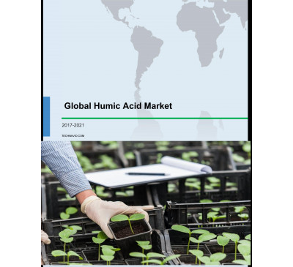

Global Humic Acid Market 2017-2021
- Sep 2017
- 81 pages
- USD 3500USD 2500
Overview of the global humic acid market Research analysis on the global humic acid market identi...
View Report
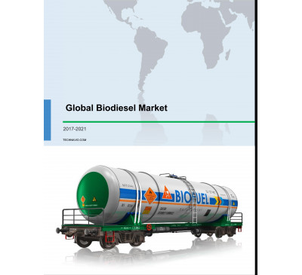

Global Biodiesel Market 2017-2021
- Sep 2017
- 80 pages
- USD 3500USD 2500
Overview of the global biodiesel market Research analysis on the global biodiesel market identifi...
View Report

Global Bioceramics Market 2017-2021
- Sep 2017
- 78 pages
- USD 3500USD 2500
Overview of the global bioceramics market Research analysis on the global bioceramics market iden...
View Report

Global Bioresorbable Polymers Market 2017-2021
- Sep 2017
- 90 pages
- USD 3500USD 2500
Overview of the global bioresorbable polymers market Research analysis on the global bioresorbabl...
View Report
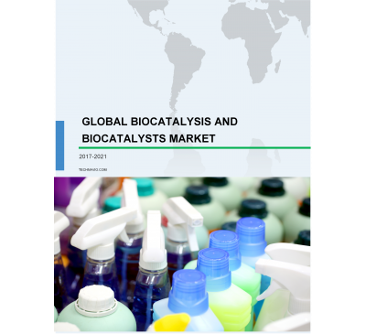

Global Biocatalysis And Biocatalysts Market 2017-2021
- Aug 2017
- 85 pages
- USD 3500USD 2500
Overview of the global biocatalysis and biocatalysts market Research analysis on the global bioca...
View Report
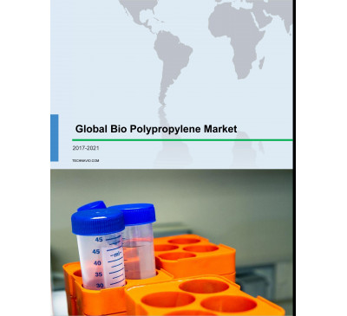

Global Bio Polypropylene Market 2017-2021
- Aug 2017
- 73 pages
- USD 3500USD 2500
Overview of the global bio polypropylene market Research analysis on the global bio polypropylene...
View Report
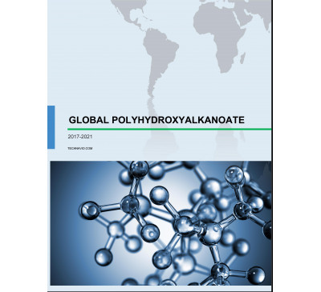

Global Polyhydroxyalkanoate Market 2017-2021
- Aug 2017
- 76 pages
- USD 3500USD 2500
Overview of the global polyhydroxyalkanoate market Research analysis on the global polyhydroxyalk...
View Report
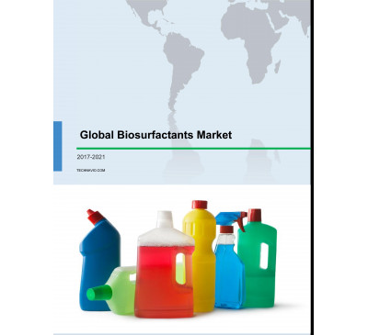

Global Bio-surfactants Market 2017-2021
- Aug 2017
- 100 pages
- USD 3500USD 2500
Overview of the global bio-surfactants market Technavio’s market study identifies the growing ne...
View Report
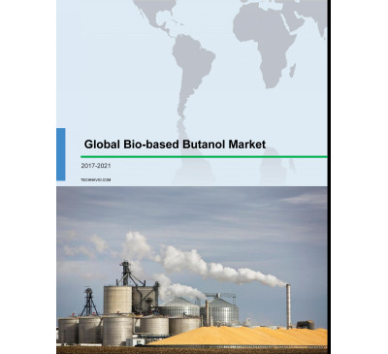

Global Bio-based Butanol Market 2017-2021
- Aug 2017
- 79 pages
- USD 3500USD 2500
Overview of the global bio-based butanol market Technavio’s market research analysis identifies t...
View Report

Global Cellulosic Ethanol Market 2017-2021
- Jun 2017
- 72 pages
- USD 3500USD 2500
Overview of the global cellulosic ethanol market Market research analysts at Technavio predict th...
View Report

Global Sheet Membrane Market 2017-2021
- May 2017
- 70 pages
- USD 3500USD 2500
Overview of the global sheet membrane market According to Technavio’s market research report, the...
View Report
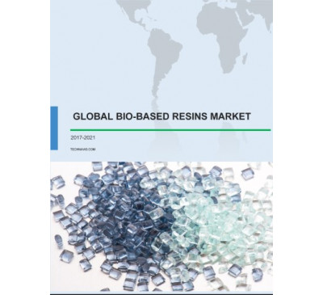

Global Bio-Based Resins Market 2017-2021
- May 2017
- 70 pages
- USD 3500USD 2500
Overview of the global bio-based resins market According to Technavio’s market research report, t...
View Report
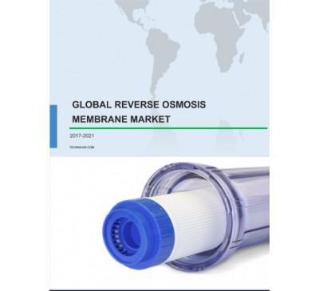

Global Reverse Osmosis (RO) Membrane Market 2017-2021
- May 2017
- 70 pages
- USD 3500USD 2500
Overview of the global reverse osmosis (RO) membrane market Market research analysts at Technavi...
View Report
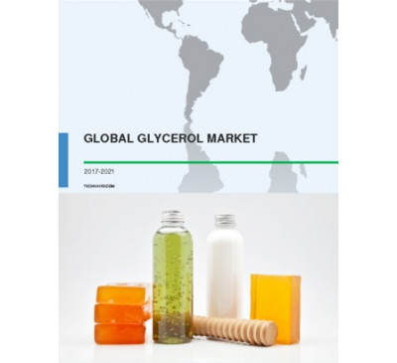

Global Glycerol Market 2017-2021
- May 2017
- 70 pages
- USD 3500USD 2500
Overview of the global glycerol market Market research analysts at Technavio predict that the glo...
View Report

Global Biodegradable Paper Packaging Materials Market 2017-2021
- May 2017
- 70 pages
- USD 3500USD 2500
Overview of the global biodegradable paper packaging materials market As per the Technavio’s mark...
View Report
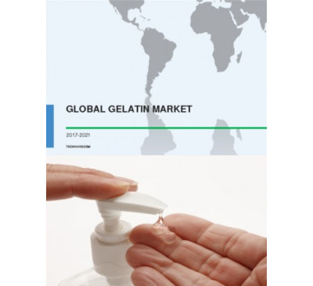

Global Gelatin Market 2017-2021
- Apr 2017
- 70 pages
- USD 3500USD 2500
Overview of the global gelatin market As per the Technavio’s market research report, the global g...
View Report

Global Liquid Applied Membrane Market For Construction Industry 2017-2021
- Apr 2017
- 70 pages
- USD 3500USD 2500
Overview of the global liquid applied membrane market for the construction industry Technavio’s m...
View Report

Global Biotechnology Reagents Market 2017-2021
- Apr 2017
- 70 pages
- USD 3500USD 2500
Overview of the global biotechnology reagents market Technavio’s market research analyst predicts...
View Report

Global Biodegradable Packaging Materials Market 2017-2021
- Apr 2017
- 70 pages
- USD 3500USD 2500
Overview of the global biodegradable packaging materials market Market research analysts at Techn...
View Report

Global Wood Plastic Composites Market 2017-2021
- Feb 2017
- 70 pages
- USD 3500USD 2500
Overview of the global wood plastic composites (WPCs) market According to Technavio’s ana.....
View Report
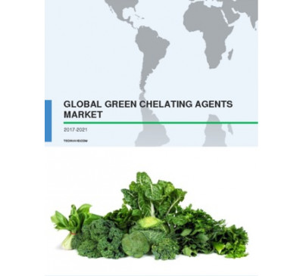

Global Green Chelating Agents Market 2017-2021
- Feb 2017
- 82 pages
- USD 3500USD 2500
Overview of the global green chelating agents market The global green chelating agents market i...
View Report

Leather And Allied Products Market In Serbia 2016-2020
- Dec 2016
- 50 pages
- USD 2500USD 2375
Outlook of the leather and allied products market in Serbia Extensive research carried out by the...
View Report

Leather And Allied Product Market In Bosnia And Herzegovina 2016-2020
- Dec 2016
- 50 pages
- USD 2500USD 2375
Overview of the leather and allied products market in Bosnia and Herzegovina Technavio’s market r...
View Report

Leather And Allied Products Market In Turkey 2016-2020
- Dec 2016
- 50 pages
- USD 2500USD 2375
Overview of the leather and allied products market in Turkey According to the market research stu...
View Report

Leather And Allied Products Market In Romania 2016-2020
- Dec 2016
- 50 pages
- USD 2500USD 2375
Outlook of the Romanian leather and allied products market Technavio’s market research analysts h...
View Report

Leather And Allied Products Market In Bulgaria 2016-2020
- Dec 2016
- 50 pages
- USD 2500USD 2375
Outlook of the leather and allied products market in Bulgaria Technavio’s market research analyst...
View Report
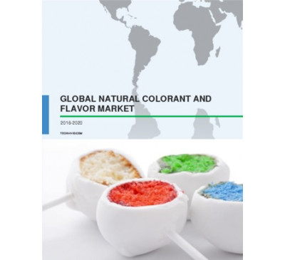

Global Natural Colorant And Flavor Market 2016-2020
- Nov 2016
- 69 pages
- USD 2500USD 2375
Overview of the global natural colorant and flavor market Technavio’s market research ana.....
View Report
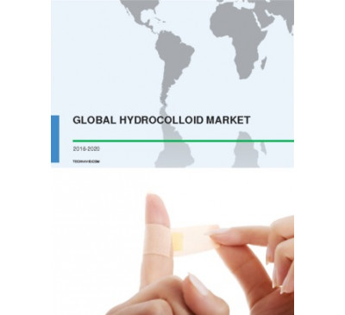

Global Hydrocolloid Market 2016-2020
- Nov 2016
- 66 pages
- USD 2500USD 2375
Overview of the global hydrocolloid market Hydrocolloids are primarily used for thickening.....
View Report

Global Bioactive Materials Market 2016-2020
- Oct 2016
- 69 pages
- USD 2500USD 2375
Overview of the global bioactive materials market Technavio’s market research analyst predicts the...
View Report

Global Vitamin Ingredients Market 2016-2020
- Aug 2016
- 79 pages
- USD 2500USD 2250
Overview of the global vitamin ingredients market Market research analysts at Technavio predict th...
View Report
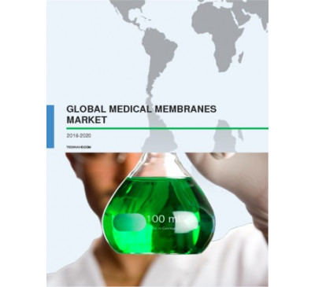

Global Medical Membranes Market 2016-2020
- Jul 2016
- 63 pages
- USD 2500USD 2250
Overview of the global medical membrane market Technavio’s market research analyst predicts the gl...
View Report
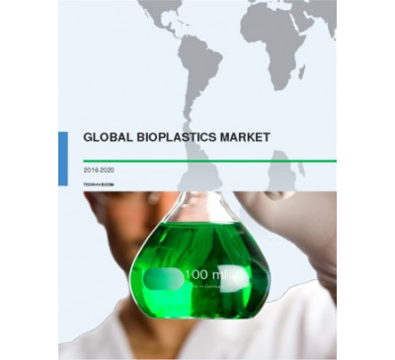

Global Bioplastics Market 2016-2020
- Jun 2016
- 78 pages
- USD 2500USD 2250
Overview of the global bioplastics market Technavio’s market research analyst predicts the global...
View Report
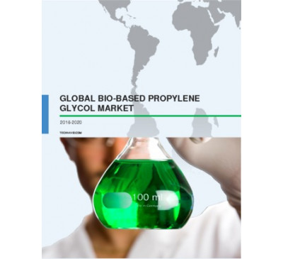

Global Bio-based Propylene Glycol Market 2016-2020
- Apr 2016
- 59 pages
- USD 2500USD 2250
Market outlook of the global bio-based propylene glycol market Technavio’s market research analyst...
View Report
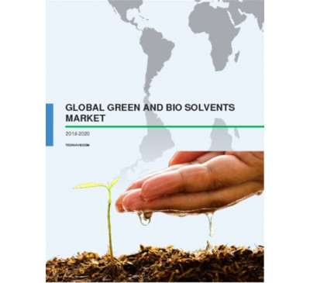

Global Green And Bio Solvents Market 2016-2020
- Mar 2016
- 69 pages
- USD 2500USD 2250
Outlook of the green and bio solvents market Extensive research carried out by the analysts at Tec...
View Report

Global Specialty Biocides Market 2016-2020
- Mar 2016
- 72 pages
- USD 2500USD 2250
Overview of the global specialty biocides market Technavio’s market analyst have predicted the glo...
View Report
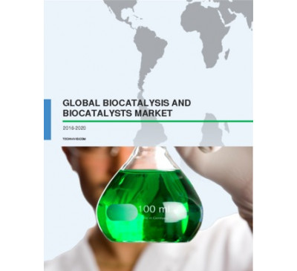

Global Biocatalysis And Biocatalysts Market 2016-2020
- Feb 2016
- 76 pages
- USD 2500USD 2250
Outlook of the biocatalysis and biocatalysts market Biocatalysis is a chemical process in which en...
View Report
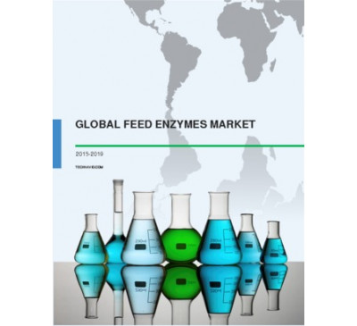

Global Feed Enzymes Market 2015-2019
- Jan 2016
- 78 pages
- USD 2500USD 2250
Market outlook of feed enzymes Technavio’s market research analyst predicts the global feed enzy...
View Report
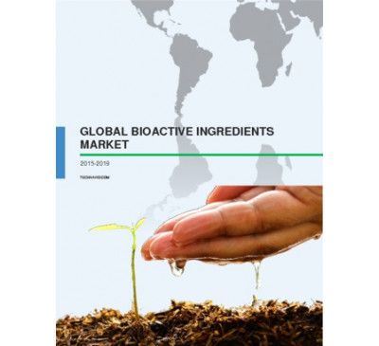

Global Bioactive Ingredients Market 2015-2019
- Nov 2015
- 73 pages
- USD 2500USD 2250
Market outlook of bioactive ingredients Bioactive ingredients are bio-molecules added to food pr...
View Report

Global Medicinal Feed Additive Market 2015-2019
- Oct 2015
- 81 pages
- USD 2500USD 2250
About medicinal feed additive Medicinal feed additives are substances containing veterinary medic...
View Report
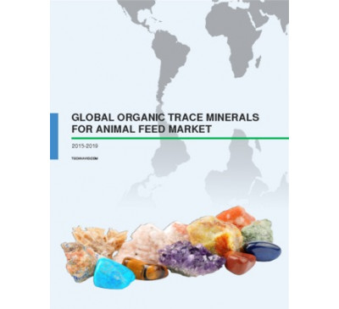

Global Organic Trace Minerals For The Animal Feed Market 2015-2019
- Sep 2015
- 96 pages
- USD 2500USD 2250
Market outlook of the global organic trace minerals for the animal feed market Organic trace min...
View Report
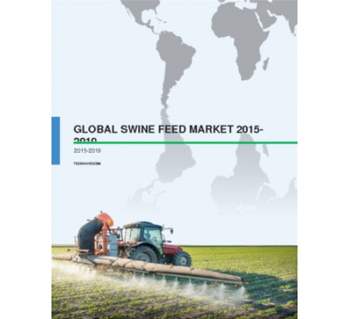

Global Swine Feed Market 2015-2019
- Sep 2015
- 60 pages
- USD 2500USD 2250
About swine feed Swine feed is used to provide nutrition to swine during their rearing process. I...
View Report
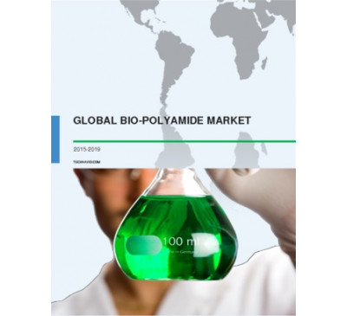

Global Bio-polyamide Market 2015-2019
- Sep 2015
- 80 pages
- USD 2500USD 2000
About bio-polyamide Polyamides are polymers that can be used to structurally and characteristical...
View Report

Global Natural And Synthetic Food Colors Market 2015-2019
- Aug 2015
- 54 pages
- USD 2500USD 2000
Overview of the global natural and synthetic food color market The global natural and synthetic ...
View Report

Global Vitamin B-complex Ingredients Market 2015-2019
- Aug 2015
- 104 pages
- USD 2500USD 2000
About Vitamin B-complex Vitamins are organic compounds that are required by living organisms in m...
View Report
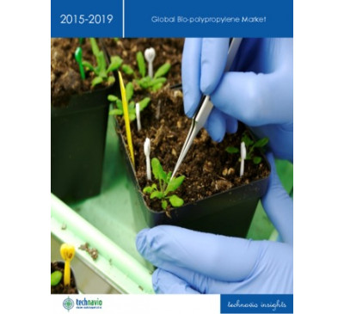

Global Bio-polypropylene (PP) Market 2015-2019
- Jul 2015
- 78 pages
- USD 2500USD 2000
About Bio-Polypropylene Bio-polypropylene belongs to the family of polyolefins which is produced ...
View Repor

Global Synthetic Zeolites Market 2015-2019
- Jul 2015
- 72 pages
- USD 2500USD 2000
About Synthetic Zeolites Zeolites are a group of hydrated aluminum silicates, which are abundantl...
View Report
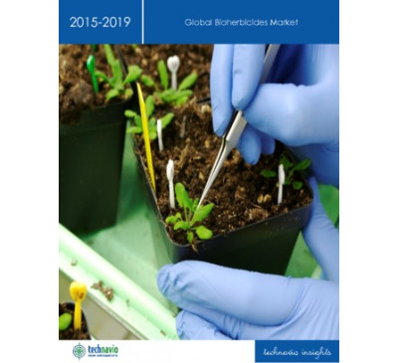

Global Bio-herbicides Market 2015-2019
- Jul 2015
- 68 pages
- USD 2500USD 2000
Market definition of bioherbicide Bioherbicide is used for controlling the growth of weeds encou...
View Report

Global Bio-based Butanol Market 2015-2019
- Jul 2015
- 93 pages
- USD 2500USD 2000
About Bio-based Butanol Bio-based butanol is a plant-based alcohol produced from sugarcane, grain...
View Report

Global Fullerene Market 2015-2019
- Jul 2015
- 103 pages
- USD 2500USD 2000
About Fullerenes Fullerenes are a group of carbon molecules that are available in various forms s...
View Report

Global Biostimulants Market 2015-2019
- Jul 2015
- 74 pages
- USD 2500USD 2000
About Biostimulants Biostimulants are a mixture of compounds, micro-organisms, and substances tha...
View Report
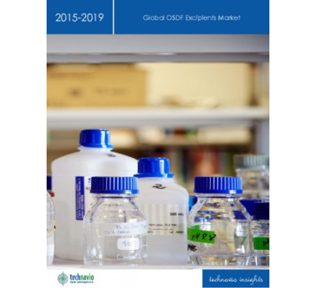

Global OSDF Excipients Market 2015-2019
- Jul 2015
- 69 pages
- USD 2500USD 2000
About OSDF Excipients OSDF excipients are chemical compounds that are added along with API and ot...
View Report
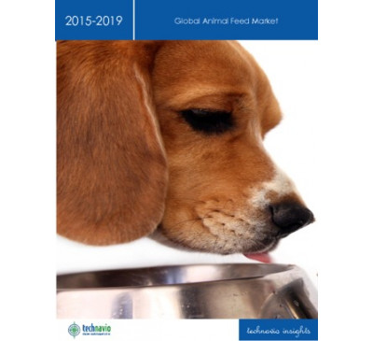

Global Animal Feed Market 2015-2019
- Jul 2015
- 79 pages
- USD 2500USD 2000
About Animal Feed Animal feed refers to food for livestock, such as poultry, swine, cattle, horse...
View Report
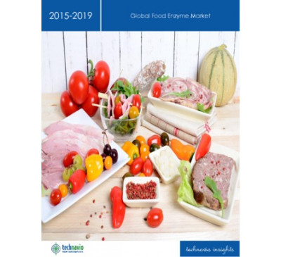

Global Food Enzyme Market 2015-2019
- Jul 2015
- 95 pages
- USD 2500USD 2000
About Food Enzymes Food enzymes are catalysts of biochemical reactions that break down complex st...
View Report

Global Chitosan Market 2015-2019
- Jul 2015
- 65 pages
- USD 2500USD 2000
About Chitosan Chitosan is a natural polysaccharide extracted from the shells of crustaceans suc...
View Report
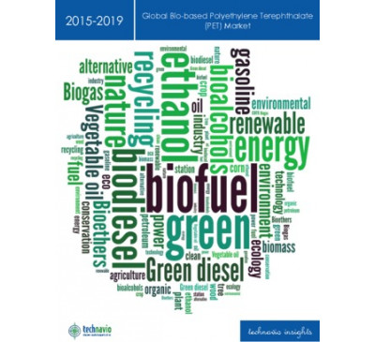

Global Bio-based Polyethylene Terephthalate (PET) Market 2015-2019
- Jul 2015
- 74 pages
- USD 2500USD 2000
About Bio-based Polyethylene Terephthalate Bio-based PET is a biodegradable product made from mat...
View Report

Global Vitamin Ingredients Market 2015-2019
- Jun 2015
- 118 pages
- USD 2500USD 2000
About Vitamins Vitamins are organic compounds that are required by living organisms in minute qu...
View Report

Global Trace Minerals For Animal Feed Market 2015-2019
- Jun 2015
- 112 pages
- USD 2500USD 2000
About Trace Minerals for Animal Feed Trace minerals are micronutrients that are used in small ...
View Report

Biosurfactants Market - Global Trends, Analysis, & Forecast 2015-2019
- May 2015
- 105 pages
- USD 2500USD 2000
.....
View Report

Global Bio Alcohol Market - Industry Insights And Forecast 2015-2019
- May 2015
- 62 pages
- USD 2500USD 2000
Market Definition and Growth of the Bio Alcohol Market: Bio alcohols are sustainable organic che...
View Report
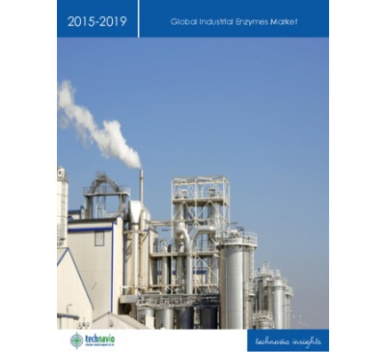

Global Industrial Enzymes Market 2015-2019
- Apr 2015
- 90 pages
- USD 2500USD 2000
About Industrial Enzymes Industrial enzymes are molecules or complex proteins, which help catalyz...
View Report

Global Biomedical Metal Market 2015-2019
- Apr 2015
- 81 pages
- USD 2500USD 2000
About Biomedical Metal Biomedical metals are being used for a number of applications in the Medic...
View Report

Global Bio-based Platform Chemicals Market 2015-2019
- Apr 2015
- 73 pages
- USD 2500USD 2000
About Bio-based Platform Chemicals Platform Chemicals, also known as building block chemicals, is a...
View Report

Active Pharmaceutical Ingredients (API) Market In The US 2015-2019
- Feb 2015
- 65 pages
- USD 2500USD 2000
About API Active pharmaceutical ingredients (API) are active substances that are used in the man...
View Report

Active Pharmaceutical Ingredients Market In India 2015-2019
- Jan 2015
- 64 pages
- USD 2500USD 2000
About Active Pharmaceutical Ingredients Active pharmaceutical ingredients are the active substanc...
View Report

Global Starch Derivatives Market 2015-2019
- Jan 2015
- 78 pages
- USD 2500USD 2000
About Starch Derivatives Starch derivatives are formed through a chemical reaction of raw starch...
View Report

Global Smart Materials Market 2014-2018
- Dec 2014
- 86 pages
- USD 2500USD 2000
About Smart Materials Market Smart materials are specialty building materials whose properties t...
View Report

Global Fermentation Chemicals Market 2015-2019
- Dec 2014
- 103 pages
- USD 2500USD 2000
About Fermentation Chemicals Fermentation chemicals are commercially produced by the fermentatio...
View Report

Global Active Pharmaceutical Ingredients Market 2015-2019
- Dec 2014
- 119 pages
- USD 2500USD 2000
About Active Pharmaceutical Ingredients Active pharmaceutical ingredients are the active substan...
View Report

Global Excipients Market 2014-2018
- Dec 2014
- 82 pages
- USD 2500USD 2000
About Excipients Excipients are pharmacologically inactive substances used in the form of a carr...
View Report

Global Synthetic And Bio-based Biodegradable Plastics Market 2014-2018
- Oct 2014
- 81 pages
- USD 2500USD 2000
About Synthetic and Bio-based Biodegradable Plastics Biodegradable materials are materials that ...
View Report
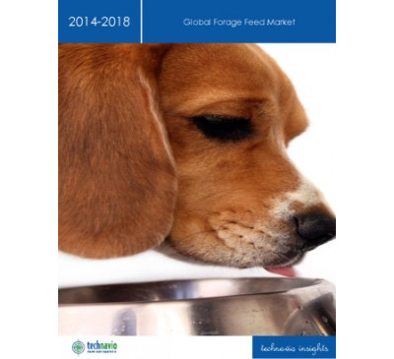

Global Forage Feed Market 2014-2018
- Oct 2014
- 71 pages
- USD 2500USD 2000
About Forage Feed Forage feed is used to provide nutrition to livestock such as poultry, swine, ...
View Report
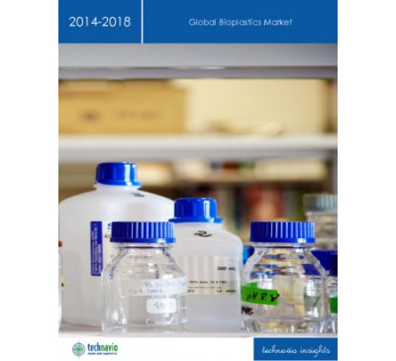

Global Bioplastics Market 2014-2018
- Oct 2014
- 81 pages
- USD 2500USD 2000
About Bioplastics Bioplastics are a type a biodegradable plastic derived from renewable sources ...
View Report

Global Bioactive Material Market 2014-2018
- Sep 2014
- 74 pages
- USD 2500USD 2000
About Bioactive Material Bioactive materials are part of the biomaterial family and are increasi...
View Report
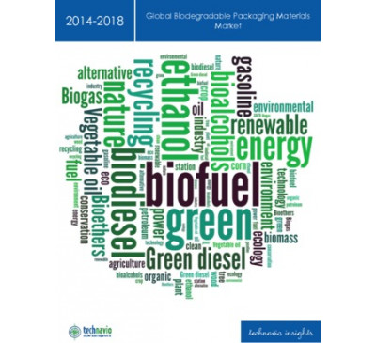

Global Biodegradable Packaging Materials Market 2014-2018
- Aug 2014
- 100 pages
- USD 2500USD 2000
About Biodegradable Packaging Materials Biodegradable materials are materials that are readily d...
View Report
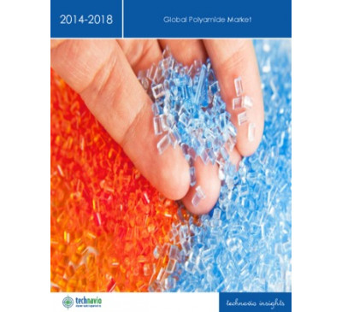

Global Polyamide Market 2014-2018
- Jul 2014
- 80 pages
- USD 2500USD 2000
About Polyamides Polyamides are polymers that can be used to structurally and characteristically ...
View Report

Global Genomics Market 2014-2018
- Jul 2014
- 57 pages
- USD 2500USD 2000
About Genomics Genomics is the study of the genetic material or genomes of an organism. It is ex...
View Report

Global Metabolomics Market 2014-2018
- Jul 2014
- 86 pages
- USD 2500USD 2000
About Metabolomics Metabolomics or Metabonomics is the scientific study of chemical processes invo...
View Report

Gelatin And Gelatin Derivatives Market In Europe 2014-2018
- May 2014
- 58 pages
- USD 2500USD 2000
About Gelatin and Gelatin Derivatives Gelatin and gelatin derivatives are a form of collagen. It...
View Report

Global Antioxidants Market 2014-2018
- Mar 2014
- 68 pages
- USD 2500USD 2000
About Antioxidants Antioxidants are molecules that inhibit oxidation of other molecules. Antioxi...
View Report

Global Nutraceutical Ingredients Market 2014-2018
- Mar 2014
- 72 pages
- USD 2500USD 2000
About Nutraceutical Ingredients Nutraceuticals are products that provide pharmacological, or hea...
View Report

Global Organic Trace Minerals For Animal Feed Market 2014-2018
- Feb 2014
- 87 pages
- USD 2500USD 2000
TechNavio's analysts forecast the Global Organic Trace Minerals for Animal Feed market to grow at a...
View Report
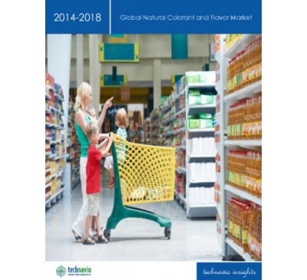

Global Natural Colorant And Flavor Market 2014-2018
- Jan 2014
- 84 pages
- USD 2500USD 2000
TechNavio's analysts forecast the Global Natural Colorant and Flavor market to grow at a CAGR of 6....
View Report
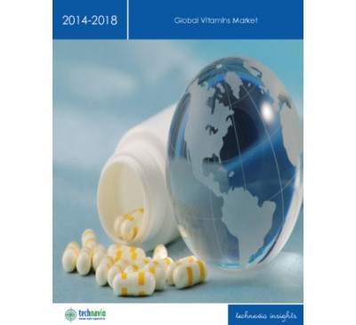

Global Vitamins Market 2014-2018
- Jan 2014
- 57 pages
- USD 2500USD 2000
TechNavio's analysts forecast the Global Vitamins market to grow at a CAGR of 6.15 percent over the...
View Report
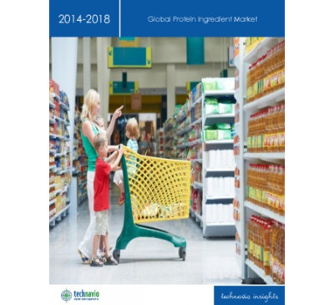

Global Protein Ingredient Market 2014-2018
- Dec 2013
- 64 pages
- USD 2500USD 2000
TechNavio's analysts forecast the Global Protein Ingredient market to grow at a CAGR of 6.03 percen...
View Report

Global Hydrocolloid Market 2014-2018
- Nov 2013
- 57 pages
- USD 2500USD 2000
TechNavio's analysts forecast the Global Hydrocolloid market to grow at a CAGR of 5.57 percent over...
View Report

Global Genomics Market 2014-2018
- Jul 2014
- 57 pages
- USD 2500USD 2000
About Genomics Genomics is the study of the genetic material or genomes of an organism. It is ex...
View Report

Global Metabolomics Market 2014-2018
- Jul 2014
- 86 pages
- USD 2500USD 2000
About Metabolomics Metabolomics or Metabonomics is the scientific study of chemical processes invo...
View Report

Gelatin And Gelatin Derivatives Market In Europe 2014-2018
- May 2014
- 58 pages
- USD 2500USD 2000
About Gelatin and Gelatin Derivatives Gelatin and gelatin derivatives are a form of collagen. It...
View Report

Global Antioxidants Market 2014-2018
- Mar 2014
- 68 pages
- USD 2500USD 2000
About Antioxidants Antioxidants are molecules that inhibit oxidation of other molecules. Antioxi...
View Report

Global Nutraceutical Ingredients Market 2014-2018
- Mar 2014
- 72 pages
- USD 2500USD 2000
About Nutraceutical Ingredients Nutraceuticals are products that provide pharmacological, or hea...
View Report

Global Organic Trace Minerals For Animal Feed Market 2014-2018
- Feb 2014
- 87 pages
- USD 2500USD 2000
TechNavio's analysts forecast the Global Organic Trace Minerals for Animal Feed market to grow at a...
View Report

Global Natural Colorant And Flavor Market 2014-2018
- Jan 2014
- 84 pages
- USD 2500USD 2000
TechNavio's analysts forecast the Global Natural Colorant and Flavor market to grow at a CAGR of 6....
View Report

Global Vitamins Market 2014-2018
- Jan 2014
- 57 pages
- USD 2500USD 2000
TechNavio's analysts forecast the Global Vitamins market to grow at a CAGR of 6.15 percent over the...
View Report

Global Protein Ingredient Market 2014-2018
- Dec 2013
- 64 pages
- USD 2500USD 2000
TechNavio's analysts forecast the Global Protein Ingredient market to grow at a CAGR of 6.03 percen...
View Report

Global Hydrocolloid Market 2014-2018
- Nov 2013
- 57 pages
- USD 2500USD 2000
TechNavio's analysts forecast the Global Hydrocolloid market to grow at a CAGR of 5.57 percent over...
View Report

13
May 2016

Bio-based Chemicals - High-Tech Materials TOE
Region : Global
Sustainability initiatives across the world have resulted in the steady adoption of bio-based chemicals and intermediates for use across different industries. These chemicals help in reducing oil dependence while promoting green initiatives. While biopolymers are well established across many geographies, growth of the bio-based chemical industry as...
USD 250
READ MORE
04
Aug 2017

Material Advances Facilitating a Bio-based Economy
Region : Global
The issue of High Tech Materials TOE is focused on material advances facilitating a bio-based economy, and research advances in hydrogen sulfide removal. It also profiles research initiatives that can result in the manufacture of biofuel from fermentation waste, a biodiesel additive, and a process to manufacture bio-based aliphatic polycarbonates. ...
USD 250
READ MORE
16
Jun 2017

Innovations in Biopackaging, Fragrances, Bio-based Materials, and Protein Production
Region : Global
This edition of the Industrial Bioprocessing TOE features trends and innovations in biopackaging and bio-based recyclable materials. The TOE also focuses on various technological innovations in natural fragrance extraction and sustainable protein production. The Industrial Bioprocessing TechVision Opportunity Engine (TOE) provides intelligence on ...
USD 250
READ MORE
07
Jul 2017

Innovations in Plastic Recycling, Textile Industries, Bio-based Materials and Chemicals
Region : Global
This edition of the Industrial Bioprocessing TOE features trends and innovations in plastic recycling, textile industries, bio-based materials and chemicals. The TOE also focuses on various technological innovations in bio-based viscose fibers, polymers, and acids aimed to replace petroleum-based materials and chemicals. The Industrial Bioprocessi...
USD 250
READ MORE
17
Jun 2016

Innovations in Bio-based Sunscreens - Industrial Bioprocessing TOE
Region : Global
This Industrial Bioprocessing TOE features innovations in bio-based sunscreens, which are composed of natural ingredients. The trend toward bio-based sunscreens is driven by higher awareness and incidences of skin cancer and the need to prevent the effects of chemicals-based sunscreens. The innovations featured in this TOE edition are sunscreens ma...
USD 250
READ MORE
16
Oct 2015

Advanced Coatings & Surface Technology Alert - Bio-based Adhesives for Healthcare Applications
Combination of environmental and performance benefits drive its adoption
Region : Global
This edition of the Bio-based Advanced Coatings & Surface Technology Alert profiles bio-based adhesives for healthcare applications.
USD 250
READ MORE
17
Mar 2014

Analysis of the Global Industrial Greases Market and Opportunities for Bio-based Materials
Strategic Opportunities Available for Bio-Greases Suppliers
Region : North America
This research service analyses the global industrial greases market as well as the opportunities for bio-based materials that can be used in industrial greases production. Moreover, it analyses the global situation, developments, trends and future opportunities for industrial greases. The market for industrial greases, especially synthetic and semi...
USD 6,950
USD 6,255
READ MORE
30
Sep 2015

Bio-based Solvents - 6 Dimensional Analysis (TechVision)
Evaluating Bio-Solvents through a 6-Dimensional Approach
Region : Global
Bio based solvents, an emerging grade of fluids is considered as a key technology to facilitate a greener manufacturing across industries. Developments in processes using bio based feed-stocks has resulted in solvents which can compete with traditional solvents in terms of performance with significant value adds such as zero toxicity, biodegradabi...
USD 4,950
READ MORE
11
Dec 2015

Plastics Advisor TechVision Opportunity Engine--Recent Advances in Bio-Based Plastics
Region : Global
This issue profiles recent advances in bio-based plastics.
USD 950
READ MORE
15
May 2015

Industrial Bioprocessing Alert. Common Fungi Convert Biomass into Aviation Fuel; Phytoremediation and Bio-Augmentation for Removal of Polychlorinated Biphenyl from Soil
Region : Global
This issue profiles common fungi that convert biomass into aviation fuel, phytoremediation and bio-augmentation for removal of polychlorinated biphenyl from soil, and genetic modification in maize crops for boosting nitrogen uptake efficiency.
USD 250
READ MORE
27
Dec 2011

A Bio-based Future for the Chemicals and Materials Market
Global Analysis of Opportunities for the Chemicals and Materials Industry
Region : Global
The concept of competition between natural and synthetic chemicals has a long history. Today, crude oil forms the largest feedstock material for the chemical industry in terms of volume. Currently, an enormous amount of work is being done by the chemical industry to develop both new bio-based chemicals and new bio-based routes to existing chemicals...
USD 6,950
USD 4,865
READ MORE
02
May 2014

Industrial Bioprocessing Alert. Converting Carbon Dioxide into Chemicals Using Light; Bioremediation of Radioactive Waste Using Green Algae; Modified
Region : Global
This issue profiles converting carbon dioxide into chemicals using light, bioremediation of radioactive waste using green algae, and modified pyrolysis processes that promise better bio-oil production.
USD 1,500
USD 1,350
READ MORE
23
Sep 2010

South African Market for Bio-renewable Chemicals
Region : Africa
This research service provides in-depth analyses on the South African market for bio-renewable chemicals. It also quantifies and forecasts the total bio-renewable chemicals industry in the country and the contribution from the various market segments. The research service also quantifies and forecasts the revenue contribution of each market segment...
USD 6,950
USD 4,865
READ MORE
09
May 2016

Emerging Applications of Nanocellulose Technology
Sustainable, Bio-based Nanomaterials, Nanofibrillated Cellulose (NFC), Nanocrystalline Cellulose (NCC) and Bacterial Nanocellulose (BNC) to Expand Application Base
Region : Global
The nanocellulose market has the potential to span many different industries that can be categorized as high volume and low volume applications. In order to be successful in nanocellulose business there must be a consistent supply of material that can be delivered in a cost-effective manner for the target application. Manufactures worldwide are a...
USD 4,950
READ MORE
24
Jan 2014

Strategic Analysis of the Global Lubricant Market and the Impact of Bio-based Feedstock
North America and Europe Push Premium, Sustainable Lubricants over Volume
Region : Global
This research service identifies the major industry drivers, restraints, regional trends, and technology segment trends in the global lubricants market. The research covers four regions: North America, Europe, Asia-Pacific, and Rest of the World (ROW). The study provides in-depth analysis of automotive, industrial, marine, and aviation segments wit...
USD 4,950
USD 4,455
READ MORE
18
Jun 2012

Analysis of the North American Medical Adhesives and Sealants Market
Bio-based Sealants for Internal Applications have Better Market-growth Opportunities
Region : North America
This research service tracks the key trends in the North American medical adhesives and sealants market while quantifying revenue for most of the markets segments. It also forecasts revenue at the total market level from 2012 to 2018. The objective is to provide a comprehensive analysis of medical adhesives and sealants used in internal, external,...
USD 4,950
USD 3,713
READ MORE
30
Apr 2009

Strategic Analysis of Second Generation Bio-feedstock
Region : Global
This research presents the strategic analysis of second-generation bio-feedstock by Frost & Sullivan covering four product type market segments. Market drivers, restraints and challenges as well as market metrics are discussed briefly offering a snapshot of the total market of second generation bio-feedstock and biofuel.
USD 6,950
USD 4,865
READ MORE
22
Dec 2009

Global Bio-based Plastics Market
Region : Global
This research service analyses the key trends, market drivers, challenges and future forecasts for the global bio-based plastics market. It discusses in detail the trends in both the conventional bio-based plastics such as PHA, PLA and starch based plastics as well as the immense growth in newer product types such as bio-based commodity plastics an...
USD 6,950
USD 4,865
READ MORE

Chemical Consulting: Commercial Renewables
you surmount your greatest challenges, such as the following:Economic and Industry AnalysisWhat is the long-term outlook for producing...
Trade Data
Technical research
Supply/Demand Data
Supply chain
Scenario planning & analysis
Production & Capacity
Product change management
Procurement
SRIC Report - Report 31C - Advances in Adiponitrile (ADN) and Hexamethylenediamine (HMDA) Processes
current technology for producing adipontirle and hexamethylenediamine used by Invista and Ascend, as well as the bio-based...

اگر منبع مورد نظرتان موجود نبود در ادامه درخواست دهید

از این به بعد شما اساتید و دانشجویان و پژوهشگران گرامی می توانید با دادن اطلاعی از منبع مورد نظر خود به ایمیل ما، کتاب های خود را از طریق درخواست کتاب این سایت بسیار ارزان قیمت دانلود کنید.

–شابک کافیست مشخصات کتاب همچون نام | شماره | نام نویسنده و … را برای ما بفرستید.
– یا لینکی از آن در سایت های دیگر همچون آمازون ، ایی بِی، گوگل بوک ، انتشارات های اصلی و … آن را به ما بگویید.
-باقی کار را به ما بسپارید؛ به شما در کمتر از ۲۴ ساعت اطلاع خواهیم داد.

