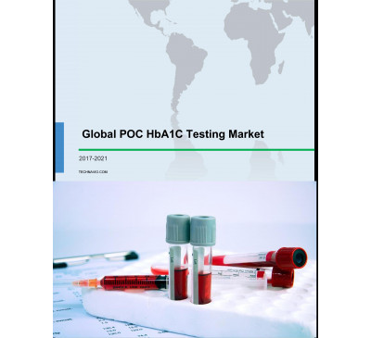

Global POC HbA1C Testing Market 2017-2021
- Sep 2017
- 84 pages
- USD 3500USD 2500
Overview of the global POC HbA1C testing market In-vitro diagnosis (IVD) provides immediate resul...
View Report

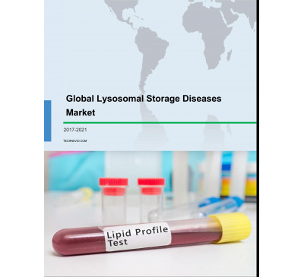

Global Lysosomal Storage Diseases Market 2017-2021
- Sep 2017
- 104 pages
- USD 3500USD 2500
Overview of the global lysosomal storage diseases market There is a rising need for efficacious t...
View Report

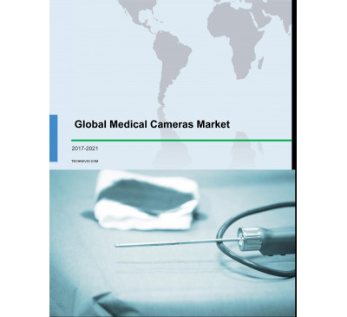

Global Medical Cameras Market 2017-2021
- Sep 2017
- 102 pages
- USD 3500USD 2500
Overview of the global medical cameras market Technavio’s market study identifies the growing pr...
View Report

Global Human Immunodeficiency Virus (HIV) Rapid Test Kits Market 2017-2021
- Sep 2017
- 75 pages
- USD 3500USD 2500
Overview of the global human immunodeficiency virus (HIV) rapid test kits market Research analysi...
View Report

Global Cryoablation Systems Market 2017-2021
- Sep 2017
- 75 pages
- USD 3500USD 2500
Overview of the global cryoablation systems market Research analysis on the global cryoablation s...
View Report

Global Thyroid Functioning Tests Market 2017-2021
- Sep 2017
- 71 pages
- USD 3500USD 2500
Overview of the global thyroid functioning tests market Technavio’s market study identifies the ...
View Report

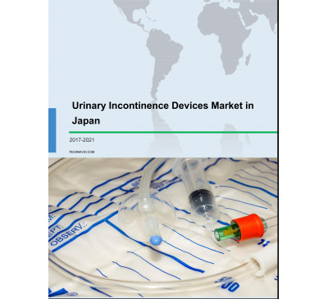

Urinary Incontinence Devices Market In Japan 2017-2021
- Sep 2017
- 72 pages
- USD 3500USD 2500
Overview of the urinary incontinence devices market in Japan Technavio’s market study identifies...
View Report

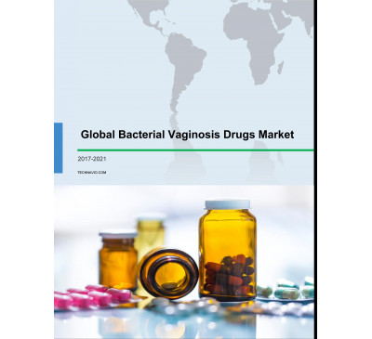

Global Bacterial Vaginosis Drugs Market 2017-2021
- Sep 2017
- 71 pages
- USD 3500USD 2500
Overview of the global bacterial vaginosis drugs market Technavio’s market study identifies the r...
View Report

Global Nitinol-based Medical Devices Market 2017-2021
- Sep 2017
- 73 pages
- USD 3500USD 2500
Overview of the global nitinol-based medical devices market Research analysis on the global nitin...
View Report

Global Neuroendovascular Coils Market 2017-2021
- Sep 2017
- 78 pages
- USD 3500USD 2500
Overview of the global neuroendovascular coils market Research analysis on the global neuroendova...
View Report
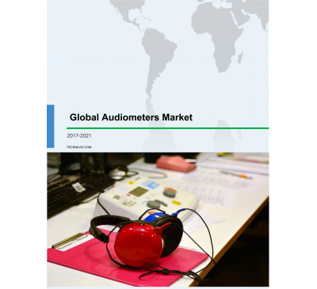

Global Audiometers Market 2017-2021
- Sep 2017
- 79 pages
- USD 3500USD 2500
Overview of the global audiometers market Research analysis on the global audiometers market show...
View Report

Global Antibiotics Market 2017-2021
- Sep 2017
- 118 pages
- USD 3500USD 2500
Overview of the global antibiotics market Research analysis on the global antibiotics market iden...
View Report
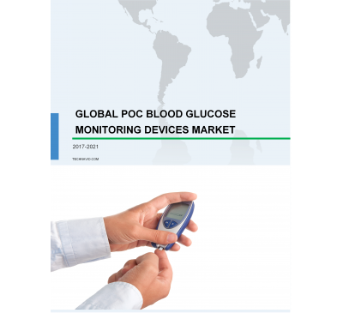

Global POC Blood Glucose Monitoring Devices Market 2017-2021
- Sep 2017
- 90 pages
- USD 3500USD 2500
Overview of the global POC blood glucose monitoring devices market Research analysis on the globa...
View Report
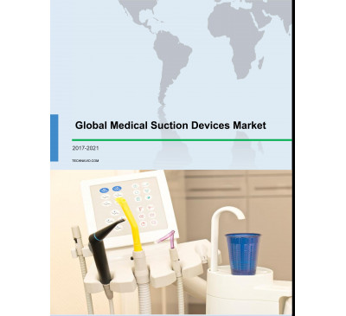

Global Medical Suction Devices Market 2017-2021
- Sep 2017
- 75 pages
- USD 3500USD 2500
Overview of the global medical suction devices market The installed wall suction systems may enco...
View Report
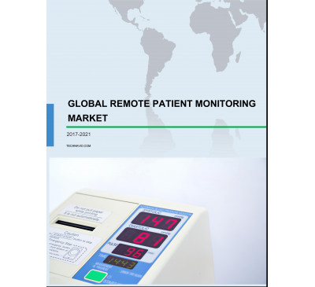

Global Remote Patient Monitoring Market 2017-2021
- Sep 2017
- 107 pages
- USD 3500USD 2500
Overview of the global remote patient monitoring market Research analysis on the global remote pa...
View Report

Global Hepatocellular Carcinoma Drugs Market 2017-2021
- Sep 2017
- 86 pages
- USD 3500USD 2500
Overview of the global hepatocellular carcinoma drugs market Research analysis on the global hepa...
View Report

Global Cell Therapy Market 2017-2021
- Sep 2017
- 118 pages
- USD 3500USD 2500
Overview of the global cell therapy market Technavio’s market research study identifies the incr...
View Report
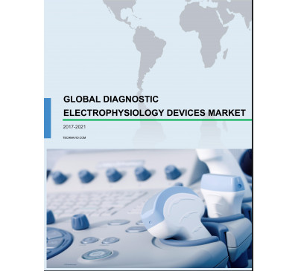

Global Diagnostic Electrophysiology Devices Market 2017-2021
- Sep 2017
- 99 pages
- USD 3500USD 2500
Overview of the global diagnostic electrophysiology devices market Cardiac ablation is used as th...
View Report
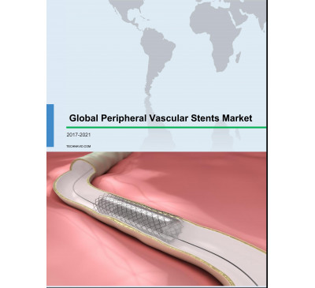

Global Peripheral Vascular Stents Market 2017-2021
- Sep 2017
- 109 pages
- USD 3500USD 2500
Overview of the global peripheral vascular stents market Peripheral stents are required to perfor...
View Report
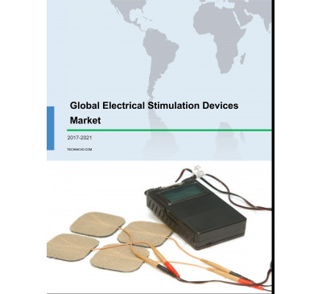

Global Electrical Stimulation Devices Market 2017-2021
- Sep 2017
- 77 pages
- USD 3500USD 2500
Overview of the global electrical stimulation devices market Factors such as road traffic acciden...
View Report
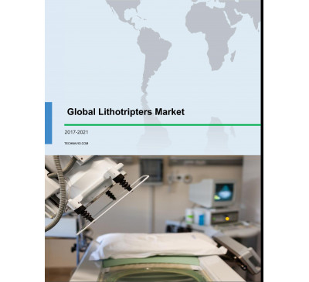

Global Lithotripters Market 2017-2021
- Sep 2017
- 105 pages
- USD 3500USD 2500
Overview of the global lithotripters market The rising preference for minimally invasive (MI) pro...
View Report
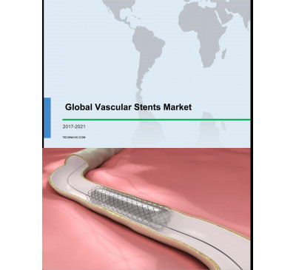

Global Vascular Stents Market 2017-2021
- Sep 2017
- 83 pages
- USD 3500USD 2500
Overview of the global vascular stents market Minimally invasive procedures such as vascular sten...
View Report

Global Audiology Devices Market 2017-2021
- Sep 2017
- 73 pages
- USD 3500USD 2500
Overview of the global audiology devices market Technavio’s market study identifies the increasi...
View Report
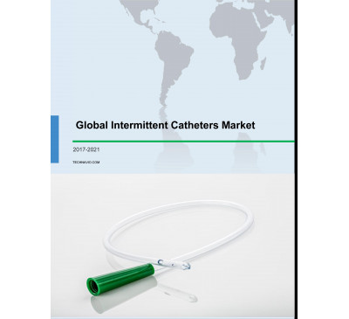

Global Intermittent Catheters Market 2017-2021
- Aug 2017
- 99 pages
- USD 3500USD 2500
Overview of the global intermittent catheters market Coated intermittent catheters have increased...
View Report

Global Sexual Dysfunction Drugs Market 2017-2021
- Aug 2017
- 91 pages
- USD 3500USD 2500
Overview of the global sexual dysfunction drugs market It has been observed that the rising incid...
View Report
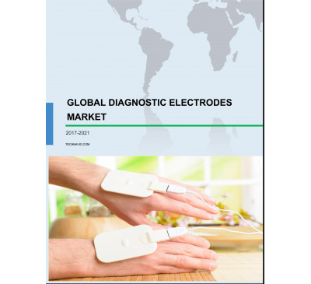

Global Diagnostic Electrodes Market 2017-2021
- Aug 2017
- 86 pages
- USD 3500USD 2500
Overview of the global diagnostic electrodes market Physicians are extensively adopting disposabl...
View Report
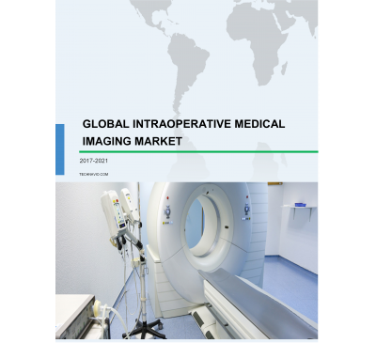

Global Intraoperative Medical Imaging Market 2017-2021
- Aug 2017
- 108 pages
- USD 3500USD 2500
Overview of the global intraoperative medical imaging market Technavio’s market study identifies...
View Report

Global Rapid Influenza Diagnostic Tests Market 2017-2021
- Aug 2017
- 74 pages
- USD 3500USD 2500
Overview of the global rapid influenza diagnostic tests market People older than 65 years of age,...
View Report

Global Orthopedic Soft Tissue Repair Devices Market 2017-2021
- Aug 2017
- 114 pages
- USD 3500USD 2500
Overview of the global orthopedic soft tissue repair devices market Technavio’s market study iden...
View Report
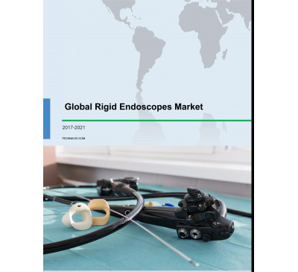

Global Rigid Endoscopes Market 2017-2021
- Aug 2017
- 103 pages
- USD 3500USD 2500
Overview of the global rigid endoscopes market The demand for minimally invasive (MI) endoscopy p...
View Report

Global Mobile Medical Imaging Services Market 2017-2021
- Aug 2017
- 80 pages
- USD 3500USD 2500
Overview of the global mobile medical imaging services market It has been observed that the healt...
View Report
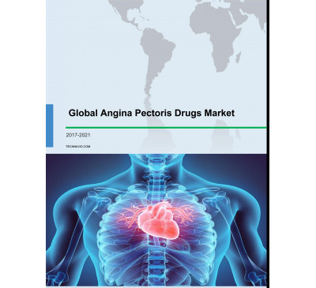

Global Angina Pectoris Drugs Market 2017-2021
- Aug 2017
- 82 pages
- USD 3500USD 2500
Overview of the global angina pectoris drugs market Technavio’s market study identifies the incr...
View Report

Global Cardiovascular Catheters Market 2017-2021
- Aug 2017
- 121 pages
- USD 3500USD 2500
Overview of the global cardiovascular catheters market Research analysis on the global cardiovasc...
View Report

Global Interventional Neurology Devices Market 2017-2021
- Aug 2017
- 86 pages
- USD 3500USD 2500
Overview of the global interventional neurology devices market Research analysis on the global in...
View Report
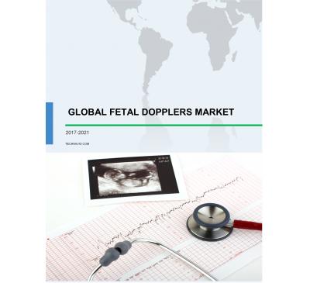

Global Fetal Dopplers Market 2017-2021
- Aug 2017
- 84 pages
- USD 3500USD 2500
Overview of the global fetal Dopplers market Research analysis on the global fetal Dopplers marke...
View Report
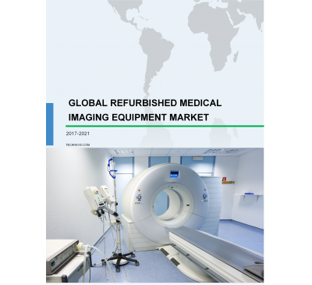

Global Refurbished Medical Imaging Equipment Market 2017-2021
- Aug 2017
- 86 pages
- USD 3500USD 2500
Overview of the global refurbished medical imaging equipment market Research analysis on the glob...
View Report

Global Dental Chairs Market 2017-2021
- Aug 2017
- 80 pages
- USD 3500USD 2500
Overview of the global dental chairs market Research analysis on the global dental chairs market ...
View Report

Global Advanced Visualization Systems Market 2017-2021
- Aug 2017
- 139 pages
- USD 3500USD 2500
Overview of the global advanced visualization systems market Technavio’s market study identifies ...
View Report
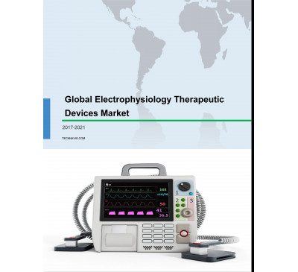

Global Electrophysiology Therapeutic Devices Market 2017-2021
- Aug 2017
- 88 pages
- USD 3500USD 2500
Overview of the global electrophysiology therapeutic devices market Technavio’s market study iden...
View Report

Global Cardiac Pacemakers Market 2017-2021
- Aug 2017
- 83 pages
- USD 3500USD 2500
Overview of the global cardiac pacemakers market Technavio’s market study identifies the rising p...
View Report

Global Fetal Monitoring Systems And Accessories Market 2017-2021
- Aug 2017
- 102 pages
- USD 3500USD 2500
Overview of the global fetal monitoring systems and accessories market Technavio’s market study i...
View Report

Global Digital Pathology Market 2017-2021
- Aug 2017
- 79 pages
- USD 3500USD 2500
Overview of the global digital pathology market Technavio’s market research study identifies the ...
View Report

Global Ophthalmic Diagnostic Devices Market 2017-2021
- Aug 2017
- 76 pages
- USD 3500USD 2500
Overview of the global ophthalmic diagnostic devices market The prevalence of eye-related disorde...
View Report

Global Parkinson's Disease (PD) Drugs Market 2017-2021
- Aug 2017
- 85 pages
- USD 3500USD 2500
Overview of the global parkinson's disease (PD) drugs market The treatment of PD involves therapi...
View Report
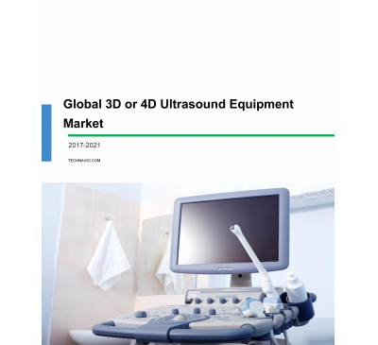

Global 3D/4D Ultrasound Equipment Market 2017-2021
- Aug 2017
- 114 pages
- USD 3500USD 2500
Overview of the global 3D/4D ultrasound equipment market Research analysis on the global 3D/4D ul...
View Report

Global Animal Growth Enhancers Market 2017-2021
- Aug 2017
- 66 pages
- USD 3500USD 2500
Overview of the global animal growth enhancers market The increasing prevalence of food-borne ill...
View Report
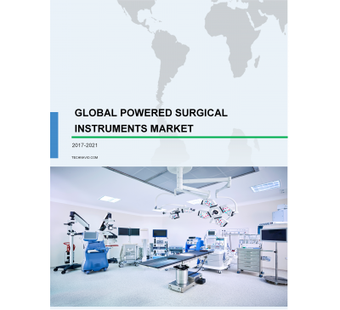

Global Powered Surgical Instruments Market 2017-2021
- Aug 2017
- 102 pages
- USD 3500USD 2500
Overview of the global powered surgical instruments market Technavio’s market research report ide...
View Report
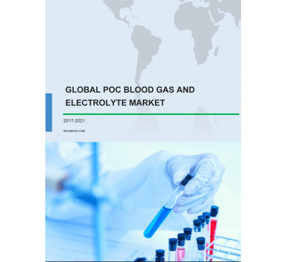

Global POC Blood Gas And Electrolyte Market 2017-2021
- Aug 2017
- 86 pages
- USD 3500USD 2500
Overview of the global POC blood gas and electrolyte market .....
View Report

Global Orthopedic Surgical Navigation Systems Market 2017-2021
- Aug 2017
- 83 pages
- USD 3500USD 2500
Overview of the global orthopedic surgical navigation systems market Technavio’s market st.....
View Report

Global Graft Vs Host Disease (GVHD) Treatment Market 2017-2021
- Aug 2017
- 78 pages
- USD 3500USD 2500
Overview of the global graft vs host disease (GVHD) treatment market Research analysis on the glo...
View Report
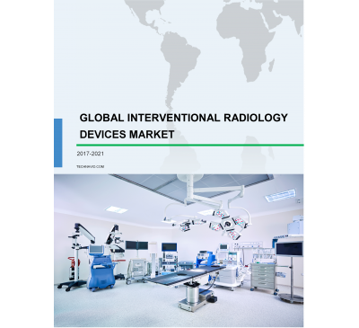

Global Interventional Radiology Devices Market 2017-2021
- Aug 2017
- 90 pages
- USD 3500USD 2500
Overview of the global interventional radiology devices market This market research study identi...
View Report

Global Wearable Medical Devices Market 2017-2021
- Aug 2017
- 102 pages
- USD 3500USD 2500
Overview of the global wearable medical devices market Technavio’s market study identifies the gr...
View Report

Global Guidewires Market 2017-2021
- Aug 2017
- 107 pages
- USD 3500USD 2500
Overview of the global guidewires market Research analysis on the global guidewires market identi...
View Report
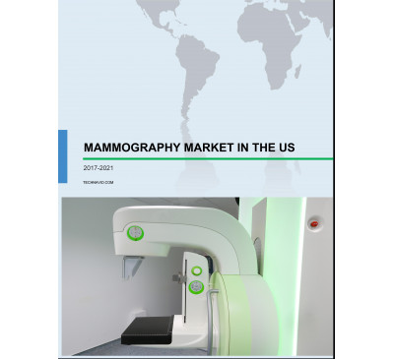

Mammography Market In The US 2017-2021
- Aug 2017
- 70 pages
- USD 3500USD 2500
Overview of the mammography market in the US Technavio’s market study identifies the prevalence o...
View Report

Global Medical Mobility Aids Market 2017-2021
- Aug 2017
- 79 pages
- USD 3500USD 2500
Overview of the global medical mobility aids market Technavio’s market study identifies the growi...
View Report

Global Cartilage Repair Market 2017-2021
- Aug 2017
- 104 pages
- USD 3500USD 2500
Overview of the global cartilage repair market Technavio’s market research report identifies that...
View Report

Global Urological Catheters Market 2017-2021
- Aug 2017
- 107 pages
- USD 3500USD 2500
Overview of the global urological catheters market Technavio’s market research report identifies ...
View Report

Global Acute Ischemic Stroke Therapeutics Market 2017-2021
- Aug 2017
- 84 pages
- USD 3500USD 2500
Overview of the global acute ischemic stroke therapeutics market Technavio’s market research repo...
View Report

Global Cancer Gene Therapy Market 2017-2021
- Aug 2017
- 85 pages
- USD 3500USD 2500
Overview of the global cancer gene therapy market This market research analysis identifies the si...
View Report
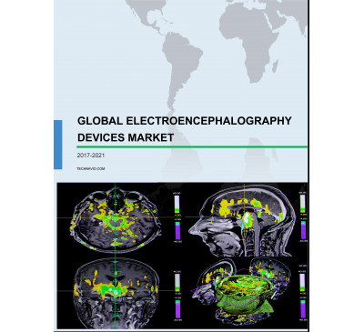

Global Electroencephalography Devices Market 2017-2021
- Aug 2017
- 89 pages
- USD 3500USD 2500
Overview of the global electroencephalography devices market Technavio’s market research report i...
View Report
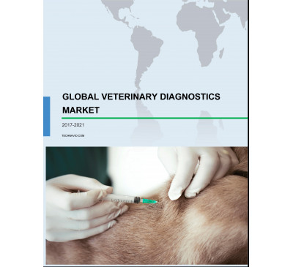

Global Veterinary Diagnostics Market 2017-2021
- Aug 2017
- 81 pages
- USD 3500USD 2500
Overview of the global veterinary diagnostics market Research analysis on the global veterinary d...
View Report
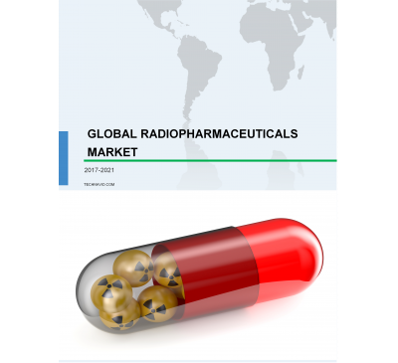

Global Radiopharmaceuticals Market 2017-2021
- Aug 2017
- 83 pages
- USD 3500USD 2500
Overview of the global radiopharmaceuticals market Research analysis on the global radiopharmaceu...
View Report
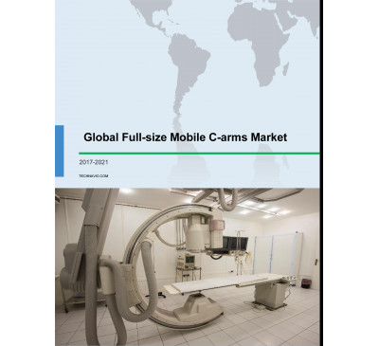

Global Full-size Mobile C-arms Market 2017-2021
- Aug 2017
- 81 pages
- USD 3500USD 2500
Overview of the global full-size mobile C-arms market Research analysis on the global full-size m...
View Report
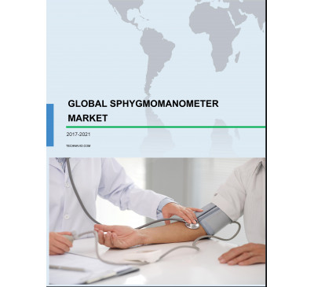

Global Sphygmomanometer Market 2017-2021
- Aug 2017
- 83 pages
- USD 3500USD 2500
Overview of the global sphygmomanometer market Technavio’s market research report identifies that...
View Report

Global Urinary Tract Infection Treatment Market 2017-2021
- Aug 2017
- 78 pages
- USD 3500USD 2500
Overview of the global urinary tract infection (UTI) treatment market Urinary tract infection (UT...
View Report

Global Trauma Fixation Devices Market 2017-2021
- Aug 2017
- 105 pages
- USD 3500USD 2500
Overview of the global trauma fixation devices market Research analysis on the global trauma fixa...
View Report

Global Food Allergen Testing Market 2017-2021
- Aug 2017
- 63 pages
- USD 3500USD 2500
Overview of the global food allergen testing market Research analysis on the global food allergen...
View Report
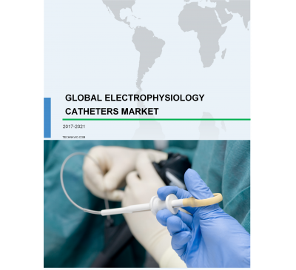

Global Electrophysiology Catheters Market 2017-2021
- Aug 2017
- 79 pages
- USD 3500USD 2500
Overview of the global electrophysiology catheters market Research analysis on the global electro...
View Report
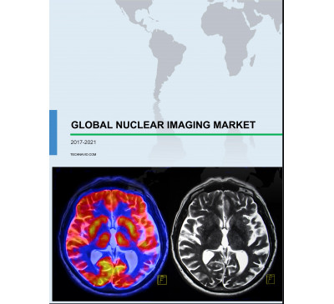

Global Nuclear Imaging Market 2017-2021
- Aug 2017
- 117 pages
- USD 3500USD 2500
Overview of the global nuclear imaging market Research analysis on the global nuclear imaging mar...
View Report
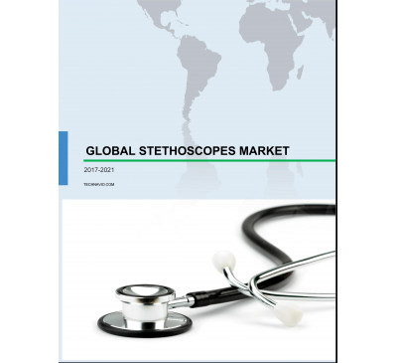

Global Stethoscopes Market 2017-2021
- Aug 2017
- 86 pages
- USD 3500USD 2500
Overview of the global stethoscopes market Technavio’s market research report identifies that the...
View Report

Global Wound Closure Devices Market 2017-2021
- Aug 2017
- 87 pages
- USD 3500USD 2500
Overview of the global wound closure devices market Technavio’s market study identifies the.....
View Report

Global Pediatric Medicines Market 2017-2021
- Aug 2017
- 91 pages
- USD 3500USD 2500
Overview of the global pediatric medicines market Technavio’s market research analysis on the ped...
View Report
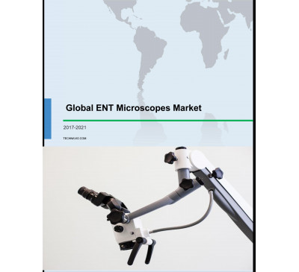

Global ENT Microscopes Market 2017-2021
- Aug 2017
- 77 pages
- USD 3500USD 2500
Overview of the global ENT microscopes market Technavio’s market research report identifies that ...
View Report

Global Huntington's Disease Therapeutics Market 2017-2021
- Aug 2017
- 86 pages
- USD 3500USD 2500
Overview of the global Huntington’s disease therapeutics market Technavio’s market research analy...
View Report
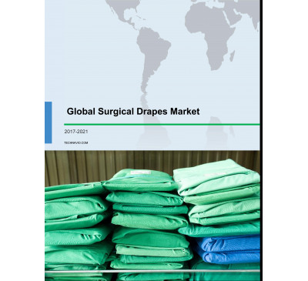

Global Surgical Drapes Market 2017-2021
- Aug 2017
- 77 pages
- USD 3500USD 2500
Overview of the global surgical drapes market Research analysis on the global surgical drapes mar...
View Report
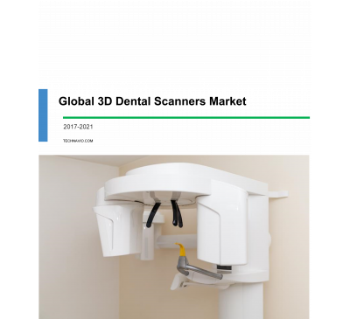

Global 3D Dental Scanners Market 2017-2021
- Aug 2017
- 80 pages
- USD 3500USD 2500
Overview of the global 3D dental scanners market This market research study identifies the increa...
View Report

Global Urodynamic Devices Market 2017-2021
- Aug 2017
- 97 pages
- USD 3500USD 2500
Overview of the global urodynamic devices market Technavio’s market research report identifies th...
View Report

Global Pruritus Therapeutic Market 2017-2021
- Aug 2017
- 81 pages
- USD 3500USD 2500
Overview of the global pruritus therapeutic market Technavio’s market research study identifies t...
View Report

Global Operating Room Cameras Market 2017-2021
- Aug 2017
- 89 pages
- USD 3500USD 2500
Overview of the global operating room cameras market Technavio’s market study identifies the grow...
View Report

Global Orthopedic Operating Tables Market 2017-2021
- Aug 2017
- 77 pages
- USD 3500USD 2500
Overview of the global orthopedic operating tables market Technavio’s market study identifies the...
View Report

Global LASIK Surgery Market 2017-2021
- Aug 2017
- 80 pages
- USD 3500USD 2500
Overview of the global LASIK surgery market This market research study identifies the increasing ...
View Report
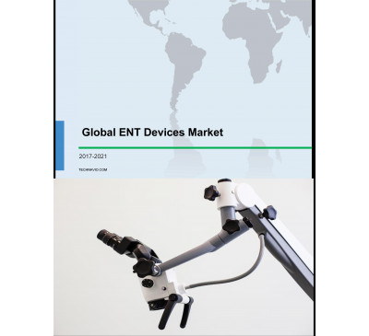

Global ENT Devices Market 2017-2021
- Jul 2017
- 89 pages
- USD 3500USD 2500
Overview of the global ENT devices market According to Technavio’s market research report, the gl...
View Report
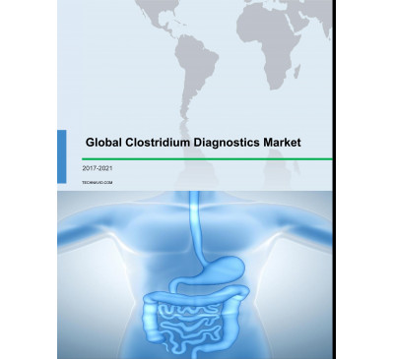

Global Clostridium Diagnostics Market 2017-2021
- Jul 2017
- 91 pages
- USD 3500USD 2500
Overview of the global clostridium diagnostics market According to Technavio’s market research re...
View Report

Global Injectable Drugs Market 2017-2021
- Jul 2017
- 84 pages
- USD 3500USD 2500
Overview of the global injectable drugs market According to Technavio’s market research report, t...
View Report
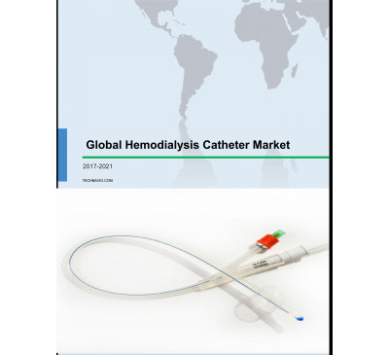

Global Hemodialysis Catheters Market 2017-2021
- Jul 2017
- 92 pages
- USD 3500USD 2500
Overview of the global hemodialysis catheters market Research analysis on the global hemodialysis...
View Report

Global Neonatal Incubators Market 2017-2021
- Jul 2017
- 87 pages
- USD 3500USD 2500
Overview of the global neonatal incubators market The increasing focus of the government on the r...
View Report
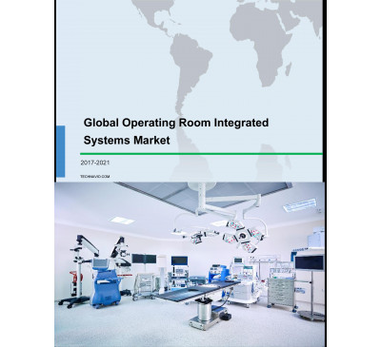

Global Operating Room Integrated Systems Market 2017-2021
- Jul 2017
- 80 pages
- USD 3500USD 2500
Overview of the global operating room integrated systems market Research analysis on the global o...
View Report

Global Schizophrenia Therapeutics Market 2017-2021
- Jul 2017
- 81 pages
- USD 3500USD 2500
Overview of the global schizophrenia therapeutics market Research analysis on the global schizoph...
View Report
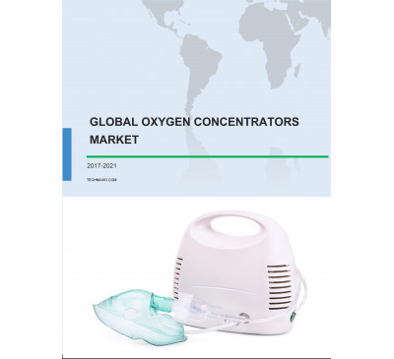

Global Oxygen Concentrators Market 2017-2021
- Jul 2017
- 94 pages
- USD 3500USD 2500
Overview of the global oxygen concentrators market Technavio’s market research report identifies ...
View Report
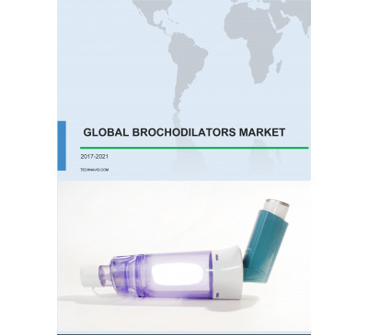

Global Bronchodilators Market 2017-2021
- Jul 2017
- 83 pages
- USD 3500USD 2500
Overview of the global bronchodilators market Research analysis on the global bronchodilators mar...
View Report
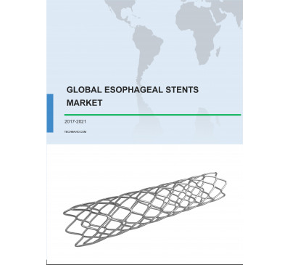

Global Esophageal Stents Market 2017-2021
- Jul 2017
- 94 pages
- USD 3500USD 2500
Overview of the global esophageal stents market Research analysis on the global esophageal stents...
View Report

Global Direct-to-consumer Genetic Testing Market 2017-2021
- Jul 2017
- 117 pages
- USD 3500USD 2500
Overview of the global direct-to-consumer genetic testing market This market study identifies th...
View Report
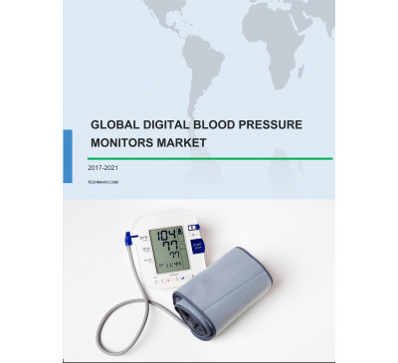

Global Digital Blood Pressure Monitors Market 2017-2021
- Jul 2017
- 106 pages
- USD 3500USD 2500
Overview of the global digital blood pressure monitors market Technavio’s market study analysis i...
View Report

Regenerative Medicine Market In The US 2017-2021
- Jul 2017
- 107 pages
- USD 3500USD 2500
Overview of the regenerative medicine market in the US According to Technavio’s market research r...
View Report
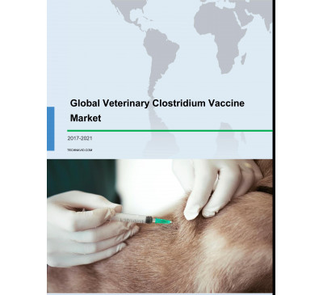

Global Veterinary Clostridium Vaccine Market 2017-2021
- Jul 2017
- 76 pages
- USD 3500USD 2500
Overview of the global veterinary Clostridium vaccine market According to Technavio’s market rese...
View Report
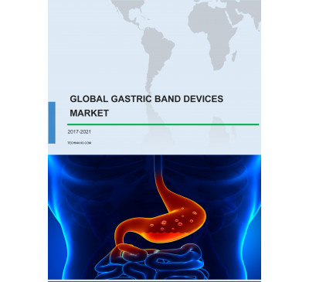

Global Gastric Band Devices Market 2017-2021
- Jul 2017
- 94 pages
- USD 3500USD 2500
Overview of the global gastric band devices market According to Technavio’s market research repor...
View Report

Global Dementia And Movement Disorder Treatment Market 2017-2021
- Jul 2017
- 102 pages
- USD 3500USD 2500
Overview of the global dementia and movement disorder treatment market Market research analysts a...
View Report

Global Patient Handling Equipment Market 2017-2021
- Jul 2017
- 101 pages
- USD 3500USD 2500
Overview of the global patient handling equipment market Market research analysts at Technavio pr...
View Report

Global Dental Surgical Equipment Market 2017-2021
- Jul 2017
- 88 pages
- USD 3500USD 2500
Overview of the global dental surgical equipment market According to Technavio’s market research ...
View Report

Global Liver Disease Treatment Market 2017-2021
- Jul 2017
- 98 pages
- USD 3500USD 2500
Overview of the global liver disease treatment market According to Technavio’s market research re...
View Report

Global Helicobacter Pylori Diagnostics Market 2017-2021
- Jul 2017
- 70 pages
- USD 3500USD 2500
Overview of the global helicobacter pylori diagnostics market According to Technavio’s market res...
View Report
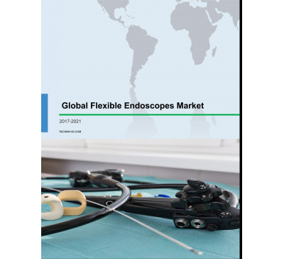

Global Flexible Endoscopes Market 2017-2021
- Jul 2017
- 102 pages
- USD 3500USD 2500
Overview of the global flexible endoscopes market According to Technavio’s market research report...
View Report

Global Single-use Negative Pressure Wound Therapy Devices Market 2017-2021
- Jul 2017
- 100 pages
- USD 3500USD 2500
Overview of the global single-use negative pressure wound therapy devices market Market research ...
View Report
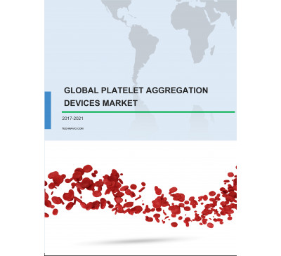

Global Platelet Aggregation Devices Market 2017-2021
- Jul 2017
- 77 pages
- USD 3500USD 2500
Overview of the global platelet aggregation devices market According to Technavio’s market resear...
View Report
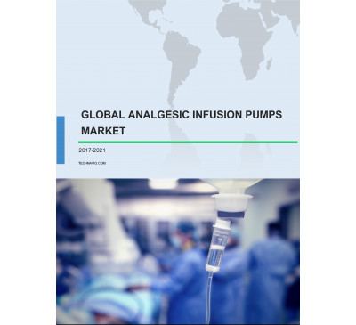

Global Analgesic Infusion Pumps Market 2017-2021
- Jul 2017
- 70 pages
- USD 3500USD 2500
Overview of the global analgesic infusion pumps market Market research analysts at Technavio...
View Report
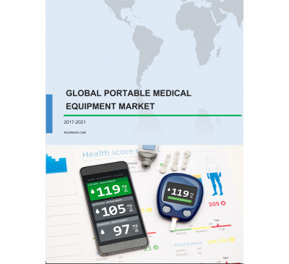

Global Portable Medical Equipment Market 2017-2021
- Jul 2017
- 70 pages
- USD 3500USD 2500
Overview of the global portable medical equipment market Market research analysts at Technavio pr...
View Report

Global Orthodontic Equipment And Consumables Market 2017-2021
- Jul 2017
- 89 pages
- USD 3500USD 2500
Overview of the global orthodontic equipment and consumables market Market research analysts at T...
View Report

Global Retinal Drugs Market 2017-2021
- Jul 2017
- 70 pages
- USD 3500USD 2500
Overview of the global retinal drugs market Market research analysts at Technavio predict that th...
View Report
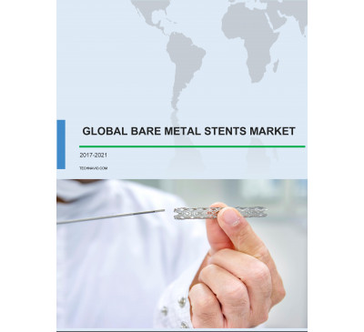

Global Bare Metal Stents Market 2017-2021
- Jul 2017
- 73 pages
- USD 3500USD 2500
Overview of the global bare metal stent market Market research analysts at Technavio predict that...
View Report

Global Alzheimer’s Drugs Market 2017-2021
- Jul 2017
- 70 pages
- USD 3500USD 2500
Overview of the global Alzheimer’s drugs market Market research analysts at Technavio predict tha...
View Report

Global Organ Transplant Immunosuppressant Market 2017-2021
- Jul 2017
- 128 pages
- USD 3500USD 2500
Overview of the global organ transplant immunosuppressant market According to Technavio’s market ...
View Report
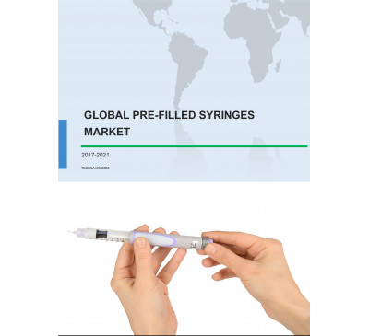

Global Pre-filled Syringes Market 2017-2021
- Jul 2017
- 94 pages
- USD 3500USD 2500
Overview of the global pre-filled syringes market Market research analysts at Technavio predict t...
View Report
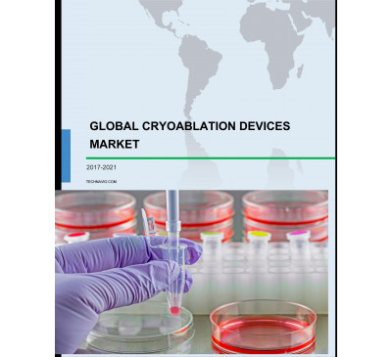

Global Cryoablation Devices Market 2017-2021
- Jul 2017
- 82 pages
- USD 3500USD 2500
Overview of the global cryoablation devices market Market research analysts at Technavio predict ...
View Report
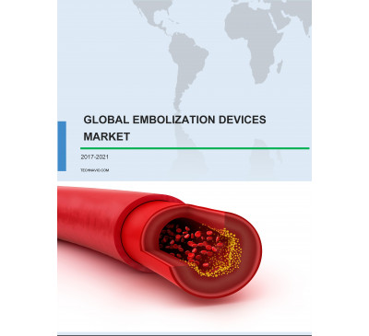

Global Embolization Devices Market 2017-2021
- Jul 2017
- 70 pages
- USD 3500USD 2500
Overview of the global embolization devices market Market research analysts at Technavio predict ...
View Report

Global Castration-Resistant Prostate Cancer (CRPC) Treatment Market 2017-2021
- Jul 2017
- 87 pages
- USD 3500USD 2500
Overview of the global castration-resistant prostate cancer (CRPC) treatment market According to ...
View Report
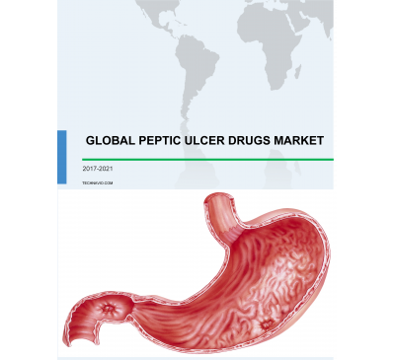

Global Peptic Ulcer Drugs Market 2017-2021
- Jul 2017
- 84 pages
- USD 3500USD 2500
Overview of the global peptic ulcer drugs market Market research analysts at Technavio predict th...
View Report
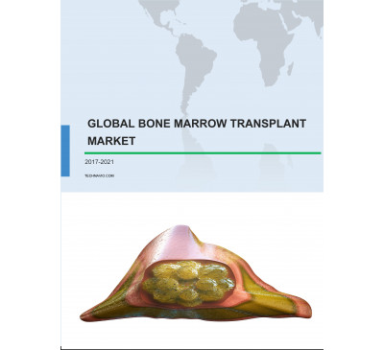

Global Bone Marrow Transplant Market 2017-2021
- Jul 2017
- 78 pages
- USD 3500USD 2500
Overview of the global bone marrow transplant market According to Technavio’s market research rep...
View Report

Global Coronary Guidewires Market 2017-2021
- Jul 2017
- 70 pages
- USD 3500USD 2500
Overview of the global coronary guidewires market Market research analysts at Technavio predict ...
View Report
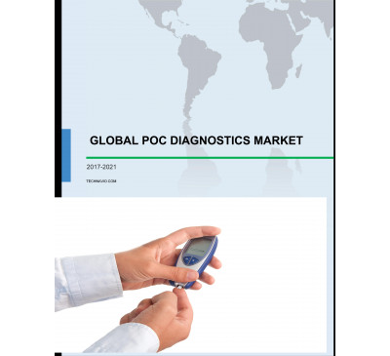

Global POC Diagnostics Market 2017-2021
- Jul 2017
- 70 pages
- USD 3500USD 2500
Overview of the global POC diagnostics market Market research analysts at Technavio predict that ...
View Report

Global Urology Guidewires Market 2017-2021
- Jun 2017
- 88 pages
- USD 3500USD 2500
Overview of the global urology guidewires market According to Technavio’s market research report,...
View Report

Global Brain Monitoring Devices Market 2017-2021
- Jun 2017
- 95 pages
- USD 3500USD 2500
Overview of the global brain monitoring devices market According to Technavio’s market research r...
View Report

Global Overactive Bladder Therapeutics Market 2017-2021
- Jun 2017
- 96 pages
- USD 3500USD 2500
Overview of the global overactive bladder (OAB) therapeutics market According to Techna.....
View Report

Global Hydrocolloid Dressing Market 2017-2021
- Jun 2017
- 71 pages
- USD 3500USD 2500
Overview of the global hydrocolloid dressing market Market research analysts at Technavio predict...
View Report

Global Surgical Ablation Market 2017-2021
- Jun 2017
- 93 pages
- USD 3500USD 2500
Overview of the global surgical ablation market According to Technavio’s market research report, ...
View Report
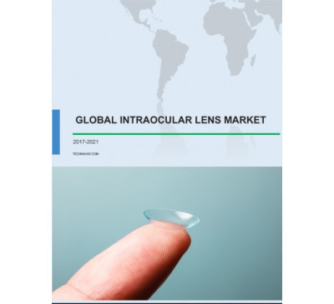

Global Intraocular Lens (IOLs) Market 2017-2021
- Jun 2017
- 72 pages
- USD 3500USD 2500
Overview of the global intraocular lens (IOLs) market According to Technavio’s market research re...
View Report

Global Clostridium Difficile Treatment Market 2017-2021
- Jun 2017
- 70 pages
- USD 3500USD 2500
Overview of the global clostridium difficile treatment market Market research analysts at Technav...
View Report

Global Celiac Disease Drugs Market 2017-2021
- Jun 2017
- 76 pages
- USD 3500USD 2500
Overview of the global celiac disease drugs market Market research analysts at Technavio predict ...
View Report

Global Surgical Lasers Market 2017-2021
- Jun 2017
- 113 pages
- USD 3500USD 2500
Overview of the global surgical lasers market Market research analysts at Technavio predict that ...
View Report
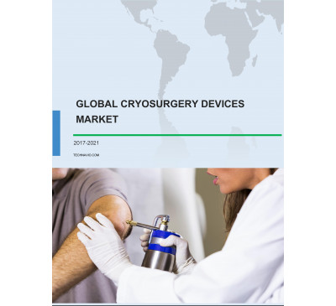

Global Cryosurgery Devices Market 2017-2021
- Jun 2017
- 85 pages
- USD 3500USD 2500
Overview of the global cryosurgery devices market According to Technavio’s market research report...
View Report

Global Scleroderma Treatment Market 2017-2021
- Jun 2017
- 83 pages
- USD 3500USD 2500
Overview of the global scleroderma treatment market According to Technavio’s market research repo...
View Report

Global Hernia Repair Devices Market 2017-2021
- Jun 2017
- 102 pages
- USD 3500USD 2500
Overview of the global hernia repair devices market According to Technavio’s market research repo...
View Report
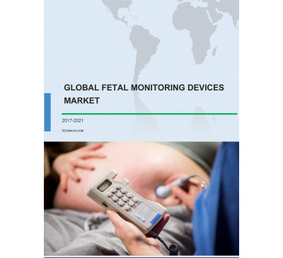

Global Fetal Monitoring Devices Market 2017-2021
- Jun 2017
- 84 pages
- USD 3500USD 2500
Overview of the global fetal monitoring devices market Market research analysts at Technavio pred...
View Report
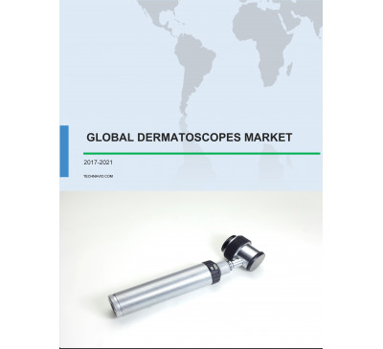

Global Dermatoscopes Market 2017-2021
- Jun 2017
- 82 pages
- USD 3500USD 2500
Overview of the global dermatoscopes market Market research analysts at Technavio predict that th...
View Report
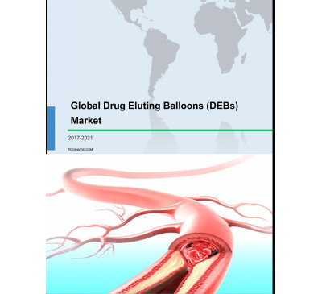

Global Drug Eluting Balloons (DEBs) Market 2017-2021
- Jun 2017
- 90 pages
- USD 3500USD 2500
Overview of the global drug-eluting balloons (DEBs) market According to Technavio’s market resear...
View Report
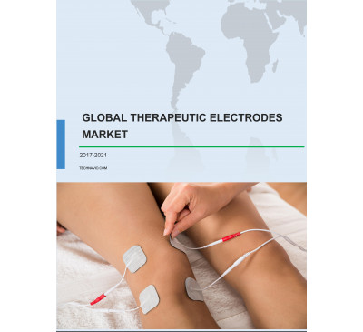

Global Therapeutic Electrodes Market 2017-2021
- Jun 2017
- 88 pages
- USD 3500USD 2500
Overview of the global therapeutic electrodes market Market research analysts at Technavio predic...
View Report
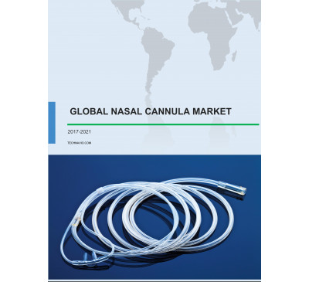

Global Nasal Cannula Market 2017-2021
- Jun 2017
- 85 pages
- USD 3500USD 2500
Overview of the global nasal cannula market According to Technavio’s market research report, the ...
View Report
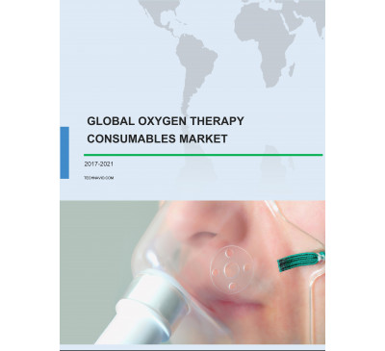

Global Oxygen Therapy Consumables Market 2017-2021
- Jun 2017
- 77 pages
- USD 3500USD 2500
Overview of the global oxygen therapy consumables market According to Technavio’s market research...
View Report
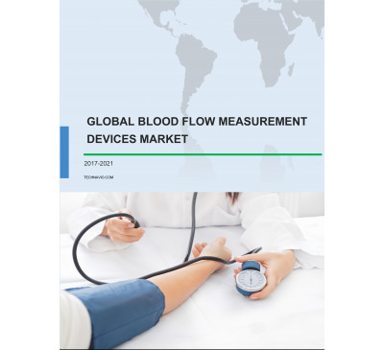

Global Blood Flow Measurement Devices Market 2017-2021
- Jun 2017
- 110 pages
- USD 3500USD 2500
Overview of the global blood flow measurement devices market According to Technavio’s market rese...
View Report
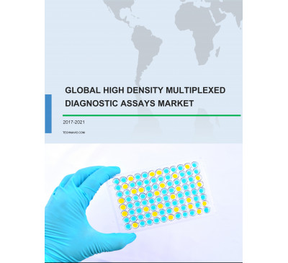

Global High-density Multiplexed Diagnostic Assays Market 2017-2021
- Jun 2017
- 89 pages
- USD 3500USD 2500
Overview of the global high-density multiplexed diagnostic assays market According to Technavio’s...
View Report
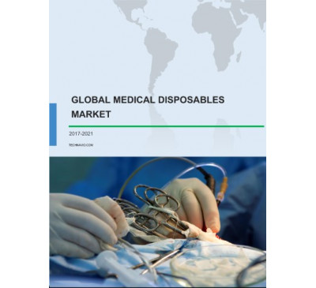

Global Medical Disposables Market 2017-2021
- Jun 2017
- 144 pages
- USD 3500USD 2500
Overview of the global medical disposables market According to Technavio’s market research report...
View Report

Global Vasculitis Treatment Market 2017-2021
- Jun 2017
- 78 pages
- USD 3500USD 2500
Overview of the global vasculitis treatment market According to Technavio’s market research repor...
View Report

Global Surgical Sealants And Adhesives Market 2017-2021
- Jun 2017
- 84 pages
- USD 3500USD 2500
Overview of the global surgical sealants and adhesives market Market research analysts at Technav...
View Report

Global Needle-Free Drug Delivery Market 2017-2021
- Jun 2017
- 70 pages
- USD 3500USD 2500
Overview of the global needle-free drug delivery market According to Technavio’s market research ...
View Report

Global Antiemetic Drug Market 2017-2021
- Jun 2017
- 70 pages
- USD 3500USD 2500
Overview of the global antiemetic drug market Market research analysts at Technavio predict that ...
View Report

Global Animal Wound Care Market 2017-2021
- Jun 2017
- 71 pages
- USD 3500USD 2500
Overview of the global animal wound care market Market research analysts at Technavio predict tha...
View Report

Global Substance Abuse Treatment Market 2017-2021
- Jun 2017
- 73 pages
- USD 3500USD 2500
Overview of the global substance abuse treatment market Market research analysts at Technavio pre...
View Report

Global Anti-inflammatory Therapeutics Market 2017-2021
- Jun 2017
- 98 pages
- USD 3500USD 2500
Overview of the global anti-inflammatory therapeutics market Market research analysts at Technavi...
View Report
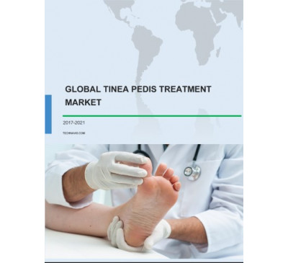

Global Tinea Pedis Treatment Market 2017-2021
- Jun 2017
- 71 pages
- USD 3500USD 2500
Overview of the global tinea pedis treatment market Market research analysts at Technavio predict...
View Report

Global Human Combination Vaccines Market 2017-2021
- Jun 2017
- 86 pages
- USD 3500USD 2500
Overview of the global human combination vaccines market Market research analysts at Technavio pr...
View Report

Global Dental Restoration Market 2017-2021
- Jun 2017
- 85 pages
- USD 3500USD 2500
Overview of the global dental restoration market Market research analysts at Technavio predict th...
View Report

Global Herpes Treatment Market 2017-2021
- Jun 2017
- 82 pages
- USD 3500USD 2500
Overview of the global herpes treatment market According to Technavio’s market research report, t...
View Report
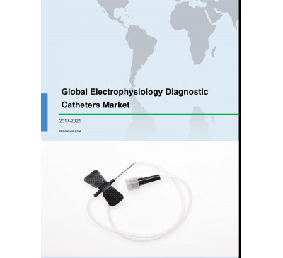

Global Electrophysiology Diagnostic Catheters Market 2017-2021
- Jun 2017
- 70 pages
- USD 3500USD 2500
Overview of the global electrophysiology diagnostic catheters market According to Technavio’s mar...
View Report

Global Head And Neck Cancer Treatment Market 2017-2021
- Jun 2017
- 79 pages
- USD 3500USD 2500
Overview of the global head and neck cancer treatment market According to Technavio’s market rese...
View Report
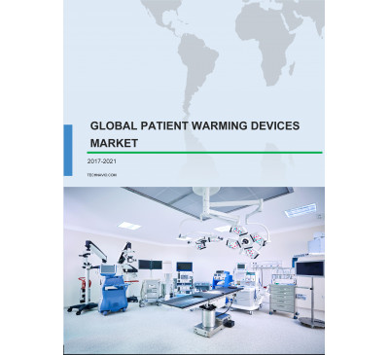

Global Patient Warming Devices Market 2017-2021
- Jun 2017
- 100 pages
- USD 3500USD 2500
Overview of the global patient warming devices market According to Technavio’s market research re...
View Report

Global Infusion Pumps Market 2017-2021
- Jun 2017
- 107 pages
- USD 3500USD 2500
Overview of the global infusion pumps market Market research analysts at Technavio predict that t...
View Report
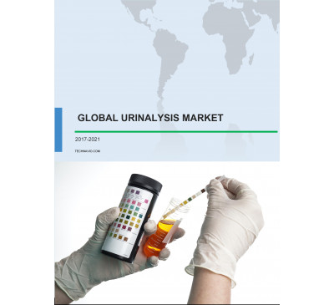

Global Urinalysis Market 2017-2021
- Jun 2017
- 70 pages
- USD 3500USD 2500
Overview of the global urinalysis market According to Technavio’s market research report, the glo...
View Report
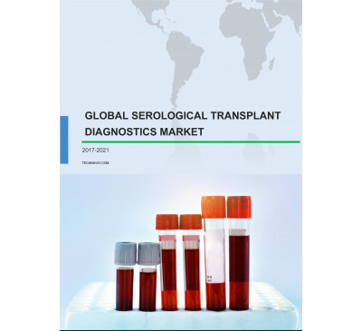

Global Serological Transplant Diagnostics Market 2017-2021
- Jun 2017
- 106 pages
- USD 3500USD 2500
Overview of the global serological transplant diagnostics market According to Technavio’s market ...
View Report

Global Autologous Cell Therapy Market 2017-2021
- Jun 2017
- 70 pages
- USD 3500USD 2500
Overview of the global autologous cell therapy market According to Technavio’s market research re...
View Report

Global Mechanical Thrombectomy Devices Market 2017-2021
- Jun 2017
- 83 pages
- USD 3500USD 2500
Overview of the mechanical thrombectomy devices market Market research analysts at Technavio pred...
View Report

Global Safety Needles Market 2017-2021
- Jun 2017
- 109 pages
- USD 3500USD 2500
Overview of the global safety needles market According to Technavio’s market research report, the...
View Report
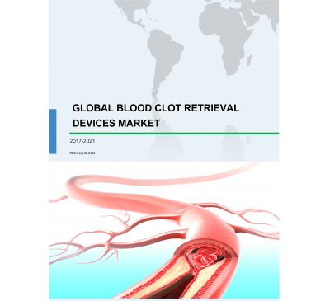

Global Blood Clot Retrieval Devices Market 2017-2021
- Jun 2017
- 70 pages
- USD 3500USD 2500
Overview of the global blood clot retrieval devices market According to Technavio’s market resear...
View Report

Global Vitamin D Testing Market 2017-2021
- Jun 2017
- 85 pages
- USD 3500USD 2500
Overview of the global vitamin D testing market According to Technavio’s market research report, ...
View Report
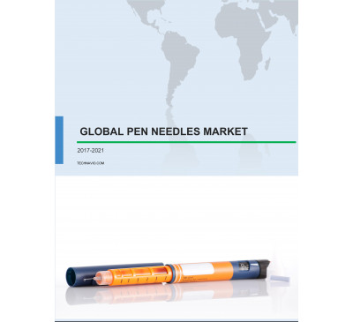

Global Pen Needles Market 2017-2021
- Jun 2017
- 70 pages
- USD 3500USD 2500
Overview of the global pen needles market Market research analysts at Technavio predict that the ...
View Report

Global Lupus Therapeutic Market 2017-2021
- Jun 2017
- 70 pages
- USD 3500USD 2500
Overview of the global lupus therapeutic market Market research analysts at Technavio predict tha...
View Report

Global Antipsychotic Drugs Market 2017-2021
- Jun 2017
- 70 pages
- USD 3500USD 2500
Overview of the global antipsychotic drugs market According to Technavio’s market research report...
View Report

Global Lymphoma Drugs Market 2017-2021
- Jun 2017
- 70 pages
- USD 3500USD 2500
Overview of the global lymphoma drugs market According to Technavio’s market research report, the...
View Report

Global Periodontal Dental Services Market 2017-2021
- Jun 2017
- 83 pages
- USD 3500USD 2500
Overview of the global periodontal dental services market According to Technavio’s market researc...
View Report

Epilepsy Therapeutic Market In APAC 2017-2021
- Jun 2017
- 81 pages
- USD 3500USD 2500
Overview of the epilepsy therapeutic market in APAC According to Technavio’s market research repo...
View Report

Global Short Bowel Syndrome (SBS) Market 2017-2021
- May 2017
- 70 pages
- USD 3500USD 2500
Overview of the global short bowel syndrome (SBS) market Market research analysts at Technavio p...
View Report

Global Orthopedic Consumables Market 2017-2021
- May 2017
- 70 pages
- USD 3500USD 2500
Overview of the global orthopedic consumables market Market research analysts at Technavio predi...
View Report

Global Urolithiasis Management Devices Market 2017-2021
- May 2017
- 70 pages
- USD 3500USD 2500
Overview of the global urolithiasis management devices market Market research analysts at Techna...
View Report
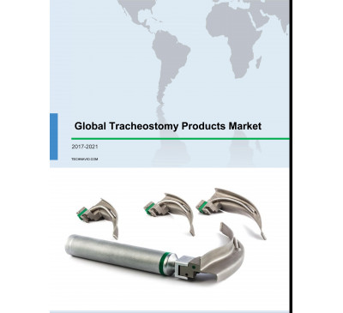

Global Tracheostomy Products Market 2017-2021
- May 2017
- 70 pages
- USD 3500USD 2500
Overview of the global tracheostomy products market Market research analysts at Technavio predict...
View Report
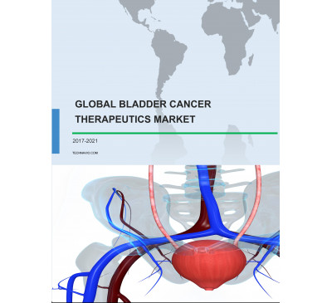

Global Bladder Cancer Therapeutics Market 2017-2021
- May 2017
- 70 pages
- USD 3500USD 2500
Overview of the global bladder cancer therapeutics market According to Technavio’s market researc...
View Report

Global Intravenous Immunoglobulins Market 2017-2021
- May 2017
- 70 pages
- USD 3500USD 2500
Overview of the global intravenous immunoglobulins market According to Technavio’s market researc...
View Report

Global Dental Fittings Market 2017-2021
- May 2017
- 70 pages
- USD 3500USD 2500
Overview of the global dental fittings market Market research analysts at Technavio predict that ...
View Report
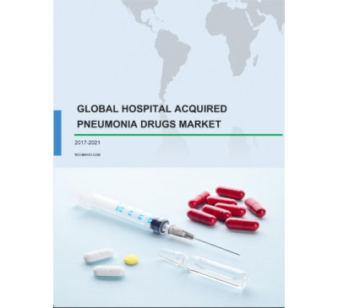

Global Hospital-acquired Pneumonia (HAP) Drugs Market 2017-2021
- May 2017
- 70 pages
- USD 3500USD 2500
Overview of the global hospital-acquired pneumonia (HAP) drugs market Market research analysts a...
View Report

Global Coronary Atherectomy Devices Market 2017-2021
- May 2017
- 70 pages
- USD 3500USD 2500
Overview of the global coronary atherectomy devices market Technavio’s market research report pre...
View Report

Global Orthopedic Prosthetics Market 2017-2021
- May 2017
- 70 pages
- USD 3500USD 2500
Overview of the global orthopedic prosthetics market According to Technavio’s market research rep...
View Report

Global Anti-nuclear Antibody (ANA) Testing Market 2017-2021
- May 2017
- 70 pages
- USD 3500USD 2500
Overview of the global anti-nuclear antibody (ANA) testing market According to Technavio’s market...
View Report
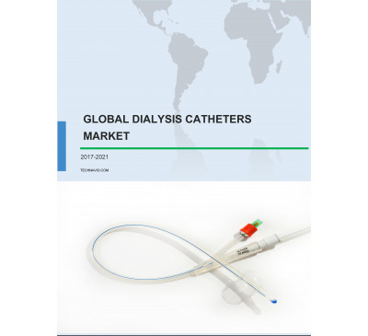

Global Dialysis Catheters Market 2017-2021
- May 2017
- 70 pages
- USD 3500USD 2500
Overview of the global dialysis catheters market According to Technavio’s market research report,...
View Repor
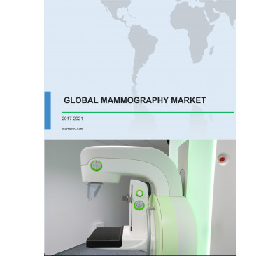

Global Mammography Market 2017-2021
- May 2017
- 70 pages
- USD 3500USD 2500
Overview of the global mammography market According to Technavio’s market research report, the gl...
View Report

Global Dental Adhesives Market 2017-2021
- May 2017
- 70 pages
- USD 3500USD 2500
Overview of the global dental adhesives market Market research analysts at Technavio predict that...
View Report
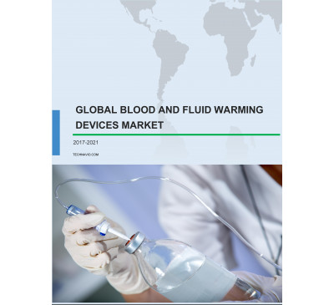

Global Blood And Fluid Warming Devices Market 2017-2021
- May 2017
- 70 pages
- USD 3500USD 2500
Overview of the global blood and fluid warming devices market Market research analysts at Techna...
View Report
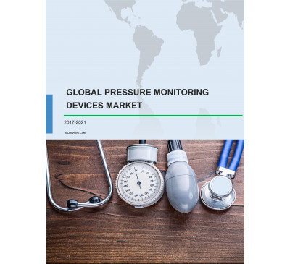

Global Pressure Monitoring Devices Market 2017-2021
- May 2017
- 70 pages
- USD 3500USD 2500
Overview of the global pressure monitoring devices market According to Technavio’s market researc...
View Report

Global Orthodontic Services Market 2017-2021
- May 2017
- 70 pages
- USD 3500USD 2500
Overview of the global orthodontic services market Technavio’s market research report predicts th...
View Report

Global Dental Lasers Market 2017-2021
- May 2017
- 70 pages
- USD 3500USD 2500
Overview of the global dental lasers market Technavio’s market research analyst predicts that the...
View Report
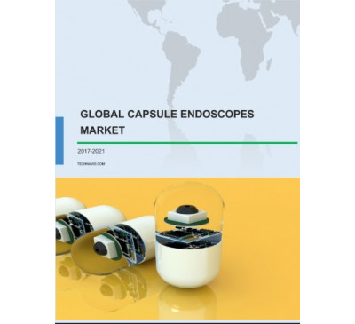

Global Capsule Endoscopes Market 2017-2021
- May 2017
- 70 pages
- USD 3500USD 2500
Overview of the global capsule endoscopes market According to Technavio’s market research report,...
View Report
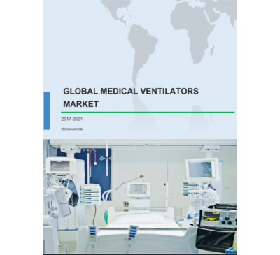

Global Medical Ventilators Market 2017-2021
- May 2017
- 70 pages
- USD 3500USD 2500
Overview of the global medical ventilators market The increasing demand for non-invasive ventilat...
View Report

Global Spinal Trauma Devices Market 2017-2021
- May 2017
- 70 pages
- USD 3500USD 2500
Overview of the global spinal trauma devices market According to Technavio’s market research repo...
View Report
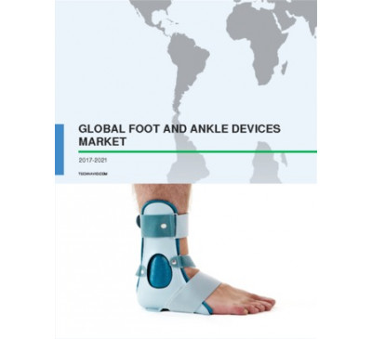

Global Foot And Ankle Devices Market 2017-2021
- May 2017
- 70 pages
- USD 3500USD 2500
Overview of the global foot and ankle devices market Technavio’s market research report predicts ...
View Report
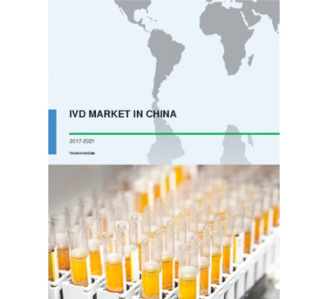

IVD Market In China 2017-2021
- May 2017
- 70 pages
- USD 3500USD 2500
Overview of the IVD market in China Market research analysts at Technavio predict that the in-vi...
View Report

Global Airway Management Products Market 2017-2021
- May 2017
- 70 pages
- USD 3500USD 2500
Overview of the global airway management products market As per Technavio’s market research repor...
View Report

Global Allergy Rhinitis Drugs Market 2017-2021
- May 2017
- 70 pages
- USD 3500USD 2500
Overview of the global allergy rhinitis drugs market Market research analysts at Technavio predi...
View Report

Global ENT Disorder Treatment Market 2017-2021
- May 2017
- 70 pages
- USD 3500USD 2500
Overview of the global ENT disorder treatment market Market research analysts at Technavio predic...
View Report
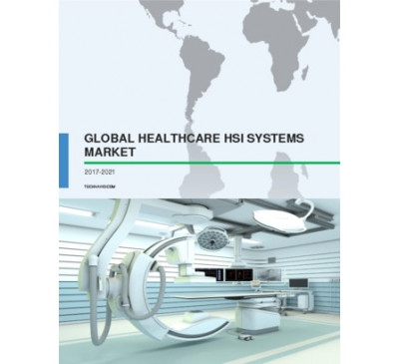

Global Healthcare Hyperspectral Imaging (HSI) Systems Market 2017-2021
- May 2017
- 70 pages
- USD 3500USD 2500
Overview of the global healthcare hyperspectral imaging (HSI) systems market As per the Technavio...
View Report

Global Women's Health Diagnostics Market 2017-2021
- May 2017
- 70 pages
- USD 3500USD 2500
Overview of the global women's health diagnostics market As per the Technavio’s market research r...
View Report

Dental Diagnostic And Surgical Equipment Market In China 2017-2021
- May 2017
- 70 pages
- USD 3500USD 2500
Overview of the dental diagnostic and surgical equipment market in China Technavio’s market resea...
View Report
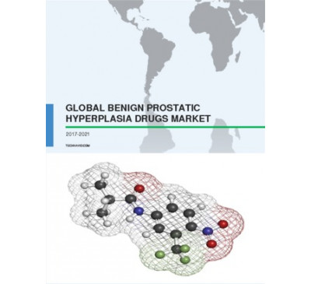

Global Benign Prostatic Hyperplasia (BPH) Drugs Market 2017-2021
- May 2017
- 70 pages
- USD 3500USD 2500
Overview of the global BPH drugs market As per the Technavio’s market research report, the global...
View Report
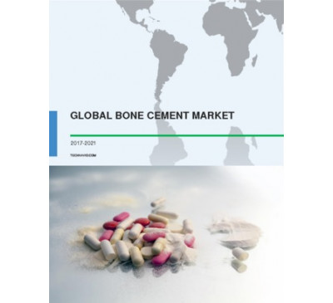

Global Bone Cement Market 2017-2021
- May 2017
- 70 pages
- USD 3500USD 2500
Overview of the global bone cement market As per the Technavio’s market research report, the glob...
View Report
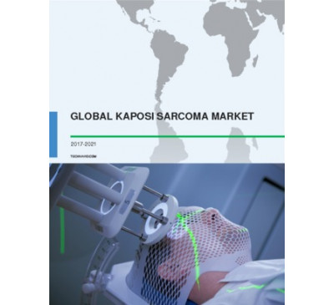

Global Kaposi Sarcoma Market 2017-2021
- May 2017
- 70 pages
- USD 3500USD 2500
Overview of the global kaposi sarcoma market As per the Technavio’s market research report, the g...
View Report

Global Anxiety And Panic Disorders Drugs Market 2017-2021
- May 2017
- 70 pages
- USD 3500USD 2500
Overview of the global anxiety and panic disorders drugs market As per the Technavio’s market res...
View Report

Global Orthopedic Bracing And Support Systems Market 2017-2021
- May 2017
- 70 pages
- USD 3500USD 2500
Overview of the global orthopedic bracing and support systems market As per the Technavio’s marke...
View Report
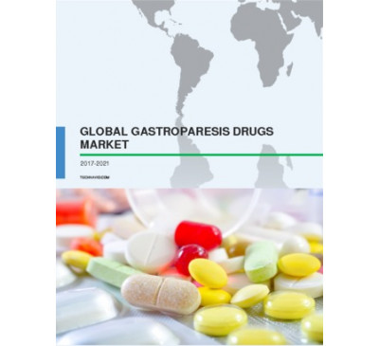

Global Gastroparesis Drugs Market 2017-2021
- May 2017
- 70 pages
- USD 3500USD 2500
Overview of the global gastroparesis drugs market As per the Technavio’s market research report, ...
View Report

Global Rabies Treatment Market 2017-2021
- May 2017
- 70 pages
- USD 3500USD 2500
Overview of the global rabies treatment market Technavio’s market research report predicts that t...
View Report

Global Veterinary Vaccines Market 2017-2021
- May 2017
- 70 pages
- USD 3500USD 2500
Overview of the global veterinary vaccines market As per the Technavio’s market research report, ...
View Report

Global Fluid Management Devices Market 2017-2021
- Apr 2017
- 70 pages
- USD 3500USD 2500
Overview of the global fluid management devices market Technavio’s market research report predict...
View Report

Global Neutropenia Treatment Market 2017-2021
- Apr 2017
- 70 pages
- USD 3500USD 2500
Overview of the global neutropenia treatment market Technavio’s market research report predicts t...
View Report

Global Swine Health Market 2017-2021
- Apr 2017
- 70 pages
- USD 3500USD 2500
Overview of the global swine health market As per the Technavio’s market research report, the glo...
View Report

Global Echocardiography Market 2017-2021
- Apr 2017
- 70 pages
- USD 3500USD 2500
Overview of the global echocardiography market Technavio’s market research report predicts that t...
View Report

Global Botanical And Plant-Derived Drugs Market 2017-2021
- Apr 2017
- 70 pages
- USD 3500USD 2500
Overview of the global botanical and plant-derived drugs market Technavio’s market research repor...
View Report

Global Clinical Chemistry Analyzers Market 2017-2021
- Apr 2017
- 70 pages
- USD 3500USD 2500
Overview of the global clinical chemistry analyzers market Market research analysts at Technavio ...
View Report

Global Cardiac Ablation Market 2017-2021
- Apr 2017
- 70 pages
- USD 3500USD 2500
Overview of the global cardiac ablation market Technavio’s market research analyst predicts the g...
View Report

Global Cosmetic Dentistry Market 2017-2021
- Apr 2017
- 70 pages
- USD 3500USD 2500
Overview of the global cosmetic dentistry market Market research analysts at Technavio predict th...
View Report
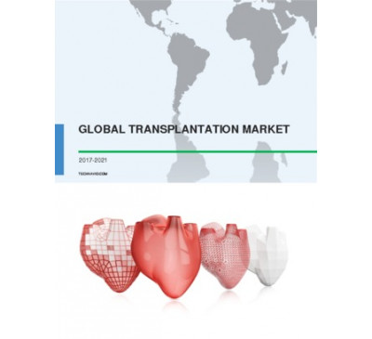

Global Transplantation Market 2017-2021
- Apr 2017
- 70 pages
- USD 3500USD 2500
Overview of the global transplantation market Technavio’s market research report predicts that th...
View Report

Global Dialyzer Market 2017-2021
- Apr 2017
- 70 pages
- USD 3500USD 2500
Overview of the global dialyzer market As per the Technavio’s market research report, the global ...
View Report
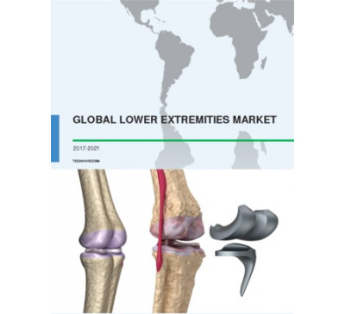

Global Lower Extremities Market 2017-2021
- Apr 2017
- 70 pages
- USD 3500USD 2500
Overview of the global lower extremities market Technavio’s market research analyst predicts the ...
View Report
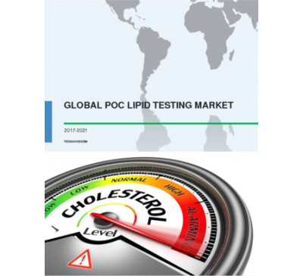

Global POC Lipid Testing Market 2017-2021
- Apr 2017
- 70 pages
- USD 3500USD 2500
Overview of the global POC lipid testing market As per the Technavio’s market research report, th...
View Report

Global Cerebrospinal Fluid (CSF) Management Devices Market 2017-2021
- Apr 2017
- 70 pages
- USD 3500USD 2500
Overview of the global CSF management devices market According to Technavio’s market research rep...
View Report

Global Inferior Vena Cava (IVC) Filter Market 2017-2021
- Apr 2017
- 70 pages
- USD 3500USD 2500
Overview of the global inferior vena cava (IVC) filter market Market research analysts at Technav...
View Report

Global HLA Typing Transplant Market 2017-2021
- Apr 2017
- 70 pages
- USD 3500USD 2500
Overview of the global HLA typing transplant market Technavio’s market research report predicts t...
View Report

Global Therapeutic Drug Monitoring Market 2017-2021
- Apr 2017
- 70 pages
- USD 3500USD 2500
Overview of the global therapeutic drug monitoring market As per the Technavio’s market research ...
View Report

Global Bipolar Disorder Therapeutic Market 2017-2021
- Apr 2017
- 70 pages
- USD 3500USD 2500
Overview of the global bipolar disorder therapeutic market According to Technavio’s analyst, the ...
View Report

Global Pulmonary Arterial Hypertension (PAH) Drugs Market 2017-2021
- Apr 2017
- 70 pages
- USD 3500USD 2500
Overview of the global PAH drugs market As per the Technavio’s market research report, the global...
View Report

Global Implantable Ports Market 2017-2021
- Apr 2017
- 70 pages
- USD 3500USD 2500
Overview of the global implantable ports market Technavio’s market research analyst predicts the ...
View Report

Global Intravenous Iron Drugs Market 2017-2021
- Apr 2017
- 70 pages
- USD 3500USD 2500
Overview of the global intravenous iron drugs market According to Technavio’s analyst, the global...
View Report
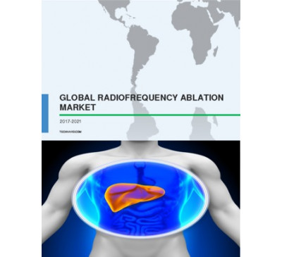

Global Radiofrequency Ablation Market 2017-2021
- Apr 2017
- 70 pages
- USD 3500USD 2500
Overview of the global radiofrequency ablation market As per the Technavio’s market research repo...
View Report

Global Gynecology Surgical Devices Market 2017-2021
- Apr 2017
- 70 pages
- USD 3500USD 2500
Overview of the global gynecology surgical devices market Technavio’s market research report pred...
View Report

Global Coronary Stents Market 2017-2021
- Apr 2017
- 70 pages
- USD 3500USD 2500
Overview of the global coronary stents market According to Technavio’s analyst, the global corona...
View Report

Global Cell Culture Protein Surface Coating Market 2017-2021
- Apr 2017
- 70 pages
- USD 3500USD 2500
Overview of the global cell culture protein surface coating market According to Technavio’s analy...
View Report

Global Urology Surgery Supplies Market 2017-2021
- Apr 2017
- 70 pages
- USD 3500USD 2500
Overview of the global urology surgery supplies market Technavio’s market research report predict...
View Report

Global Knee Replacement Devices Market 2017-2021
- Apr 2017
- 70 pages
- USD 3500USD 2500
Overview of the global knee replacement devices market Technavio’s market research analyst predic...
View Report
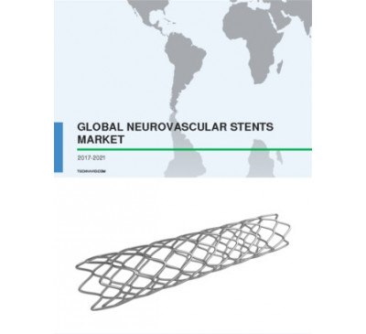

Global Neurovascular Stents Market 2017-2021
- Apr 2017
- 70 pages
- USD 3500USD 2500
Overview of the global neurovascular stents market Technavio’s market research report predicts th...
View Report
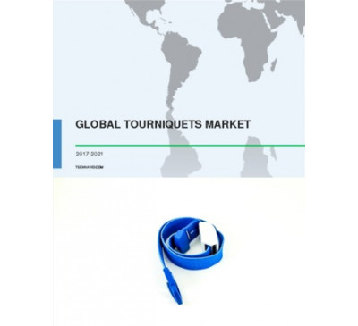

Global Tourniquets Device Market 2017-2021
- Apr 2017
- 70 pages
- USD 3500USD 2500
Overview of the global tourniquets device market Technavio’s market research report predicts that...
View Report

Global Botulinum Toxin Market 2017-2021
- Apr 2017
- 70 pages
- USD 3500USD 2500
Overview of the global botulinum toxin market According to Technavio’s analyst, the global botuli...
View Report
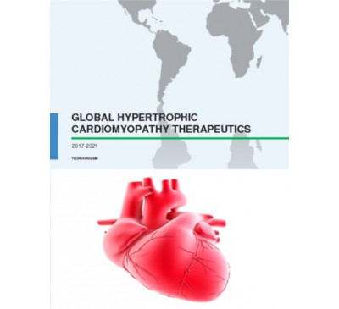

Global Hypertrophic Cardiomyopathy Therapeutics Market 2017-2021
- Apr 2017
- 70 pages
- USD 3500USD 2500
Overview of the global hypertrophic cardiomyopathy therapeutics market According to Technavio’s a...
View Report
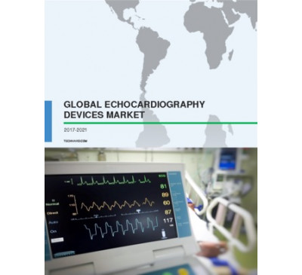

Global Echocardiography (ECG) Devices Market 2017-2021
- Apr 2017
- 70 pages
- USD 3500USD 2500
Overview of the global echocardiography (ECG) devices market Technavio’s market research analyst ...
View Report

Global Orphan Drugs Market 2017-2021
- Apr 2017
- 70 pages
- USD 3500USD 2500
Overview of the global orphan drugs market Technavio’s market research report predicts that the g...
View Report

Global Upper Extremities Market 2017-2021
- Mar 2017
- 70 pages
- USD 3500USD 2500
Overview of the global upper extremities market Technavio’s market research analyst predicts the ...
View Report
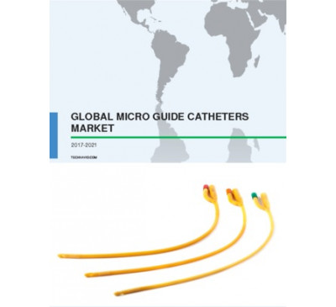

Global Micro Guide Catheters Market 2017-2021
- Mar 2017
- 70 pages
- USD 3500USD 2500
Overview of the global micro guide catheters market According to Technavio’s analyst, the global ...
View Report

Global Surgical Waste Management Market 2017-2021
- Mar 2017
- 70 pages
- USD 3500USD 2500
Overview of the global surgical waste management market Technavio’s market research analyst .....
View Report

Global Dental Consumables Market 2017-2021
- Mar 2017
- 70 pages
- USD 3500USD 2500
Overview of the global dental consumables market Technavio’s market research analyst predicts the...
View Report
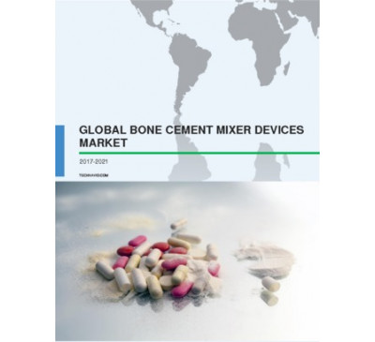

Global Bone Cement Mixer Devices Market 2017-2021
- Mar 2017
- 70 pages
- USD 3500USD 2500
Overview of the global bone cement mixer devices market Technavio’s market research report predic...
View Report

Global Angiography Catheters Market 2017-2021
- Mar 2017
- 70 pages
- USD 3500USD 2500
Overview of the global angiography catheters market Technavio’s market research analyst predicts ...
View Report
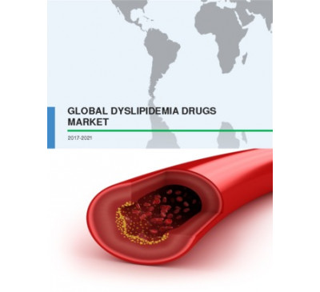

Global Dyslipidemia Drugs Market 2017-2021
- Mar 2017
- 70 pages
- USD 3500USD 2500
Overview of the global dyslipidemia drugs market Technavio’s market research report predicts that...
View Report

Global Biobanking Market 2017-2021
- Mar 2017
- 70 pages
- USD 3500USD 2500
Overview of the global biobanking market Technavio’s market research analyst predicts the global&...
View Report

Global Interventional Oncology Market 2017-2021
- Mar 2017
- 70 pages
- USD 3500USD 2500
Overview of the global interventional oncology market According to Technavio’s analyst, the globa...
View Report
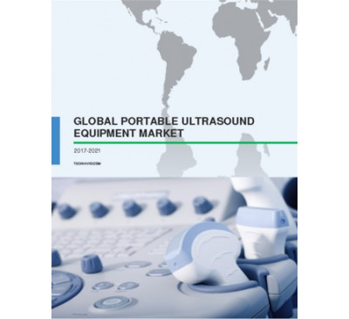

Global Portable Ultrasound Equipment Market 2017-2021
- Mar 2017
- 70 pages
- USD 3500USD 2500
Overview of the global portable ultrasound equipment market Technavio’s market research analyst a...
View Report
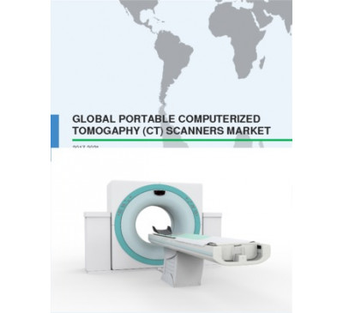

Global Portable Computerized Tomography Scanners Market 2017-2021
- Mar 2017
- 70 pages
- USD 3500USD 2500
Overview of the global portable computerized tomography (CT) scanners market Technavio’s market r...
View Report

Global Thyroid Gland Disorder Treatment Market 2017-2021
- Mar 2017
- 70 pages
- USD 3500USD 2500
Overview of the global thyroid gland disorder treatment market Technavio’s market research report...
View Report

Global Ear-Based Hearing Aids Market 2017-2021
- Mar 2017
- 70 pages
- USD 3500USD 2500
Overview of the global ear-based hearing aids market Technavio’s market research analyst predicts...
View Report

Global Foot And Mouth Disease Vaccines Market 2017-2021
- Mar 2017
- 70 pages
- USD 3500USD 2500
Overview of the global foot and mouth disease (FMD) vaccines market Technavio’s market research a...
View Report
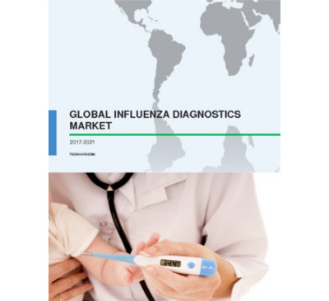

Global Influenza Diagnostics Market 2017-2021
- Mar 2017
- 70 pages
- USD 3500USD 2500
Overview of the global influenza diagnostics market Technavio’s market research analyst predicts ...
View Report
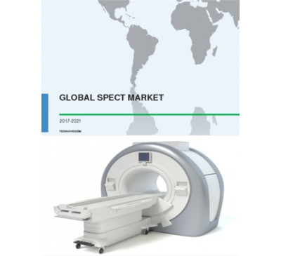

Global SPECT Market 2017-2021
- Mar 2017
- 70 pages
- USD 3500USD 2500
Overview of the global SPECT market Technavio’s market research analyst predicts the global singl...
View Report

Global Optical Coherence Tomography Market 2017-2021
- Mar 2017
- 70 pages
- USD 3500USD 2500
Overview of the global OCT market According to Technavio’s analysts, the global OCT market is ant...
View Report
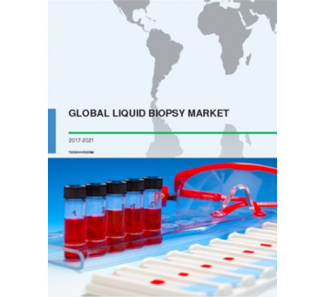

Global Liquid Biopsy Market 2017-2021
- Mar 2017
- 70 pages
- USD 3500USD 2500
Overview of the global liquid biopsy market Technavio’s market research analyst predicts the glob...
View Report

Global Surgical Stapling Devices Market 2017-2021
- Mar 2017
- 70 pages
- USD 3500USD 2500
Overview of the global surgical stapling devices market Technavio’s market research report p.....
View Report
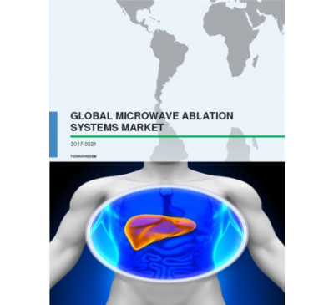

Global Microwave Ablation Systems Market 2017-2021
- Mar 2017
- 70 pages
- USD 3500USD 2500
Overview of the microwave ablation systems market Technavio’s market research analyst predicts th...
View Report
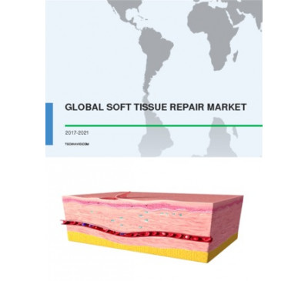

Global Soft Tissue Repair Market 2017-2021
- Mar 2017
- 70 pages
- USD 3500USD 2500
Overview of the global soft tissue repair market Technavio’s market research analyst predicts the...
View Report

Global Snoring Control Devices Market 2017-2021
- Mar 2017
- 70 pages
- USD 3500USD 2500
Overview of the global snoring control devices market Technavio’s market research report pr.....
View Report
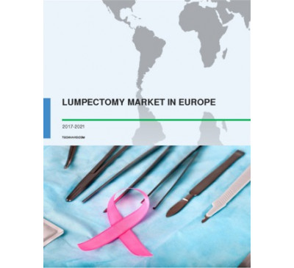

Lumpectomy Market In Europe 2017-2021
- Mar 2017
- 70 pages
- USD 3500USD 2500
Overview of the lumpectomy market in Europe Technavio’s market research analyst predicts the ...
View Report
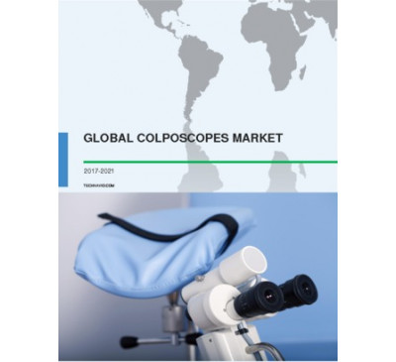

Global Colposcopes Market 2017-2021
- Mar 2017
- 70 pages
- USD 3500USD 2500
Overview of the global colposcopes market Technavio’s market research analyst predicts the global...
View Report

Global Animal Parasiticides Market 2017-2021
- Mar 2017
- 70 pages
- USD 3500USD 2500
Overview of the global animal parasiticides market Technavio’s market research report predicts th...
View Report

Global Bovine Respiratory Disease Treatment 2017-2021
- Mar 2017
- 70 pages
- USD 3500USD 2500
Overview of the global BRD treatment market According to Technavio’s analyst, the global BRD trea...
View Report

Global Arthroscopy Devices Market 2017-2021
- Mar 2017
- 70 pages
- USD 3500USD 2500
Overview of the global arthroscopy devices market According to Technavio’s analyst, the global ar...
View Report
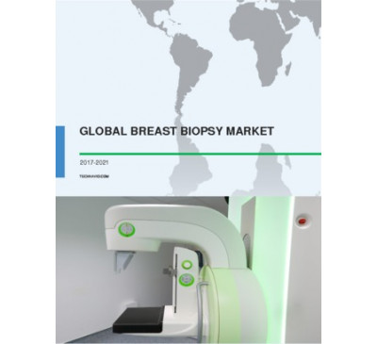

Global Breast Biopsy Market 2017-2021
- Mar 2017
- 70 pages
- USD 3500USD 2500
Overview of the global breast biopsy market According to Technavio’s analyst, the global breast b...
View Report

Global Antiviral Drugs Market 2017-2021
- Mar 2017
- 70 pages
- USD 3500USD 2500
Overview of the global antiviral drugs market Technavio’s market research analyst predicts the gl...
View Report
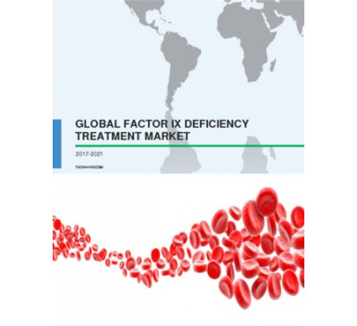

Global Factor IX Deficiency Treatment Market 2017-2021
- Mar 2017
- 70 pages
- USD 3500USD 2500
Overview of the global factor IX deficiency treatment market Technavio’s market research analyst ...
View Report

Global Microbiology Testing Market 2017-2021
- Mar 2017
- 70 pages
- USD 3500USD 2500
Overview of the global microbiology testing market Technavio’s market research analyst predicts t...
View Report

Global IVF Devices Market 2017-2021
- Mar 2017
- 70 pages
- USD 3500USD 2500
Overview of the global IVF devices market Technavio’s market research report predicts that the gl...
View Report

Global Neuropathy Pain Treatment Market 2017-2021
- Mar 2017
- 70 pages
- USD 3500USD 2500
Overview of the global neuropathy pain treatment market Technavio’s market research analyst predi...
View Report

Global Muscle Relaxant Drugs Market 2017-2021
- Mar 2017
- 70 pages
- USD 3500USD 2500
Overview of the global muscle relaxant drugs market Technavio’s market research analyst predicts ...
View Report
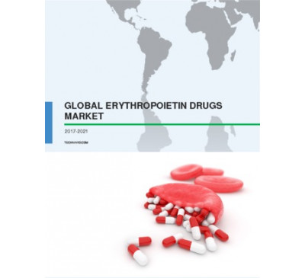

Global Erythropoietin Drugs Market 2017-2021
- Mar 2017
- 70 pages
- USD 3500USD 2500
Overview of the global erythropoietin drugs market Technavio’s market research analyst predicts t...
View Report
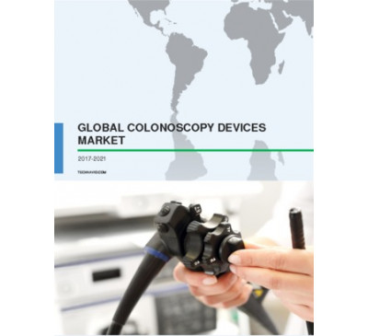

Global Colonoscopy Devices Market 2017-2021
- Mar 2017
- 70 pages
- USD 3500USD 2500
Overview of the global colonoscopy devices market Technavio’s market research analyst predicts th...
View Report
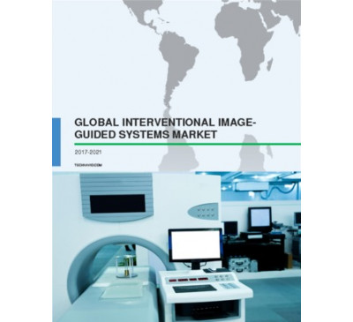

Global Interventional Image-Guided Systems Market 2017-2021
- Mar 2017
- 70 pages
- USD 3500USD 2500
Overview of the global interventional image-guided systems market Technavio’s market research ana...
View Report
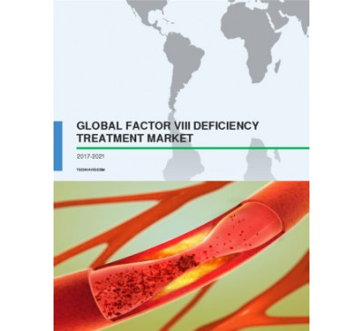

Global Factor VIII Deficiency Treatment Market 2017-2021
- Mar 2017
- 70 pages
- USD 3500USD 2500
Overview of the global factor VIII deficiency treatment market According to Technavio’s analyst, ...
View Report

Global Intraoperative Neuromonitoring Market 2017-2021
- Mar 2017
- 70 pages
- USD 3500USD 2500
Overview of the global intraoperative neuromonitoring (IONM) market Technavio’s market research a...
View Report

Global Lifestyle Drugs Market 2017-2021
- Feb 2017
- 70 pages
- USD 3500USD 2500
Overview of the lifestyle drugs market According to the market research analysts at Technavio, th...
View Report
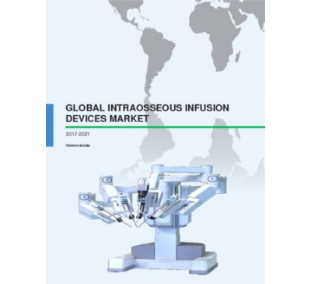

Global Intraosseous Infusion Devices Market 2017-2021
- Feb 2017
- 90 pages
- USD 3500USD 2500
Overview of the global intraosseous infusion devices market According to Technavio’s anal.....
View Report
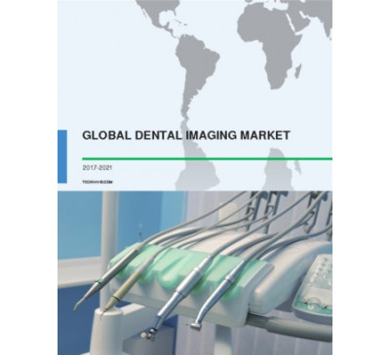

Global Dental Imaging Market 2017-2021
- Feb 2017
- 103 pages
- USD 3500USD 2500
Overview of the global dental imaging market Technavio’s market research analyst predicts the glo...
View Report
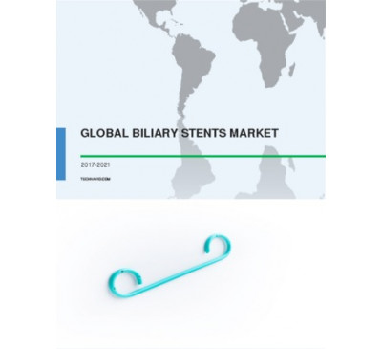

Global Biliary Stents Market 2017-2021
- Feb 2017
- 98 pages
- USD 3500USD 2500
Overview of the global biliary stents market According to Technavio’s analyst, the global.....
View Report

Global Canal Hearing Aids Market 2017-2021
- Feb 2017
- 78 pages
- USD 3500USD 2500
Overview of the global canal hearing aids market Technavio’s market research analyst pred.....
View Report

Global Anatomic Pathology Testing Market 2017-2021
- Feb 2017
- 95 pages
- USD 3500USD 2500
Overview of the global anatomic pathology testing market According to the Technavio’s ana.....
View Report
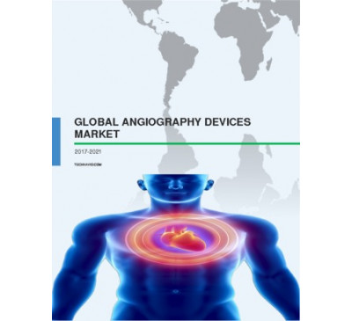

Global Angiography Devices Market 2017-2021
- Feb 2017
- 117 pages
- USD 3500USD 2500
Overview of the global angiography devices market According to the Technavio’s analyst, t.....
View Report

Global Pneumonia Testing Market 2017-2021
- Feb 2017
- 117 pages
- USD 3500USD 2500
Overview of the global pneumonia testing market Market research analysts at Technavio predict t...
View Report
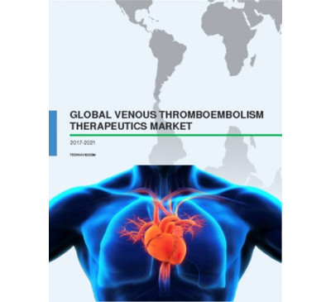

Global Venous Thromboembolism Therapeutics Market 2017-2021
- Feb 2017
- 82 pages
- USD 3500USD 2500
Overview of the venous thromboembolism (VTE) therapeutics market According to the market rese...
View Repor

Global Epinephrine Autoinjector Market 2017-2021
- Feb 2017
- 84 pages
- USD 3500USD 2500
Overview of the global epinephrine autoinjector market Technavio’s market research analys.....
View Report

Global Hybrid Imaging Market 2017-2021
- Feb 2017
- 91 pages
- USD 3500USD 2500
Overview of the global hybrid imaging market According to the Technavio’s analyst, the gl.....
View Report
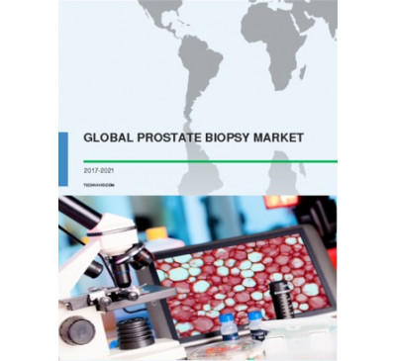

Global Prostate Biopsy Market 2017-2021
- Feb 2017
- 97 pages
- USD 3500USD 2500
Overview of the global prostate biopsy market Market research analysts at Technavio predict tha...
View Report

Global Medical Laser Systems Market 2017-2021
- Feb 2017
- 127 pages
- USD 3500USD 2500
Overview of the global medical laser systems market According to the Technavio’s analyst,.....
View Report

Global Anticoagulant Market 2017-2021
- Feb 2017
- 79 pages
- USD 3500USD 2500
Overview of the global anticoagulant market Technavio’s market research analyst predicts .....
View Report
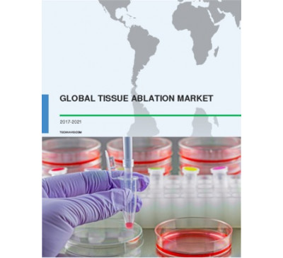

Global Tissue Ablation Market 2017-2021
- Feb 2017
- 111 pages
- USD 3500USD 2500
Overview of the global tissue ablation market According to the Technavio’s analyst, the g.....
View Report
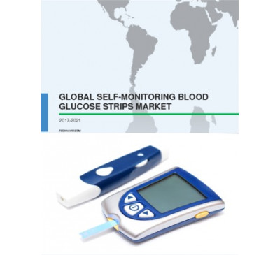

Global Self-Monitoring Blood Glucose Strips Market 2017-2021
- Feb 2017
- 75 pages
- USD 3500USD 2500
Overview of the global SMBG strips market According to the Technavio’s analyst, the globa.....
View Report

Global Picture Archiving And Communication System Market 2017-2021
- Feb 2017
- 100 pages
- USD 3500USD 2500
Overview of the global PACS market According to Technavio’s analysts, the global PACS mar.....
View Report
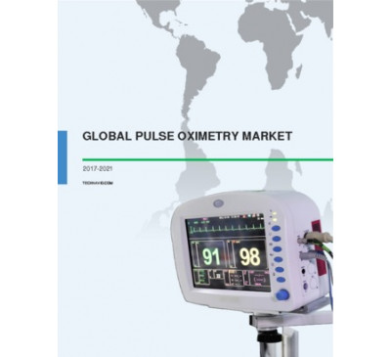

Global Pulse Oximetry Market 2017-2021
- Feb 2017
- 85 pages
- USD 3500USD 2500
Overview of the global pulse oximetry market Technavio’s market research analyst predicts the glo...
View Report
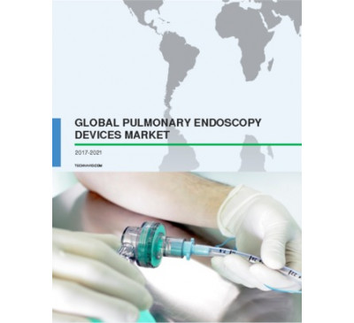

Global Pulmonary Endoscopy Devices Market 2017-2021
- Feb 2017
- 95 pages
- USD 3500USD 2500
Overview of the global pulmonary endoscopy devices market According to the Technavio’s .....
View Report

Global Antifungal Drugs Market 2017-2021
- Feb 2017
- 91 pages
- USD 3500USD 2500
Overview of the global antifungal drugs market Market research analysts at Technavio predict th...
View Report
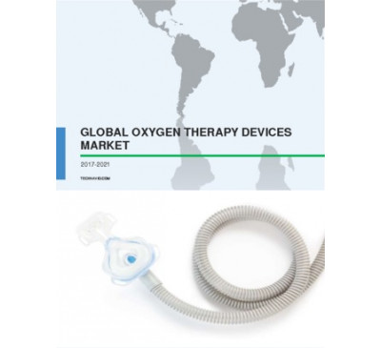

Global Oxygen Therapy Devices Market 2017-2021
- Feb 2017
- 103 pages
- USD 3500USD 2500
Overview of the global oxygen therapy devices market According to the Technavio’s analyst.....
View Report

Global Blood Glucose Monitoring Devices Market 2017-2021
- Feb 2017
- 86 pages
- USD 3500USD 2500
Overview of the global blood glucose monitoring (BGM) devices market The global blood glucose mon...
View Report

Global Tuberculosis Drug Market 2017-2021
- Feb 2017
- 76 pages
- USD 3500USD 2500
Global outlook of the tuberculosis (TB) drug market Technavio’s market research analysts predict ...
View Report

Global Ultrasonic Aspirator Market 2017-2021
- Feb 2017
- 90 pages
- USD 3500USD 2500
Overview of the global ultrasonic aspirator market The global ultrasonic aspirator market is an...
View Report
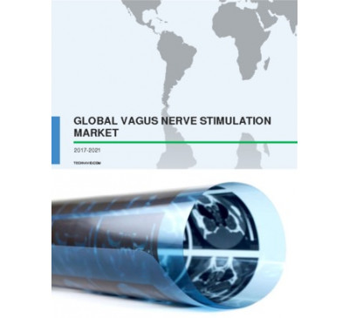

Global Vagus Nerve Stimulation Market 2017-2021
- Feb 2017
- 63 pages
- USD 3500USD 2500
Overview of the global VNS market According to the Technavio’s analyst, the global VNS ma.....
View Report

Global Blood Pressure Transducers Market 2017-2021
- Feb 2017
- 92 pages
- USD 3500USD 2500
Overview of the global blood pressure transducers market According to the Technavio’s ana.....
View Report
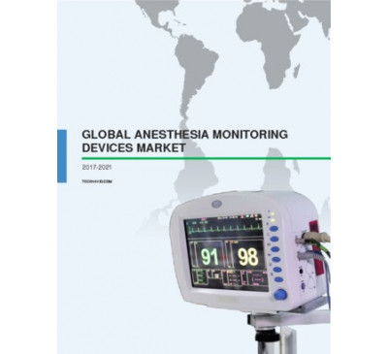

Global Anesthesia Monitoring Devices Market 2017-2021
- Feb 2017
- 109 pages
- USD 3500USD 2500
Overview of the anesthesia monitoring devices market Technavio’s market research analysts.....
View Report
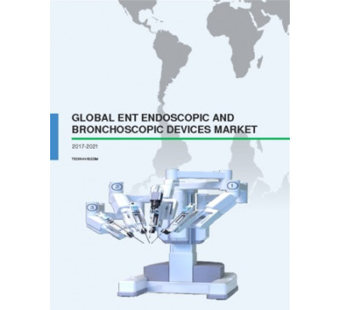

Global ENT Endoscopic And Bronchoscopic Devices Market 2017-2021
- Feb 2017
- 76 pages
- USD 3500USD 2500
Overview of the global ENT endoscopic and bronchoscopic devices market Market research analys...
View Report

Global Sacral Nerve Stimulation Market 2017-2021
- Feb 2017
- 63 pages
- USD 3500USD 2500
Overview of the sacral nerve stimulation market Extensive research carried out by the analysts ...
View Report

Global MRI Systems Market 2017-2021
- Feb 2017
- 111 pages
- USD 3500USD 2500
Global outlook of the MRI systems market Technavio’s market research analysts predict the global ...
View Report
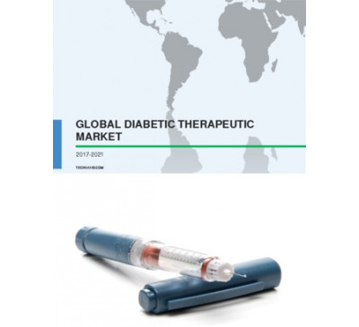

Global Diabetic Therapeutic Market 2017-2021
- Feb 2017
- 167 pages
- USD 3500USD 2500
Global outlook of the diabetic therapeutic market Technavio’s market research analysts predict th...
View Report
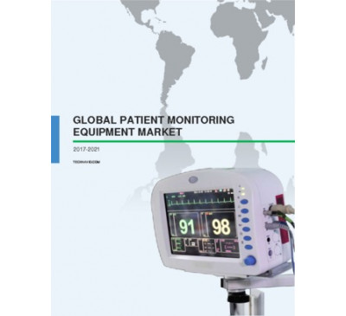

Global Patient Monitoring Equipment Market 2017-2021
- Feb 2017
- 131 pages
- USD 3500USD 2500
Overview of the global patient monitoring equipment market The global patient monitoring equipmen...
View Report

Global Coagulation Testing Market 2017-2021
- Jan 2017
- 81 pages
- USD 3500USD 2500
Overview of the global coagulation testing market The global coagulation testing market is antici...
View Report
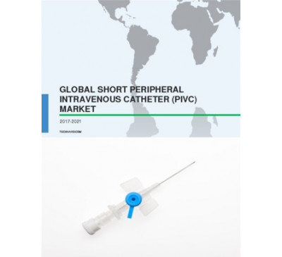

Global Short Peripheral Intravenous Catheter Market 2017-2021
- Jan 2017
- 93 pages
- USD 3500USD 2500
Overview of the global short peripheral intravenous catheter (PIVC) market Technavio’s market res...
View Report
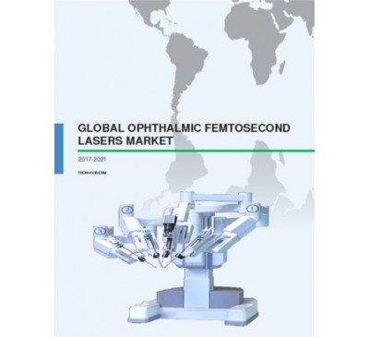

Global Ophthalmic Femtosecond Lasers Market 2017-2021
- Jan 2017
- 94 pages
- USD 3500USD 2500
Overview of the ophthalmic femtosecond lasers market Technavio’s market research analyst predicts...
View Report

Global MRSA Testing Market 2017-2021
- Jan 2017
- 70 pages
- USD 3500USD 2500
Overview of the global MRSA testing market The global MRSA testing market is anticipated to grow ...
View Report

Global Stem Cell Therapy Market 2017-2021
- Jan 2017
- 70 pages
- USD 3500USD 2500
Overview of the global stem cell therapy market Technavio’s market research analyst pre.....
View Report
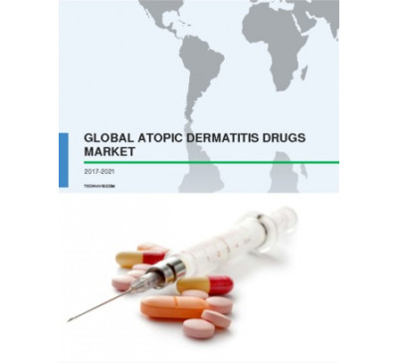

Global Atopic Dermatitis Drugs Market 2017-2021
- Jan 2017
- 68 pages
- USD 3500USD 2500
Overview of the global atopic dermatitis drugs market The global atopic dermatitis drugs market i...
View Report

Global Medical Imaging Market 2017-2021
- Jan 2017
- 158 pages
- USD 3500USD 2500
Overview of the medical imaging market Extensive research carried out by the analysts at Technavi...
View Report
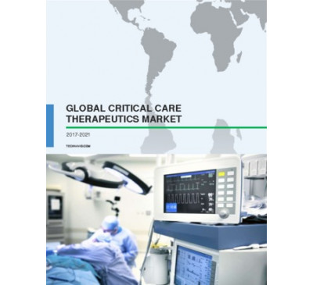

Global Critical Care Therapeutics Market 2017-2021
- Jan 2017
- 101 pages
- USD 3500USD 2500
Overview of the critical care therapeutics market According to the market research analysts at Te...
View Report

Global Bioabsorbable Stents Market 2017-2021
- Jan 2017
- 77 pages
- USD 3500USD 2500
Overview of the bio-absorbable stents market Extensive research carried out by the analysts at Te...
View Report

Global Neurology Endoscopy Devices Market 2017-2021
- Jan 2017
- 83 pages
- USD 3500USD 2500
Overview of the global neurology endoscopy devices market Technavio’s market research analyst pre...
View Report

Global Pharmerging Markets 2017-2021
- Jan 2017
- 116 pages
- USD 3500USD 2500
Overview of the global pharmerging markets Technavio’s market research analyst predicts the globa...
View Report
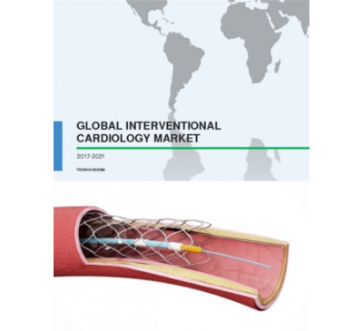

Global Interventional Cardiology Market 2017-2021
- Jan 2017
- 123 pages
- USD 3500USD 2500
Overview of the global interventional cardiology market The global interventional cardiology mark...
View Report
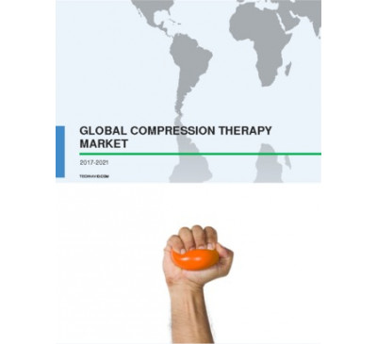

Global Compression Therapy Market 2017-2021
- Jan 2017
- 83 pages
- USD 3500USD 2500
Overview of the global compression therapy market Technavio’s market research analyst predicts th...
View Report
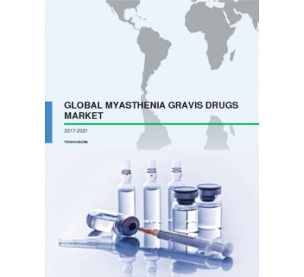

Global Myasthenia Gravis Drugs Market 2017-2021
- Jan 2017
- 73 pages
- USD 3500USD 2500
Overview of the myasthenia gravis drugs market Extensive research carried out by the market resea...
View Report

Global Anesthesia Drugs Market 2017-2021
- Jan 2017
- 85 pages
- USD 3500USD 2500
Overview of the global anesthesia drugs market The global anesthesia drugs market is anticipated ...
View Report

Global Immunodiagnostics Market 2017-2021
- Jan 2017
- 70 pages
- USD 3500USD 2500
Overview of the global immunodiagnostics market The global immunodiagnostics market is anticipate...
View Report

Global Interventional Spine Devices Market 2017-2021
- Jan 2017
- 114 pages
- USD 3500USD 2500
Overview of the global interventional spine devices market Technavio’s market research analyst pr...
View Report

Global Genomics Biomarkers Market 2017-2021
- Jan 2017
- 83 pages
- USD 3500USD 2500
Overview of the global genomics biomarkers market The global genomics biomarkers market is antici...
View Report

Interventional Spine Devices Market In The US 2017-2021
- Jan 2017
- 89 pages
- USD 3500USD 2500
Overview of the interventional spine devices market in the US Technavio’s market research analyst...
View Report
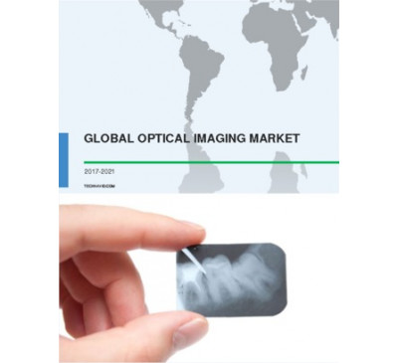

Global Optical Imaging Market 2017-2021
- Jan 2017
- 95 pages
- USD 3500USD 2500
Overview of the global optical imaging market The global optical imaging market is anticipated to...
View Report

Global Left Atrial Appendage Closure Market 2017-2021
- Jan 2017
- 115 pages
- USD 3500USD 2500
Overview of the global left atrial appendage (LAA) closure market The global LAA closure market i...
View Report
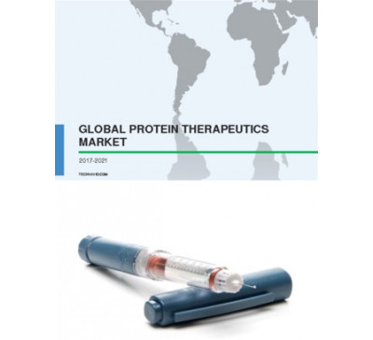

Global Protein Therapeutics Market 2017-2021
- Dec 2016
- 128 pages
- USD 3500USD 2500
Overview of the global protein therapeutics market Market research analysts at Technavio predict ...
View Report

Global Infantile Spasms Therapeutics Market 2017-2021
- Dec 2016
- 73 pages
- USD 3500USD 2500
Overview of the global infantile spasms therapeutics market The global infantile spasms therape...
View Report

Global Chemotherapy-induced Nausea And Vomiting Drugs Market 2017-2021
- Dec 2016
- 77 pages
- USD 3500USD 2500
Overview of the global chemotherapy-induced nausea and vomiting (CINV) drugs market Market rese...
View Report

Global Cancer Monoclonal Antibodies Market 2017-2021
- Dec 2016
- 115 pages
- USD 3500USD 2500
Overview of the global cancer monoclonal antibodies (mAbs) market Technavio’s market research ana...
View Report

Global Multiple Myeloma Drugs Market 2017-2021
- Dec 2016
- 86 pages
- USD 3500USD 2500
Overview of the global multiple myeloma drugs market Technavio’s market research analyst .....
View Report
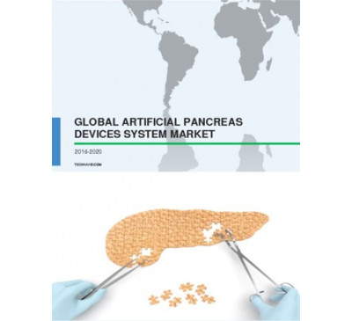

Global Artificial Pancreas Devices System Market 2016-2020
- Dec 2016
- 85 pages
- USD 2500USD 2375
Overview of the global artificial pancreas devices system market Market research analysts at Te...
View Report

Nurse Call System Market In The US 2016-2020
- Dec 2016
- 70 pages
- USD 2500USD 2375
Overview of the NCS market in the US The NCS market in the US is anticipated to grow rapidly an...
View Report

Global Laparotomy Sponges Market 2016-2020
- Dec 2016
- 60 pages
- USD 2500USD 2375
Overview of the global laparotomy sponges market The global laparotomy sponges market is antici...
View Report

Global HPV Testing Market 2016-2020
- Dec 2016
- 60 pages
- USD 2500USD 2375
Overview of the global HPV testing market The global human papillomavirus (HPV) testing market ...
View Report

Global Pompe Disease Treatment Market 2016-2020
- Dec 2016
- 65 pages
- USD 2500USD 2375
Overview of the global Pompe disease treatment market Market research analysts at Technavio pre...
View Report
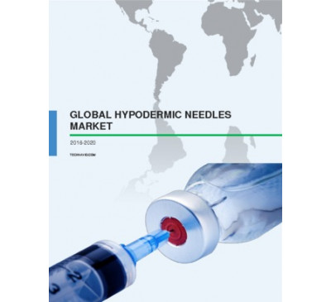

Global Hypodermic Needles Market 2016-2020
- Dec 2016
- 103 pages
- USD 2500USD 2375
Overview of the global hypodermic needles market Technavio’s market research analyst pred.....
View Report
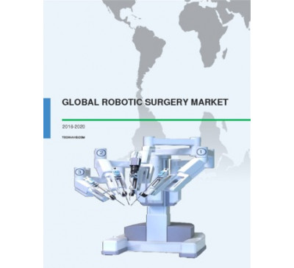

Global Robotic Surgery Market 2016-2020
- Dec 2016
- 129 pages
- USD 2500USD 2375
Global outlook of the robotic surgery market Technavio’s market research analysts predict the glo...
View Report

Global Human Respiratory Syncytial Virus Drugs Market 2016-2020
- Dec 2016
- 74 pages
- USD 2500USD 2375
Overview of the global human respiratory syncytial virus drugs market The global human respirat...
View Report
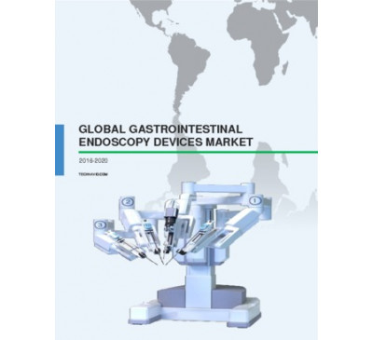

Global Gastrointestinal Endoscopy Devices Market 2016-2020
- Dec 2016
- 93 pages
- USD 2500USD 2375
Overview of the global gastrointestinal endoscopy devices market The global gastrointestinal (G...
View Report
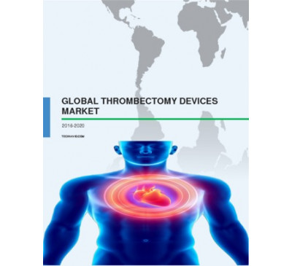

Global Thrombectomy Devices Market 2016-2020
- Dec 2016
- 91 pages
- USD 2500USD 2375
Overview of the global thrombectomy devices market The global thrombectomy devices market is an...
View Report

Surgical Navigation Systems Market In The US 2016-2020
- Dec 2016
- 102 pages
- USD 2500USD 2375
Overview of the surgical navigation systems market in the US Market research analysts at Techna...
View Report

Global Infantile Spasms Therapeutics Market 2017-2021
- Dec 2016
- 73 pages
- USD 3500USD 2500
Overview of the global infantile spasms therapeutics market The global infantile spasms therape...
View Report

Global Chemotherapy-induced Nausea And Vomiting Drugs Market 2017-2021
- Dec 2016
- 77 pages
- USD 3500USD 2500
Overview of the global chemotherapy-induced nausea and vomiting (CINV) drugs market Market rese...
View Report

Global Cancer Monoclonal Antibodies Market 2017-2021
- Dec 2016
- 115 pages
- USD 3500USD 2500
Overview of the global cancer monoclonal antibodies (mAbs) market Technavio’s market research ana...
View Report

Global Multiple Myeloma Drugs Market 2017-2021
- Dec 2016
- 86 pages
- USD 3500USD 2500
Overview of the global multiple myeloma drugs market Technavio’s market research analyst .....
View Report

Global Artificial Pancreas Devices System Market 2016-2020
- Dec 2016
- 85 pages
- USD 2500USD 2375
Overview of the global artificial pancreas devices system market Market research analysts at Te...
View Report

Nurse Call System Market In The US 2016-2020
- Dec 2016
- 70 pages
- USD 2500USD 2375
Overview of the NCS market in the US The NCS market in the US is anticipated to grow rapidly an...
View Report

Global Laparotomy Sponges Market 2016-2020
- Dec 2016
- 60 pages
- USD 2500USD 2375
Overview of the global laparotomy sponges market The global laparotomy sponges market is antici...
View Report

Global HPV Testing Market 2016-2020
- Dec 2016
- 60 pages
- USD 2500USD 2375
Overview of the global HPV testing market The global human papillomavirus (HPV) testing market ...
View Report

Global Pompe Disease Treatment Market 2016-2020
- Dec 2016
- 65 pages
- USD 2500USD 2375
Overview of the global Pompe disease treatment market Market research analysts at Technavio pre...
View Report

Global Hypodermic Needles Market 2016-2020
- Dec 2016
- 103 pages
- USD 2500USD 2375
Overview of the global hypodermic needles market Technavio’s market research analyst pred.....
View Report

Global Robotic Surgery Market 2016-2020
- Dec 2016
- 129 pages
- USD 2500USD 2375
Global outlook of the robotic surgery market Technavio’s market research analysts predict the glo...
View Report

Global Human Respiratory Syncytial Virus Drugs Market 2016-2020
- Dec 2016
- 74 pages
- USD 2500USD 2375
Overview of the global human respiratory syncytial virus drugs market The global human respirat...
View Report

Global Gastrointestinal Endoscopy Devices Market 2016-2020
- Dec 2016
- 93 pages
- USD 2500USD 2375
Overview of the global gastrointestinal endoscopy devices market The global gastrointestinal (G...
View Report

Global Thrombectomy Devices Market 2016-2020
- Dec 2016
- 91 pages
- USD 2500USD 2375
Overview of the global thrombectomy devices market The global thrombectomy devices market is an...
View Report

Surgical Navigation Systems Market In The US 2016-2020
- Dec 2016
- 102 pages
- USD 2500USD 2375
Overview of the surgical navigation systems market in the US Market research analysts at Techna...
View Report

Global Cervical Cancer Diagnostic Testing Market 2016-2020
- Dec 2016
- 111 pages
- USD 2500USD 2375
Overview of the global cervical cancer diagnostic testing market The global cervical cancer dia...
View Report

Global Neurosurgery Market 2016-2020
- Dec 2016
- 108 pages
- USD 2500USD 2375
Overview of the global neurosurgery market Technavio’s market research analyst predicts t.....
View Report

Global Electrophysiology Devices Market 2016-2020
- Dec 2016
- 105 pages
- USD 2500USD 2375
Global outlook of the electrophysiology devices market Technavio’s market research analys.....
View Report
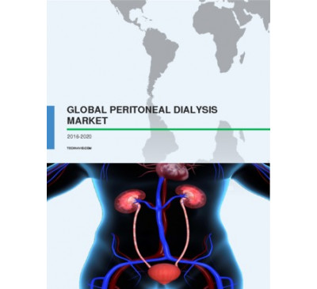

Global Peritoneal Dialysis Market 2016-2020
- Dec 2016
- 82 pages
- USD 2500USD 2375
Overview of the global peritoneal dialysis market Technavio’s market research analyst pre.....
View Report
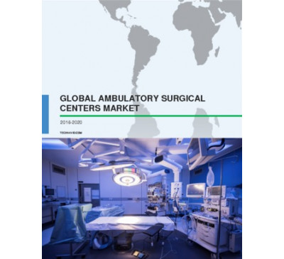

Global Ambulatory Surgical Centers Market 2016-2020
- Dec 2016
- 94 pages
- USD 2500USD 2375
Overview of the global ambulatory surgical centers market Market research analysts at Technavio...
View Report

Global Respiratory Disposable Devices Market 2016-2020
- Dec 2016
- 87 pages
- USD 2500USD 2375
Overview of the global automotive battery management system market Market research analysts at ...
View Report
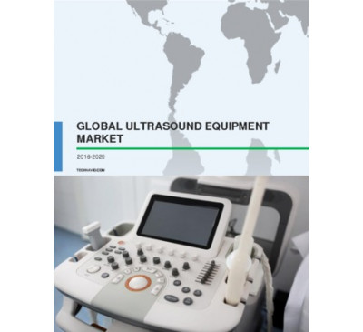

Global Ultrasound Equipment Market 2016-2020
- Dec 2016
- 115 pages
- USD 2500USD 2375
Global market overview for ultrasound equipment The global market for ultrasound equipment is e...
View Report

Global Nucleic Acid Testing Market 2016-2020
- Dec 2016
- 79 pages
- USD 2500USD 2375
Outlook of the global nucleic acid testing market The global market for nucleic acid testing wi...
View Report

Global Prostate Cancer Drugs Market 2016-2020
- Nov 2016
- 91 pages
- USD 2500USD 2375
Global outlook of the prostate cancer drugs market Technavio’s market research analysts p.....
View Report

Global Hospital-acquired Urinary Tract Infection Testing Market 2016-2020
- Nov 2016
- 57 pages
- USD 2500USD 2375
Overview of the global hospital-acquired urinary tract infection testing market Technavio&rsquo...
View Report
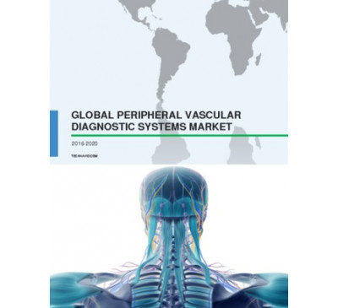

Global Peripheral Vascular Diagnostic Systems Market 2016-2020
- Nov 2016
- 90 pages
- USD 2500USD 2375
Overview of the global peripheral vascular diagnostic systems market The global peripheral va...
View Report

Global Hearing Aids Market 2016-2020
- Nov 2016
- 86 pages
- USD 2500USD 2375
Overview of the global hearing aids market The global hearing aids market is anticipated to gro...
View Report

Global Next-Generation Biologics Market 2016-2020
- Nov 2016
- 124 pages
- USD 2500USD 2375
Overview of the global next-generation biologics market According to the market research analys...
View Report

Global Gout Therapeutics Market 2016-2020
- Nov 2016
- 59 pages
- USD 2500USD 2375
Outlook of the gout therapeutics market The global market for gout therapeutics will grow at a ...
View Report

Global Travel Vaccines Market 2016-2020
- Nov 2016
- 60 pages
- USD 2500USD 2375
Overview of the travel vaccines market Technavio’s market research analysts have predicte.....
View Repor
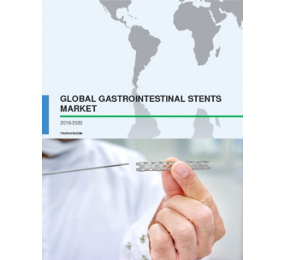

Global Gastrointestinal Stents Market 2016-2020
- Nov 2016
- 99 pages
- USD 2500USD 2375
Overview of the global gastrointestinal stents market The global gastrointestinal stents market...
View Report

Global Gynecology Robotic Surgery Market 2016-2020
- Nov 2016
- 95 pages
- USD 2500USD 2375
Overview of the global gynecology robotic surgery market The global gynecology robotic surgery ma...
View Report
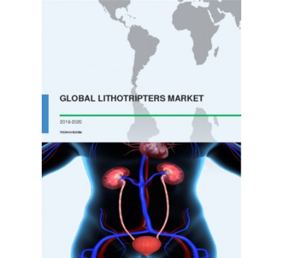

Global Lithotripters Market 2016-2020
- Nov 2016
- 82 pages
- USD 2500USD 2375
Overview of the lithotripters market According to the market research analysts at Technavio, th...
View Report
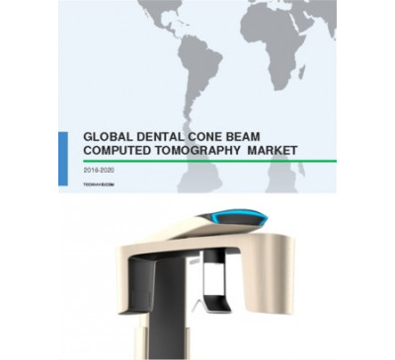

Global Dental Cone Beam Computed Tomography Market 2016-2020
- Nov 2016
- 91 pages
- USD 2500USD 2375
Overview of the dental cone-beam computed tomography (CBCT) market Extensive research carried o...
View Report
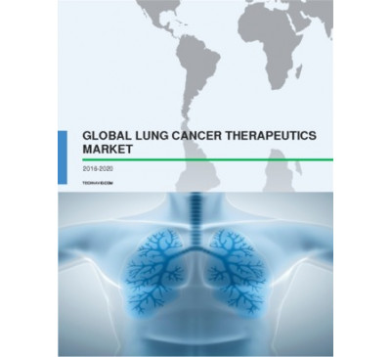

Global Lung Cancer Therapeutics Market 2016-2020
- Nov 2016
- 101 pages
- USD 2500USD 2375
Overview of the lung cancer therapeutics market According to the market research analysts at Te...
View Report

Global Minimally Invasive Spine Surgery Market 2016-2020
- Nov 2016
- 115 pages
- USD 2500USD 2375
Overview of the minimally invasive spine surgery market According to the market research analys...
View Report

Global Surgical Navigation Systems Market 2016-2020
- Nov 2016
- 94 pages
- USD 2500USD 2375
Overview of the global surgical navigation systems market According to the market research anal...
View Report

Global Alopecia Drugs Market 2016-2020
- Nov 2016
- 76 pages
- USD 2500USD 2375
Overview of the global alopecia drugs market The global alopecia drugs market is anticipated to...
View Report
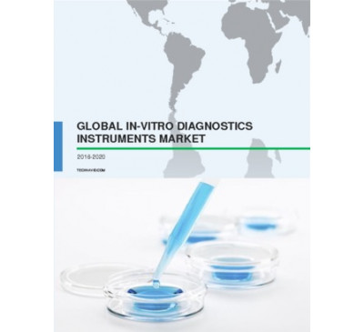

Global In-vitro Diagnostics Instruments Market 2016-2020
- Nov 2016
- 101 pages
- USD 2500USD 2375
Overview of the global in-vitro diagnostics instruments market The global in-vitro diagnostics (I...
View Report

Global Urology Robotic Surgery Market 2016-2020
- Nov 2016
- 88 pages
- USD 2500USD 2375
Overview of the global urology robotic surgery market The global urology robotic surgery market i...
View Report
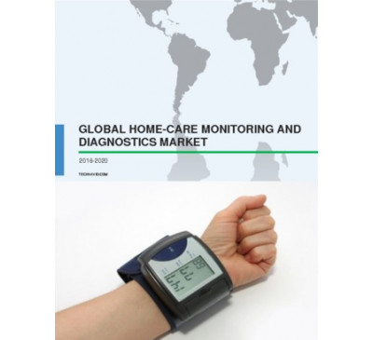

Global Home-care Monitoring And Diagnostics Market 2016-2020
- Nov 2016
- 73 pages
- USD 2500USD 2375
Global overview of the home-care monitoring and diagnostics market Technavio’s market res.....
View Report
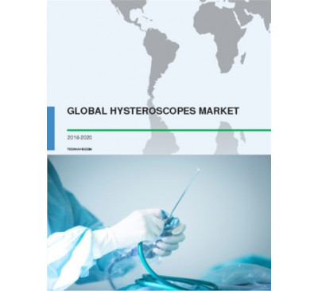

Global Hysteroscopes Market 2016-2020
- Nov 2016
- 79 pages
- USD 2500USD 2375
Overview of the hysteroscopes market According to the market research analysts at Technavio, th...
View Report

Global Blood Stream Infection Testing Market 2016-2020
- Nov 2016
- 82 pages
- USD 2500USD 2375
Overview of the blood stream infection testing market Extensive research carried out by the ana...
View Report

Global Professional Diagnostics Market 2016-2020
- Nov 2016
- 86 pages
- USD 2500USD 2375
Overview of the professional diagnostics market According to the market research analysts at Te...
View Report

Global Autoimmune And Inflammatory Immunomodulators Market 2016-2020
- Nov 2016
- 98 pages
- USD 2500USD 2375
Overview of the autoimmune and inflammatory immunomodulators market According to the market res...
View Report

Global Pharmaceutical Contract Manufacturing Market 2016-2020
- Nov 2016
- 81 pages
- USD 2500USD 2375
Overview of the pharmaceutical contract manufacturing market Extensive research carried out by th...
View Report

Global Intravascular Ultrasound Market 2016-2020
- Nov 2016
- 63 pages
- USD 2500USD 2375
Overview of the intravascular ultrasound market According to the market research analysts at Te...
View Report
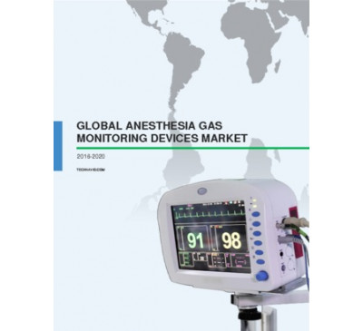

Global Anesthesia Gas Monitoring Devices Market 2016-2020
- Nov 2016
- 104 pages
- USD 2500USD 2375
Overview of the anesthesia gas monitoring devices market Technavio’s market research anal.....
View Report
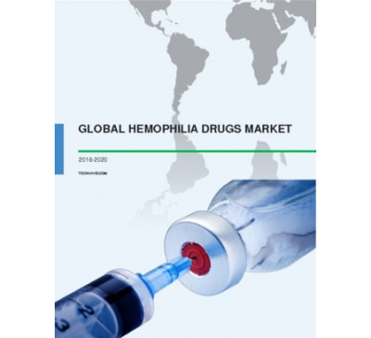

Global Hemophilia Drugs Market 2016-2020
- Oct 2016
- 84 pages
- USD 2500USD 2375
Overview of hemophilia drugs market Extensive research carried out by the analysts at Technavio...
View Report

Global Animal Antibacterial And Antibiotics Market 2016-2020
- Oct 2016
- 71 pages
- USD 2500USD 2375
Overview of the animal antibacterial and antibiotics market According to the market research anal...
View Report
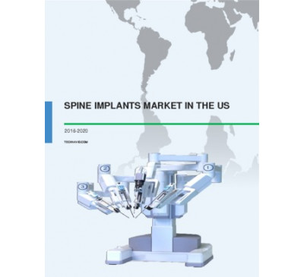

Spine Implants Market In The US 2016-2020
- Oct 2016
- 70 pages
- USD 2500USD 2375
Overview of the spine implants market in the US Extensive research carried out by the analysts at...
View Report
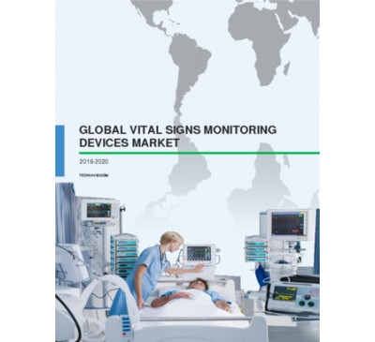

Global Vital Signs Monitoring Devices Market 2016-2020
- Oct 2016
- 70 pages
- USD 2500USD 2375
Overview of the vital signs monitoring devices market According to the market research analysts...
View Report

Global Neuroendovascular Non-coils Market 2016-2020
- Oct 2016
- 98 pages
- USD 2500USD 2375
Overview of the neuroendovascular non-coils market According to the market research analysts at Te...
View Report
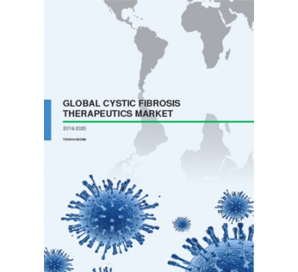

Global Cystic Fibrosis Therapeutics Market 2016-2020
- Oct 2016
- 80 pages
- USD 2500USD 2375
Overview of the cystic fibrosis therapeutics market The global cystic fibrosis therapeutics mark...
View Report
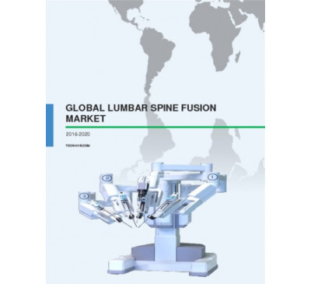

Global Lumbar Spine Fusion Market 2016-2020
- Oct 2016
- 105 pages
- USD 2500USD 2375
Overview of the lumbar spine fusion market According to the market research analysts at Technavio,...
View Report

Global Dental Services Market 2016-2020
- Oct 2016
- 86 pages
- USD 2500USD 2375
Overview of the dental services market Technavio’s market research analysts have predicted that gl...
View Report

Global Positive Airway Pressure Devices Market 2016-2020
- Oct 2016
- 91 pages
- USD 2500USD 2375
Overview of the positive airway pressure devices market According to the market research analysts ...
View Report

Global Facial Injectables Market 2016-2020
- Oct 2016
- 80 pages
- USD 2500USD 2375
Overview of the global facial injectables market Market research analysts at Technavio predict tha...
View Report

Global Anesthesia Endotracheal Tubes Market 2016-2020
- Oct 2016
- 67 pages
- USD 2500USD 2375
Overview of the anesthesia ETT market Market research analysts at Technavio predict that the glob...
View Report
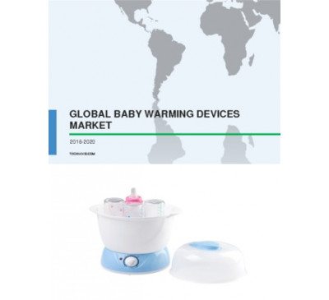

Global Baby Warming Devices Market 2016-2020
- Sep 2016
- 83 pages
- USD 2500USD 2375
Global market overview for baby warming devices Technavio’s market research analysts have estimate...
View Report

Global Autoimmune Disease Diagnostics Market 2017-2021
- Sep 2016
- 134 pages
- USD 3500USD 2500
Overview of the autoimmune disease diagnostics market The autoimmune disease diagnostics market is...
View Report

Global Gastrointestinal Therapeutics Market 2016-2020
- Sep 2016
- 102 pages
- USD 2500USD 2375
Global outlook of the gastrointestinal therapeutics market Technavio’s market research analysts pr...
View Report
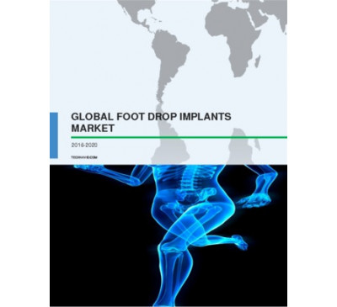

Global Foot Drop Implants Market 2016-2020
- Sep 2016
- 97 pages
- USD 2500USD 2375
Overview of the foot drop implants market Extensive research carried out by the analysts at Techna...
View Report

Global Fluoroscopy C-arms Market 2016-2020
- Sep 2016
- 60 pages
- USD 2500USD 2375
Overview of the fluoroscopy C-arms market According to the market research analysts at Technavio, ...
View Report

Global Immunohematology Market 2016-2020
- Sep 2016
- 99 pages
- USD 2500USD 2375
Outlook of the immunohematology market Extensive research carried out by the analysts at Technavio...
View Report

Global Age-related Macular Degeneration Market 2016-2020
- Sep 2016
- 99 pages
- USD 2500USD 2375
Overview of the age-related macular degeneration (AMD) market The age-related macular degeneratio...
View Report

Global Motion Preservation Market 2016-2020
- Sep 2016
- 72 pages
- USD 2500USD 2375
Overview of the motion preservation market Motion preservation surgery helps preserve the motion o...
View Report

Regenerative Medicine Market In Japan 2016-2020
- Sep 2016
- 102 pages
- USD 2500USD 2375
Outlook of the regenerative medicine market in Japan According to the market research analyst at T...
View Report

Global Metabolic Disorders Therapeutics Market 2016-2020
- Sep 2016
- 163 pages
- USD 2500USD 2375
Overview of the metabolic disorders therapeutics market Extensive research carried out by the mark...
View Report

Global Genome Engineering Market 2016-2020
- Sep 2016
- 69 pages
- USD 2500USD 2375
Overview of the global genome engineering marketMarket research analysts at Technavio predict that t...
View Report
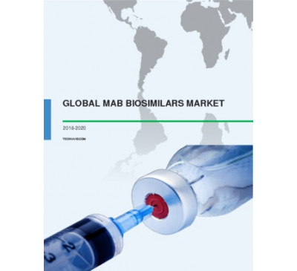

Global MAb Biosimilars Market 2016-2020
- Sep 2016
- 103 pages
- USD 2500USD 2375
Overview of the mAb biosimilars market Extensive research carried out by the analysts at Technavio...
View Report

Global Anesthesia Breathing Circuits Market 2016-2020
- Sep 2016
- 93 pages
- USD 2500USD 2375
Overview of the global anesthesia breathing circuits market Market research analysts at Technavio ...
View Report

Global Central Nervous System Disorders Therapeutics Market 2016-2020
- Sep 2016
- 147 pages
- USD 2500USD 2375
Overview of the central nervous system (CNS) disorders therapeutics market The market research ana...
View Report

Global Dermatology Diagnostic Devices Market 2016-2020
- Sep 2016
- 85 pages
- USD 2500USD 2375
Overview of the global dermatology diagnostic devices market Market research analysts at Technavio...
View Report

Global Leukemia Therapeutics Market 2016-2020
- Sep 2016
- 110 pages
- USD 2500USD 2375
Overview of the leukemia therapeutics market According to the market research analysts at Technavi...
View Report
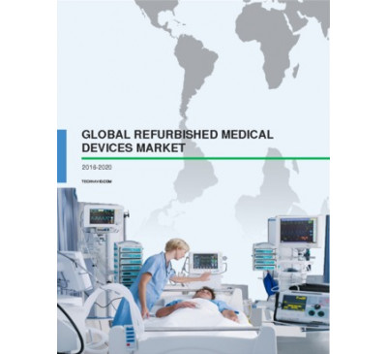

Global Refurbished Medical Devices Market 2016-2020
- Sep 2016
- 65 pages
- USD 2500USD 2375
Overview of the refurbished medical devices market According to the market research analysts at Te...
View Report

Global Clinical Reference Laboratory Services Market 2016-2020
- Sep 2016
- 68 pages
- USD 2500USD 2250
Overview of the global clinical reference laboratory services market According to the market resea...
View Report

Global Invisible Orthodontics Market 2016-2020
- Sep 2016
- 66 pages
- USD 2500USD 2250
Overview of the global invisible orthodontics market Extensive research carried out by the analyst...
View Report
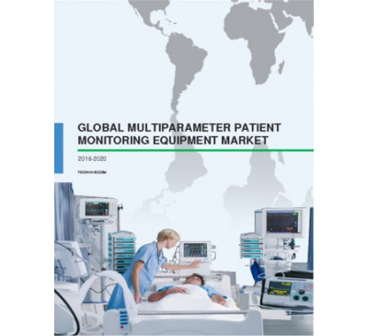

Global Multiparameter Patient Monitoring Equipment Market 2016-2020
- Sep 2016
- 81 pages
- USD 2500USD 2250
Overview of the multiparameter patient monitoring equipment market According to the market researc...
View Report

Global Anesthesia Vaporizers Market 2016-2020
- Sep 2016
- 92 pages
- USD 2500USD 2250
Overview of the anesthesia vaporizers market Extensive research carried out by the market research...
View Report
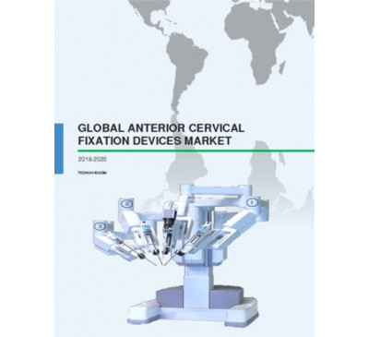

Global Anterior Cervical Fixation Devices Market 2016-2020
- Sep 2016
- 91 pages
- USD 2500USD 2250
Overview of the global anterior cervical fixation devices market Spinal disorders such as spond...
View Report

Global Intracranial Pressure Monitoring Market 2016-2020
- Sep 2016
- 87 pages
- USD 2500USD 2250
Overview of the global intracranial pressure (ICP) monitoring market Market research analysts at T...
View Report
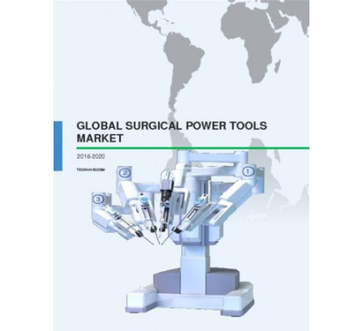

Global Surgical Power Tools Market 2016-2020
- Sep 2016
- 82 pages
- USD 2500USD 2250
Outlook of the surgical power tools market Extensive research carried out by the analysts at Techn...
View Report

Global RFID Blood Monitoring Systems Market 2016-2020
- Sep 2016
- 65 pages
- USD 2500USD 2250
Overview of the global RFID blood monitoring systems market Market research analysts at Technavio ...
View Report

Global Neurological Biomarkers Market 2016-2020
- Sep 2016
- 68 pages
- USD 2500USD 2250
Outlook of the global neurological biomarkers market Technavio’s market research predicts that the...
View Report

Global Vascular Guidewires Market 2016-2020
- Sep 2016
- 80 pages
- USD 2500USD 2250
Overview of the global vascular guidewires market The market research analyst at Technavio predict...
View Report
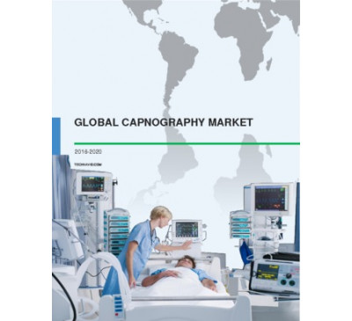

Global Capnography Market 2016-2020
- Sep 2016
- 78 pages
- USD 2500USD 2250
Overview of the global capnography market According to the market analysts at Technavio, the globa...
View Report

Global Fetal And Neonatal Care Equipment Market 2016-2020
- Sep 2016
- 74 pages
- USD 2500USD 2250
Overview of the global fetal and neonatal care equipment market Technavio’s market research analy...
View Report

Global Point-of-Care Coagulation Testing Market 2016-2020
- Sep 2016
- 63 pages
- USD 2500USD 2250
Overview of the point-of-care (POC) coagulation testing market Extensive research carried out by ...
View Report

Global Breast Cancer Monoclonal Antibodies Market 2016-2020
- Sep 2016
- 88 pages
- USD 2500USD 2250
Overview of the global breast cancer monoclonal antibodies (mAbs) market Market research analysts ...
View Report

Global Digital X-Ray Systems Market 2016-2020
- Sep 2016
- 85 pages
- USD 2500USD 2250
Overview of the digital X-ray systems market According to Technavio’s analysts, the global marke...
View Report

Global Bone Anchored Hearing Aids Market 2016-2020
- Sep 2016
- 68 pages
- USD 2500USD 2250
Outlook of the bone anchored hearing aids market Technavio’s market research analysts have predict...
View Report

Global Fecal Occult Testing Market 2016-2020
- Sep 2016
- 89 pages
- USD 2500USD 2250
Overview of the fecal occult testing market Extensive research carried out by the analysts at Tech...
View Report
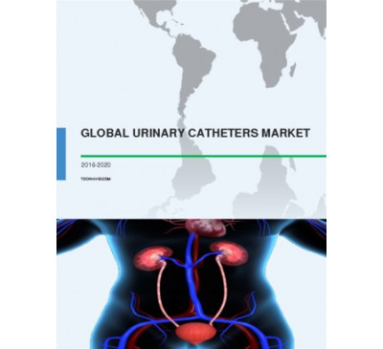

Global Urinary Catheters Market 2016-2020
- Aug 2016
- 63 pages
- USD 2500USD 2250
Overview of the urinary catheters market Extensive research carried out by the analysts at Technav...
View Report
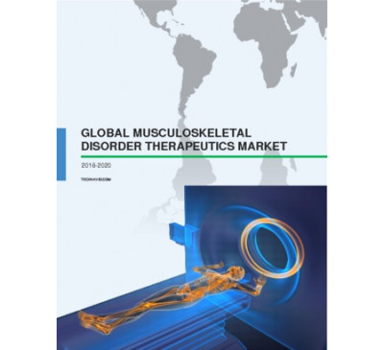

Global Musculoskeletal Disorders Therapeutics Market 2016-2020
- Aug 2016
- 120 pages
- USD 2500USD 2250
Outlook of the global musculoskeletal disorders therapeutics market The analyst at Technavio predi...
View Report

Dental Services Market In China 2016-2020
- Aug 2016
- 77 pages
- USD 2500USD 2250
Outlook of the dental services market in China According to the market research analysts at Techna...
View Report

Global Hepatitis B And C Diagnostics Market 2016-2020
- Aug 2016
- 110 pages
- USD 2500USD 2250
Outlook of the global hepatitis B and C diagnostics market The analyst at Technavio, predicts that...
View Report
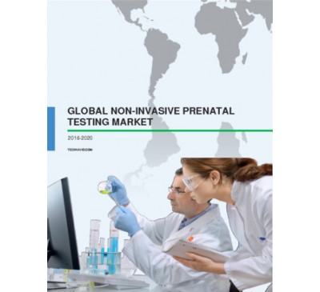

Global Non-Invasive Prenatal Testing Market 2016-2020
- Aug 2016
- 70 pages
- USD 2500USD 2250
Outlook of the non-invasive prenatal testing (NIPT) market Non-invasive prenatal testing (NIPT) is...
View Report
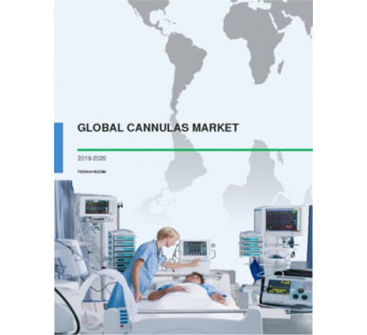

Global Cannulas Market 2016-2020
- Aug 2016
- 84 pages
- USD 2500USD 2250
Global market outlook for cannulas According to the analysts at Technavio, the global market for...
View Report

Global Angioplasty Balloons Market 2016-2020
- Aug 2016
- 87 pages
- USD 2500USD 2250
Overview of the global angioplasty balloons market Comprehensive market research carried out by th...
View Report

Invisible Orthodontics Market In China 2016-2020
- Aug 2016
- 67 pages
- USD 2500USD 2250
Overview of the invisible orthodontics market in China According to the market research analysts a...
View Report
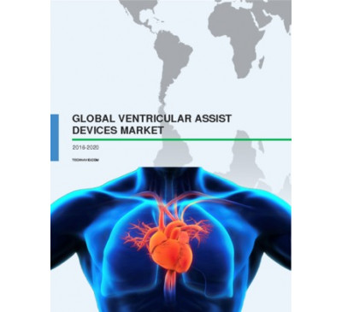

Global Ventricular Assist Devices Market 2016-2020
- Aug 2016
- 93 pages
- USD 2500USD 2250
Overview of the global ventricular assist devices (VADs) market According to the market research a...
View Report
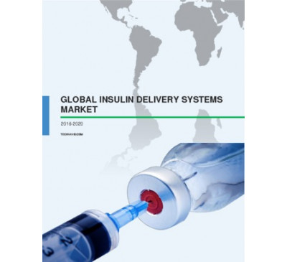

Global Insulin Delivery Systems Market 2016-2020
- Aug 2016
- 81 pages
- USD 2500USD 2250
Global outlook of the insulin delivery systems market According to the market research analysts at...
View Report

Global Blood Culture Tests Market 2016-2020
- Aug 2016
- 71 pages
- USD 2500USD 2250
Outlook of the blood culture tests market Extensive research carried out by the analysts at Techna...
View Report

Global Over-the-Counter Drug Market 2016-2020
- Aug 2016
- 120 pages
- USD 2500USD 2250
Global outlook of the over-the-counter (OTC) drugs market Technavio’s market research analysts hav...
View Report

Global Craniomaxillofacial Devices Market 2016-2020
- Aug 2016
- 61 pages
- USD 2500USD 2250
Overview of the global craniomaxillofacial ( CMF ) devices market Technavio’s market research anal...
View Report
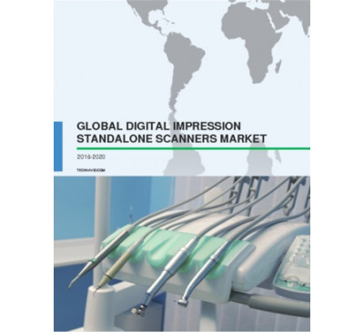

Global Digital Impression Standalone Scanners Market 2016-2020
- Aug 2016
- 64 pages
- USD 2500USD 2250
Overview of the digital impression standalone scanners market According to the market research ana...
View Report
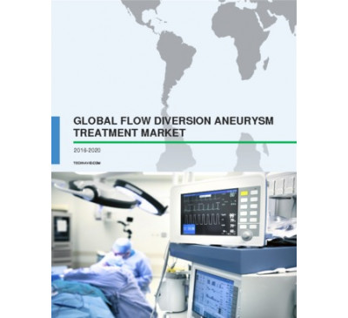

Global Flow Diversion Aneurysm Treatment Market 2016-2020
- Aug 2016
- 72 pages
- USD 2500USD 2250
Overview of the global flow diversion aneurysm treatment market Technavio’s market research analys...
View Report
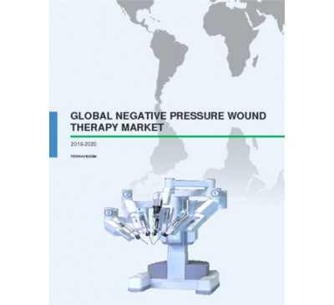

Global Negative Pressure Wound Therapy Market 2016-2020
- Aug 2016
- 109 pages
- USD 2500USD 2250
Overview of the global negative pressure wound therapy (NPWT) market Market research analysts at T...
View Report

Global Pneumococcal Vaccine Market 2016-2020
- Aug 2016
- 82 pages
- USD 2500USD 2250
Outlook of the global pneumococcal vaccine market In terms of volume, the global market for pneum...
View Report

Global Biosimilars Market 2016-2020
- Aug 2016
- 152 pages
- USD 2500USD 2250
Overview of the global biosimilars market Technavio’s market research analysts have predicted tha...
View Report

Global Pain Management Drugs Market 2016-2020
- Aug 2016
- 94 pages
- USD 2500USD 2250
Outlook of the global pain management drugs market Technavio’s market research analyst predicts th...
View Report

Global Spinal Cord Stimulation Devices Market 2016-2020
- Aug 2016
- 62 pages
- USD 2500USD 2250
Overview of the global spinal cord stimulation (SCS) devices market Technavio’s market research an...
View Report

Global Renal Denervation Market 2016-2020
- Jul 2016
- 47 pages
- USD 2500USD 2250
Market outlook of global renal denervation Technavio’s market research analyst predicts the global...
View Report
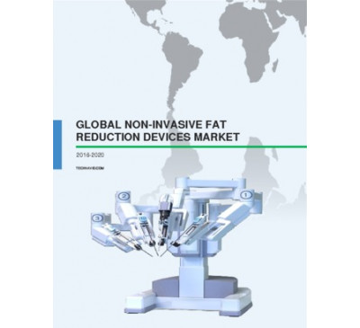

Global Non-invasive Fat Reduction Devices Market 2016-2020
- Jul 2016
- 60 pages
- USD 2500USD 2250
Outlook of the global non-invasive fat reduction devices market Technavio’s market research analys...
View Report

Global MRSA Drugs Market 2016-2020
- Jul 2016
- 79 pages
- USD 2500USD 2250
Overview of the methicillin-resistant Staphylococcus aureus (MRSA) drugs market Methicillin-resist...
View Report

Global Eye Care Surgical Market 2016-2020
- Jul 2016
- 82 pages
- USD 2500USD 2250
Overview of the global eye care surgical market Technavio’s market research analyst predicts that ...
View Report

Global Testosterone Replacement Therapy Market 2016-2020
- Jul 2016
- 59 pages
- USD 2500USD 2250
Overview of the global testosterone replacement therapy market Technavio’s market research analyst...
View Report

Global Asthma Therapeutics Market 2016-2020
- Jul 2016
- 110 pages
- USD 2500USD 2250
Overview of the global asthma therapeutics market Market research analysts at Technavio have predi...
View Report
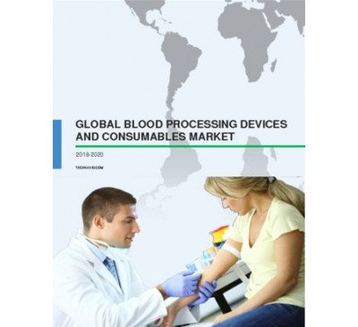

Global Blood Processing Devices And Consumables Market 2016-2020
- Jul 2016
- 55 pages
- USD 2500USD 2250
Outlook of the global blood processing devices and consumables market This market study anticipate...
View Report

Global Hypercholesterolemia Drugs Market 2016-2020
- Jul 2016
- 98 pages
- USD 2500USD 2250
Outlook of the hypercholesterolemia drugs market Extensive research carried out by the analysts at...
View Report
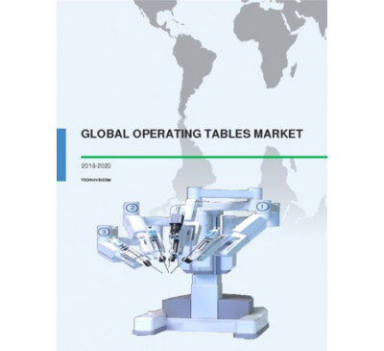

Global Operating Table Market 2016-2020
- Jul 2016
- 73 pages
- USD 2500USD 2250
Overview of the operating table market According to the market research analysts at Technavio, the...
View Report

Global Atherectomy Devices Market 2016-2020
- Jul 2016
- 56 pages
- USD 2500USD 2250
Overview of the global atherectomy devices market Atherectomy is a minimally invasive surgical pro...
View Report

Global Neurophysiology Needles And Electrodes Market 2016-2020
- Jul 2016
- 63 pages
- USD 2500USD 2250
Outlook of the global neurophysiology needles and electrodes market Technavio’s market research an...
View Report

Global Moist Wound Dressings Market 2016-2020
- Jul 2016
- 65 pages
- USD 2500USD 2250
Market outlook of moist wound dressings Technavio’s market research analyst predicts the global mo...
View Report

Global Monoclonal Antibodies Market 2016-2020
- Jul 2016
- 160 pages
- USD 2500USD 2250
Overview of the global monoclonal antibodies (mAbs) market Technavio’s market research analyst pr...
View Report

Global Chronic Obstructive Pulmonary Disease Drugs Market 2016-2020
- Jul 2016
- 107 pages
- USD 2500USD 2250
Overview of the COPD drugs market Technavio’s market research analysts have predicted that the glo...
View Report

Global PET Scanners Market 2016-2020
- Jul 2016
- 61 pages
- USD 2500USD 2250
Market outlook of the PET scanners market Technavio’s research analyst predicts the global PET sca...
View Report

Neurodiagnostic And Monitoring Devices Market In The US 2016-2020
- Jul 2016
- 41 pages
- USD 2500USD 2250
Outlook of the neurodiagnostic and monitoring devices market in the US Technavio’s market research...
View Report

Global Enteric Disease Testing Market 2016-2020
- Jul 2016
- 65 pages
- USD 2500USD 2250
Outlook of the global enteric disease testing market Technavio’s market research analyst predicts ...
View Report
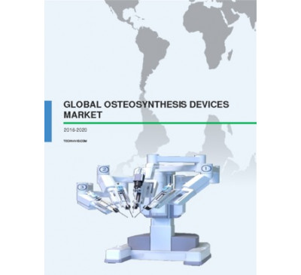

Global Osteosynthesis Devices Market 2016-2020
- Jul 2016
- 52 pages
- USD 2500USD 2250
Overview of the global osteosynthesis devices market Technavio’s market research analyst predicts ...
View Report
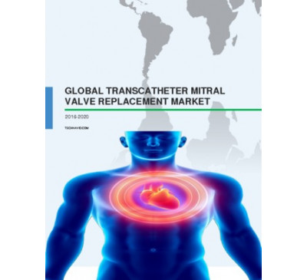

Global Transcatheter Mitral Valve Replacement Market 2016-2020
- Jul 2016
- 46 pages
- USD 2500USD 2250
Outlook of the transcatheter mitral valve replacement market In this market research report, Techn...
View Report

Global Tissue Banking Market 2016-2020
- Jul 2016
- 83 pages
- USD 2500USD 2250
Overview of the global tissue banking market Technavio’s market research analyst predicts the glob...
View Report

Global Embolic Protection Devices Market 2016-2020
- Jul 2016
- 84 pages
- USD 2500USD 2250
Market outlook for embolic protection devices The global market for embolic protection devices wil...
View Report

Global Lyophilization Equipment And Services Market 2016-2020
- Jul 2016
- 59 pages
- USD 2500USD 2250
Overview of the global lyophilization equipment and services market Market research analysts at Te...
View Report
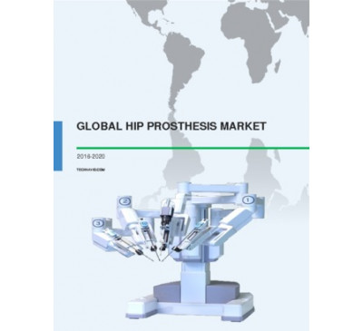

Global Hip Prosthesis Market 2016-2020
- Jul 2016
- 82 pages
- USD 2500USD 2250
Overview of the hip prosthesis market Extensive research carried out by the analysts at Technavio ...
View Report

Global Meningococcal Vaccines Market 2016-2020
- Jul 2016
- 68 pages
- USD 2500USD 2250
Global market outlook of meningococcal vaccines Technavio’s market research analyst predicts the g...
View Report

Global Cardiac Resynchronization Therapy Pacemaker Market 2016-2020
- Jul 2016
- 48 pages
- USD 2500USD 2250
Market overview of cardiac resynchronization therapy pacemakers (CRT-P) Technavio’s market researc...
View Report
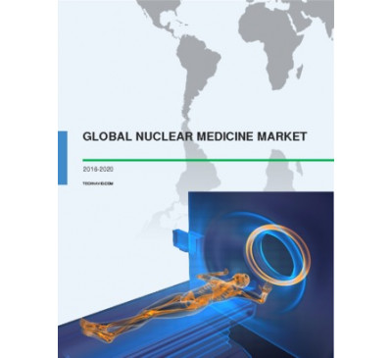

Global Nuclear Medicine Market 2016-2020
- Jul 2016
- 73 pages
- USD 2500USD 2250
Overview of the global nuclear medicine market Technavio’s market research analysts expect the glo...
View Report
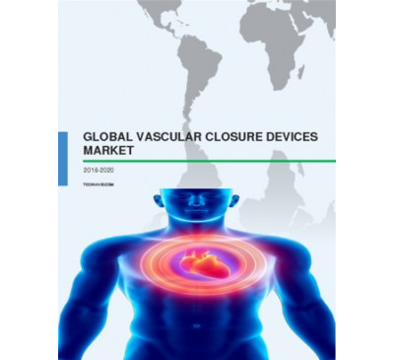

Global Vascular Closure Devices Market 2016-2020
- Jul 2016
- 69 pages
- USD 2500USD 2250
Outlook of the vascular closure devices market Vascular closure devices are used for diagnostic an...
View Report
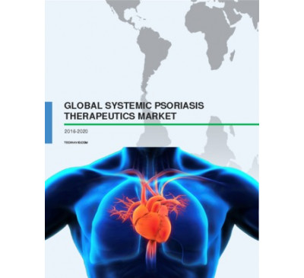

Global Systemic Psoriasis Therapeutics Market 2016-2020
- Jul 2016
- 89 pages
- USD 2500USD 2250
Outlook of the systemic psoriasis therapeutics market The global systemic psoriasis therapeutics m...
View Report

Global Endometriosis Drugs Market 2016-2020
- Jul 2016
- 70 pages
- USD 2500USD 2250
Overview of the endometriosis drugs market According to the market research analysts at Technavio,...
View Report

Global Epilepsy Drugs Market 2016-2020
- Jul 2016
- 87 pages
- USD 2500USD 2250
Overview of the epilepsy drugs market Extensive research carried out by the analysts at Technavio ...
View Report

Global Allergy Immunotherapies Market 2016-2020
- Jul 2016
- 87 pages
- USD 2500USD 2250
Overview of the allergy immunotherapies market Extensive research carried out by the analysts at T...
View Report

Global Cardiology Electrodes Market 2016-2020
- Jul 2016
- 62 pages
- USD 2500USD 2250
Outlook of the global cardiology electrodes market Technavio’s market research analyst predicts th...
View Report

Global Cerebral And Tissue Oximetry Devices Market 2016-2020
- Jun 2016
- 50 pages
- USD 2500USD 2250
Outlook of the global cerebral and tissue oximetry market Technavio’s market research analyst pred...
View Report
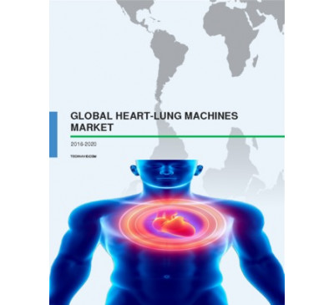

Global Heart-lung Machines Market 2016-2020
- Jun 2016
- 57 pages
- USD 2500USD 2250
Outlook of the global heart-lung machines market According to the analysts at Technavio, the globa...
View Report
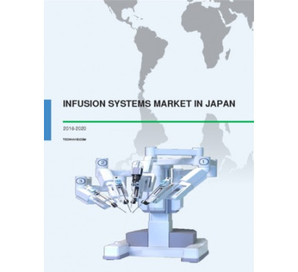

Infusion Systems Market In Japan 2016-2020
- Jun 2016
- 62 pages
- USD 2500USD 2250
Outlook of the infusion systems market in Japan Technavio’s market research analyst predicts the i...
View Report

Global Fractional Flow Reserve Market 2016-2020
- Jun 2016
- 65 pages
- USD 2500USD 2250
Overview of the global fractional flow reserve market The market research analyst at Technavio has...
View Report

Global Human Albumin Market 2016-2020
- Jun 2016
- 75 pages
- USD 2500USD 2250
Overview of the human albumin market According to the market research analysts at Technavio, the g...
View Report
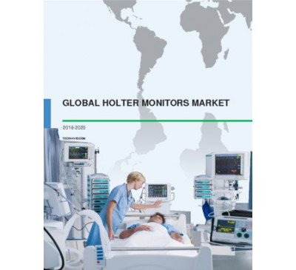

Global Holter Monitors Market 2016-2020
- Jun 2016
- 61 pages
- USD 2500USD 2250
Outlook of the Holter monitors market Extensive research carried out by the analysts at Technavio ...
View Report

Global Solid Tumors Drugs Market 2016-2020
- Jun 2016
- 156 pages
- USD 2500USD 2250
Overview of the global solid tumors drugs market According to the market research analysts at Tech...
View Report

Cardiac Rhythm Management Devices Market In China 2016-2020
- Jun 2016
- 66 pages
- USD 2500USD 2250
Overview of the cardiac rhythm management devices market in China Technavio’s market research anal...
View Report

Global Analgesics Market 2016-2020
- Jun 2016
- 102 pages
- USD 2500USD 2250
Overview of the global analgesics market The global analgesics market is envisaged to grow steadil...
View Report

Global Cardiopulmonary Stress Testing Systems Market 2016-2020
- Jun 2016
- 70 pages
- USD 2500USD 2250
Overview of the cardiopulmonary stress testing systems market According to the market research ana...
View Report

COPD Drugs Market In China 2016-2020
- Jun 2016
- 75 pages
- USD 2500USD 2250
Overview of the chronic obstructive pulmonary disease (COPD) drugs market in China The chronic obs...
View Report

Global Cardiopulmonary Autotransfusion Systems Market 2016-2020
- Jun 2016
- 65 pages
- USD 2500USD 2250
Overview of the global cardiopulmonary autotransfusion systems market Technavio’s market research ...
View Report

Global Dental Prosthetics Market 2016-2020
- Jun 2016
- 78 pages
- USD 2500USD 2250
Overview of the dental prosthetics market According to the market research analysts at Technavio, ...
View Report
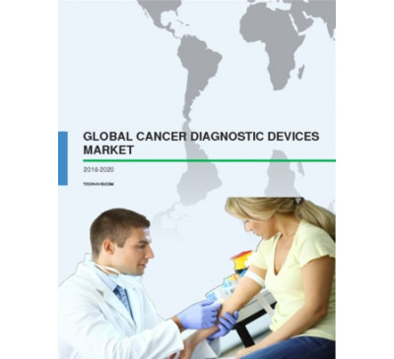

Global Cancer Diagnostic Devices Market 2016-2020
- Jun 2016
- 67 pages
- USD 2500USD 2250
Overview of the global cancer diagnostic devices market Technavio’s market research analyst predi...
View Report

Global Gonorrhea Diagnostics Market 2016-2020
- Jun 2016
- 62 pages
- USD 2500USD 2250
Overview of the global gonorrhea diagnostics market Technavio’s market research analyst predicts t...
View Report
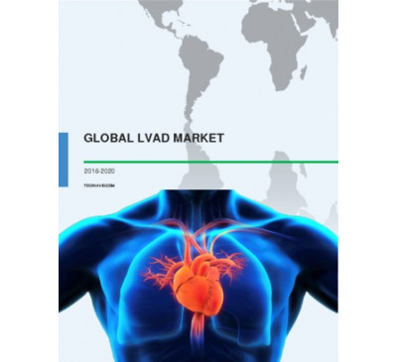

Global LVAD Market 2016-2020
- Jun 2016
- 61 pages
- USD 2500USD 2250
Market overview of the left ventricular assist device (LVAD) market Technavio’s market research an...
View Report

Global Blood Pressure Monitoring Testing Market 2016-2020
- Jun 2016
- 75 pages
- USD 2500USD 2250
Overview of the global blood pressure (BP) monitoring testing market Technavio’s market research a...
View Report
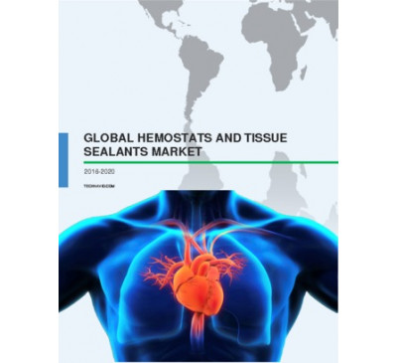

Global Hemostats And Tissue Sealants Market 2016-2020
- Jun 2016
- 66 pages
- USD 2500USD 2250
Outlook of the global hemostats and tissue sealants market Technavio’s market research analyst pre...
View Report
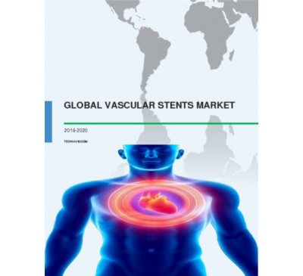

Global Vascular Stents Market 2016-2020
- Jun 2016
- 65 pages
- USD 2500USD 2250
Overview of the vascular stents market Extensive research carried out by the analyst at Technavio ...
View Report

Global Dental Implants Market 2016-2020
- Jun 2016
- 66 pages
- USD 2500USD 2250
Market outlook of the global dental implants market Technavio’s market research analyst predicts ...
View Repor
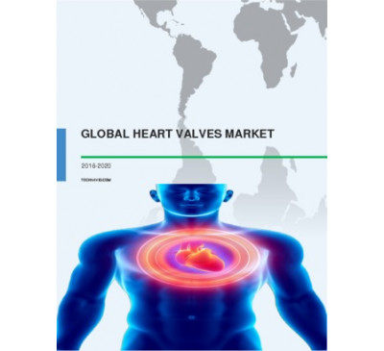

Global Heart Valves Market 2016-2020
- Jun 2016
- 67 pages
- USD 2500USD 2250
Overview of the global heart valves market The market research analyst at Technavio has predicted ...
View Report
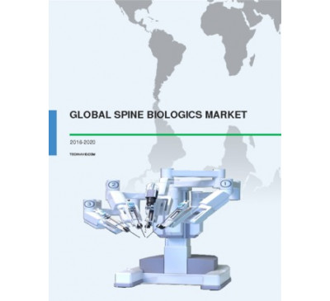

Global Spine Biologics Market 2016-2020
- Jun 2016
- 79 pages
- USD 2500USD 2250
Outlook of the spine biologics market According to the market research analysts at Techanvio, the ...
View Report

Global Hemoglobin Testing Market 2016-2020
- Jun 2016
- 73 pages
- USD 2500USD 2250
Outlook of the global hemoglobin testing market According to the analysts at Technavio, the global...
View Report
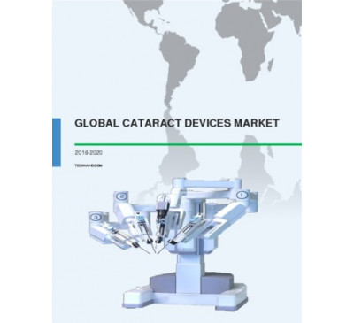

Global Cataract Devices Market 2016-2020
- Jun 2016
- 65 pages
- USD 2500USD 2250
Outlook of the cataract devices market Technavio’s market research analyst predicts the global cat...
View Report
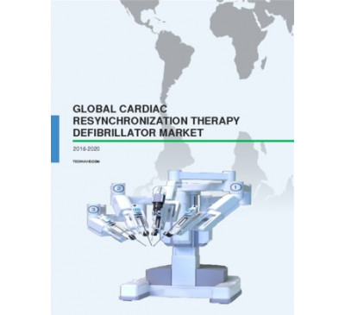

Global Cardiac Resynchronization Therapy Defibrillator Market 2016-2020
- Jun 2016
- 56 pages
- USD 2500USD 2250
Overview of the cardiac resynchronization therapy defibrillator (CRT-D) market Technavio’s market ...
View Report
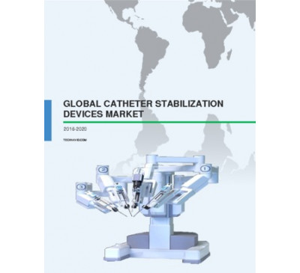

Global Catheter Stabilization Device Market 2016-2020
- Jun 2016
- 59 pages
- USD 2500USD 2250
An outlook of the global catheter stabilization device market Technavio’s market research analyst ...
View Report
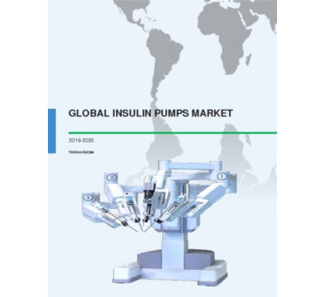

Global Insulin Pumps Market 2016-2020
- Jun 2016
- 57 pages
- USD 2500USD 2250
Outlook of the global insulin pumps market Technavio’s market research analysts have deduced that ...
View Report

Global Bioactive Wound Care Market 2016-2020
- Jun 2016
- 67 pages
- USD 2500USD 2250
Overview of the global bioactive wound care market Market research analysts at Technavio have esti...
View Report

Global Ophthalmic Lasers Market 2016-2020
- Jun 2016
- 60 pages
- USD 2500USD 2250
Overview of the global ophthalmic lasers market Technavio’s market research analyst predicts the g...
View Report
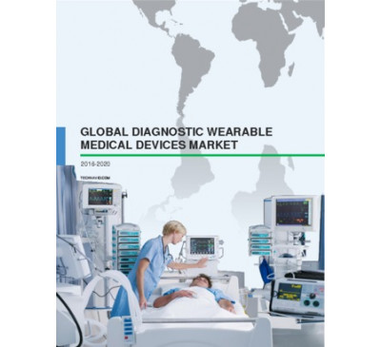

Global Diagnostic Wearable Medical Devices Market 2016-2020
- Jun 2016
- 77 pages
- USD 2500USD 2250
Outlook of the diagnostic wearable medical devices market The diagnostic wearable medical devices ...
View Report

RhEPO Market In China 2016-2020
- Jun 2016
- 65 pages
- USD 2500USD 2250
Outlook of the rhEPO market in China Erythropoietin (EPO), also known as hematopoietin, is a glyco...
View Report

Global H1N1 Vaccines Market 2016-2020
- Jun 2016
- 83 pages
- USD 2500USD 2250
Overview of the H1N1 vaccines market According to the analysts at Technavio, the global H1N1 vacc...
View Report

Global DNA Sequencing Products Market 2016-2020
- Jun 2016
- 64 pages
- USD 2500USD 2250
Overview of the DNA sequencing products market Technavio’s market research analyst predicts the gl...
View Report

Global Chronic Lymphocytic Leukemia Therapeutics Market 2016-2020
- Jun 2016
- 78 pages
- USD 2500USD 2250
Global outlook of the chronic lymphocytic leukemia (CLL) therapeutics market According to the anal...
View Report
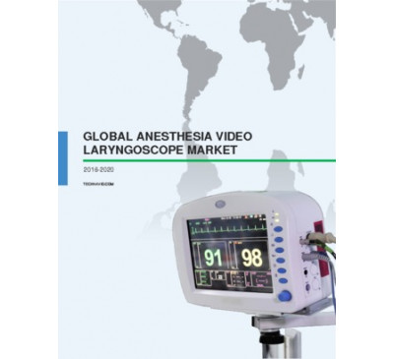

Global Anesthesia Video Laryngoscope Market 2016-2020
- May 2016
- 64 pages
- USD 2500USD 2250
Outlook of the global anesthesia video laryngoscope market Technavio’s market research analysts es...
View Report
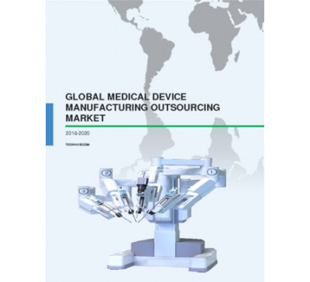

Global Medical Device Manufacturing Outsourcing Market 2016-2020
- May 2016
- 88 pages
- USD 2500USD 2250
Overview of the global medical device manufacturing outsourcing market Technavio’s market research...
View Report

Infectious Disease Treatment Market In China 2016-2020
- May 2016
- 125 pages
- USD 2500USD 2250
Outlook of the infectious disease treatment market in China According to the market research analy...
View Report

Global Generic Drugs Market 2016-2020
- May 2016
- 111 pages
- USD 2500USD 2250
Overview of the generic drugs market Extensive research carried out by the market research analyst...
View Report
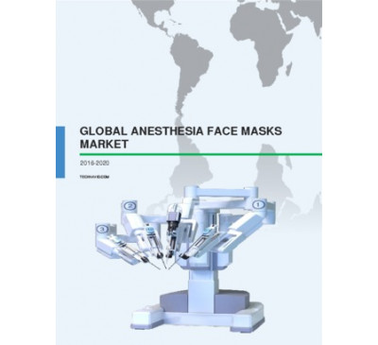

Global Anesthesia Face Masks Market 2016-2020
- May 2016
- 63 pages
- USD 2500USD 2250
Outlook of the global anesthesia face masks market Technavio’s market research analyst predicts th...
View Report
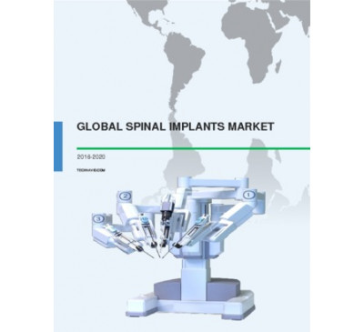

Global Spinal Implants Market 2016-2020
- May 2016
- 82 pages
- USD 2500USD 2250
Outlook of the spinal implants market The global spinal implants market is envisaged to witness st...
View Report

Global Anesthesia Resuscitators Market 2016-2020
- May 2016
- 66 pages
- USD 2500USD 2250
Overview of the anesthesia resuscitators market Extensive research carried out by the analysts at ...
View Report
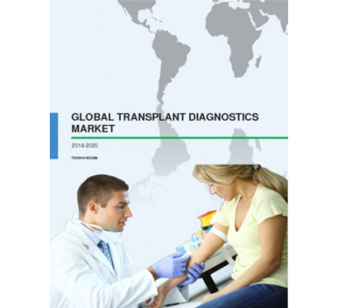

Global Transplant Diagnostics Market 2016-2020
- May 2016
- 81 pages
- USD 2500USD 2250
Overview of the global transplant diagnostics market Technavio’s market research analyst predicts ...
View Report
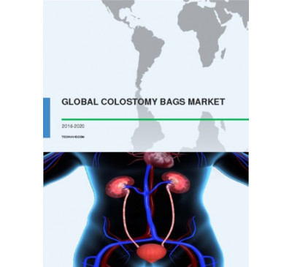

Global Colostomy Bags Market 2016-2020
- May 2016
- 63 pages
- USD 2500USD 2250
Overview of the global colostomy bags market Technavio’s market research analyst predicts the glo...
View Report

Global Ambulatory Blood Pressure Monitoring Systems Market 2016-2020
- May 2016
- 73 pages
- USD 2500USD 2250
Overview of the global ambulatory blood pressure monitoring system market Technavio’s market resea...
View Report
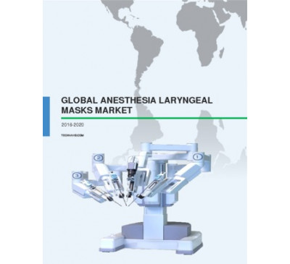

Global Anesthesia Laryngeal Masks Market 2016-2020
- May 2016
- 60 pages
- USD 2500USD 2250
Overview of the anesthesia laryngeal masks market Extensive research carried out by the analysts a...
View Report

Global Intrathecal Pumps Market 2016-2020
- May 2016
- 63 pages
- USD 2500USD 2250
Overview of the global intrathecal pumps market Technavio’s market research analyst predicts the g...
View Report

Global Pneumatic Nebulizers Market 2016-2020
- May 2016
- 64 pages
- USD 2500USD 2250
Outlook of the global pneumatic nebulizers market Technavio’s market research analyst predicts the...
View Report
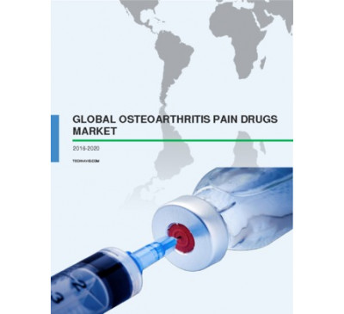

Global Osteoarthritis Pain Drugs Market 2016-2020
- May 2016
- 60 pages
- USD 2500USD 2250
Overview of the global osteoarthritis pain drugs market Technavio’s market research analyst predic...
View Report
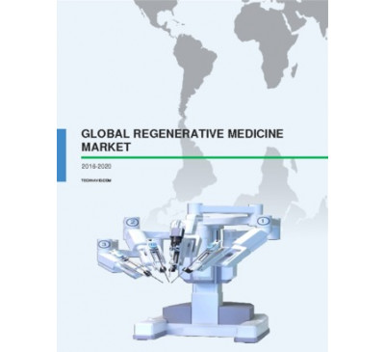

Global Regenerative Medicine Market 2016-2020
- May 2016
- 117 pages
- USD 2500USD 2250
Overview of the global regenerative medicine market Technavio’s market research analyst predicts t...
View Report

Anticoagulants Market In The US 2016-2020
- May 2016
- 89 pages
- USD 2500USD 2250
Overview of the anticoagulants market in the US Technavio’s market research analyst predicts the a...
View Report

24
Jan 2011

Canadian Healthcare and Life Sciences Industry

Region : North America
The following deliverable provides an overview of the healthcare and life sciences industry in Canada. Macro qualitative and quantitative information is provided on a variety of aspects of major industry sub-segments, industry metrics and areas including: overall healthcare system, medical devices, pharma, biotechnology, bioclusters and emerging te...
USD 1,500
USD 1,050
READ MORE
03
Nov 2005

Strategic Analysis of World IT Spending in Life Sciences Industry

Region : Global
This strategic analysis service provides detailed analysis of IT markets in life sciences. The service focuses not just only on the revenues and competitor analysis but also on strategies for achieving success in this highly competitive market
USD 4,950
USD 3,465
READ MORE
18
Apr 2014

Frost & Sullivans 2014 Life Sciences Outlook
Innovative Transformations and Value Creations in Life Sciences
Region : Global
In 2013, healthcare moved towards access, transparency, investments, and spending. In 2014, Frost & Sullivan anticipates new launches to occur across the life sciences spectrum, from preventive medicine to treating complex diseases. This market insight touches upon major events that occurred in 2013 and how 2014 is expected to shape up, includi...
USD 1,500
USD 1,350
READ MORE
28
Mar 2013

Vital Signs - The Healthcare News - March Issue
Region : North America
This issue of Vital Signs, released on March 28, 2013, discusses perspectives of different Frost & Sullivan analysts on recent noteworthy news items for various markets including Life Sciences and Advanced Medical Technology.
USD 1,500
USD 1,275
READ MORE
01
May 2013

Vital Signs - The Healthcare News - April Issue
Region : North America
This issue of Vital Signs, released on April 30, 2013, discusses perspectives of different Frost & Sullivan analysts on recent noteworthy news items for various markets including Life Sciences and Advanced Medical Technology.
USD 1,500
USD 1,275
READ MORE
12
Dec 2006

European Markets for Grid Computing in Life Sciences R&D

Region : Europe
This research service discusses the market for grid computing in the Life sciences sector.
USD 4,950
USD 3,465
READ MORE
28
Feb 2013

Vital Signs - Healthcare News - The Analysts Perspective - February Issue
Region : North America
This issue of Vital Signs, released on February 28, 2013, discusses perspectives of different Frost & Sullivan analysts on recent noteworthy news items for various markets including Life Sciences and Advanced Medical Technology.
USD 1,500
USD 1,275
READ MORE
01
Nov 2006

Life Sciences Funding in Europe (2006)- Phase I

Region : Europe
The research service provides the sources of life sciences funding in Europe with specific funding analysis of Germany, UK, France, Scandinavia and Spain. Denmark, Finland, Norway and Sweden are included in Scandinavia.
USD 4,950
USD 3,465
READ MORE
31
Dec 2009

Life Sciences Funding - 2008

Region : Europe
This study covers the life sciences funding scenario in Europe covering the UK, Germany, Italy, Spain, France and Italy for 2008.
USD 4,950
USD 3,465
READ MORE
04
Nov 2014

2014 Life Sciences Outlook in Turkey
Rapid Economic Development and Healthcare Reforms Set the Stage for the Future
Region : North America
The diabetes diagnostics markets in the United States and Europe have been in a mature stage for many years. Growth is sustained due to the high prevalence of diabetes in both regions. The segments covered in the study are self-monitoring of blood glucose (SMBG), point-of-care testing (POCT), and lab-based HbA1c testing. The emerging market of non-...
USD 2,450
USD 2,205
READ MORE
26
Jun 2013

Vital Signs - Healthcare News - The Analysts Perspective June Issue
Region : North America
This issue of Vital Signs, released on June 30, 2013, discusses perspectives of different Frost & Sullivan analysts on recent noteworthy news items for various markets including Life Sciences, Advanced Medical Technology and Connected Health.
USD 1,500
USD 1,275
READ MORE
31
Oct 2013

Chinas 2013 Life Sciences Industry Outlook and Regulatory Review
Government Investments Could Make China the Third-largest Pharmaceutical Market in the World
Region : Global
China is predicted to become the third-largest pharmaceutical market in the world by the end of 2013 due to the governments considerable investment in the healthcare industry and the populations unmet healthcare needs. The life sciences industry is broad and involves a wide range of disciplines. This research service focuses on the trends and mar...
USD 4,950
USD 4,208
READ MORE
23
May 2014

Regulatory Trends in the US Life Sciences Industry
Efficiency of FDA Review Process Expedites Access to Care
Region : Europe
Biomarkers will certainly change the way healthcare is provided. They are being increasingly used in early drug development and for clinical use as well, boosting their demand. The penetration of biomarkers in various therapeutic applications, the impact of market trends and dynamics are analysed in this study. This research service offers market o...
USD 1,500
USD 1,350
READ MORE
22
Jul 2016

European Life Sciences Landscape - Genetic Technology TOE
Region : Global
This edition of the Genetic Technology TOE depicts trends in the current landscape and the new life sciences trends across Europe. In this TOE, silica-based drug delivery solutions, light-based technologies in life sciences, advancements in topical skin treatments, and gene discovery platforms for novel drug products and stem cells in cancer therap...
USD 250
READ MORE
03
Feb 2016

Growing Burden of Lifestyle Diseases in Emerging Countries
The Healthcare and Life Sciences Growth Trajectory Beyond BRICS
Region : Global
While low and middle income group countries are typically characterized by a high burden of communicable diseases, the trend appears to be changing. By 2030, NCDs are expected to account for nearly 55% of the disease burden of these country groups. A growing middle aged population increases the risk of NCDs in the low and middle income country grou...
USD 1,500
READ MORE
30
Dec 2008

Pharmaceuticals and Life Sciences IT Market in Malaysia

Region : Asia Pacific
This research service provides the latest update on the pharmaceuticals and life sciences IT Market in Malaysia, as well as, the competitive market landscape in terms of major participants and future trends. The research service identifies the market opportunities and evolving trends that will influence market entry, expansion and domination in yea...
USD 6,950
USD 4,865
READ MORE
03
Jan 2009

Australian Pharmaceuticals and Life Sciences IT Market

Region : Asia Pacific
This research service provides the latest update on the pharmaceuticals and life sciences IT Market in Australia, as well as, the competitive market landscape in terms of major participants and future trends. The research service identifies the market opportunities and evolving trends that will influence market entry, expansion and domination in ye...
USD 10,000
USD 7,000
READ MORE
29
Dec 2008

Singaporean Pharmaceuticals and Life Sciences IT Market

Region : Asia Pacific
This research service provides the latest update on the pharmaceuticals and life sciences IT Market in Singapore, as well as, the competitive market landscape in terms of major participants and future trends. The research service identifies the market opportunities and evolving trends that will influence market entry, expansion and domination in ye...
USD 6,950
USD 4,865
READ MORE
20
Feb 2012

Vital Signs - Healthcare News - The Analyst's Perspective - February Issue

Region : North America
This issue of Vital Signs, released on February 20, 2012, discusses perspectives of different Frost & Sullivan analysts on recent noteworthy news items for various markets including Life Sciences and Advanced Med Tech.
USD 1,500
USD 1,125
READ MORE
16
Mar 2012

Vital Signs - Healthcare News - The Analyst Perspective - March Issue

Region : North America
This issue of Vital Signs, released on March 16, 2012, discusses perspectives of different Frost & Sullivan analysts on recent noteworthy news items for various markets including Life Sciences and Advanced Med Tech.
USD 1,500
USD 1,125
READ MORE
14
Apr 2017

Innovations in Life sciences, Solar cells, Healthcare, and Poultry Farms
Region : Global
This edition of the Inside R&D TOE depicts innovations in life sciences, solar cells, and poultry farms. This TOE also emphasizes on developments in healthcare related to rapid diagnosis of tuberculosis. Inside R&D TechVision Opportunity Engine (TOE) covers global innovations that are in research and development in virtually all technology areas. ...
USD 250
READ MORE
12
Feb 2016

Vital Signs - Impact of Strategic Acquisitions on Life Sciences Market, 2016
Portfolio Expansions Follow Acquisitions by Panasonic Healthcare Holdings Co.,Thermo Fisher Scientific and Abbott Laboratories
Region : Global
This Vital Signs issues discusses Panasonic Healthcare's completed acquisition of Bayer's Diabetes Care Unit, Thermo Fisher Scientific's acquisition of Affymetrix, several moves in the single cell-genomics market by Bio-Rad, Illumina, Qiagen, and 10x Genomics, and Abbott's acquisition of Alere.
USD 450
READ MORE
19
Oct 2009

Vital Signs - The New Economics of Healthcare: Evaluating Medical Technologies Based on Actual Value as a Growth Strategy for Healthcare Providers
Region : North America
This issue of Vital Signs, released on October 19, 2009, provides an analysis of evaluating medical technologies based on actual value as a growth strategy for healthcare providers with the I-Flow ON-Q® Pain Relief System as a case study. Additionally, a company spotlight is provided for Cardo Medical, an emerging company focused on cutting-edge r...
USD 1,500
USD 1,050
READ MORE
09
Apr 2007

Vital Signs - Life Sciences and Drug Discovery Technologies Market Consolidation - Unique Aims of Mergers & Acquisitions

Region : North America
This issue of Vital Signs, released on April 9, 2007, provides a strategic overview of the impact of consolidation in the life sciences and drug discovery technologies market. Additionally, an emerging company profile is provided for Network Biosystems, a developer of DNA analysis technologies for forensics, clinical diagnostics, homeland security,...
USD 1,500
USD 1,050
READ MORE
01
Sep 2005

Life Sciences Funding in Europe 2005 (Phase I) - Sources of Funding

Region : Europe
This research service examines and monitors life science funding trends in Europe. Funding analysis and challenges are discussed for United Kingdom, Germany and France and from the European Commission's perspective.
USD 6,950
USD 4,865
READ MORE
25
Jan 2013

GIL-100 Sales and Investment Attractiveness Index for Healthcare
Country Attractiveness for Healthcare
Region : Global
Where should one invest or sell in the aftermath of the financial crisis of 2008 and the on-going European debt crisis? While rich countries have shown very slow growth rates, emerging markets have shown much greater resilience. To increase profitability, you can either find new markets to increase sales, or seek opportunities to invest. Emerging ...
USD 1,500
USD 1,275
READ MORE
05
May 2015

Market Trends - Digitalisation, Decentralisation and Democratisation of Healthcare in Australia
A Market Insight by Frost & Sullivan
Region : Asia Pacific
Frost & Sullivan presented the 2015 Australia Healthcare Outlook at a live event in Sydney in March. This document compiles key trends and opinions presented at the event with supporting data and figures. 2015 predictions in the areas of healthcare financing, aged care, primary care, and emerging technologies have been detailed here.
USD 850
READ MORE
13
Jul 2005

Emerging U.S. EDetailing Markets for Life Sciences

Region : North America
This research study addresses the latest issues and market metrics that are forming in the Emerging U.S. EDetailing Markets for Life Science. It contains major drivers, restraints, challenges and strategies, competitive analysis, pricing dynamics, market trends, business model comparisons, and strategic guidelines for implementation. Included are ...
USD 2,450
USD 1,715
READ MORE
12
Oct 2004

U.S. PLM Markets for Life Sciences

Region : North America
This report comprehensively covers the market for enterprise product lifecycle management software sold to the life sciences industry in the U.S. Segments are broken out into total market metrics, competitive metrics, and component metrics like product data management, project collaboration software, computer aided design (CAD), and materials manag...
USD 2,450
USD 1,715
READ MORE
13
Dec 2004

U.S. Electronic Lab Notebook Markets for Life Sciences

Region : North America
This white paper report covers the most salient issues and growth statistics affecting the Electronic Laboratory Notebook Markets in the U.S. Included in the white paper are discussions of the various market drivers, restraints and challenges, as well as the overall number of seat licenses issued, growth in license issuances, concurrent user pricin...
USD 2,450
USD 1,715
READ MORE
14
Aug 2002

World Electronic Regulatory Document Markets for Life Sciences

Region : Global
This report covers all salient dynamics of the electronic regulatory document systems markets for life sciences for the forecast period of 2001-2005. Its basic segmentation covers the commercial market for electronic publishing software, electronic regulatory document management systems, and systems integrators/consultants, with regard to parameter...
USD 2,450
USD 1,715
READ MORE
27
Feb 2004

Strategic Analysis - U.S. Data Mining and Predictive Analytics Markets for Life Sciences R&D

Region : North America
This strategic analysis service report presents a concise snapshot of the most salient aspects driving the commercial data mining and predictive analytics tools markets from 2003-2007 in the U.S. life sciences research industry. It contains all major issues that are affecting the growth of this product, such as major market adoption factors, techno...
USD 2,450
USD 1,715
READ MORE
02
Dec 2016

Startup Companies across the Life Sciences Industry - Genetic TOE
Region : Global
This edition of Genetic Technology TOE profiles across startup companies across the life sciences industry. The corresponding patent scenario is also depicted along with industry interactions. The Genetic Technology TechVision Opportunity Engine (TOE) presents the latest R&D developments and advances with an emphasis on opportunities to profit in ...
USD 250
READ MORE
09
Dec 2016

Start-ups across the Life Sciences Industry - Genetic TOE
Region : Global
This edition of Genetic Technology TOE profiles life sciences trends in start-ups across the life science industry. The corresponding patent scenario is depicted along with the industry interactions. The Genetic Technology TechVision Opportunity Engine (TOE) presents the latest R&D developments and advances with an emphasis on opportunities to pro...
USD 250
READ MORE
28
Jun 2017

Microbiome Technologies Energizing Pharma and Life Sciences
A New World of Microbiome Innovations
Region : Global
Microbiome science has become a key area of research for biopharmaceutical companies. At present, there are multiple start-ups emerging, which are focusing their resources towards the development of novel therapeutics as well as diagnostic/screening technologies and services. In an era of personalized medicine, the current trajectory of growth witn...
USD 4,950
READ MORE
14
Jul 2017

Advances across the Life Sciences Industry
Region : Global
This edition of the Genetic Technology TOE depicts the current landscape and the new trends across the life sciences industry. Biotechnology innovations in drug discovery, 3D printing, and skin testing are exhibited. The corresponding drug validation scenario is depicted, along with industry interactions. Special focus has been placed on clinical ...
USD 250
READ MORE
18
Apr 2016

Africa Healthcare Industry Outlook, 2016
Value-based Transformations in Home Diagnostic Technologies, Exclusive Drugs, and Improved Point of Care Energise Healthcare Ecosystem
Region : Africa
Africa is experiencing a plethora of changes in the healthcare segment. From being the market of imports and low-value manufacturing, the continent is transforming into a region of tailor-made medical equipment that is compatible with telemedicine solutions. There is an increase in the in-country production of pharmaceuticals, smart phone applicati...
USD 4,950
READ MORE
06
Nov 2012

Vital Signs - The Healthcare News - The Analyst's Perspective - October Issue

Region : North America
This issue of Vital Signs, released on October 22, 2012, discusses perspectives of different Frost & Sullivan analysts on recent noteworthy news items for various markets including Life Sciences, Advanced Medical Technology and Connected Health.
USD 1,500
USD 1,125
READ MORE
27
Mar 2014

2013 APAC Healthcare Outlook
Changing Dynamics to Disrupt and Transform Healthcare in Asia-Pacific by 2018
Region : Asia Pacific
Healthcare expenditure in Asia-Pacific is expected to continue growing over the next 6 years, as rising demand for better healthcare for patients spurs reforms. This would also increase life expectancy, resulting in a large elderly population requiring long-term care. This study covers the hospital, life sciences, advanced medical technology, and c...
USD 2,450
USD 2,205
READ MORE
18
May 2015

2015 Asia-Pacific Healthcare Industry Outlook
APAC will Continue to Remain in Global Spotlight for Investment, Innovation, and Growth in Healthcare
Region : Asia Pacific
The research service provides an analysis of the healthcare market in Asia-Pacific (APAC). It discusses the current technology and country-specific trends and provides predictions. Market participants and key opinion leaders in APAC hospitals were interviewed to obtain their views on trends and opportunities in the healthcare industry. The regional...
USD 2,450
READ MORE
31
20
Jul 2012

Vital Signs - Healthcare News - The Analyst's Perspective - July Issue

Region : North America
This issue of Vital Signs, released on July 20, 2012, discusses perspectives of different Frost & Sullivan analysts on recent noteworthy news items for various markets including Life Sciences, Advanced Medical Technology and Connected Health.
USD 1,500
USD 1,125
READ MORE
20
Aug 2012

Vital Signs - Healthcare News - The Analyst's Perspective - August Issue

Region : North America
This issue of Vital Signs, released on August 20, 2012, discusses perspectives of different Frost & Sullivan analysts on recent noteworthy news items for various markets including Life Sciences, Advanced Medical Technology and Connected Health.
USD 1,500
USD 1,125
READ MORE
28
Sep 2012

Vital Signs - Healthcare News - The Analyst's Perspective - September Issue

Region : North America
This issue of Vital Signs, released on September 28, 2012, discusses perspectives of different Frost & Sullivan analysts on recent noteworthy news items for various markets including Life Sciences, Advanced Medical Technology and Connected Health.
USD 1,500
USD 1,125
READ MORE
27
Nov 2012

Vital Signs - Healthcare News - The Analyst Perspective - November Issue

Region : North America
This issue of Vital Signs, released on November 23, 2012, discusses perspectives of different Frost & Sullivan analysts on recent noteworthy news items for various markets including Life Sciences, Advanced Medical Technology and Connected Health.
USD 1,500
USD 1,125
READ MORE
07
Feb 2007

Country Industry Forecast - Political and Policy Analysis for the South Korean Healthcare Industry
Region : Asia Pacific
After the Asian economic crisis in 1997, the South Korean healthcare industry underwent a phase of overhauling with government initiatives such as the introduction of health insurance and others.These initiatives by the government were aimed at bringing down the costs and increase the competitiveness of the healthcare industry through series of hea...
USD 450
USD 315
READ MORE
16
Jun 2007

Country Industry Forecast - Economic Analysis for the South Korean Healthcare Industry
Region : Asia Pacific
Strong economic growth and increasing public healthcare expenditure has contributed to the growth of healthcare industry in South Korea. The Government is currently focusing on upgrading the healthcare centres, increase the number of healthcare facilities and training programs for doctors. These are expected to result in increased coverage of heal...
USD 450
USD 315
READ MORE
05
May 2016

Future of Global Retail Healthcare Delivery Markets, Forecast to 2022
Escalating Demand for Low-cost Alternatives to Create Market Size of Nearly $4 Billion
Region : Global
Retail healthcare entails primary care services for minor illnesses provided through clinics located in retail environments, such as a pharmacies, grocery chains, supermarkets, or departmental stores. These retail care clinics, also called convenient care clinics, walk-in clinics, or in-store clinics, are often open beyond regular operating hours o...
USD 3,000
READ MORE
05
Mar 2015

Growth Drivers for Biomarkers in Healthcare
Managing Success in the Biomarker Industry—Challenges and Opportunities
Region : Global
Biomarkers are no longer mere tools used to measure the criteria of a biological process characteristic. They are being increasingly used in patient stratification and customised medical interventions. This research service presents an overview and analysis of the global biomarker market. It provides revenue forecasts for biomarker on technological...
USD 2,450
READ MORE
31
Mar 2015

Trends in Preventative Healthcare (Technical Insights)
Impact and assessment of key innovations in preventive healthcare
Region : Global
Preventative healthcare, or preventive healthcare, accounts for measures that are adopted for disease prevention rather than disease treatment. Millions of people die preventable deaths every year and this can be due to environmental factors, lifestyle choices, and genetic susceptibility. Leading causes for the majority of preventable deaths includ...
USD 3,950
READ MORE
26
Oct 2015

Asia-Pacific Regulations Driving Innovation in Healthcare
Innovative Public-Private Initiatives Attracting Investment in Research & Development
Region : Asia Pacific
The following article is an abstract of some recent whitepapers developed by Frost & Sullivan on the evolving regulatory policies impacting healthcare in Asia-Pacific (APAC). Government initiatives and incentives in the APAC have resulted in increasing investment in research and development (R&D) in healthcare, while free trade economics across the...
USD 1,500
READ MORE
22
Jan 2015

Drivers for Healthcare R&D Investment in Asia-Pacific
Rise of the APAC R&D Giants
Region : Asia Pacific
Investments in Research and Development (R&D) is the key to sustaining innovation and promoting growth in the healthcare industry. Between 2007 and 2012, global investment in R&D in the industry took a detour from US and Europe towards Asia-Pacific (APAC) countries, primarily targeting Australia, Singapore, and South Korea. This research report pre...
USD 1,500
READ MORE
19
Aug 2016

Innovations in Healthcare Mobile Apps - Medical Device TOE
Region : Global
This edition of the Medical Device TOE depicts the current landscape and the new trends healthcare mobile apps. The most relevant applications and company profiles are depicted along with industry influencers. The Medical Device TechVision Opportunity Engine (TOE) analyzes and reports on new and emerging technologies and advances in R&D; product ...
USD 950
READ MORE
24
Jul 2014

Emerging Pharma Trends that will Revolutionize the Healthcare Landscape in the Asia Pacific
Region : Asia Pacific
This issue of Vital Signs, released on July 24, 2014, discusses emerging pharma trends in the Asia Pacific and how the region will act as an anchor to global pharma in coming years, especially in segments such as manufacturing, R&D and clinical trials.
USD 500
USD 450
READ MORE
07
May 2015

Top Health and Wellness Technologies in 2015 (Technical Insights)
Healthcare Technologies of the Future
Region : Global
Technical Insights division of Frost & Sullivan evaluated technology trends in the Health and Wellness sector and has identified top technology trends that are likely to have an impact in the year 2015. The research service provides an in depth analysis of the top 10 health and wellness technologies that are anticipated to have the highest impact a...
USD 4,950
READ MORE
03
Mar 2015

Singapore Private Outpatient Diagnostic Imaging Services Market
Sophisticated Technologies Present Opportunities in a Highly Vibrant Healthcare Industry
Region : Asia Pacific
The Singapore private outpatient diagnostic imaging services market offers insights on diagnostic imaging products such as computed tomography scanners, magnetic resonance imaging, X-ray, mammogram, positron emission tomography, and single-photon emission computed tomography used in polyclinics, private hospitals, and diagnostic centers. Procedura...
USD 1,500
READ MORE
30
Sep 2015

Profiling the Top Mergers and Acquisition Within Medical Devices Space
Changing Healthcare Dynamics Driving the M&A
Region : Europe
The landscape of healthcare is rapidly changing worldwide as governments are reducing healthcare spending through means such as reimbursement cuts. The medical devices market bears the direct brunt of these measures. To overcome this, medical device companies are involved in active mergers and acquisitions (M&A). The study analyses the key factors ...
USD 1,500
READ MORE
29
Dec 2015

Collaboration between Medical Devices, Pharmaceuticals, and Biotechnology
Strategic Partnerships that are Transforming the Healthcare Industry
Region : Global
In an increasingly convergent industry such as healthcare, business collaborations are not only a necessity, but an inevitability. It is interesting to note that technologies and market segments that receive the most funding and research focus, are also the areas that are ripe for collaborative partnerships. Market segments such as personalized med...
USD 4,950
READ MORE
05
Dec 2014

US Hemostasis Market
Increase in the Number of Patients within the Healthcare System Triggers Reagent Market Growth
Region : North America
The Affordable Care Act has created an upswing in the number of patients entering the US healthcare system, boosting the volume of routine and specialized testing performed in laboratories. This market insight analyzes the instrumentation and reagent segment activity within the US hemostasis market. Key trends and a comparative analysis between the...
USD 2,450
USD 2,205
READ MORE
29
Apr 2016

2016 Top Technologies in Medical Devices and Imaging (TechVision)
High-impact Technologies Poised to Propel the Healthcare Industry
Region : Global
TechVision's Medical Devices and Imaging technology cluster's latest research service profiles ten technologies that are expected to have a huge impact on the healthcare industry in the next two years. This report provides an overview of the ten technologies, and provides key pointers that are needed for strategic decision-making. Each of these tec...
USD 4,950
READ MORE
13
Feb 2015

Futuretech Alert. Biosensors--The Key to Organs on a Chip
Region : Global
This issue profiles developments, drivers, challenges, and applications of biosensors in healthcare.
USD 750
READ MORE
30
Mar 2011

Top Technologies in Lifesciences (Technical Insights)

Region : Global
This research service provides a list of key technology trends in Lifesciences and Biotech that are likely to have an impact in the year 2011-2015.
USD 4,950
USD 3,465
READ MORE
12
Aug 2014

Malaysia Healthcare Outlook
Showcasing Value Propositions for Investors
Region : Asia Pacific
The Malaysia healthcare outlook addresses the investment opportunities across various segments. The study explores the developments in the hospital industry, IVD and POCT industry, pharmaceutical industry, biotechnology industry, medical devices industry, connected health industry, and the aged care industry in the country. The study explores oppor...
USD 3,950
USD 3,555
READ MORE
10
Jun 2015

Vietnam Healthcare Outlook
Value Propositions and Market Entry Guides for Investors
Region : Asia Pacific
This research service provides an analysis for the healthcare market in Vietnam. In addition to an overview of the total healthcare market, it presents detailed analyses of current trends, market sizes, revenue forecasts, and drivers and restraints for the hospital (private and public) market, and for the manufacturing and distribution of medical d...
USD 4,950
READ MORE
06
May 2013

Healthcare Landscape and Outlook in Turkey
Top Growth Opportunities by 2015
Region : Europe
The study analyses the Turkish healthcare landscape, market outlook and growth opportunities by covering private healthcare services, pharmaceuticals, medical devices, medical imaging and clinical diagnostics segments. Rapid economic growth and healthcare transformation program generated a significant increase in healthcare expenditure in Turkey. T...
USD 4,950
USD 4,208
READ MORE
14
Jan 2015

Indonesia Healthcare Outlook
Value Propositions and Market Entry Guides for Investors
Region : Asia Pacific
Indonesia has become one of the most attractive markets for investors during 2014-2015. Implementation of the Jaminan Kesehatan Nasional (JKN) scheme, initiated in January 2014, has been one of the major drivers besides the initiatives by the new government elected in 2014. As per the initial reports, patient volumes have significantly increased af...
USD 3,950
READ MORE
15
Jul 2015

Market Trends Impact of Indonesia’s National Healthcare Scheme
Insights for Market Participants
Region : Asia Pacific
Indonesia has gathered much attention after implementation of the National Healthcare Scheme or JKN. Due to the heavy demand of healthcare services and supplies, the market is expected to be an attraction for the next 2-3 years. The report evaluates the current scenario and shares the actual market conditions, hurdles and drivers for existing and n...
USD 1,500
READ MORE
26
Jun 2014

Impact of US Healthcare Reform on the In Vitro Diagnostics Market
Patient Influx and Increased Testing Will Steer Clinical Labs toward ACO Models
Region : North America
This Market Insight highlights the effects of the US Patient Protection and Affordable Care Act on the in vitro diagnostics (IVD) market, diagnostic test service providers, and IVD manufacturers. The deliverable also focuses on global trends and the outlook for the IVD market. Estimates and trends for all IVD segmentsimmunochemistry, point-of-care...
USD 2,450
USD 2,205
READ MORE
05
May 2017

Diagnostic and Therapeutic Developments across Global Healthcare
Region : Global
This Genetic Technology TOE depicts recent diagnostic and therapeutic advances across the global healthcare industry. Clinical trial scenario for monoclonal antibody therapies for migraine are also depicted. The Genetic Technology TechVision Opportunity Engine (TOE) presents the latest R&D developments and advances with an emphasis on opportunitie...
USD 250
READ MORE
28
May 2014

Profiling of Top 50 Healthcare Service Providers in Asia-Pacific
A Deep-dive Analysis of the Business and Financial Health of Leading Companies in the Region
Region : Asia Pacific
Increased competition between healthcare providers which has lead to increased development of competitive features, such as premium care facilities, aesthetic and wellness medicine facilities, improved patient customer service, and so on. This has also stimulated the increased application of technology in both medical devices and information and c...
USD 4,950
USD 4,455
READ MORE
04
May 2015

Market Trends - Technologies to Reduce Healthcare System Fragmentation in Australia
A Market Insight by Frost & Sullivan
Region : Asia Pacific
Frost & Sullivan presented the 2015 Australia Healthcare Information Technology (IT) Outlook at a live event in Sydney in March. This document compiles key trends and opinions presented at the event with supporting data and figures. 2015 predictions highlight key challenges and unmet healthcare industry needs that can be addressed through meaningfu...
USD 850
READ MORE
31
Jul 2013

Vital Signs - Healthcare News - The Analysts Perspective July 2013 Issue
Region : North America
This issue of Vital Signs, released on July 31, 2013, discusses perspectives of different Frost & Sullivan analysts on recent noteworthy news items for various markets including Pharma/Biotech, In Vitro Diagnostics, Advanced Medical Technology and Connected Health.
USD 450
USD 383
READ MORE
31
Aug 2013

Vital Signs - Healthcare News - The Analysts Perspective August 2013 Issue
Region : North America
This issue of Vital Signs, released on August 31, 2013, discusses perspectives of different Frost & Sullivan analysts on recent noteworthy news items for various markets including Pharma/Biotech, Advanced Medical Technology and Connected Health.
USD 450
USD 383
READ MORE
30
Sep 2013

Vital Signs - Healthcare News - The Analysts Perspective September 2013 Issue
Region : North America
This issue of Vital Signs, released on September 30, 2013, discusses perspectives of different Frost & Sullivan analysts on recent noteworthy news items for various markets including Pharma/Biotech, In Vitro Diagnostics, Advanced Medical Technology and Connected Health.
USD 450
USD 383
READ MORE
31
Oct 2013

Vital Signs - Healthcare News - The Analysts Perspective October 2013 Issue
Region : North America
This issue of Vital Signs, released on October 31, 2013, discusses perspectives of different Frost & Sullivan analysts on recent noteworthy news items for various markets including Pharma/Biotech, In Vitro Diagnostics, and Advanced Medical Technology.
USD 450
USD 383
READ MORE
17
Jan 2014

Vital Signs - Healthcare News - The Analysts Perspective December 2013 Issue
Region : North America
This issue of Vital Signs, released on January 17, 2014, discusses perspectives of different Frost & Sullivan analysts on recent noteworthy news items for our core markets including Pharma/Biotech, In Vitro Diagnostics, Advanced Medical Technology, and Connected Health.
USD 450
USD 405
READ MORE
28
Feb 2014

Vital Signs - Healthcare News - The Analysts Perspective February 2014 Issue
Region : North America
This issue of Vital Signs, released on February 28, 2014, discusses three M&A transactions this month by Nestle, Myriad Genetics, and Fludigm and what these deals mean for the industry. Additionally, Illuminas first stab at personalized medicine through a partnership with Amgen is explored.
USD 450
USD 405
READ MORE
02
Jun 2014

Vital Signs - Healthcare News - The Analysts Perspective - May Issue
Region : Global
This issue of Vital Signs, released on June 2, 2014, discusses the latest strategy surrounding mega deals in the pharma/biotech industry, Eurofins agreement to acquire ViroCor-IBT Laboratories, Qiagens acquisition of BIOBASE, and the FDAs latest announcement on regulatory requirements for biosimilars.
USD 450
USD 405
READ MORE
01
Jul 2014

Vital Signs - Healthcare News - The Analysts Perspective - June 2014
Region : Global
This issue of Vital Signs, released on July 1, 2014, discusses the FDA approval of Biogens Eloctate, Qiagens acquisition of Primera Dx, Roches acquisition of Genia Technologies, Cues at-home connected lab test, and the Credihealth Teen Clinic.
USD 450
USD 405
READ MORE
04
Aug 2014

Vital Signs - Healthcare News - The Analysts Perspective - July Issue
Region : Global
This issue of Vital Signs, released on August 5, 2014, discusses the Senators plead to the FDA for the quick action regarding draft guidance on laboratory developed tests (LDTs), Synthetic Biologys Series A funding round, Roches investment in Stratos Genomics, and Indias cap on drug prices.
USD 500
USD 450
READ MORE
06
Nov 2014

Vital Signs - Healthcare News - The Analysts Perspective - October Issue
Region : North America
This issue of Vital Signs, released on November 6, 2014, discusses Immucors collaboration with Sirona Genomics, Becton Dickinsons acquisition of GenCell Biosystems, and an update on the Ebola virus.
USD 500
USD 450
READ MORE
31
Mar 2014

Vital Signs - Healthcare News - The Analysts Perspect March 2014 Issue
Region : North America
This issue of Vital Signs, released on March 31, 2014, discusses the premium price tag of Gileads Sovaldi, Sonys genomic partnership with Illumina, and Craig Venters latest venture, Human Longevity, Inc.
USD 450
USD 405
READ MORE
30
Apr 2014

Healthcare News - Vital Signs - The Analysts Perspective - April Issue
Region : Global
This issue of Vital Signs, released on May 1, 2014, discusses the mega deals brewing in the pharma/biotech industry, Pfizer Incs Xalkori for non-small cell lung cancer, Novartis halt on RNAi development efforts, the high-ranked Malaysian healthcare system, Roches acquisition of IQuums Liat Analyzer, and Bio-Rads acquisition of GnuBio.
USD 450
USD 405
READ MORE
11
Dec 2015

Impact of Lifting Nuclear Sanctions on Iran’s Healthcare Market—Now and Later
The Lifting of Nuclear Sanctions on Iran will open a Plethora of Opportunities in the Medical Tourism and Pharmaceutical Sectors
Region : South Asia, Middle East & North Africa
Several international sanctions were imposed over Iran over the last decade, restraining its international trade capacity. Yet, Iran is the 17th largest economy in the world; its Gross Domestic Product (GDP) was $415.3 billion in 2014. The nuclear sanctions imposed by the United Nations on Iran resulted in trade bans and restrictions on financial t...
USD 1,500
READ MORE
03
Sep 2015

Impact of Policies Shaping ASEAN Healthcare—Outlook till 2020
Policies Raising Standards and Lowering Barriers Across ASEAN
Region : Asia Pacific
The research service provides an analysis of the policies impacting the healthcare market in the Association of Southeast Asian Nations (ASEAN). It includes the current trends, market size, revenue forecast, and market drivers and restraints. Healthcare market participants and key opinion leaders were interviewed to obtain their perception about tr...
USD 2,450
READ MORE
03
Oct 2014

Vital Signs - Healthcare News - The Analysts Perspective - September 2014 Issue
Region : Global
This issue of Vital Signs, released on October 3, 2014, discusses Merck KGaAs acquisition of Sigma-Aldrich, highlights from the 2014 AACC Meeting, Abbotts CE Mark for FreeStyle® Libre, laboratory developed test (LDT) regulations, and the sale of Fortis Healthcares Singapore subsidiary, RadLink-Asia Pte Ltd, and its arm, RadLink Singapore.
USD 450
USD 405
READ MORE
28
Jan 2013

Vital Signs - Healthcare News - The Analysts Perspective - January Issue
Region : North America
This issue of Vital Signs, released on January 28, 2013, discusses perspectives of different Frost & Sullivan analysts on recent noteworthy news items for various markets including Life Sciences, Advanced Medical Technology and Connected Health.
USD 1,500
USD 1,275
READ MORE
08
Sep 2003

Strategic Assessment of HTS in the Asia Pacific Life Sciences Market

Region : Asia Pacific

USD 1,500
USD 1,050
READ MORE
13
Dec 2012

Global Life Sciences Trends and Opportunities 2012-2015
Pharma, Diagnostics, and Research Industry Converge to Address Complex Disease Challenge
Region : Global
Frost & Sullivans global life sciences team analyzes the impact of important changes and key trends across the total pharmaceutical/biotechnology, diagnostics, and life sciences research industries. This research deliverable captures the global life sciences trends and opportunities for the period of 2012-2015, as supported by Frost & Sullivans p...
USD 4,950
USD 3,713
READ MORE
01
Mar 2008

Life Sciences Funding in Europe (2007)

Region : Europe
Life Sciences Funding in Europe (2007) analyses the public, private and charity funding scenario in European Countries. Analysis of the Framework Programme 7 and other funding organisations in Europe has been provided. The countries included in the analysis are the United Kingdom, Germany, France, Italy and Spain. Challenges faced by the European...
USD 4,950
USD 3,465
READ MORE

Life SciencesMergers, Acquisitions, and Partnerships

Region : North America
This deliverable provides insights on the many macro issues facing the life sciences industry which have resulted in consolidation and an increasing number in partnerships. This research service presents merger and acquisition activity by select life sciences participants and business strategies for new drug development, including contract research...
USD 1,500
USD 1,125
READ MORE

World Markets Healthcare - Healthcare Market Trends, Analysis & Reports
World Markets Healthcare Identify the next growth opportunity Can you keep pace with shifting policy and market dynamics? Need to optimize your...
Risk assessment
Market Analysis
Industry monitoring & trends
Country Intelligence
Market Insight, Forecasts & Company Analysis
Life Sciences
Strategic Planning
Product/Project Management
Pricing and Reimbursement Market Analysis - Pharmaceutical P&R Strategic Planning
World Markets Pricing and Reimbursement Market Analysis Optimize your drug pricing, reimbursement and market access strategy This service tracks...
Pricing and reimbursement
Market Analysis
Industry monitoring & trends
Economic risk
Market Insight, Forecasts & Company Analysis
Life Sciences
Strategic Planning
Product/Project Management
PharmOnline International - Pharmaceutical Pricing & Reimbursement Database
PharmOnline International (POLI) Set the optimal drug price Pressed to make informed global pharmaceutical pricing decisions? Need to negotiate...
Risk assessment
Pricing and reimbursement
Market Analysis
Industry monitoring & trends
Market Insight, Forecasts & Company Analysis
Life Sciences
Strategic Planning
Product/Project Management
Healthcare Consulting - Reimbursement & Pricing Consulting, Market Research & Analysis
Life Sciences Consulting Advance your company’s footprint Looking to price a new drug? Enter an emerging market? We provide customized healthcare...
Risk assessment
Pricing and reimbursement
Opportunity sizing
Market Analysis
Life Sciences
Strategic Planning
Product/Project Management
Marketing
Healthcare Modeling - Demand, Workforce, Disease Burden & Market Drivers Modeling
Life Sciences Modeling Plan with accuracy and efficiency Do you need to quantify how demographics and disease will impact health care demand?...
Scenario planning & analysis
Risk assessment
Opportunity sizing
Market Analysis
Life Sciences
Strategic Planning
Product/Project Management
Marketing
Multi-client Studies and Market Research - Healthcare Market Studies, Primary Research
Multi-client Studies and Market Research Get insight on key questions and challenges facing the life sciences industry Need to understand how...
Risk assessment
Pricing and reimbursement
Market Analysis
Industry monitoring & trends
Market Insight, Forecasts & Company Analysis
Life Sciences
Strategic Planning
Product/Project Management
Oncology, Ophthalmology, Cardiovascular & Metabolic Drug Development – Pricing, Cost & Reimbursement Information
Therapeutic Services Perfect your go-to-market strategy How can I effectively manage my pipeline and optimize new product launches? These services...
Pricing and reimbursement
Market Insight, Forecasts & Company Analysis
Life Sciences
Strategic Planning
Product/Project Management
Marketing
Librarian
Government
Medical Industry Device Standards, Codes and Specifications
Medical Industry Collections Secure required certification by meeting performance and safety standards Find the latest standards and European...
Standards management
Standards and Regulations
Life Sciences
Standards and Regulations
Manufacturing
Association for the Advancement of Medical Instrumentation (AAMI) Standards
Association for the Advancement of Medical Instrumentation (AAMI) Increase adoption of high-quality precision medical devices Standards from...
Standards management
Standards and Regulations
Life Sciences
Standards and Regulations
Manufacturing
Chartered Institute of Environmental Health (CIEH) Standards
Chartered Institute of Environmental Health (CIEH) The Chartered Institute of Environmental Health (CIEH) and IHS collaborative agreement brings...
Standards management
Standards and Regulations
Life Sciences
Standards and Regulations
Clinical and Laboratory Standards Institute (CLSI) Standards
Clinical and Laboratory Standards Institute (CLSI) Conduct testing with confidence using standards and guidelines for clinics and laboratories...
Standards management
Standards and Regulations
Life Sciences
Standards and Regulations
European Union Directives
European Union Directives Develop safe and effective medical devices for the European Union European Union Directives, covering medical devices...
Standards management
Standards and Regulations
Life Sciences
Standards and Regulations
International Safety Equipment Association (ISEA) Standards
International Safety Equipment Association (ISEA) Improve the performance of safety equipment and apparel ISEA, the International Safety Equipment...
Standards management
Standards and Regulations
Life Sciences
Standards and Regulations
Biosimilars and Non-Innovator Biologics in Emerging Markets
Biosimilars and Non-Innovator Biologics in Emerging Markets Biosimilars and Non-Innovator Biologics in Emerging Markets: Payer, Regulator and...
Risk assessment
Pricing and reimbursement
Country Intelligence
Life Sciences
Economics & Country Risk
Dynamic Pharmaceutical Pricing 2012
Dynamic Pharmaceutical Pricing 2012: What’s Really Behind Drug Prices? Understanding drug prices is challenging. Price drivers are difficult...
Risk assessment
Pricing and reimbursement
Country Intelligence
Life Sciences
Economics & Country Risk
MCS European Pharmacovigilance Reform
European Pharmacovigilance Reform Strategic Implications of Ongoing Benefit-Risk Assessment Across the Product Lifecycle Globally, there is...
Risk assessment
Pricing and reimbursement
Market Analysis
Industry monitoring & trends
Life Sciences
Economics & Country Risk
The New Reality of Relative Effectiveness Study
An International Comparison of Evolving Requirements Relative effectiveness assessment systems are new, complex, and set to shape the future...
Risk assessment
Pricing and reimbursement
Industry monitoring & trends
Country Intelligence
Life Sciences
Economics & Country Risk
Value-Based Pricing in the UK: How Would it Change Drug Reimbursement
Value-Based Pricing in the UK: How Would it Change Drug Reimbursement?
Risk assessment
Pricing and reimbursement
Industry monitoring & trends
Country Intelligence
Life Sciences
Economics & Country Risk
IHS Global Insight - Payer: Best Practices for Successful Market Access of New Pharmaceuticals
Payer - Industry Partnerships: Best Practices for Successful Market Access of New Pharmaceuticals Mounting healthcare costs and growing economic...
Risk assessment
Pricing and reimbursement
Market Analysis
Industry monitoring & trends
Life Sciences
Economics & Country Risk
Payer - Industry Partnerships in the Emerging Markets
Best Practices for Successful Market Access of New Pharmaceuticals With drug spending slowing in the traditional biopharmaceutical markets...
Risk assessment
Pricing and reimbursement
Market Analysis
Industry monitoring & trends
Life Sciences
Economics & Country Risk
Chemical Economics Handbooks (CEH)
Chemical Economics Handbook® (CEH) Keep pace with the global chemical industry and its competitive markets. Every year, the chemical industry...
Market Insight, Forecasts & Company Analysis
Chemicals
Supply Chain
Strategic Planning
Product/Project Management
Procurement
Marketing
Manufacturing
Specialty Chemicals Update Program (SCUP)
Specialty Chemicals Update Program (SCUP) Leverage unique strategic analysis and insight. IHS Specialty Chemicals Update Program (SCUP) (formerly...
Market Insight, Forecasts & Company Analysis
Chemicals
Supply Chain
Strategic Planning
Product/Project Management
Procurement
Marketing
Manufacturing
Standards, Codes & Specs
IHS Standards Expert is a powerful, yet easy-to-use standards management solution with the flexibility to meet your needs. Learn more and see...
Standards management
Standards and Regulations
Standards and Regulations
Engineer
Applied Technical Reference
Applied Technical Reference Single-point access to engineering and technical publications and relevant content What if your engineers could...
Technical research
Internal knowledge management
Technical and Specialized Data
Engineering Knowledge & Tools
Engineer
Enterprise Knowledge
Find and Reuse Corporate Knowledge Unlock technical knowledge buried in enterprise systems What if you could give your engineers back 1/3 of...
Technical research
Problem solving
Internal knowledge management
Software
Engineering Knowledge & Tools
Engineer
China Regional Service - National, Regional & City-level Economic Forecasts & Analysis
China Regional Service Enhance strategy and operations Looking to expand operations in China? Meet the country’s growing consumer demand? This...
Risk assessment
Political risk
Economic forecasts and analysis
Country Intelligence
Market Insight, Forecasts & Company Analysis
Economics & Country Risk
Supply Chain
Strategic Planning
Economic and Country Risk Analysis by Industry
Global Industry Analysis Evaluate industry opportunities and risks. IHS Economics & Country Risk provides comprehensive data, analysis, and...
Risk assessment
Economic forecasts and analysis
Economics & Country Risk
Industrial, Security and Medical Technology Industry Research
Industrial, Security and Medical Technology Advance your strategic position. Emerging technologies are changing the way we do business in factories...
Market Insight, Forecasts & Company Analysis
Electronics
C-Suite Executive
Strategic Planning
US Consumer Markets Service - Demand, Consumption & Spending Data, Trends & Forecasts
US Consumer Markets Service Build smarter strategic plans Do you need an unbiased view of US consumer demand over the next decade? Looking to...
Consumer spend & income distribution
Market Insight, Forecasts & Company Analysis
Retail
Economics & Country Risk
Strategic Planning
Product/Project Management
Manufacturing
Librarian
Every Point on the Planet - Global Risk Ratings
Every Point on the Planet Calculate global risk exposure How granular is your risk intelligence? This service provides precise, one-year risk...
Risk assessment
Political risk
Market Insight, Forecasts & Company Analysis
Aerospace & Defense
Economics & Country Risk
Strategic Planning
Government
Financial/Investment
Chemical Company Handbook: Americas
Chemical Company Handbook: Americas IHS Chemical Company Handbook: America is scheduled to be discontinued once current supplies are exhausted....
Market Insight, Forecasts & Company Analysis
Chemicals
Supply Management
Supply Chain
Strategic Planning
Product/Project Management
Procurement
Marketing
Acetaldehyde - Chemical Economics Handbook (CEH)
Chemical Economics Handbook Acetaldehyde Published December 2016 Acetaldehyde is an important chemical intermediate. Pyridines, pentaerythritol...
Trade Data
Technical research
Supply/Demand Data
Supply chain
Scenario planning & analysis
Risk assessment
Regulatory
Production & Capacity
Acetic Acid - Chemical Economics Handbook (CEH)
Chemical Economics Handbook Acetic Acid Published December 2016 Acetic acid is a global product. China, the United States, the rest of Asia...
Trade Data
Technical research
Supply/Demand Data
Supply chain
Scenario planning & analysis
Risk assessment
Regulatory
Production & Capacity
Acetic Anhydride - Chemical Economics Handbook (CEH)
Chemical Economics Handbook Acetic Anhydride Published November 2016 Acetic anhydride is a colorless liquid with a pungent odor and strong lachrymatory...
Trade Data
Technical research
Supply/Demand Data
Supply chain
Scenario planning & analysis
Risk assessment
Regulatory
Production & Capacity
Acetone - Chemical Economics Handbook (CEH)
Chemical Economics Handbook Acetone Published November 2016 About 97% of the world's acetone production is as a by-product of phenol production....
Trade Data
Technical research
Supply/Demand Data
Supply chain
Scenario planning & analysis
Risk assessment
Regulatory
Production & Capacity
Acetonitrile - Chemical Economics Handbook (CEH)
Chemical Economics Handbook Acetonitrile Published March 2014 INEOS in the United States, Asahi Kasei in Japan and CNPC Jilin Chemical Group...
Trade Data
Technical research
Supply/Demand Data
Supply chain
Scenario planning & analysis
Risk assessment
Regulatory
Production & Capacity
Acetylene - Chemical Economics Handbook (CEH)
Chemical Economics Handbook Acetylene Published January 2017 Acetylene is used as an intermediate in chemical manufacture and as an industrial...
Trade Data
Technical research
Supply/Demand Data
Supply chain
Scenario planning & analysis
Risk assessment
Regulatory
Production & Capacity
Acrylamide - Chemical Economics Handbook (CEH)
Chemical Economics Handbook Acrylamide Published October 2014 Overall, water management is the largest use for acrylamide globally. It accounts...
Trade Data
Technical research
Supply/Demand Data
Supply chain
Scenario planning & analysis
Risk assessment
Regulatory
Production & Capacity
Acrylic Acid, Acrylate Esters and Polymers - Chemical Economics Handbook (CEH)
Chemical Economics Handbook Acrylic Acid and Esters Published June 2014 Acrylic acid and esters are versatile monomers used as building blocks...
Trade Data
Technical research
Supply/Demand Data
Supply chain
Scenario planning & analysis
Risk assessment
Regulatory
Production & Capacity
Acrylic and Modacrylic Fibers - Chemical Economics Handbook (CEH)
Chemical Economics Handbook Acrylic and Modacrylic Fibers Published May 2016 In this report, both acrylic and modacrylic fibers are generally...
Trade Data
Technical research
Supply/Demand Data
Supply chain
Scenario planning & analysis
Risk assessment
Regulatory
Production & Capacity
Acrylic Resins and Plastics - Chemical Economics Handbook (CEH)
Chemical Economics Handbook Acrylic Resins and Plastics Published May 2016 Acrylic resins are thermoplastic materials produced by the polymerization...
Trade Data
Technical research
Supply/Demand Data
Supply chain
Scenario planning & analysis
Risk assessment
Regulatory
Production & Capacity
Acrylic Surface Coatings - Chemical Economics Handbook (CEH)
Chemical Economics Handbook Acrylic Surface Coatings Published May 2013 Acrylic surface coatings are used in all three of the paint and coatings...
Trade Data
Technical research
Supply/Demand Data
Supply chain
Scenario planning & analysis
Risk assessment
Regulatory
Production & Capacity
Acrylonitrile-Butadiene-Styrene (ABS) Resins -Chemical Economics Handbook-CEHl Economics Handbook (CEH)
Chemical Economics Handbook Acrylonitrile-Butadiene-Styrene Resins (ABS) Published May 2017 Acrylonitrile-butadiene-styrene (ABS) is the largest-volume...
Trade Data
Technical research
Supply/Demand Data
Supply chain
Scenario planning & analysis
Risk assessment
Regulatory
Production & Capacity
Activated Carbon - Chemical Economics Handbook (CEH)
Chemical Economics Handbook Activated Carbon Published June 2017 Activated carbon is an amorphous form of elemental carbon prepared by the destructive...
Trade Data
Technical research
Supply/Demand Data
Supply chain
Scenario planning & analysis
Risk assessment
Regulatory
Production & Capacity
Adipic Acid - Chemical Economics Handbook (CEH)
Chemical Economics Handbook Adipic Acid Published June 2017 Adipic acid is one of the most important of the commercially available aliphatic...
Trade Data
Technical research
Supply/Demand Data
Supply chain
Scenario planning & analysis
Risk assessment
Regulatory
Production & Capacity
Air Separation Gases - Chemical Economics Handbook (CEH)
Chemical Economics Handbook Air Separation Gases Published April 2016 The industrial gas industry has been at the forefront of consolidation...
Trade Data
Technical research
Supply/Demand Data
Supply chain
Scenario planning & analysis
Risk assessment
Regulatory
Production & Capacity
Alkyd/Polyester Surface Coatings - Chemical Economics Handbook (CEH)
Chemical Economics Handbook Alkyd/Polyester Surface Coatings Published December 2016 Alkyd surface coatings continue to be one of the most highly...
Trade Data
Technical research
Supply/Demand Data
Supply chain
Scenario planning & analysis
Risk assessment
Regulatory
Production & Capacity
Alkyl Acetates - Chemical Economics Handbook (CEH)
Chemical Economics Handbook Alkyl Acetates Published August 2016 The C1 -C4 alkyl acetates discussed in this report include methyl acetate...
Trade Data
Technical research
Supply/Demand Data
Supply chain
Scenario planning & analysis
Risk assessment
Regulatory
Production & Capacity
Alkylamines (C1-C6) - Chemical Economics Handbook (CEH)
Chemical Economics Handbook Alkylamines (C1-C6) Published July 2014 Amines are a versatile class of compounds used in organic synthesis. There...
Trade Data
Technical research
Supply/Demand Data
Supply chain
Scenario planning & analysis
Risk assessment
Regulatory
Production & Capacity
Alkylbenzenes, Linear and Branched - Chemical Economics Handbook (CEH)
Chemical Economics Handbook Linear and Branched Alkylbenzenes Published February 2015 Nearly all linear alkylbenzene (LAB) is converted to linear...
Trade Data
Technical research
Supply/Demand Data
Supply chain
Scenario planning & analysis
Risk assessment
Regulatory
Production & Capacity
Aluminum Chemicals - Chemical Economics Handbook (CEH)
Chemical Economics Handbook Aluminum Chemicals Published May 2014 The principal products covered in this report are alumina trihydrate, aluminum...
Trade Data
Technical research
Supply/Demand Data
Supply chain
Scenario planning & analysis
Risk assessment
Regulatory
Production & Capacity
Amino Resins - Chemical Economics Handbook (CEH)
Chemical Economics Handbook Amino Resins Published May 2017 There are two types of amino resins: urea-formaldehyde (UF) and melamine-formaldehyde...
Trade Data
Technical research
Supply/Demand Data
Supply chain
Scenario planning & analysis
Risk assessment
Regulatory
Production & Capacity
Ammonia - Chemical Economics Handbook (CEH)
Chemical Economics Handbook Ammonia Published July 2017 Ammonia is the basic building block of the world nitrogen industry; consumption of ammonia...
Trade Data
Technical research
Supply/Demand Data
Supply chain
Scenario planning & analysis
Risk assessment
Regulatory
Production & Capacity
Ammonium Nitrate - Chemical Economics Handbook (CEH)
Chemical Economics Handbook Ammonium Nitrate Published July 2016 Ammonium nitrate (AN) had been a popular fertilizer since the 1920s, but hit...
Trade Data
Technical research
Supply/Demand Data
Supply chain
Scenario planning & analysis
Risk assessment
Regulatory
Production & Capacity
Ammonium Phosphates - Chemical Economics Handbook (CEH)
Chemical Economics Handbook Ammonium Phosphates Published November 2016 Ammonium phosphates are inorganic salts derived from the reaction between...
Trade Data
Technical research
Supply/Demand Data
Supply chain
Scenario planning & analysis
Risk assessment
Regulatory
Production & Capacity
Ammonium Sulfate - Chemical Economics Handbook (CEH)
Chemical Economics Handbook Ammonium Sulfate Published June 2016 Ammonium sulfate is used almost exclusively as a fertilizer material; minor...
Trade Data
Technical research
Supply/Demand Data
Supply chain
Scenario planning & analysis
Risk assessment
Regulatory
Production & Capacity
Aniline - Chemical Economics Handbook (CEH)
Chemical Economics Handbook Aniline Published August 2017 World aniline consumption is driven by consumption for MDI production, which is consumed...
Trade Data
Technical research
Supply/Demand Data
Supply chain
Scenario planning & analysis
Risk assessment
Regulatory
Production & Capacity
Animal Feeds: Nonprotein Nitrogen (NPN) Supplements - Chemical Economics Handbook (CEH)
Chemical Economics Handbook Animal Feeds: Nonprotein Nitrogen (NPN) Supplements Published April 2016 China, the United States, and Central and...
Trade Data
Technical research
Supply/Demand Data
Supply chain
Scenario planning & analysis
Risk assessment
Regulatory
Production & Capacity
Animal Feeds: Phosphate Supplements - Chemical Economics Handbook (CEH)
Chemical Economics Handbook Animal Feeds: Phosphate Supplements Published February 2016 Inorganic phosphate supplements play an important role...
Trade Data
Technical research
Supply/Demand Data
Supply chain
Scenario planning & analysis
Risk assessment
Regulatory
Production & Capacity
Aromatic Ketone Polymers - Chemical Economics Handbook (CEH)
Chemical Economics Handbook Aromatic Ketone Polymers Published October 2015 Aromatic ketone polymers (AKPs), sometimes referred to as polyaryletherketones...
Trade Data
Technical research
Supply/Demand Data
Supply chain
Scenario planning & analysis
Risk assessment
Regulatory
Production & Capacity
Benzoic Acid - Chemical Economics Handbook (CEH)
Chemical Economics Handbook Benzoic Acid Published March 2014 In 2013, beverages and food accounted for nearly 49% of world consumption of benzoic...
Trade Data
Technical research
Supply/Demand Data
Supply chain
Scenario planning & analysis
Risk assessment
Regulatory
Production & Capacity
Benzyl Chloride - Chemical Economics Handbook (CEH)
Chemical Economics Handbook Benzyl Chloride Published August 2014 World consumption of benzyl chloride increased at an average annual rate of...
Trade Data
Technical research
Supply/Demand Data
Supply chain
Scenario planning & analysis
Risk assessment
Regulatory
Production & Capacity
Biodegradable Polymers - Chemical Economics Handbook (CEH)
Chemical Economics Handbook Biodegradable Polymers Published May 2015 Biodegradable polymers, as defined in this report, are bio-based or synthetic...
Trade Data
Technical research
Supply/Demand Data
Supply chain
Scenario planning & analysis
Risk assessment
Regulatory
Production & Capacity
Biodiesel - Chemical Economics Handbook (CEH)
Chemical Economics Handbook Biodiesel Published March 2015 Biodiesel is a renewable fuel, made from vegetable oils or animal fats. These esters...
Trade Data
Technical research
Supply/Demand Data
Supply chain
Scenario planning & analysis
Risk assessment
Regulatory
Production & Capacity
Bisphenol A - Chemical Economics Handbook (CEH)
Chemical Economics Handbook Bisphenol A Published September 2016 While polycarbonate and epoxy resins are the major applications for bisphenol...
Trade Data
Technical research
Supply/Demand Data
Supply chain
Scenario planning & analysis
Risk assessment
Regulatory
Production & Capacity
Boron Minerals and Chemicals - Chemical Economics Handbook (CEH)
Chemical Economics Handbook Boron Minerals and Chemicals Published January 2015 This report is divided into two sections—boron mineral markets...
Trade Data
Technical research
Supply/Demand Data
Supply chain
Scenario planning & analysis
Risk assessment
Regulatory
Production & Capacity
Bromine - Chemical Economics Handbook (CEH)
Chemical Economics Handbook Bromine Published January 2014 Bromine is used in numerous inorganic and organic compounds. Since it is an element...
Trade Data
Technical research
Supply/Demand Data
Supply chain
Scenario planning & analysis
Risk assessment
Regulatory
Production & Capacity
1,4-Butanediol - Chemical Economics Handbook (CEH)
Chemical Economics Handbook 1,4-Butanediol Published May 2016 China continues to be the world's most active country and has added the most capacity...
Trade Data
Technical research
Supply/Demand Data
Supply chain
Scenario planning & analysis
Risk assessment
Regulatory
Production & Capacity
Butanes - Chemical Economics Handbook (CEH)
Chemical Economics Handbook Butanes Published April 2017 Shale gas and tight oil extraction in the United States have competitive advantages...
Trade Data
Technical research
Supply/Demand Data
Supply chain
Scenario planning & analysis
Risk assessment
Regulatory
Production & Capacity
Butyl Elastomers - Chemical Economics Handbook (CEH)
Chemical Economics Handbook Butyl Elastomers Published June 2017 Butyl rubber’s most outstanding characteristics are its low permeability to...
Trade Data
Technical research
Supply/Demand Data
Supply chain
Scenario planning & analysis
Risk assessment
Regulatory
Production & Capacity
Butylenes - Chemical Economics Handbook (CEH)
Chemical Economics Handbook Butylenes Published March 2016 Butylenes are four-carbon monoolefins that are used in fuel and chemical applications....
Trade Data
Technical research
Supply/Demand Data
Supply chain
Scenario planning & analysis
Risk assessment
Regulatory
Production & Capacity
C2 Chlorinated Solvents - Chemical Economics Handbook (CEH)
Chemical Economics Handbook C2 Chlorinated Solvents Published September 2014 The C2 chlorinated solvents that have major commercial significance...
Trade Data
Technical research
Supply/Demand Data
Supply chain
Scenario planning & analysis
Risk assessment
Regulatory
Production & Capacity
Calcium Chloride - Chemical Economics Handbook (CEH)
Chemical Economics Handbook Calcium Chloride Published May 2015 Calcium chloride (CaCl2 ) is a salt, appearing as a white crystal. It is commercially...
Trade Data
Technical research
Supply/Demand Data
Supply chain
Scenario planning & analysis
Risk assessment
Regulatory
Production & Capacity
Calcium Carbide - Chemical Economics Handbook (CEH)
Chemical Economics Handbook Calcium Carbide Published March 2017 Calcium carbide is an inorganic compound with the following primary commercial...
Trade Data
Technical research
Supply/Demand Data
Supply chain
Scenario planning & analysis
Risk assessment
Regulatory
Production & Capacity
Caprolactam - Chemical Economics Handbook (CEH)
Chemical Economics Handbook Caprolactam Published March 2017 Caprolactam is used primarily in the production of nylon 6 fibers and nylon 6 engineering...
Trade Data
Technical research
Supply/Demand Data
Supply chain
Scenario planning & analysis
Risk assessment
Regulatory
Production & Capacity
Carbon Dioxide - Chemical Economics Handbook (CEH)
Chemical Economics Handbook Carbon Dioxide Published April 2015 The carbon dioxide business is traditionally thought of as the recovery and...
Trade Data
Technical research
Supply/Demand Data
Supply chain
Scenario planning & analysis
Risk assessment
Regulatory
Production & Capacity
Carbon Black - Chemical Economics Handbook (CEH)
Chemical Economics Handbook Carbon Black Published July 2014 The leading application for carbon black is as a reinforcing agent in the production...
Trade Data
Technical research
Supply/Demand Data
Supply chain
Scenario planning & analysis
Risk assessment
Regulatory
Production & Capacity
Cellulose Acetate Fibers - Chemical Economics Handbook (CEH)
Chemical Economics Handbook Cellulose Acetate Fibers Published September 2016 Cellulose acetate and triacetate ﬁbers are derived from acetylated...
Trade Data
Technical research
Supply/Demand Data
Supply chain
Scenario planning & analysis
Risk assessment
Regulatory
Production & Capacity
Carbon Fibers - Chemical Economics Handbook (CEH)
Chemical Economics Handbook Carbon Fibers Published June 2016 Carbon fibers are used primarily as reinforcing agents in high-performance composites...
Trade Data
Technical research
Supply/Demand Data
Supply chain
Scenario planning & analysis
Risk assessment
Regulatory
Production & Capacity
Cellulose Acetate Flake - Chemical Economics Handbook (CEH)
Chemical Economics Handbook Cellulose Acetate Flake Published September 2016 Cellulose acetate flake is mostly consumed in one major application—the...
Trade Data
Technical research
Supply/Demand Data
Supply chain
Scenario planning & analysis
Risk assessment
Regulatory
Production & Capacity
Cellulose Ethers - Chemical Economics Handbook (CEH)
Chemical Economics Handbook Cellulose Ethers Published March 2016 Cellulose ethers are polymers produced by the chemical modification of cellulose....
Trade Data
Technical research
Supply/Demand Data
Supply chain
Scenario planning & analysis
Risk assessment
Regulatory
Production & Capacity
Chelating Agents - Chemical Economics Handbook (CEH)
Chemical Economics Handbook Chelating Agents Published May 2017 This report discusses the applications and major markets for traditional chelating...
Trade Data
Technical research
Supply/Demand Data
Supply chain
Scenario planning & analysis
Risk assessment
Regulatory
Production & Capacity
Chlorinated Methanes - Chemical Economics Handbook (CEH)
Chemical Economics Handbook Chlorinated Methanes Published December 2016 This report covers the four chlorinated methanes: methyl chloride (CH3...
Trade Data
Technical research
Supply/Demand Data
Supply chain
Scenario planning & analysis
Risk assessment
Regulatory
Production & Capacity
Chlorinated Polyethylene Resins and Elastomers - Chemical Economics Handbook (CEH)s
Chemical Economics Handbook Chlorinated Polyethylene Resins and Elastomers Published February 2015 Chlorinated polyethylene resins and elastomers...
Trade Data
Technical research
Supply/Demand Data
Supply chain
Scenario planning & analysis
Risk assessment
Regulatory
Production & Capacity
Chlorine/Sodium Hydroxide (Chlor-Alkali) - Chemical Economics Handbook (CEH)
Chemical Economics Handbook Chlorine/Sodium Hydroxide (Chlor-Alkali) Published December 2014 Chlor-alkali production is energy intensive, with...
Trade Data
Technical research
Supply/Demand Data
Supply chain
Scenario planning & analysis
Risk assessment
Regulatory
Production & Capacity
Chlorobenzenes - Chemical Economics Handbook (CEH)
Receive supply/demand analysis of current markets for Chlorobenzenes, future growth with five-year projections, and historical data
Trade Data
Technical research
Supply/Demand Data
Supply chain
Scenario planning & analysis
Risk assessment
Regulatory
Production & Capacity
Citric Acid - Chemical Economics Handbook (CEH)
Chemical Economics Handbook Citric Acid Published December 2015 Citric acid is the most widely used food acidulant. The acid and its derivatives...
Trade Data
Technical research
Supply/Demand Data
Supply chain
Scenario planning & analysis
Risk assessment
Regulatory
Production & Capacity
Controlled- and Slow-Release Fertilizers - Chemical Economics Handbook (CEH)
Chemical Economics Handbook Controlled- and Slow-Release Fertilizers Published February 2015 Controlled-release (CRF) and slow-release (SRF)...
Trade Data
Technical research
Supply/Demand Data
Supply chain
Scenario planning & analysis
Risk assessment
Regulatory
Production & Capacity
Thermoplastic Copolyester Elastomers - Chemical Economics Handbook (CEH)
Chemical Economics Handbook Thermoplastic Copolyester Elastomers Published November 2014 Thermoplastic copolyester elastomers (TPC) are a class...
Trade Data
Technical research
Supply/Demand Data
Supply chain
Scenario planning & analysis
Risk assessment
Regulatory
Production & Capacity
Cresols, Xylenols and Cresylic Acids - Chemical Economics Handbook (CEH)
Chemical Economics Handbook Cresols, Xylenols and Cresylic Acids Published September 2015 This report covers cresols (o-, m-, and p-), xylenols...
Trade Data
Technical research
Supply/Demand Data
Supply chain
Scenario planning & analysis
Risk assessment
Regulatory
Production & Capacity
Crude Petroleum and Petroleum Products - Chemical Economics Handbook (CEH)
Chemical Economics Handbook Crude Petroleum and Petroleum Products Published August 2016 This report presents an overview of the global supply...
Trade Data
Technical research
Supply/Demand Data
Supply chain
Scenario planning & analysis
Risk assessment
Regulatory
Production & Capacity
Cumene - Chemical Economics Handbook (CEH)
Chemical Economics Handbook Cumene Published August 2016 Cumene is produced from benzene and propylene, accounting for 20% of benzene demand...
Trade Data
Technical research
Supply/Demand Data
Supply chain
Scenario planning & analysis
Risk assessment
Regulatory
Production & Capacity
Cyclohexane - Chemical Economics Handbook (CEH)
Chemical Economics Handbook Cyclohexane Published August 2017 Nearly all cyclohexane is used to make cyclohexanol and cyclohexanone, which...
Trade Data
Technical research
Supply/Demand Data
Supply chain
Scenario planning & analysis
Risk assessment
Regulatory
Production & Capacity
Cyclohexanol and Cyclohexanone - Chemical Economics Handbook (CEH)
Chemical Economics Handbook Cyclohexanol and Cyclohexanone Published August 2017 This report primarily covers uncoupled cyclohexanol/cyclohexanone...
Trade Data
Technical research
Supply/Demand Data
Supply chain
Scenario planning & analysis
Risk assessment
Regulatory
Production & Capacity
Detergent Alcohols - Chemical Economics Handbook (CEH)
Chemical Economics Handbook Detergent Alcohols Published September 2016 Detergent alcohols and their derivatives are widely used as raw materials...
Trade Data
Technical research
Supply/Demand Data
Supply chain
Scenario planning & analysis
Risk assessment
Regulatory
Production & Capacity
Cyclopentadiene/Dicyclopentadiene - Chemical Economics Handbook (CEH)
Chemical Economics Handbook Cyclopentadiene/Dicyclopentadiene Published July 2016 Cyclopentadiene and its dimer, dicyclopentadiene (DCPD), are...
Trade Data
Technical research
Supply/Demand Data
Supply chain
Scenario planning & analysis
Risk assessment
Regulatory
Production & Capacity
Diisocyanates and Polyisocyanates - Chemical Economics Handbook (CEH)
Chemical Economics Handbook Diisocyanates and Polyisocyanates Published August 2015 Diisocyanates and polyisocyanates are reactive intermediates...
Trade Data
Technical research
Supply/Demand Data
Supply chain
Scenario planning & analysis
Risk assessment
Regulatory
Production & Capacity
Dimethyl Terephthalate (DMT) and Terephthalic Acid - Chemical Economics Handbook (CEH)
Chemical Economics Handbook Dimethyl Terephthalate (DMT) and Terephthalic Acid (TPA) Published September 2013 Terephthalic acid and dimethyl...
Trade Data
Technical research
Supply/Demand Data
Supply chain
Scenario planning & analysis
Risk assessment
Regulatory
Production & Capacity
Dimethylformamide (DMF) - Chemical Economics Handbook (CEH)
Chemical Economics Handbook Dimethylformamide (DMF) Published May 2014 Dimethylformamide (DMF) is a clear, colorless, water-soluble liquid that...
Trade Data
Technical research
Supply/Demand Data
Supply chain
Scenario planning & analysis
Risk assessment
Regulatory
Production & Capacity
Dyes - Chemical Economics Handbook (CEH)
Chemical Economics Handbook Dyes Published December 2014 In the past 25 years, the production of dyes in the United States, Western Europe and...
Trade Data
Technical research
Supply/Demand Data
Supply chain
Scenario planning & analysis
Risk assessment
Regulatory
Production & Capacity
Elastomers Overview - Chemical Economics Handbook (CEH)
Chemical Economics Handbook Elastomers Overview Published April 2014 This report provides a world overview of elastomer supply and demand; however...
Trade Data
Technical research
Supply/Demand Data
Supply chain
Scenario planning & analysis
Risk assessment
Regulatory
Production & Capacity
Epichlorohydrin - Chemical Economics Handbook (CEH)
Chemical Economics Handbook Epichlorohydrin Published July 2014 Epichlorohydrin is a liquid epoxide most frequently manufactured by the chlorohydrination...
Trade Data
Technical research
Supply/Demand Data
Supply chain
Scenario planning & analysis
Risk assessment
Regulatory
Production & Capacity
Epoxy Resins - Chemical Economics Handbook (CEH)
Epoxy Resins Published May 2014 Epoxy resins are high-performance thermosetting resins. Coatings continue to be the primary application worldwide...
Trade Data
Technical research
Supply/Demand Data
Supply chain
Scenario planning & analysis
Risk assessment
Regulatory
Production & Capacity
Epoxy Surface Coatings - Chemical Economics Handbook (CEH)
Chemical Economics Handbook Epoxy Surface Coatings Published August 2014 Epoxy surface coatings are among the most widely used industrial finishes...
Trade Data
Technical research
Supply/Demand Data
Supply chain
Scenario planning & analysis
Risk assessment
Regulatory
Production & Capacity
Ethane - Chemical Economics Handbook (CEH)
Chemical Economics Handbook Ethane Published January 2017 This report covers supply and demand for ethane. Nearly all of the ethane produced...
Trade Data
Technical research
Supply/Demand Data
Supply chain
Scenario planning & analysis
Risk assessment
Regulatory
Production & Capacity
Ethanol - Chemical Economics Handbook (CEH)
Chemical Economics Handbook Ethanol Published January 2015 Consumption of ethanol as a fuel now accounts for more than 85% of total global consumption....
Trade Data
Technical research
Supply/Demand Data
Supply chain
Scenario planning & analysis
Risk assessment
Regulatory
Production & Capacity
Ethanolamines - Chemical Economics Handbook (CEH)
Chemical Economics Handbook Ethanolamines Published May 2016 Ethanolamines are a class of organic compounds that include monoethanolamine (MEA)...
Trade Data
Technical research
Supply/Demand Data
Supply chain
Scenario planning & analysis
Risk assessment
Regulatory
Production & Capacity
Ethylbenzene - Chemical Economics Handbook (CEH)
Chemical Economics Handbook Ethylbenzene Published April 2015 Nearly all ethylbenzene produced in the world is used in the manufacture of styrene...
Trade Data
Technical research
Supply/Demand Data
Supply chain
Scenario planning & analysis
Risk assessment
Regulatory
Production & Capacity
Ethylene - Chemical Economics Handbook (CEH)
Chemical Economics Handbook Ethylene Published May 2017 Ethylene is primarily a petrochemically derived monomer used as a feedstock in the manufacture...
Trade Data
Technical research
Supply/Demand Data
Supply chain
Scenario planning & analysis
Risk assessment
Regulatory
Production & Capacity
Ethyleneamines - Chemical Economics Handbook (CEH)
Chemical Economics Handbook Ethyleneamines Published October 2015 Ethyleneamines are used in a wide range of applications, primarily as reactive...
Trade Data
Technical research
Supply/Demand Data
Supply chain
Scenario planning & analysis
Risk assessment
Regulatory
Production & Capacity
Ethylene Dichloride - Chemical Economics Handbook (CEH)
Receive supply/demand analysis of current markets for Ethylene Dichloride, future growth with five-year projections, and historical data
Trade Data
Technical research
Supply/Demand Data
Supply chain
Scenario planning & analysis
Risk assessment
Regulatory
Production & Capacity
Ethylene Oxide - Chemical Economics Handbook (CEH)
Chemical Economics Handbook Ethylene Oxide Published September 2016 Ethylene oxide (EO) is a basic chemical primarily produced by the catalytic...
Trade Data
Technical research
Supply/Demand Data
Supply chain
Scenario planning & analysis
Risk assessment
Regulatory
Production & Capacity
Ethylene-Propylene Elastomers - Chemical Economics Handbook (CEH)
Chemical Economics Handbook Ethylene-Propylene Elastomers Published August 2015 Ethylene-propylene elastomers (EP elastomers) are the third-largest...
Trade Data
Technical research
Supply/Demand Data
Supply chain
Scenario planning & analysis
Risk assessment
Regulatory
Production & Capacity
Ethylene-Vinyl Alcohol Resins - Chemical Economics Handbook (CEH)
Chemical Economics Handbook Ethylene-Vinyl Alcohol Resins Published October 2015 Ethylene–vinyl alcohol copolymer resins (EVOH) are specialty...
Trade Data
Technical research
Supply/Demand Data
Supply chain
Scenario planning & analysis
Risk assessment
Regulatory
Production & Capacity
Ethyl Ether - Chemical Economics Handbook (CEH)
Chemical Economics Handbook Ethyl Ether Published February 2014 Because of its inertness, ethyl ether is used as a reaction or extraction medium...
Trade Data
Technical research
Supply/Demand Data
Supply chain
Scenario planning & analysis
Risk assessment
Regulatory
Production & Capacity
Explosives and Blasting Agents - Chemical Economics Handbook (CEH)
Chemical Economics Handbook Explosives and Blasting Agents Published February 2015 The principal distinction between explosives and blasting...
Trade Data
Technical research
Supply/Demand Data
Supply chain
Scenario planning & analysis
Risk assessment
Regulatory
Production & Capacity
Major Fats and Oils Industry Overview - Chemical Economics Handbook (CEH)
Chemical Economics Handbook Major Fats and Oils Industry Overview Published September 2015 Fats and oils are used throughout the world for both...
Trade Data
Technical research
Supply/Demand Data
Supply chain
Scenario planning & analysis
Risk assessment
Regulatory
Production & Capacity
Natural and Man-Made Fibers Overview - Chemical Economics Handbook (CEH)
Chemical Economics Handbook Natural and Man-Made Fibers Overview Published September 2015 This report presents an overview of the global supply...
Trade Data
Technical research
Supply/Demand Data
Supply chain
Scenario planning & analysis
Risk assessment
Regulatory
Production & Capacity
Ferric Chloride - Chemical Economics Handbook (CEH)
Chemical Economics Handbook Ferric Chloride Published December 2016 The primary use of ferric chloride is to remove impurities in water and...
Trade Data
Technical research
Supply/Demand Data
Supply chain
Scenario planning & analysis
Risk assessment
Regulatory
Production & Capacity
Calcium Carbonate, Fine-Ground and Precipitated - Chemical Economics Handbook (CEH)
Chemical Economics Handbook Calcium Carbonate, Fine-Ground and Precipitated Published October 2014 Fine-ground calcium carbonate (FGCC) and...
Trade Data
Technical research
Supply/Demand Data
Supply chain
Scenario planning & analysis
Risk assessment
Regulatory
Production & Capacity
Fluorocarbons - Chemical Economics Handbook (CEH)
Chemical Economics Handbook Fluorocarbons Published February 2014 As a result of the Montreal Protocol and Kyoto Protocol and subsequent amendments...
Trade Data
Technical research
Supply/Demand Data
Supply chain
Scenario planning & analysis
Risk assessment
Regulatory
Production & Capacity
Fluoroelastomers - Chemical Economics Handbook (CEH)
Chemical Economics Handbook Fluoroelastomers Published September 2016 Fluoroelastomers are ﬂuorine-containing polymers noted for their exceptional...
Trade Data
Technical research
Supply/Demand Data
Supply chain
Scenario planning & analysis
Risk assessment
Regulatory
Production & Capacity
Fluoropolymers - Chemical Economics Handbook (CEH)
Chemical Economics Handbook Fluoropolymers Published April 2016 Fluoropolymers are among the most useful modern materials, providing nonstick...
Trade Data
Technical research
Supply/Demand Data
Supply chain
Scenario planning & analysis
Risk assessment
Regulatory
Production & Capacity
Fluorspar and Inorganic Fluorine Compounds - Chemical Economics Handbook (CEH)
Chemical Economics Handbook Fluorspar and Inorganic Fluorine Compounds Published January 2016 This report covers fluorspar and its major derivative...
Trade Data
Technical research
Supply/Demand Data
Supply chain
Scenario planning & analysis
Risk assessment
Regulatory
Production & Capacity
Formaldehyde - Chemical Economics Handbook (CEH)
Chemical Economics Handbook Formaldehyde Published September 2015 Formaldehyde is the most commercially important aldehyde. Urea-, phenol-...
Trade Data
Technical research
Supply/Demand Data
Supply chain
Scenario planning & analysis
Risk assessment
Regulatory
Production & Capacity
Formic Acid - Chemical Economics Handbook (CEH)
Chemical Economics Handbook Formic Acid Published December 2016 Formic acid (methanoic acid, HCOOH) is a colorless liquid with a sharp odor....
Trade Data
Technical research
Supply/Demand Data
Supply chain
Scenario planning & analysis
Risk assessment
Regulatory
Production & Capacity
Fumaric Acid - Chemical Economics Handbook (CEH)
Chemical Economics Handbook Fumaric Acid Published February 2017 Fumaric acid (trans-butenedioic acid) is a multifunctional chemical with a...
Trade Data
Technical research
Supply/Demand Data
Supply chain
Scenario planning & analysis
Risk assessment
Regulatory
Production & Capacity
Furfural - Chemical Economics Handbook (CEH)
Chemical Economics Handbook Furfural Published March 2016 China is the dominant player in the world furfural market. With 85% of global capacity...
Trade Data
Technical research
Supply/Demand Data
Supply chain
Scenario planning & analysis
Risk assessment
Regulatory
Production & Capacity
Furfuryl Alcohol and Furan Resins - Chemical Economics Handbook (CEH)
Chemical Economics Handbook Furfuryl Alcohol and Furan Resins Published April 2016 The majority of furfuryl alcohol is used in the production...
Trade Data
Technical research
Supply/Demand Data
Supply chain
Scenario planning & analysis
Risk assessment
Regulatory
Production & Capacity
Gasoline Octane Improvers/Oxygenates - Chemical Economics Handbook (CEH)
Chemical Economics Handbook Gasoline Octane Improvers/Oxygenates Published August 2017 Gasoline octane improvers/oxygenates include three major...
Trade Data
Technical research
Supply/Demand Data
Supply chain
Scenario planning & analysis
Risk assessment
Regulatory
Production & Capacity
Glycerin - Chemical Economics Handbook (CEH)
Chemical Economics Handbook Glycerin Published April 2015 Before 2008, most of the glycerin consumed globally was refined (this continues to...
Trade Data
Technical research
Supply/Demand Data
Supply chain
Scenario planning & analysis
Risk assessment
Regulatory
Production & Capacity
Glycol Ethers - Chemical Economics Handbook (CEH)
Chemical Economics Handbook Glycol Ethers Published August 2017 Over half of all glycol ether consumption (including E-series and P-series)...
Trade Data
Technical research
Supply/Demand Data
Supply chain
Scenario planning & analysis
Risk assessment
Regulatory
Production & Capacity
Helium - Chemical Economics Handbook (CEH)
Chemical Economics Handbook Helium Published April 2016 The global helium market suffered under massive supply constraints during 2011–13, which...
Trade Data
Technical research
Supply/Demand Data
Supply chain
Scenario planning & analysis
Risk assessment
Regulatory
Production & Capacity
Hexamethylenediamine/Adiponitrile (HDMA) - Chemical Economics Handbook (CEH)
Chemical Economics Handbook Hexamethylenediamine/Adiponitrile Published May 2017 Adiponitrile (ADN) is a key precursor to hexamethylenediamine...
Trade Data
Technical research
Supply/Demand Data
Supply chain
Scenario planning & analysis
Risk assessment
Regulatory
Production & Capacity
Polyethylene Resins, High-Density - Chemical Economics Handbook (CEH)
Chemical Economics Handbook Polyethylene Resins, High-Density (HDPE) Published February 2017 In terms of volume, HDPE is the third-largest commodity...
Trade Data
Technical research
Supply/Demand Data
Supply chain
Scenario planning & analysis
Risk assessment
Regulatory
Production & Capacity
Sweeteners, High-Intensity - Chemical Economics Handbook (CEH)
Chemical Economics Handbook Sweeteners, High-Intensity Published May 2017 High-intensity sweeteners (HIS) are a structurally diverse set of...
Trade Data
Technical research
Supply/Demand Data
Supply chain
Scenario planning & analysis
Risk assessment
Regulatory
Production & Capacity
Hydrochloric Acid - Chemical Economics Handbook (CEH)
Chemical Economics Handbook Hydrochloric Acid Published October 2015 Hydrochloric acid is an integral part of the worldwide chlorine industry....
Trade Data
Technical research
Supply/Demand Data
Supply chain
Scenario planning & analysis
Risk assessment
Regulatory
Production & Capacity
Hydrocolloids - Chemical Economics Handbook (CEH)
Chemical Economics Handbook Hydrocolloids Published August 2016 This report provides an overview of the markets for naturally derived hydrocolloids....
Trade Data
Technical research
Supply/Demand Data
Supply chain
Scenario planning & analysis
Risk assessment
Regulatory
Production & Capacity
Hydrogen - Chemical Economics Handbook (CEH)
Chemical Economics Handbook Hydrogen Published June 2015 Hydrogen is produced in large quantities both as a principal product and as a by-product....
Trade Data
Technical research
Supply/Demand Data
Supply chain
Scenario planning & analysis
Risk assessment
Regulatory
Production & Capacity
Hydrogen Cyanide - Chemical Economics Handbook (CEH)
Chemical Economics Handbook Hydrogen Cyanide Published October 2016 Hydrogen Cyanide (HCN) is extremely toxic. At manufacturing plants, extensive...
Trade Data
Technical research
Supply/Demand Data
Supply chain
Scenario planning & analysis
Risk assessment
Regulatory
Production & Capacity
Hydrogen Peroxide - Chemical Economics Handbook (CEH)
Chemical Economics Handbook Hydrogen Peroxide Published September 2014 In most markets, hydrogen peroxide functions as a bleach or oxidizer....
Trade Data
Technical research
Supply/Demand Data
Supply chain
Scenario planning & analysis
Risk assessment
Regulatory
Production & Capacity
Hydroquinone - Chemical Economics Handbook (CEH)
Chemical Economics Handbook Hydroquinone Published February 2015 World consumption of hydroquinone grew at an average annual rate of almost...
Trade Data
Technical research
Supply/Demand Data
Supply chain
Scenario planning & analysis
Risk assessment
Regulatory
Production & Capacity
Phosphates, Industrial - Chemical Economics Handbook (CEH)
Chemical Economics Handbook Phosphates, Industrial Published February 2016 The industrial phosphate market is a minor but important segment...
Trade Data
Technical research
Supply/Demand Data
Supply chain
Scenario planning & analysis
Risk assessment
Regulatory
Production & Capacity
Hypochlorite Bleaches - Chemical Economics Handbook (CEH)
Chemical Economics Handbook Hypochlorite Bleaches Published November 2015 Sodium, calcium, potassium, and lithium hypochlorite are strong oxidizing...
Trade Data
Technical research
Supply/Demand Data
Supply chain
Scenario planning & analysis
Risk assessment
Regulatory
Production & Capacity
Chromium Compounds, Inorganic - Chemical Economics Handbook (CEH)
Chemical Economics Handbook Chromium Compounds, Inorganic Published March 2012 Global consumption of chromium chemicals, which had been slowly...
Trade Data
Technical research
Supply/Demand Data
Supply chain
Scenario planning & analysis
Risk assessment
Regulatory
Production & Capacity
Color Pigments, Inorganic - Chemical Economics Handbook (CEH)
Chemical Economics Handbook Inorganic Color Pigments Published June 2015 Since the mid-1990s, the global color pigments market has experienced...
Trade Data
Technical research
Supply/Demand Data
Supply chain
Scenario planning & analysis
Risk assessment
Regulatory
Production & Capacity
Potassium Chemicals Inorganic - Chemical Economics Handbook (CEH)
Chemical Economics Handbook Potassium Chemicals, Inorganic Published December 2015 This report covers supply and demand for a number of industrially...
Trade Data
Technical research
Supply/Demand Data
Supply chain
Scenario planning & analysis
Risk assessment
Regulatory
Production & Capacity
Zinc Chemicals, Inorganic - Chemical Economics Handbook (CEH)
Chemical Economics Handbook Zinc Chemicals, Inorganic Published April 2017 This report covers the major zinc chemicals of commercial importance...
Trade Data
Technical research
Supply/Demand Data
Supply chain
Scenario planning & analysis
Risk assessment
Regulatory
Production & Capacity
Isophthalic Acid - Chemical Economics Handbook (CEH)
Chemical Economics Handbook Isophthalic Acid Published September 2016 Isophthalic acid is an aromatic dicarboxylic acid industrially produced...
Trade Data
Technical research
Supply/Demand Data
Supply chain
Scenario planning & analysis
Risk assessment
Regulatory
Production & Capacity
Isoprene - Chemical Economics Handbook (CEH)
Chemical Economics Handbook Isoprene Published June 2017 Consumption of high-purity isoprene is dominated by demand for and production of polyisoprene...
Trade Data
Technical research
Supply/Demand Data
Supply chain
Scenario planning & analysis
Risk assessment
Regulatory
Production & Capacity
Isopropanolamines - Chemical Economics Handbook (CEH)
Chemical Economics Handbook Isopropanolamines Published December 2014 Isopropanolamines include monoisopropanolamine (MIPA), diisopropanolamine...
Trade Data
Technical research
Supply/Demand Data
Supply chain
Scenario planning & analysis
Risk assessment
Regulatory
Production & Capacity
Isopropyl Alcohol (IPA) - Chemical Economics Handbook (CEH)
Chemical Economics Handbook Isopropyl Alcohol (IPA) Published June 2015 There are several grades of IPA, including industrial/technical, cosmetic...
Trade Data
Technical research
Supply/Demand Data
Supply chain
Scenario planning & analysis
Risk assessment
Regulatory
Production & Capacity
Lactic Acid, Its Salts and Esters - Chemical Economics Handbook (CEH)
Chemical Economics Handbook Lactic Acid, Its Salts and Esters Published November 2015 Lactic acid is widely used as an acidulant, flavor enhancer...
Trade Data
Technical research
Supply/Demand Data
Supply chain
Scenario planning & analysis
Risk assessment
Regulatory
Production & Capacity
Lignosulfonates - Chemical Economics Handbook (CEH)
Chemical Economics Handbook Lignosulfonates Published October 2016 The two most abundant biopolymers on earth are cellulose and lignin. Both...
Trade Data
Technical research
Supply/Demand Data
Supply chain
Scenario planning & analysis
Risk assessment
Regulatory
Production & Capacity
Lime/Limestone - Chemical Economics Handbook (CEH)
Chemical Economics Handbook Lime/Limestone Published December 2014 Lime, or calcium oxide (CaO), is derived through the decarbonation of limestone....
Trade Data
Technical research
Supply/Demand Data
Supply chain
Scenario planning & analysis
Risk assessment
Regulatory
Production & Capacity
Linear Alkylate Sulfonates - Chemical Economics Handbook (CEH)
Chemical Economics Handbook Linear Alkylbenzene Sulfonic Acid (LABSA)/Linear Alkylate Sulfonate (LAS) Published April 2015 Linear alkylbenzene...
Trade Data
Technical research
Supply/Demand Data
Supply chain
Scenario planning & analysis
Risk assessment
Regulatory
Production & Capacity
Linear Alpha-Olefins - Chemical Economics Handbook (CEH)
Chemical Economics Handbook Linear Alpha-Olefins Published March 2017 This report covers supply and demand for linear alpha-olefins (LAOs) with...
Trade Data
Technical research
Supply/Demand Data
Supply chain
Scenario planning & analysis
Risk assessment
Regulatory
Production & Capacity
Polyethylene (LLDPE) Resins, Linear Low-Density - Chemical Economics Handbook (CEH)
Chemical Economics Handbook Linear Low-Density Polyethylene (LLDPE) Resins Published July 2017 First produced by DuPont in 1959 in Canada, LLDPE...
Trade Data
Technical research
Supply/Demand Data
Supply chain
Scenario planning & analysis
Risk assessment
Regulatory
Production & Capacity
Liquid Crystal Polymers - Chemical Economics Handbook (CEH)
Chemical Economics Handbook Liquid Crystal Polymers Published November 2015 Liquid crystal polymers (LCPs) are a unique group of linear polymers...
Trade Data
Technical research
Supply/Demand Data
Supply chain
Scenario planning & analysis
Risk assessment
Regulatory
Production & Capacity
Lithium, Lithium Minerals and Lithium Chemicals - Chemical Economics Handbook (CEH)
Chemical Economics Handbook Lithium, Lithium Minerals and Lithium Chemicals Published February 2014 During 2010–2013, global lithium demand...
Trade Data
Technical research
Supply/Demand Data
Supply chain
Scenario planning & analysis
Risk assessment
Regulatory
Production & Capacity
Polyethylene Resins, Low-Density (LDPE) - Chemical Economics Handbook (CEH)
Chemical Economics Handbook Polyethylene Resins, Low-Density (LDPE) Published August 2017 The global polyethylene (PE) industry can be characterized...
Trade Data
Technical research
Supply/Demand Data
Supply chain
Scenario planning & analysis
Risk assessment
Regulatory
Production & Capacity
Magnesium Oxide and Other Magnesium Chemicals - Chemical Economics Handbook (CEH)
Receive supply/demand analysis of current markets for Magnesium Oxide and Other Magnesium Chemicals, future growth with five-year projections...
Trade Data
Technical research
Supply/Demand Data
Supply chain
Scenario planning & analysis
Risk assessment
Regulatory
Production & Capacity
Amino Acids - Chemical Economics Handbook (CEH)
Chemical Economics Handbook Amino Acids Published July 2016 This report covers the major amino acids used in animal feed throughout the world....
Trade Data
Technical research
Supply/Demand Data
Supply chain
Scenario planning & analysis
Risk assessment
Regulatory
Production & Capacity
Malic Acid, DL - Chemical Economics Handbook (CEH)
Chemical Economics Handbook DL-Malic Acid Published February 2017 In 2016, beverages (both liquids and powders, mainly fruit-flavored beverages)...
Trade Data
Technical research
Supply/Demand Data
Supply chain
Scenario planning & analysis
Risk assessment
Regulatory
Production & Capacity
Melamine - Chemical Economics Handbook (CEH)
Chemical Economics Handbook Melamine Published July 2014 Melamine is used almost exclusively in the manufacture of melamine-based thermosetting...
Trade Data
Technical research
Supply/Demand Data
Supply chain
Scenario planning & analysis
Risk assessment
Regulatory
Production & Capacity
Methanol - Chemical Economics Handbook (CEH)
Chemical Economics Handbook Methanol Published May 2014 Methanol is also known as methyl alcohol or wood alcohol. It was once produced chiefly...
Trade Data
Technical research
Supply/Demand Data
Supply chain
Scenario planning & analysis
Risk assessment
Regulatory
Production & Capacity
Methyl Ethyl Ketone (MEK) - Chemical Economics Handbook (CEH)
Chemical Economics Handbook Methyl Ethyl Ketone (MEK) Published July 2015 Paints and coatings continue to consume the majority of MEK. Worldwide...
Trade Data
Technical research
Supply/Demand Data
Supply chain
Scenario planning & analysis
Risk assessment
Regulatory
Production & Capacity
Methyl Isobutyl Ketone and Methyl Isobutyl Carbinol - Chemical Economics Handbook (CEH)
Chemical Economics Handbook Methyl Isobutyl Ketone (MIBK) and Methyl Isobutyl Carbinol (MIBC) Published May 2015 Total consumption of MIBK grew...
Trade Data
Technical research
Supply/Demand Data
Supply chain
Scenario planning & analysis
Risk assessment
Regulatory
Production & Capacity
Sulfur Chemicals, Miscellaneous - Chemical Economics Handbook (CEH)
Chemical Economics Handbook Miscellaneous Sulfur Chemicals Published May 2013 This report presents information on seven miscellaneous sulfur...
Trade Data
Technical research
Supply/Demand Data
Supply chain
Scenario planning & analysis
Risk assessment
Regulatory
Production & Capacity
Ethylene Glycols - Chemical Economics Handbook (CEH)
Chemical Economics Handbook Ethylene Glycols Published October 2016 Within the Ethylene Glycols product group, Monoethylene Glycol (MEG) is...
Trade Data
Technical research
Supply/Demand Data
Supply chain
Scenario planning & analysis
Risk assessment
Regulatory
Production & Capacity
Monochloroacetic Acid - Chemical Economics Handbook (CEH)
Chemical Economics Handbook Monochloroacetic Acid Published November 2016 Monochloroacetic acid (MCA) is one of the most important halogenated...
Trade Data
Technical research
Supply/Demand Data
Supply chain
Scenario planning & analysis
Risk assessment
Regulatory
Production & Capacity
Monosodium Glutamate (MSG) - Chemical Economics Handbook (CEH)
Chemical Economics Handbook Monosodium Glutamate (MSG) Published August 2015 Almost all MSG is consumed in food applications; major end users...
Trade Data
Technical research
Supply/Demand Data
Supply chain
Scenario planning & analysis
Risk assessment
Regulatory
Production & Capacity
Natural Fatty Acids - Chemical Economics Handbook (CEH)
Chemical Economics Handbook Natural Fatty Acids Published July 2015 This report describes fatty acids obtained from the hydrolysis of natural...
Trade Data
Technical research
Supply/Demand Data
Supply chain
Scenario planning & analysis
Risk assessment
Regulatory
Production & Capacity
Naphthalene - Chemical Economics Handbook (CEH)
Chemical Economics Handbook Naphthalene Published September 2016 Naphthalene is derived from two sources—coal tar and petroleum. In 2015, over...
Trade Data
Technical research
Supply/Demand Data
Supply chain
Scenario planning & analysis
Risk assessment
Regulatory
Production & Capacity
Natural Gas - Chemical Economics Handbook (CEH)
Chemical Economics Handbook Natural Gas Published September 2016 While world energy demand continues to increase, alternative forms of energy—nonconventional...
Trade Data
Technical research
Supply/Demand Data
Supply chain
Scenario planning & analysis
Risk assessment
Regulatory
Production & Capacity
Natural Gas Liquids - Chemical Economics Handbook (CEH)
Chemical Economics Handbook Natural Gas Liquids Published December 2016 This report provides an overview of global natural gas liquids, specifically...
Trade Data
Technical research
Supply/Demand Data
Supply chain
Scenario planning & analysis
Risk assessment
Regulatory
Production & Capacity
Rubber, Natural - Chemical Economics Handbook (CEH)
Chemical Economics Handbook Natural Rubber Published April 2017 Asia continues to dominate the world supply of natural rubber, with 92% of total...
Trade Data
Technical research
Supply/Demand Data
Supply chain
Scenario planning & analysis
Risk assessment
Regulatory
Production & Capacity
Neopentyl/Polyhydric Alcohols - Chemical Economics Handbook (CEH)
Chemical Economics Handbook Neopentyl/Polyhydric Alcohols Published November 2016 The neopentyl polyhydric alcohols discussed in this report...
Trade Data
Technical research
Supply/Demand Data
Supply chain
Scenario planning & analysis
Risk assessment
Regulatory
Production & Capacity
Nitrile Elastomers - Chemical Economics Handbook (CEH)
Chemical Economics Handbook Nitrile Elastomers Published March 2016 This report focuses on the global market for the major nitrile elastomers....
Trade Data
Technical research
Supply/Demand Data
Supply chain
Scenario planning & analysis
Risk assessment
Regulatory
Production & Capacity
Nitric Acid - Chemical Economics Handbook (CEH)
Chemical Economics Handbook Nitric Acid Published May 2017 World nitric acid consumption has exhibited a steady upward trend since 2000, with...
Trade Data
Technical research
Supply/Demand Data
Supply chain
Scenario planning & analysis
Risk assessment
Regulatory
Production & Capacity
Nitrobenzene - Chemical Economics Handbook (CEH)
Chemical Economics Handbook Nitrobenzene Published March 2014 Supply and demand for nitrobenzene throughout the world are closely tied to demand...
Trade Data
Technical research
Supply/Demand Data
Supply chain
Scenario planning & analysis
Risk assessment
Regulatory
Production & Capacity
Nitrogen Solutions - Chemical Economics Handbook (CEH)
Chemical Economics Handbook Nitrogen Solutions Published September 2016 Urea–ammonium nitrate (UAN) solutions, containing 28–32% nitrogen, account...
Trade Data
Technical research
Supply/Demand Data
Supply chain
Scenario planning & analysis
Risk assessment
Regulatory
Production & Capacity
Nonene (Propylene Trimer) and Tetramer - Chemical Economics Handbook (CEH)
Chemical Economics Handbook Nonene (Propylene Trimer) and Tetramer Published September 2015 Propylene trimer and tetramer are oligomers produced...
Trade Data
Technical research
Supply/Demand Data
Supply chain
Scenario planning & analysis
Risk assessment
Regulatory
Production & Capacity
Nonwoven Fabrics - Chemical Economics Handbook (CEH)
Chemical Economics Handbook Nonwoven Fabrics Published November 2013 The performance of nonwoven fabrics has tended to be limited in comparison...
Trade Data
Technical research
Supply/Demand Data
Supply chain
Scenario planning & analysis
Risk assessment
Regulatory
Production & Capacity
Paraffins (C9-C17), Normal - Chemical Economics Handbook (CEH)
Chemical Economics Handbook Paraffins (C9-C17), Normal Published November 2016 Normal paraffins (n-paraffins) are linear, aliphatic hydrocarbons...
Trade Data
Technical research
Supply/Demand Data
Supply chain
Scenario planning & analysis
Risk assessment
Regulatory
Production & Capacity
Nylon Fibers - Chemical Economics Handbook (CEH)
Chemical Economics Handbook Nylon Fibers Published August 2016 Textile and industrial filaments is the largest application for nylon fibers...
Trade Data
Technical research
Supply/Demand Data
Supply chain
Scenario planning & analysis
Risk assessment
Regulatory
Production & Capacity
Nylon Resins - Chemical Economics Handbook (CEH)
Chemical Economics Handbook Nylon Resins Published May 2016 Nylons constitute a family of resins, the most important of which are nylon 6 and...
Trade Data
Technical research
Supply/Demand Data
Supply chain
Scenario planning & analysis
Risk assessment
Regulatory
Production & Capacity
Color Pigments, Organic - Chemical Economics Handbook (CEH)
Chemical Economics Handbook Color Pigments, Organic Published October 2015 The worldwide pigments industry produces hundreds of colorant, extender...
Trade Data
Technical research
Supply/Demand Data
Supply chain
Scenario planning & analysis
Risk assessment
Regulatory
Production & Capacity
Organometallics - Chemical Economics Handbook (CEH)
Chemical Economics Handbook Organometallics Published March 2016 The main product categories covered in this report are organotins, organoaluminums...
Trade Data
Technical research
Supply/Demand Data
Supply chain
Scenario planning & analysis
Risk assessment
Regulatory
Production & Capacity
Oxo Chemicals - Chemical Economics Handbook (CEH)
Chemical Economics Handbook Oxo Chemicals Published August 2015 The oxo process or hydroformylation of olefins with synthesis gas is the principal...
Trade Data
Technical research
Supply/Demand Data
Supply chain
Scenario planning & analysis
Risk assessment
Regulatory
Production & Capacity
Paint and Coatings Industry Overview - Chemical Economics Handbook (CEH)
Chemical Economics Handbook Paint and Coatings Industry Overview Published April 2017 The coatings industry is one of the most heavily regulated...
Trade Data
Technical research
Supply/Demand Data
Supply chain
Scenario planning & analysis
Risk assessment
Regulatory
Production & Capacity
PET Polymer - Chemical Economics Handbook (CEH)
Chemical Economics Handbook PET Polymer Published May 2015 Polyethylene terephthalate, commonly referred to as PET or simply polyester, is the...
Trade Data
Technical research
Supply/Demand Data
Supply chain
Scenario planning & analysis
Risk assessment
Regulatory
Production & Capacity
Petrochemical Industry Overview - Chemical Economics Handbook (CEH)
Chemical Economics Handbook Petrochemical Industry Overview Published April 2017 In the petrochemical industry, the organic chemicals produced...
Trade Data
Technical research
Supply/Demand Data
Supply chain
Scenario planning & analysis
Risk assessment
Regulatory
Production & Capacity
Petroleum Liquid Feedstocks - Naphtha and Gas Oil - Chemical Economics Handbook (CEH)
Chemical Economics Handbook Petroleum Liquid Feedstocks - Naphtha and Gas Oil Published October 2016 The primary uses for naphtha and gas oil...
Trade Data
Technical research
Supply/Demand Data
Supply chain
Scenario planning & analysis
Risk assessment
Regulatory
Production & Capacity
Phenol - Chemical Economics Handbook (CEH)
Chemical Economics Handbook Phenol Published October 2016 Over the past few years there have been some shifts in the global phenol industry...
Trade Data
Technical research
Supply/Demand Data
Supply chain
Scenario planning & analysis
Risk assessment
Regulatory
Production & Capacity
Phenolic Resins - Chemical Economics Handbook (CEH)
Chemical Economics Handbook Phenolic Resins Published December 2014 Phenol-formaldehyde resins, commonly referred to as phenolic resins, are...
Trade Data
Technical research
Supply/Demand Data
Supply chain
Scenario planning & analysis
Risk assessment
Regulatory
Production & Capacity
Phosgene - Chemical Economics Handbook (CEH)
Chemical Economics Handbook Phosgene Published August 2013 The United States, Western Europe and Asia are currently the major producing and...
Trade Data
Technical research
Supply/Demand Data
Supply chain
Scenario planning & analysis
Risk assessment
Regulatory
Production & Capacity
Phosphorus and Phosphorus Chemicals - Chemical Economics Handbook (CEH)
Chemical Economics Handbook Phosphorus and Phosphorus Chemicals Published February 2017 Elemental phosphorus (P4 ) is the starting material...
Trade Data
Technical research
Supply/Demand Data
Supply chain
Scenario planning & analysis
Risk assessment
Regulatory
Production & Capacity
Phosphate Rock - Chemical Economics Handbook (CEH)
Chemical Economics Handbook Phosphate Rock Published October 2015 The term phosphate rock is broadly used to denote minerals commercially valued...
Trade Data
Technical research
Supply/Demand Data
Supply chain
Scenario planning & analysis
Risk assessment
Regulatory
Production & Capacity
Plasticizer Alcohols (C4-C13) - Chemical Economics Handbook (CEH)
Chemical Economics Handbook Plasticizer Alcohols (C4-C13) Published April 2015 2-Ethylhexanol and n-butanol continue to account for the majority...
Trade Data
Technical research
Supply/Demand Data
Supply chain
Scenario planning & analysis
Risk assessment
Regulatory
Production & Capacity
Plasticizers - Chemical Economics Handbook (CEH)
Chemical Economics Handbook Plasticizers Published July 2015 Plasticizers are organic esters added to polymers to facilitate processing and...
Trade Data
Technical research
Supply/Demand Data
Supply chain
Scenario planning & analysis
Risk assessment
Regulatory
Production & Capacity
Plastics Recycling - Chemical Economics Handbook (CEH)
Chemical Economics Handbook Plastics Recycling Published December 2016 The plastics recycling industry has faced many obstacles in recent years...
Trade Data
Technical research
Supply/Demand Data
Supply chain
Scenario planning & analysis
Risk assessment
Regulatory
Production & Capacity
Polyacetal Resins - Chemical Economics Handbook (CEH)
Receive supply/demand analysis of current China markets for Polyacetal Resins with 10-year demand forecasts, future trends, and 20-year historical...
Trade Data
Technical research
Supply/Demand Data
Supply chain
Scenario planning & analysis
Risk assessment
Regulatory
Production & Capacity
Polyamide Elastomers - Chemical Economics Handbook (CEH)
Chemical Economics Handbook Polyamide Elastomers, Thermoplastic Published December 2014 Thermoplastic polyamide elastomers (PAE, TPA, TPE-A...
Trade Data
Technical research
Supply/Demand Data
Supply chain
Scenario planning & analysis
Risk assessment
Regulatory
Production & Capacity
Polyalkylene Glycols - Chemical Economics Handbook (CEH)
Chemical Economics Handbook Polyalkylene Glycols Published January 2017 Polyalkylene glycols (PAGs ) are used in a wide variety of end-use markets...
Trade Data
Technical research
Supply/Demand Data
Supply chain
Scenario planning & analysis
Risk assessment
Regulatory
Production & Capacity
Polyamide Resins (Non-nylon types) - Chemical Economics Handbook (CEH)
Chemical Economics Handbook Polyamide Resins (Non-nylon types) Published July 2016 Dimer acid–based (DAB) polyamide resins are either reactive...
Trade Data
Technical research
Supply/Demand Data
Supply chain
Scenario planning & analysis
Risk assessment
Regulatory
Production & Capacity
Polybutadiene Elastomers - Chemical Economics Handbook (CEH)
Receive supply/demand analysis of current China markets for Polybutadiene Elastomers with 10-year demand forecasts, future trends, and 20-year...
Trade Data
Technical research
Supply/Demand Data
Supply chain
Scenario planning & analysis
Risk assessment
Regulatory
Production & Capacity
Polycarbonate Resins - Chemical Economics Handbook (CEH)
Chemical Economics Handbook Polycarbonate Resins Published June 2016 Polycarbonate resins are tough thermoplastics usually derived from bisphenol...
Trade Data
Technical research
Supply/Demand Data
Supply chain
Scenario planning & analysis
Risk assessment
Regulatory
Production & Capacity
Polychloroprene Elastomer - Chemical Economics Handbook (CEH)
Chemical Economics Handbook Polychloroprene Elastomers Published May 2015 Polychloroprene is noted primarily for its resistance to weathering...
Trade Data
Technical research
Supply/Demand Data
Supply chain
Scenario planning & analysis
Risk assessment
Regulatory
Production & Capacity
Polyester Fibers - Chemical Economics Handbook (CEH)
Chemical Economics Handbook Polyester Fibers Published November 2016 Polyester fiber has become the fiber of choice within the textile industry...
Trade Data
Technical research
Supply/Demand Data
Supply chain
Scenario planning & analysis
Risk assessment
Regulatory
Production & Capacity
Polyester Film - Chemical Economics Handbook (CEH)
Chemical Economics Handbook Polyester Film Published December 2015 Polyester film, as discussed in this report, refers to a high-performance...
Trade Data
Technical research
Supply/Demand Data
Supply chain
Scenario planning & analysis
Risk assessment
Regulatory
Production & Capacity
Polyester Polyols - Chemical Economics Handbook (CEH)
Chemical Economics Handbook Polyester Polyols Published January 2016 Before the economic crisis hit the chemical industry in the fourth quarter...
Trade Data
Technical research
Supply/Demand Data
Supply chain
Scenario planning & analysis
Risk assessment
Regulatory
Production & Capacity
Polyether Polyols for Urethanes - Chemical Economics Handbook (CEH)
Chemical Economics Handbook Polyether Polyols for Urethanes Published November 2015 Polyurethanes are based on the exothermic reaction of polyisocyanates...
Trade Data
Technical research
Supply/Demand Data
Supply chain
Scenario planning & analysis
Risk assessment
Regulatory
Production & Capacity
Polyethylene Terephthalate (PET) Solid-State Resins - Chemical Economics Handbook (CEH)
Chemical Economics Handbook Polyethylene Terephthalate (PET) Solid-State Resins Published August 2015 Polyethylene terephthalate (PET) solid-state...
Trade Data
Technical research
Supply/Demand Data
Supply chain
Scenario planning & analysis
Risk assessment
Regulatory
Production & Capacity
Polyimides and Imide Polymers - Chemical Economics Handbook (CEH)
Chemical Economics Handbook Polyimides and Imide Polymers Published May 2015 Polyimide and imide polymer resins are high-temperature-resistant...
Trade Data
Technical research
Supply/Demand Data
Supply chain
Scenario planning & analysis
Risk assessment
Regulatory
Production & Capacity
Polyisoprene Elastomers - Chemical Economics Handbook (CEH)
Chemical Economics Handbook Polyisoprene Elastomers Published May 2017 Polyisoprene elastomers (IR) are synthetic, predominantly stereoregular...
Trade Data
Technical research
Supply/Demand Data
Supply chain
Scenario planning & analysis
Risk assessment
Regulatory
Production & Capacity
Polyolefin Fibers - Chemical Economics Handbook (CEH)
Chemical Economics Handbook Polyolefin Fibers Published December 2014 Polypropylene is the predominant polyolefin fiber used in textile applications...
Trade Data
Technical research
Supply/Demand Data
Supply chain
Scenario planning & analysis
Risk assessment
Regulatory
Production & Capacity
Polyphenylene Sulfide Resins - Chemical Economics Handbook (CEH)
Chemical Economics Handbook Polyphenylene Sulfide Resins Published March 2015 Polyphenylene sulfide (PPS) resins exhibit an exceptional combination...
Trade Data
Technical research
Supply/Demand Data
Supply chain
Scenario planning & analysis
Risk assessment
Regulatory
Production & Capacity
Polypropylene Resins - Chemical Economics Handbook (CEH)
Chemical Economics Handbook Polypropylene Resins Published January 2015 Polypropylene (PP) resins are one of the fastest-growing commodity thermoplastic...
Trade Data
Technical research
Supply/Demand Data
Supply chain
Scenario planning & analysis
Risk assessment
Regulatory
Production & Capacity
Polystyrene - Chemical Economics Handbook (CEH)
Chemical Economics Handbook Polystyrene Published December 2014 Polystyrene is a thermoplastic resin that is easily processed. As such it is...
Trade Data
Technical research
Supply/Demand Data
Supply chain
Scenario planning & analysis
Risk assessment
Regulatory
Production & Capacity
Polysulfide Elastomers - Chemical Economics Handbook (CEH)
Chemical Economics Handbook Polysulfide Elastomers Published July 2012 Polysulfide elastomers are the oldest of the specialty elastomers and...
Trade Data
Technical research
Supply/Demand Data
Supply chain
Scenario planning & analysis
Risk assessment
Regulatory
Production & Capacity
Polytetramethylene Ether Glycol (PTMEG) - Chemical Economics Handbook (CEH)
Chemical Economics Handbook Polytetramethylene Ether Glycol (PTMEG) Published June 2016 Polytetramethylene ether glycol (PTMEG) is a waxy, white...
Trade Data
Technical research
Supply/Demand Data
Supply chain
Scenario planning & analysis
Risk assessment
Regulatory
Production & Capacity
Polyurethane Elastomers - Chemical Economics Handbook (CEH)
Chemical Economics Handbook Polyurethane Elastomers Published March 2017 Polyurethane (PU) elastomers are polymeric materials based on diisocyanates...
Trade Data
Technical research
Supply/Demand Data
Supply chain
Scenario planning & analysis
Risk assessment
Regulatory
Production & Capacity
Polyurethane Foams - Chemical Economics Handbook (CEH)
Chemical Economics Handbook Polyurethane Foams Published October 2016 Polyurethane (PU) foams are produced, for the most part, in either flexible...
Trade Data
Technical research
Supply/Demand Data
Supply chain
Scenario planning & analysis
Risk assessment
Regulatory
Production & Capacity
Polyvinyl Acetate - Chemical Economics Handbook (CEH)
Chemical Economics Handbook Polyvinyl Acetate Published November 2014 The largest markets for PVAc and copolymers are adhesives (40–45% of the...
Trade Data
Technical research
Supply/Demand Data
Supply chain
Scenario planning & analysis
Risk assessment
Regulatory
Production & Capacity
Polyvinyl Alcohols - Chemical Economics Handbook (CEH)
Chemical Economics Handbook Polyvinyl Alcohols Published November 2015 Polyvinyl alcohols (PVOH) are a group of products that have a similar...
Trade Data
Technical research
Supply/Demand Data
Supply chain
Scenario planning & analysis
Risk assessment
Regulatory
Production & Capacity
Polyvinyl Butyral - Chemical Economics Handbook (CEH)
Chemical Economics Handbook Polyvinyl Butyral Published July 2017 Polyvinyl butyral (PVB) is a specialty resin used primarily as a raw material...
Trade Data
Technical research
Supply/Demand Data
Supply chain
Scenario planning & analysis
Risk assessment
Regulatory
Production & Capacity
Polyvinyl Chloride Resins - Chemical Economics Handbook (CEH)
Chemical Economics Handbook Polyvinyl Chloride (PVC) Resins Published March 2017 Polyvinyl chloride, more commonly known as PVC, is the third-most-widely...
Trade Data
Technical research
Supply/Demand Data
Supply chain
Scenario planning & analysis
Risk assessment
Regulatory
Production & Capacity
Potash - Chemical Economics Handbook (CEH)
Chemical Economics Handbook Potash Published July 2015 Potash is the third most widely used fertilizer nutrient, following nitrogen and phosphorus....
Trade Data
Technical research
Supply/Demand Data
Supply chain
Scenario planning & analysis
Risk assessment
Regulatory
Production & Capacity
Propane - Chemical Economics Handbook (CEH)
Chemical Economics Handbook Propane Published February 2017 The global propane business is operated by oil and natural gas companies from the...
Trade Data
Technical research
Supply/Demand Data
Supply chain
Scenario planning & analysis
Risk assessment
Regulatory
Production & Capacity
Propionic Acid - Chemical Economics Handbook (CEH)
Chemical Economics Handbook Propionic Acid Published December 2016 Preservation of animal feed, grain, and food (calcium and sodium propionates)...
Trade Data
Technical research
Supply/Demand Data
Supply chain
Scenario planning & analysis
Risk assessment
Regulatory
Production & Capacity
Propylene - Chemical Economics Handbook (CEH)
Chemical Economics Handbook Propylene Published August 2017 Propylene is the second-largest-volume chemical produced globally. It is an important...
Trade Data
Technical research
Supply/Demand Data
Supply chain
Scenario planning & analysis
Risk assessment
Regulatory
Production & Capacity
Propylene Oxide - Chemical Economics Handbook (CEH)
Chemical Economics Handbook Propylene Oxide Published March 2016 Propylene oxide (PO) is a small-volume differentiated petrochemical used, for...
Trade Data
Technical research
Supply/Demand Data
Supply chain
Scenario planning & analysis
Risk assessment
Regulatory
Production & Capacity
Propylene Glycols - Chemical Economics Handbook (CEH)
Receive supply/demand analysis of current markets for Propylene Glycols, future growth with five-year projections, and historical data
Trade Data
Technical research
Supply/Demand Data
Supply chain
Scenario planning & analysis
Risk assessment
Regulatory
Production & Capacity
Pyridines - Chemical Economics Handbook (CEH)
Chemical Economics Handbook Pyridines Published December 2014 The main pyridines include pyridine, alpha-picoline, beta-picoline, gamma-picoline...
Trade Data
Technical research
Supply/Demand Data
Supply chain
Scenario planning & analysis
Risk assessment
Regulatory
Production & Capacity
Rare Earth Minerals and Products - Chemical Economics Handbook (CEH)
Chemical Economics Handbook Rare Earth Minerals and Products Published August 2016 The production and consumption of rare earth minerals constitute...
Trade Data
Technical research
Supply/Demand Data
Supply chain
Scenario planning & analysis
Risk assessment
Regulatory
Production & Capacity
Resorcinol - Chemical Economics Handbook (CEH)
Chemical Economics Handbook Resorcinol Published January 2017 The resorcinol business is global. Markets are similar across world regions (except...
Trade Data
Technical research
Supply/Demand Data
Supply chain
Scenario planning & analysis
Risk assessment
Regulatory
Production & Capacity
Silicates and Silicas - Chemical Economics Handbook (CEH)
Chemical Economics Handbook Silicates and Silicas Published August 2014 This report covers the markets for silicates and silicas. Specifically...
Trade Data
Technical research
Supply/Demand Data
Supply chain
Scenario planning & analysis
Risk assessment
Regulatory
Production & Capacity
Silicones - Chemical Economics Handbook (CEH)
Chemical Economics Handbook Silicones Published April 2017 Enabled by the increasing availability of domestic capacity, China continues to be...
Trade Data
Technical research
Supply/Demand Data
Supply chain
Scenario planning & analysis
Risk assessment
Regulatory
Production & Capacity
Sodium Bicarbonate - Chemical Economics Handbook (CEH)
Chemical Economics Handbook Sodium Bicarbonate Published November 2016 Sodium bicarbonate (bicarb, baking soda) is produced primarily from natural...
Trade Data
Technical research
Supply/Demand Data
Supply chain
Scenario planning & analysis
Risk assessment
Regulatory
Production & Capacity
Sodium Chlorate - Chemical Economics Handbook (CEH)
Chemical Economics Handbook Sodium Chlorate Published December 2015 The largest use for sodium chlorate is for the generation of chlorine dioxide...
Trade Data
Technical research
Supply/Demand Data
Supply chain
Scenario planning & analysis
Risk assessment
Regulatory
Production & Capacity
Sodium Carbonate - Chemical Economics Handbook (CEH)
Sodium carbonate is a white crystalline solid that is also known as disodium carbonate or soda ash. It is a member of the chlor-alkali chemical...
Trade Data
Technical research
Supply/Demand Data
Supply chain
Scenario planning & analysis
Risk assessment
Regulatory
Production & Capacity
Sodium Chloride - Chemical Economics Handbook (CEH)
Chemical Economics Handbook Sodium Chloride Published December 2016 Sodium chloride (salt) is one of the largest,volume inorganic raw materials...
Trade Data
Technical research
Supply/Demand Data
Supply chain
Scenario planning & analysis
Risk assessment
Regulatory
Production & Capacity
Sodium Cyanide - Chemical Economics Handbook (CEH)
Chemical Economics Handbook Sodium Cyanide Published September 2016 Sodium cyanide is used throughout the world, primarily as a reagent in the...
Trade Data
Technical research
Supply/Demand Data
Supply chain
Scenario planning & analysis
Risk assessment
Regulatory
Production & Capacity
Sodium Sulfate - Chemical Economics Handbook (CEH)
Chemical Economics Handbook Sodium Sulfate Published November 2016 Sodium sulfate is used mostly in detergents but also finds use in sodium...
Trade Data
Technical research
Supply/Demand Data
Supply chain
Scenario planning & analysis
Risk assessment
Regulatory
Production & Capacity
Sorbitol - Chemical Economics Handbook (CEH)
Chemical Economics Handbook Sorbitol Published February 2017 Sorbitol is the largest-volume sugar alcohol. Because of its sweet taste, it is...
Trade Data
Technical research
Supply/Demand Data
Supply chain
Scenario planning & analysis
Risk assessment
Regulatory
Production & Capacity
Fibers, Specialty Organic - Chemical Economics Handbook (CEH)
Chemical Economics Handbook Fibers, Specialty Organic Published January 2016 This report covers organic fibers used in either specialty high...
Trade Data
Technical research
Supply/Demand Data
Supply chain
Scenario planning & analysis
Risk assessment
Regulatory
Production & Capacity
Styrene-Acrylonitrile (SAN) Resins - Chemical Economics Handbook (CEH)
Chemical Economics Handbook Styrene-Acrylonitrile (SAN) Resins Published October 2016 Styrene-acrylonitrile resins (SAN) are optically clear...
Trade Data
Technical research
Supply/Demand Data
Supply chain
Scenario planning & analysis
Risk assessment
Regulatory
Production & Capacity
Styrene - Chemical Economics Handbook (CEH)
Chemical Economics Handbook Styrene Published July 2015 The major markets for styrene are polystyrene, acrylonitrile-butadiene-styrene (ABS)/styrene-acrylonitrile...
Trade Data
Technical research
Supply/Demand Data
Supply chain
Scenario planning & analysis
Risk assessment
Regulatory
Production & Capacity
Styrene-Butadiene Latexes - Chemical Economics Handbook (CEH)
Chemical Economics Handbook Styrene-Butadiene Latexes Published July 2017 This report mainly covers supply/demand for styrene-butadiene latexes...
Trade Data
Technical research
Supply/Demand Data
Supply chain
Scenario planning & analysis
Risk assessment
Regulatory
Production & Capacity
Styrene-Butadiene Elastomers (SBR) - Chemical Economics Handbook (CEH)
Chemical Economics Handbook Styrene-Butadiene Elastomers (SBR) Published December 2015 Styrene-butadiene elastomers (SBR) are the largest-volume...
Trade Data
Technical research
Supply/Demand Data
Supply chain
Scenario planning & analysis
Risk assessment
Regulatory
Production & Capacity
Styrenic Copolymers - Chemical Economics Handbook (CEH)
Chemical Economics Handbook Styrenic Copolymers Published April 2013 This report covers the following styrenic copolymer and terpolymer products...
Trade Data
Technical research
Supply/Demand Data
Supply chain
Scenario planning & analysis
Risk assessment
Regulatory
Production & Capacity
Styrenic Block Copolymers - Chemical Economics Handbook (CEH)
Chemical Economics Handbook Styrenic Block Copolymers Published April 2014 Styrenic block copolymers (SBCs) are the largest-volume market of...
Trade Data
Technical research
Supply/Demand Data
Supply chain
Scenario planning & analysis
Risk assessment
Regulatory
Production & Capacity
Sulfone Polymers - Chemical Economics Handbook (CEH)
Chemical Economics Handbook Sulfone Polymers Published December 2015 Among the high-performance thermoplastics, which all share the common characteristic...
Trade Data
Technical research
Supply/Demand Data
Supply chain
Scenario planning & analysis
Risk assessment
Regulatory
Production & Capacity
Sulfur - Chemical Economics Handbook (CEH)
Chemical Economics Handbook Sulfur Published December 2014 Sulfur is one of the chemical industrys most important raw materials. It is used...
Trade Data
Technical research
Supply/Demand Data
Supply chain
Scenario planning & analysis
Risk assessment
Regulatory
Production & Capacity
Sulfuric Acid - Chemical Economics Handbook (CEH)
Chemical Economics Handbook Sulfuric Acid Published October 2014 Sulfuric acid is one of the largest-volume industrial chemicals produced in...
Trade Data
Technical research
Supply/Demand Data
Supply chain
Scenario planning & analysis
Risk assessment
Regulatory
Production & Capacity
Water-Soluble Polymers, Synthetic - Chemical Economics Handbook (CEH)
Chemical Economics Handbook Synthetic Water-Soluble Polymers Published June 2016 (Rev 14 October 2016) Synthetic Water-Soluble Polymers are...
Trade Data
Technical research
Supply/Demand Data
Supply chain
Scenario planning & analysis
Risk assessment
Regulatory
Production & Capacity
Surfactants, Household Detergents & Their Raw Materials - Chemical Economics Handbook (CEH)
Chemical Economics Handbook Surfactants, Household Detergents & Their Raw Materials Published March 2016 This report provides an overview of...
Trade Data
Technical research
Supply/Demand Data
Supply chain
Scenario planning & analysis
Risk assessment
Regulatory
Production & Capacity
Tartaric Acid - Chemical Economics Handbook (CEH)
Chemical Economics Handbook Tartaric Acid Published January 2017 Tartaric acid is a dihydroxy dicarboxylic acid that occurs naturally in grapes...
Trade Data
Technical research
Supply/Demand Data
Supply chain
Scenario planning & analysis
Risk assessment
Regulatory
Production & Capacity
Thermoplastic Polyester Engineering Resins - Chemical Economics Handbook (CEH)
Chemical Economics Handbook Thermoplastic Polyester Engineering Resins Published November 2015 Thermoplastic polyester engineering resins, sometimes...
Trade Data
Technical research
Supply/Demand Data
Supply chain
Scenario planning & analysis
Risk assessment
Regulatory
Production & Capacity
Tetrahydrofuran - Chemical Economics Handbook (CEH)
Chemical Economics Handbook Tetrahydrofuran Published June 2016 Tetrahydrofuran (THF) is a cyclic ether with two primary industrial uses. The...
Trade Data
Technical research
Supply/Demand Data
Supply chain
Scenario planning & analysis
Risk assessment
Regulatory
Production & Capacity
Olefinic Thermoplastic Elastomers - Chemical Economics Handbook (CEH)
Chemical Economics Handbook Olefinic Thermoplastic Elastomers Published March 2017 Olefinic thermoplastic elastomers, as defined in this report...
Trade Data
Technical research
Supply/Demand Data
Supply chain
Scenario planning & analysis
Risk assessment
Regulatory
Production & Capacity
Titanium Dioxide - Chemical Economics Handbook (CEH)
Chemical Economics Handbook Titanium Dioxide Published March 2015 Titanium dioxide (TiO2) is the standard white pigment used principally in...
Trade Data
Technical research
Supply/Demand Data
Supply chain
Scenario planning & analysis
Risk assessment
Regulatory
Production & Capacity
Toluene - Chemical Economics Handbook (CEH)
Chemical Economics Handbook Toluene Published March 2016 Toluene is used in the manufacture of benzene, p-xylene for polyethylene terephthalate...
Trade Data
Technical research
Supply/Demand Data
Supply chain
Scenario planning & analysis
Risk assessment
Regulatory
Production & Capacity
Superphosphate - Chemical Economics Handbook (CEH)
Superphosphates Published August 2017 Normal superphosphate or single superphosphate (NSP, SSP) is used solely as a fertilizer material. NSP...
Trade Data
Technical research
Supply/Demand Data
Supply chain
Scenario planning & analysis
Risk assessment
Regulatory
Production & Capacity
Polyester Resins, Unsaturated - Chemical Economics Handbook (CEH)
Chemical Economics Handbook Polyester Resins, Unsaturated Published November 2016 Unsaturated polyester resin is the most important polymer...
Trade Data
Technical research
Supply/Demand Data
Supply chain
Scenario planning & analysis
Risk assessment
Regulatory
Production & Capacity
Urea - Chemical Economics Handbook (CEH)
Chemical Economics Handbook Urea Published December 2016 Urea is the most popular form of solid nitrogen fertilizer, particularly in the developing...
Trade Data
Technical research
Supply/Demand Data
Supply chain
Scenario planning & analysis
Risk assessment
Regulatory
Production & Capacity
Urethane Surface Coatings - Chemical Economics Handbook (CEH)
Chemical Economics Handbook Urethane Surface Coatings Published December 2016 Polyurethane surface coatings, often referred to as urethane coatings...
Trade Data
Technical research
Supply/Demand Data
Supply chain
Scenario planning & analysis
Risk assessment
Regulatory
Production & Capacity
Vinyl Acetate - Chemical Economics Handbook (CEH)
Chemical Economics Handbook Vinyl Acetate Published September 2016 Vinyl acetate (VAM) is a colorless, flammable, volatile liquid with a boiling...
Trade Data
Technical research
Supply/Demand Data
Supply chain
Scenario planning & analysis
Risk assessment
Regulatory
Production & Capacity
Vinyl Chloride Monomer (VCM) - Chemical Economics Handbook (CEH)
Chemical Economics Handbook Vinyl Chloride Monomer (VCM) Published May 2017 Vinyl chloride monomer (VCM) is one of the world’s most important...
Trade Data
Technical research
Supply/Demand Data
Supply chain
Scenario planning & analysis
Risk assessment
Regulatory
Production & Capacity
Vinyl Surface Coatings - Chemical Economics Handbook (CEH)
Chemical Economics Handbook Vinyl Surface Coatings Published August 2013 Almost all vinyl coatings are based on emulsions of vinyl acetate copolymers...
Trade Data
Technical research
Supply/Demand Data
Supply chain
Scenario planning & analysis
Risk assessment
Regulatory
Production & Capacity
Waxes - Chemical Economics Handbook (CEH)
Chemical Economics Handbook Waxes Published December 2015 The group of waxes profiled in this report is a composite of 10 of the more significant...
Trade Data
Technical research
Supply/Demand Data
Supply chain
Scenario planning & analysis
Risk assessment
Regulatory
Production & Capacity
Phosphoric Acid - Chemical Economics Handbook (CEH)
Chemical Economics Handbook Phosphoric Acid Published September 2015 Phosphoric acid (H3 PO4 ) is the leading inorganic acid produced and consumed...
Trade Data
Technical research
Supply/Demand Data
Supply chain
Scenario planning & analysis
Risk assessment
Regulatory
Production & Capacity
Xylenes - Chemical Economics Handbook (CEH)
Chemical Economics Handbook Xylenes Published October 2015 This report presents data on xylenes in four major sections-mixed xylenes, para-xylene...
Trade Data
Technical research
Supply/Demand Data
Supply chain
Scenario planning & analysis
Risk assessment
Regulatory
Production & Capacity
Zeolites - Chemical Economics Handbook (CEH)
Chemical Economics Handbook Zeolites Published December 2016 Natural zeolites account for nearly 60% of the total consumption of zeolites; synthetic...
Trade Data
Technical research
Supply/Demand Data
Supply chain
Scenario planning & analysis
Risk assessment
Regulatory
Production & Capacity
ABS Resins - Process Economics Program (PEP)
Receive supply/demand analysis of current China markets for ABS Resins with 10-year demand forecasts, future trends, and 20-year historical data...
Trade Data
Technical research
Supply/Demand Data
Supply chain
Scenario planning & analysis
Risk assessment
Regulatory
Production & Capacity
Acetaldehyde China Report
CHINA Report Acetaldehyde This China Report product profile on Acetaldehyde contains a summary, leading producers in China with plant locations...
Trade Data
Technical research
Supply/Demand Data
Supply chain
Scenario planning & analysis
Risk assessment
Regulatory
Production & Capacity
Acetic Acid China Report
CHINA Report Acetic Acid This China Report product profile on Acetic Acid contains a summary, leading producers in China with plant locations...
Trade Data
Technical research
Supply/Demand Data
Supply chain
Scenario planning & analysis
Risk assessment
Regulatory
Production & Capacity
Acetic Anhydride China Report
CHINA Report Acetic Anhydride This China Report product profile on Acetic Anhydride contains a summary, leading producers in China with plant...
Trade Data
Technical research
Supply/Demand Data
Supply chain
Scenario planning & analysis
Risk assessment
Regulatory
Production & Capacity
Acetone China Report
CHINA Report Acetone Published : June, 2012 This China Report product profile on Acetone contains a summary, leading producers in China with...
Trade Data
Technical research
Supply/Demand Data
Supply chain
Scenario planning & analysis
Risk assessment
Regulatory
Production & Capacity
Acetylene China Report
CHINA Report Acetylene This China Report product profile on Acetylene contains a summary, leading producers in China with plant locations, salient...
Trade Data
Technical research
Supply/Demand Data
Supply chain
Scenario planning & analysis
Risk assessment
Regulatory
Production & Capacity
Acrylic Acid and Esters China Report
CHINA Report Acrylic Acid and Esters This China Report product profile on Acrylic Acid and Esters contains a summary, leading producers in China...
Trade Data
Technical research
Supply/Demand Data
Supply chain
Scenario planning & analysis
Risk assessment
Regulatory
Production & Capacity
Acrylic Fibers China Report
CHINA Report Acrylic Fibers Published : April, 2012 This China Report product profile on Acrylic Fibers contains a summary, leading producers...
Trade Data
Technical research
Supply/Demand Data
Supply chain
Scenario planning & analysis
Risk assessment
Regulatory
Production & Capacity
Acrylonitrile China Report
CHINA Report Acrylonitrile This China Report product profile on Acrylonitrile contains a summary, leading producers in China with plant locations...
Trade Data
Technical research
Supply/Demand Data
Supply chain
Scenario planning & analysis
Risk assessment
Regulatory
Production & Capacity
Adipic Acid China Report
CHINA Report Adipic Acid This Global China Report product profile on Adipic Acid contains a summary, leading producers in China with plant locations...
Trade Data
Technical research
Supply/Demand Data
Supply chain
Scenario planning & analysis
Risk assessment
Regulatory
Production & Capacity
Ammonia China Report
CHINA Report Ammonia Report product profile on Ammonia contains a summary, leading producers in China with plant locations, salient statistics...
Trade Data
Technical research
Supply/Demand Data
Supply chain
Scenario planning & analysis
Risk assessment
Regulatory
Production & Capacity
Ammonium Phosphates China Report
CHINA Report Ammonium Phosphates Report product profile on Ammonium Phosphates contains a summary, leading producers in China with plant locations...
Trade Data
Technical research
Supply/Demand Data
Supply chain
Scenario planning & analysis
Risk assessment
Regulatory
Production & Capacity
Aniline China Report
CHINA Report Aniline This China Report product profile on Aniline contains a summary, leading producers in China with plant locations, salient...
Trade Data
Technical research
Supply/Demand Data
Supply chain
Scenario planning & analysis
Risk assessment
Regulatory
Production & Capacity
Anthraquinone China Report
CHINA Report Anthraquinone This China Report product profile on Anthraquinone contains a summary, leading producers in China with plant locations...
Trade Data
Technical research
Supply/Demand Data
Supply chain
Scenario planning & analysis
Risk assessment
Regulatory
Production & Capacity
Barium Carbonate China Report
CHINA Report Barium Carbonate This China Report product profile on Barium Carbonate contains a summary, leading producers in China with plant...
Trade Data
Technical research
Supply/Demand Data
Supply chain
Scenario planning & analysis
Risk assessment
Regulatory
Production & Capacity
Benzene China Report
CHINA Report Benzene Published : June, 2012 This China Report product profile on Benzene contains a summary, leading producers in China with...
Trade Data
Technical research
Supply/Demand Data
Supply chain
Scenario planning & analysis
Risk assessment
Regulatory
Production & Capacity
Biochemicals China Report
CHINA Report Biochemicals This China Report product profile on Biochemicals contains a summary, leading producers in China with plant locations...
Trade Data
Technical research
Supply/Demand Data
Supply chain
Scenario planning & analysis
Risk assessment
Regulatory
Production & Capacity
Bisphenol A China Report
Chemical Ecnomics Handbook Bisphenol A Published : June, 2012 Report product profile on Bisphenol A contains a summary, leading producers in...
Trade Data
Technical research
Supply/Demand Data
Supply chain
Scenario planning & analysis
Risk assessment
Regulatory
Production & Capacity
Butadiene China Report
Chemical Ecnomics Handbook Butadiene Published : June, 2012 This China Report product profile on Butadiene contains a summary, leading producers...
Trade Data
Technical research
Supply/Demand Data
Supply chain
Scenario planning & analysis
Risk assessment
Regulatory
Production & Capacity
Butanediol China Report
CHINA Report Butanediol This China Report product profile on Butanediol contains a summary, leading producers in China with plant locations...
Trade Data
Technical research
Supply/Demand Data
Supply chain
Scenario planning & analysis
Risk assessment
Regulatory
Production & Capacity
n-Butanol China Report
Receive supply/demand analysis of current China markets for n-Butanol with 10-year demand forecasts, future trends, and 20-year historical data...
Trade Data
Technical research
Supply/Demand Data
Supply chain
Scenario planning & analysis
Risk assessment
Regulatory
Production & Capacity
Butyl Acetates China Report
CHINA Report Butyl Acetates This China Report product profile on Butyl Acetates contains a summary, leading producers in China with plant locations...
Trade Data
Technical research
Supply/Demand Data
Supply chain
Scenario planning & analysis
Risk assessment
Regulatory
Production & Capacity
Butyl Elastomers China Report
CHINA Report Butyl Elastomers This China Report product profile on Butyl Elastomers contains a summary, leading producers in China with plant...
Trade Data
Technical research
Supply/Demand Data
Supply chain
Scenario planning & analysis
Risk assessment
Regulatory
Production & Capacity
Calcium Carbide China Report
CHINA Report Calcium Carbide This China Report product profile on Calcium Carbide contains a summary, leading producers in China with plant...
Trade Data
Technical research
Supply/Demand Data
Supply chain
Scenario planning & analysis
Risk assessment
Regulatory
Production & Capacity
Caprolactam China Report
CHINA Report Caprolactam Report product profile on Caprolactam contains a summary, leading producers in China with plant locations, salient...
Trade Data
Technical research
Supply/Demand Data
Supply chain
Scenario planning & analysis
Risk assessment

اگر منبع مورد نظرتان موجود نبود در ادامه درخواست دهید

از این به بعد شما اساتید و دانشجویان و پژوهشگران گرامی می توانید با دادن اطلاعی از منبع مورد نظر خود به ایمیل ما، کتاب های خود را از طریق درخواست کتاب این سایت بسیار ارزان قیمت دانلود کنید.

–شابک کافیست مشخصات کتاب همچون نام | شماره | نام نویسنده و … را برای ما بفرستید.
– یا لینکی از آن در سایت های دیگر همچون آمازون ، ایی بِی، گوگل بوک ، انتشارات های اصلی و … آن را به ما بگویید.
-باقی کار را به ما بسپارید؛ به شما در کمتر از ۲۴ ساعت اطلاع خواهیم داد.

