Global Naval Vessels MRO Market 2017-2021
- May 2017
- 70 pages
- USD 3500USD 2500
Overview of the global naval vessels MRO market As per the Technavio’s market research report, th...
View Report
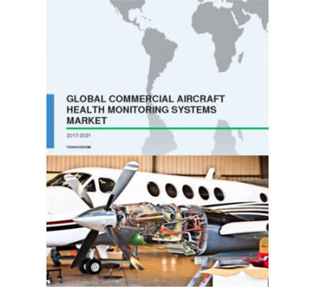

Global Commercial Aircraft Health Monitoring Systems (AHMS) Market 2017-2021
- May 2017
- 70 pages
- USD 3500USD 2500
Overview of the global commercial aircraft health monitoring systems (AHMS) market Market researc...
View Report

Global Commercial And Military Aircraft MRO Market 2017-2021
- Apr 2017
- 70 pages
- USD 3500USD 2500
Overview of the global commercial and military aircraft MRO market Market research analysts at Te...
View Report

Global Aircraft Line Maintenance Market 2016-2020
- Dec 2016
- 57 pages
- USD 2500USD 2375
Outlook of the global aircraft line maintenance market At present, the global market for aircra...
View Report

Global Commercial Aircraft MRO Market 2016-2020
- Nov 2016
- 68 pages
- USD 2500USD 2375
Overview of the global commercial aircraft MRO market Technavio’s market research analyst.....
View Report

Global Civil Helicopter MRO Market 2016-2020
- Jan 2016
- 66 pages
- USD 2500USD 2250
Outlook of the civil helicopter MRO market Technavio’s market research analyst anticipates the glo...
View Report

Aircraft Modernization, Upgrade, And Retrofit Market 2015-2019
- Oct 2015
- 70 pages
- USD 2500USD 2250
Market segmentation by aircraft type Wide-body Regional jets As of 2014, there were more th...
View Report
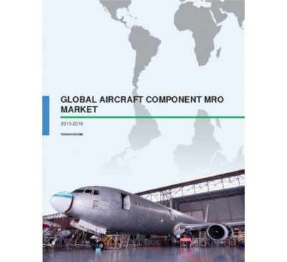

Global Aircraft Component MRO Market 2015-2019
- Sep 2015
- 54 pages
- USD 2500USD 2250
About aircraft component MRO Aircraft component MRO services are essential in ensuring the smooth...
View Report
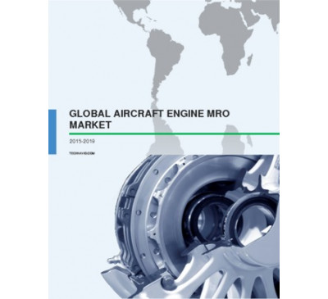

Global Aircraft Engine MRO Market 2015-2019
- Aug 2015
- 64 pages
- USD 2500USD 2000
About aircraft engine MRO In the aerospace industry, engine MRO is carried out at regular interva...
View Report
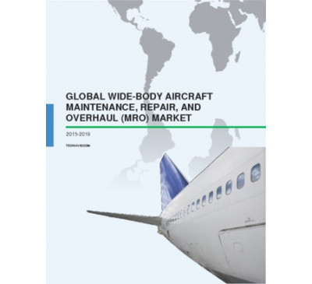

Global Widebody Aircraft MRO Market 2015-2019
- Aug 2015
- 50 pages
- USD 2500USD 2000
About widebody aircraft MRO Aircraft MRO is crucial for sustaining and extending the life of wide...
View Report
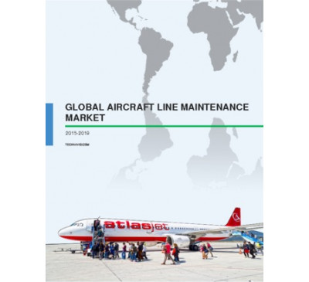

Global Aircraft Line Maintenance Market 2015-2019
- Aug 2015
- 55 pages
- USD 2500USD 2000
About aircraft line maintenance Line maintenance is a part of aircraft MRO; it involves maintenan...
View Report
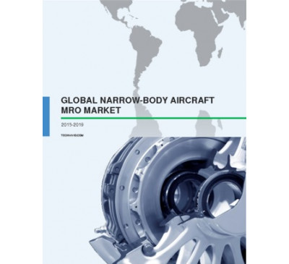

Global Narrow-body Aircraft MRO Market 2015-2019
- Aug 2015
- 53 pages
- USD 2500USD 2000
About aircraft MRO In the aerospace industry, aircraft MRO has become an essential component to ...
View Report

Global Commercial And Military Aircraft MRO Market 2015-2019
- Aug 2015
- 76 pages
- USD 2500USD 2000
About Aircraft MRO Aircraft maintenance, repair, and overhaul (MRO) has become an essential comp...
View Report

Global Commercial Aircraft MRO Market 2015-2019
- Feb 2015
- 60 pages
- USD 2500USD 2000
About Commercial Aircraft MRO MRO plays an important role in sustaining and extending the life of...
View Report
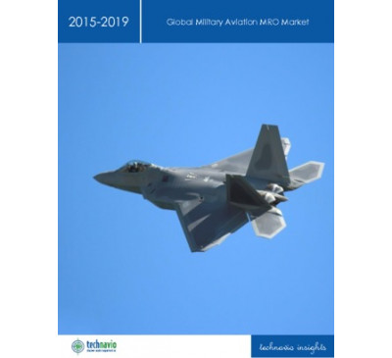

Global Military Aviation MRO Market 2015-2019
- Jan 2015
- 73 pages
- USD 2500USD 2000
About Military Aviation MRO MRO plays an important role in sustaining the life of an aircraft. It...
View Report

Global Aircraft Dismantling Market 2015-2019
- Dec 2014
- 50 pages
- USD 2500USD 2000
About Aircraft Dismantling The process of dismantling an aircraft at the end of its life as a com...
View Report

Global Military Helicopter MRO Market 2014-2018
- Apr 2014
- 48 pages
- USD 2500USD 2000
About Military Helicopter MRO MRO refers to the activity of fixing any broken-down or out-of-ord...
View Report

18
Jul 2006

European Industrial Power Plant Maintenance Repair and Overhaul (MRO) Strategies

Region : Europe
This research provides an understanding of the maintenance repair and overhaul requirements and strategies of Industrial Power plants in Western Europe, as well as the key strategic opportunities and players within this sector.
USD 6,950
USD 4,865
READ MORE
26
Jun 2015

Global Military Aircraft Maintenance, Repair, and Overhaul (MRO) Market
Reduced Operations Tempo has Little Effect
Region : Global
The global military maintenance, repair, and overhaul (MRO) market is one of the most diverse markets in the defense industry. Market participants include the militaries, aircraft manufacturers, engine manufacturers, component manufacturers, specialty MRO companies, and airlines. This market research examines all of the military aircraft fleets glo...
USD 6,950
READ MORE
18
Jan 2017

Global Aerospace Maintenance, Repair, and Overhaul Internet of Things Market, 2016
Internet Protocol-based Software and Devices Offer Improved Functionality and Cost Control while Health Management Systems Usher Market toward a Truly
Region : Global
The global aerospace maintenance, repair, and overhaul (MRO) market, like many others, is in a state of change. The introduction of enhanced Internet protocol-based software and equipment is driving the market in new directions. This insight covers the market from 2016 to 2026. Logistics to support MRO and spares sales is a significant part of the ...
USD 1,500
READ MORE
13
Mar 2014

Analysis of the Global Advanced Aerospace Coatings Market
Robust Growth is Expected in the Commercial and Maintenance, Repair and Overhaul (MRO) Segments
Region : North America
This research service covers the global advanced aerospace coatings market and includes commercial aerospace coatings, general aerospace coatings, and MRO coatings. The regions covered are North America (United States and Canada), Europe (including Russia), and APAC (India, China, Korea, South East Asia, Japan, Australia, and New Zealand). The stud...
USD 4,950
USD 4,455
READ MORE
09
Jun 1999

World Aircraft and Engine Maintenance, Repair and Overhaul Markets

Region : Global

USD 3,950
USD 2,765
READ MORE
04
Oct 2013

The Market for Power Station Maintenance Repair and Overhaul (MRO) in Key African Countries
Aging Facilities and New Builds will Drive Growth
Region : Africa
The Energy and Power Systems (EPS) business unit within Frost & Sullivan constantly monitors global maintenance, repair, and overhaul (MRO) markets within the energy and power industry. This research service provides a concise analysis of the current state of the power plant maintenance, repair, and overhaul markets in South Africa, Nigeria, and Za...
USD 4,950
USD 4,208
READ MORE
10
Sep 2001

European Power Plant Maintenance Repair and Overhaul (MRO) Strategies and Upgrading Requirements

Region : Europe
This study assesses the views of a statistically relevant proportion of all thermal power plants in the European Union (EU). This piece of research provides a detailed analysis of the level of satisfaction with key aspects of OEMs' aftermarket activities. The study also aims to assess the power plant's (and utilities, IPPs and industrial owners) r...
USD 4,950
USD 3,465
READ MORE
30
Dec 2004

Power Plant Maintenance Repair and Overhaul (MRO) Services in North America

Region : North America
This study provides power plant maintenance, repair and overhaul (MRO) service providers an understanding of North American customers purchase decision criteria, perceptions and preferences, and actionable insights to improve their companys marketing and selling strategies.
USD 10,000
USD 7,000
READ MORE
29
Mar 2006

European Utility & Independent Power Plant Maintenance Repair and Overhaul (MRO) Strategies

Region : Europe
This research provides an understanding of the maintenance repair and overhaul requirements and strategies of utility and Independent Power Producer (IPP) plants in Western Europe, as well as the key strategic opportunities and players within this sector.
USD 6,950
USD 4,865
READ MORE
02
Jul 2005

Power Plant Maintenance Repair and Overhaul Strategies in Central and Eastern Europe

Region : Europe

USD 4,950
USD 3,465
READ MORE
27
Mar 2008

EMEA Oil & Gas Prime Mover Maintenance Repair and Overhaul (MRO) Markets

Region : Europe
The services market for prime movers in the oil and gas industry in the EMEA region is entering into a rapid expansion phase. Opportunities for market participants exist in all of the geographical regions analysed. However, the long term trends vary greatly from area to area. The prime movers which are utilized in the oil and gas industry and cove...
USD 6,950
USD 4,865
READ MORE
04
Feb 2004

European Power Plant Maintenance Repair and Overhaul (MRO) Strategies

Region : Europe

USD 10,000
USD 7,000
READ MORE
27
Apr 2007

Sub-Saharan Africa Power Plant Maintenance Repair and Overhaul (MRO) Strategies

Region : Africa
The market for power plant maintenance repair and overhaul strategies (MRO) in sub-Saharan Africa is growing. MRO Service providers who will be able to offer competitive prices without compromising financial results, a strong after-sale support service with a clear emphasis on labor force availability, and flexible payment terms will be in pole pos...
USD 12,500
USD 8,750
READ MORE
13
Mar 2002

North American Commercial and Military Aircraft and Engine Maintenance & Repair and Overhaul Markets

Region : North America
This report covers the North American aircraft (airframe) and engine maintenance, repair, and overhaul market. The report includes a commercial analysis and military analysis. Within each chapter, aircraft and engine markets are analyzed separately. Analysis includes revenue forecasts, competitive market share and structure, and market and techn...
USD 2,450
USD 1,715
READ MORE
10
Oct 2003

North American Commercial and Military Aircraft and Engine Maintenance Repair and Overhaul Markets

Region : North America
This report forecasts the North American Commercial and Military Aircraft and Engine Maintenance, Repair and Overhaul Markets. The prime thrust of the MRO market is airframe and engine heavy maintenance requirements necessary to serve the needs of commercial and military airfleet operations. Market forecasts, program analysis, and general trends a...
USD 2,450
USD 1,715
READ MORE
02
May 2017

Global Military Airframe Maintenance, Repair, and Overhaul (MRO) Market, Forecast to 2026
Reduced Deliveries of New Aircraft and Increased Reliance on Health Management Systems Conflict with Rising Event Costs Resulting in Minimal Growth
Region : Global
The global airframe MRO market registered $24.34 billion in 2016 revenue and is expected to reach 27.31 billion by 2026 growing at a compound annual growth rate of 1.2%. The North American market is the largest, but will experience modest growth. Meanwhile, rotary wing utility aircraft will experience the most significant segment growth. New delive...
USD 4,950
READ MORE
28
Jun 2017

Global Military Aircraft Engine Maintenance, Repair, and Overhaul Market, Forecast to 2025
Reduced Deliveries of New Aircraft, Increased Reliance on Modular Design, and Improved Engine Control Conflicts with Increased Event Costs Result in M
Region : North America
The North American engine maintenance, repair, and overhaul (MRO) market is the largest individual market, but will experience modest growth. Meanwhile, Fighter aircraft market will experience the most significant aircraft segment growth. New deliveries of airframes are slow, except in Russia and China, which are not included. Additionally, initial...
USD 4,950
READ MORE
10
Apr 2013

Analysis of the Indian Aerospace Industry
Engineering Services Create Tremendous Opportunity in the Indian Aerospace Industry
Region : South Asia, Middle East & North Africa
This research service analyses the opportunities and avenues for future growth of the aerospace manufacturing, engineering services, and maintenance, repair and overhaul segments in India. A ten-year forecast is provided, up to the year 2022, keeping in mind the drivers, restraints, and challenges that the industry faces.
USD 4,950
USD 4,208
READ MORE
22
Sep 2015

Commercial Aviation in APAC
A Future Aerospace Region Giant on the Rise
Region : Asia Pacific
During the last decade, APAC has been the most dynamic region with regard to air traffic. As a result, the region has witnessed the highest aircraft demand globally and a strong development of new infrastructure to cope with increasing traffic. The countries in this region realise that investment in this industrial sector is profitable. Thus, they ...
USD 1,500
READ MORE
31
Mar 2010

Middle East (GCC) Gas Turbine Maintenance Repair and Overhaul (MRO) Services Market

Region : South Asia, Middle East & North Africa
The GCC turbine services market is expected to grow with increased number of turbine installations in the recent years. Competition among the major service providers is expected to be more intense in the coming years. Many of the service providers have established facilities in GCC and are investing more in their facilities. Investments in sectors ...
USD 4,950
USD 3,465
READ MORE
21
Apr 2010

Gulf Cooperation Council (GCC) Steam Turbine Maintenance Repair and Overhaul (MRO) Service Market

Region : South Asia, Middle East & North Africa
With upcoming investments in the Power sector and Process industries the GCC Steam Turbine MRO market is expected to have a moderate growth of 3.8 percent till the forecasted period 2013. As a result of increase in demand of power and petrochemical products there is an increase in installation of Steam turbine which directly increases the need for ...
USD 4,950
USD 3,465
READ MORE
19
Dec 2016

Strategic Analysis of Major Global Airlines
Return to Profitability Brings Opportunities and Challenges to Airline Suppliers
Region : North America
This research service focuses on the competitive profiling of 15 global airline and airline groups that include 4 from the United States, 4 from Europe, 1 from Russia, 2 from the Middle-East, and 4 from Asia. The 10-year profiling of these airlines and airline groups includes their financial performance, major traffic, and capacity metrics, as well...
USD 4,950
READ MORE
16
Dec 2016

Global Aerospace Logistics IIoT, 2016
SaaS Providers Will Change the Nature of Aerospace Logistics, Using IoT To Significantly Reduce Costs and Increase Delivery Time
Region : Global
The aerospace logistics market, like many others, is in a state of change. The introduction of enhanced Internet protocol-based software and equipment is driving the market in new directions. This insight covers the market from 2016 to 2026. Logistics to support aerospace activities such as manufacturing; maintenance, repair, and overhaul (MRO); a...
USD 1,500
READ MORE
09
Jan 2008

European Commercial Airframe Components Aftermarket Analysis

Region : Europe
This research describes the growing European airframe components aftermarket and supply chain in the aircraft and engine maintenance, repair and overhaul domain.
USD 4,950
USD 3,465
READ MORE
12
May 2016

Global Business Aircraft Market, Forecast to 2020
Maintenance, Repair, and Overhaul (MRO) and Modification Programs
Emerge as Pockets of Revenue Growth Amid Softening Environment
Region : Global
This research service on the global business aircraft market provides detailed market forecasts and drivers and restraints as well as market shares and competitive analyses of participants from 2015 to 2020. This study covers 4 market segments: heavy aircraft, medium aircraft, light aircraft, and turboprop aircraft. Additionally, this study present...
USD 4,950
READ MORE
23
Mar 2007

Decision Support Database - Maintenance Repair and Overhauling

Region : Global

USD 1,500
USD 1,050
READ MORE
14
Nov 2012

Analysis of the Market for T&D Maintenance Services in Asia-Pacific
Power Utilities, IPPs, and Industries Promote Market Growth
Region : Asia Pacific
Electrical equipment used in the power transmission and distribution (T&D) sectors must undergo periodic maintenance to ensure reliable operation of the power grid. The main customers of T&D maintenance services are utilities, industries, independent power producers (IPPs), and commercial complexes. The market revenue covered in this research servi...
USD 4,950
USD 3,713
READ MORE
19
Aug 2015

US DoD Helicopter Market
Upgrades and Service Life Extension Projects Drive a Decreasing Market with Limited New Starts
Region : North America
Research Overview
This Frost & Sullivan research service on the United States (US) Department of Defense (DoD) helicopter market provides detailed revenue forecasts, drivers and restraints as well as market shares and competitive analyses of participants from 2014 to 2020. In this research, Frost & Sullivan's expert analysts thoro...
USD 6,950
READ MORE
09
Feb 2011

Asia Pacific Engine MRO Market - Revenue Opportunities and Stakeholder Mapping

Region : Asia Pacific
The civil maintenance, repair, and overhaul (MRO) market is segmented into airframe heavy maintenance, engine overhaul, component MRO and line maintenance. Engine MRO accounted for the largest share of the MRO market. There are several key challenges that the engine MRO market is facing today, following the global economic crisis, along with the h...
USD 12,500
USD 8,750
READ MORE
18
Feb 2008

Southeast Asian Power Plant Services Markets

Region : Asia Pacific
The Southeast Asian Power Plant Services covers the servicing of thermal power plants primarily the gas fired and coal fired power plants. The research service covers the operation & maintenance (O&M) services and the maintenance, repair and overhaul services (MRO) of the major equipments namely the turbines and boilers.This study analyses the mark...
USD 4,950
USD 3,465
READ MORE
29
Jun 2011

Asia Pacific Power Plant Services Market
What Differentiates Companies in the Power Generation Market beyond Selling Power Equipment?
Region : Asia Pacific
This research service covers the current state and future potential of the power plant services market in Southeast Asia and Australia and New Zealand (ANZ) regions. It provides an in-depth analysis of maintenance, repair and overhaul (MRO) services market for gas turbines, steam turbines and boilers, and turnkey operation and maintenance (O&M) se...
USD 4,950
USD 3,465
READ MORE
06
Sep 2017

Global Aerospace Sealants Market, Forecast to 2023
High Demand for Aircraft Fleet Expansion in Asia-Pacific and the Middle East is Expected to Spur Demand
Region : Global
Aerospace is one of the key industries of leading economies that supplies to market such as commercial aviation, defense aviation, and general aviation. Aircrafts and related components and products that are in operation or are being manufactured require a variety of highly specific and durable sealants for various applications on parts such as fue...
USD 4,950
READ MORE
23
Oct 2015

Analysis of the Australian Pump Services Market
Shift from CAPEX to OPEX Drives Near-term Opportunities while Demand for Value-added Services is a Long-term Growth Driver
Region : Asia Pacific
This research service provides the market size and growth forecasts for pump services in Australia. It provides the segmentation by end-user sectors and by types of pump services (such as maintenance, repair, and overhaul, installation and commissioning, decommissioning, and value-added services). The analysis also covers key market drivers, restra...
USD 1,500
READ MORE
12
May 2016

Global Commercial Cabin Interiors Market, Forecast to 2020
Record Aircraft Production Sustains the Cabin Interiors Market
Region : Global
This study on the global cabin interiors market provides market forecasts and drivers and restraints as well as market shares and competitive analyses of participants from 2015 to 2020. This study covers 4 market segments: seating, lavatories, galleys, and cabin components. This study presents the technological changes to the market and the compani...
USD 4,950
READ MORE
27
Sep 2013

Global Cabin Interiors Market
Is it Time for Renewed Growth?
Region : North America
This research describes the global market for aircraft cabin interiors. Supporting research data was collected from industry records for delivery of new aircraft; contracts for modifications; and contracts for maintenance, repair, and overhaul. Data was verified by conversations with industry participants. Market segmentation includes: cabin compo...
USD 6,950
USD 5,908
READ MORE
20
Feb 2008

Strategic Analysis of Asia Pacific PMA Parts Market

Region : Asia Pacific
This research service provides the market assessment for Asia Pacific PMA Parts Market. The topics covered includes market overview, market drivers, market metrics, market share, market trends, restraints, revenues, strategy, and technology trends. The research covers the dynamics, trends and forecasts of the PMA and EPA parts market penetration in...
USD 10,150
USD 7,105
READ MORE
07
Feb 2006

Asian Commercial Aircraft/Engine MRO Markets

Region : Asia Pacific
This research service addresses Asian commercial aircraft/engine maintenance, repair and overhaul (MRO) market with particular emphasis on engine, line, component, modification and airframe maintenance. Detailed market share of individual Asian countries are also forecasted. Aircraft/engine MRO market directly correlated with air traffic growth and...
USD 4,950
USD 3,465
READ MORE
19
Jun 2006

African Airframe and Engine MRO Markets

Region : Africa
This research initiative aims to identify the drivers, restraints and challenges faced by maintenance, repair and overhaul (MRO) providers in Africa, whilst analysing the characteristics of the end-users (airlines) in the region. It also provides a market revenue forecast over a 6 year period up to 2012 based on these drivers, restraints and chall...
USD 4,950
USD 3,465
READ MORE
28
Feb 2006

European MRO Markets

Region : Europe
This research initiative aims to identify the drivers, restraints and challenges faced by Maintenance, repair and overhaul (MRO) providers in Europe (EU-25 states plus Norway and Switzerland). It also provides a market revenue forecast over a 7 years period up to 2012 based on these drivers, restraints and challenges.
USD 4,950
USD 3,465
READ MORE
20
Jun 2006

Middle Eastern Airframe and Engine MRO Markets

Region : South Asia, Middle East & North Africa
This research initiative aims to identify the drivers, restraints and challenges faced by maintenance, repair and overhaul (MRO) providers in Middle East, whilst analysing the characteristics of the end-users (airlines) in the region. It also provides a market revenue forecast over a 6 year period up to 2012 based on these drivers, restraints and ...
USD 4,950
USD 3,465
READ MORE
01
Apr 2015

Analysis of Southeast Asian Pump Services Market
Focus on Increasing Plant Productivity and Efficiency across Industries Boosts Demand for Pump Services
Region : Asia Pacific
The scope of the study includes pump services used in oil and gas, chemicals and petrochemicals, power generation, water and wastewater treatment, food and beverage, and other industries such as pharmaceuticals, pulp and paper, and metals and mining. Services include maintenance, repair, and overhaul (MRO), installation and commissioning (I&C), val...
USD 4,950
READ MORE
26
Dec 2005

Refinery MRO Services Markets in India

Region : South Asia, Middle East & North Africa
This research service provides an understanding of the current practices, evolving trends and market insights of the Indian refinery maintenance, repair, and overhaul (MRO) services market. This research service helps market participants understand the Indian refining companies' purchase decision criteria, perceptions and preferences
USD 1,950
USD 1,365
READ MORE
07
Feb 2011

Asia Pacific Commercial Rotary Wing MRO Market - Revenue Opportunities and Stakeholder Mapping

Region : Asia Pacific
The aviation industry in Asia at large has been witnessing growth over the past two years only marred slightly by the recent global economic crisis. The Asia Pacific region has always been referred to as the region for growth and opportunity, be it business, trade, communication, information technology or aviation. There is a great level of revampi...
USD 12,500
USD 8,750
READ MORE
28
Sep 2004

European Equity Research - 2Q04 MRO Analysis

Region : Europe
This research service looks at the European commercial and regional/business jet maintenance, repair and overhaul (MRO) markets. The study, as part of Frost & Sullivan's Financial Services offering, focuses on the near-term status of the market, provides insight into the state of the market in the recently completed 2Q04, and analyses fundamental ...
USD 2,450
USD 1,715
READ MORE
19
Jan 2004

Asia Pacific Aircraft and Engine MRO Markets

Region : Asia Pacific
This report details the findings for the Asia Pacific Aircraft Maintenance, Repair and Overhaul (MRO) markets in both commercial and military segments. Revenue forecasts are discussed along with market and technology trends, market share analysis, and related general industry information. Industry awards are also presented to this year's winners ...
USD 2,450
USD 1,715
READ MORE
24
Jan 2005

North American Aircraft & Engine MRO Markets

Region : North America
This study covers the North American Aircraft and Engine maintenance, repair and overhaul market. Revenue forecasts are presented along with competitive analysis and market and technology trends. Industry awards are also presented for this research service.
USD 2,450
USD 1,715
READ MORE
05
Jul 2007

Country Industry Forecast - Social and Infrastructure Analysis for the Chinese Aerospace and Defense Industry
Region : Asia Pacific
Rapid economic and industrial growth in China are leading to increased demand for air travel and frieght. China has liberalized policies relating to airport infrastructure development and modernization. Maintenance, repair and overhaul market and aircraft suppliers are expected to benefit from the growing demand for Chinese air travel. Growth oppo...
USD 450
USD 315
READ MORE

Strategic Industry Analysis of China's Commercial Aviation Supplier Market

Region : Asia Pacific
This research service provides strategic industry analysis of the dynamics of commercial aviation suppliers in China. The analyses include identification of industry challenges, market drivers and restraints and key industrial influences that are affecting the commercial aviation market in China. Market coverage includes aviation manufacturing, avi...
USD 13,000
USD 9,100
READ MORE
15
Jan 2005

Aerospace Equipment and Services - Growth and Investment Opportunities

Region : North America
This initiation research service from Aerospace financial services group highlights growth sectors of notable interest and also provides a comprehensive financial analysis of the leading U.S. aerospace firms. This study presents a broad outline of the current aerospace industry, highlighting major market and financial trends with an emphasis on fou...
USD 6,950
USD 4,865
READ MORE

اگر منبع مورد نظرتان موجود نبود در ادامه درخواست دهید

از این به بعد شما اساتید و دانشجویان و پژوهشگران گرامی می توانید با دادن اطلاعی از منبع مورد نظر خود به ایمیل ما، کتاب های خود را از طریق درخواست کتاب این سایت بسیار ارزان قیمت دانلود کنید.

–شابک کافیست مشخصات کتاب همچون نام | شماره | نام نویسنده و … را برای ما بفرستید.
– یا لینکی از آن در سایت های دیگر همچون آمازون ، ایی بِی، گوگل بوک ، انتشارات های اصلی و … آن را به ما بگویید.
-باقی کار را به ما بسپارید؛ به شما در کمتر از ۲۴ ساعت اطلاع خواهیم داد.

